Sprint 3 Plan

ScrumLite

2/18/16

Revision 3

3/15/16

Goal:

We need to fix many bugs and complete all backlogged tasks, there are many of each. Everything needs to be polished and nicely packaged.

User Stories/ Tasks:

As a project member, I want the project calendar to be able to sync with my personal one.

Google API

Create Calendar

As a project member, I want to communicate with other team members.

Integrate Chat

As a project member, I want the interface to be aesthetically pleasing and easy to

learn/use.

CSS

Click and drag tasks

Upcoming tasks feed

As a project member, I want the application to have as much utility as possible.

Fix all bugs

TSR’s

Burn-up charts

Fix Remove member

Fix invite system

Fix view/manage team

Restructure Scrum Board

Team Roles:

Manmeet Singh: Product Owner

Colton: Develeoper

Alessio Alba: Developer

Jake: Scrum Master

David: Developer

Muhammed Saber: Developer

Task Assignment:

Manmeet Singh: (1, create calendar) (2, integrate chat) (4, Fix all bugs) (4, Burn-up charts), (4, Fix view/manage team), (4, restructure scrum board)

Colton: (4, Fix all bugs), (4, Fix view/manage team)

Alessio Alba: (2, create calendar), (3, upcoming tasks feed) , (4, TSR’s), (4, Fix remove), (4, Fix view/manage team)

Jake: (4, Fix all bugs), (4, Fix invite system)

David: (3, CSS), (3, click and drag tasks)

Muhammed: (1, Google API), (2, integrate chat)

Initial Burnup Chart:

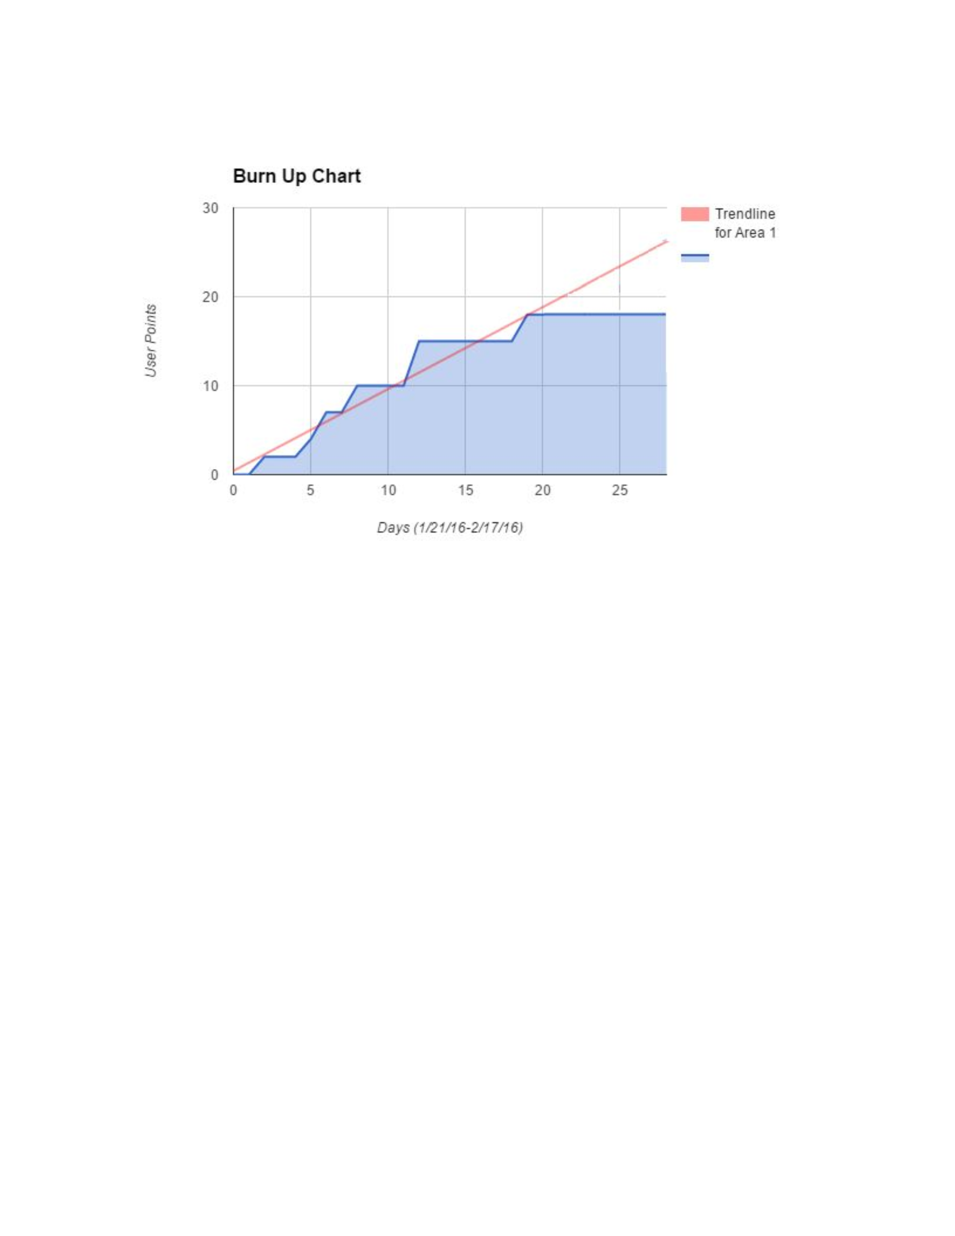

Scrum board: <https://trello.com/b/yhp1NgCI/scrum-board>

Scrum Times: MWF 2:00 Merrill Library