Part 1 – Project Concept – Fitness Logger

At a high level, our web app will be a fitness log where users can create and maintain their own personal accounts to carefully record their workout data and track their progress over time. Many fitness apps exist, but they almost always restrict the functionalities/features unless the user pays for an upgraded account. We hope to create a functional and robust app that will satisfy the general need to track workout data, while also providing an aesthetic and user-friendly interface. There are three main functionalities:

1. **Users will be able to create, edit, and delete routines.** A routine will consist of a list of exercises in a specific order. Editing a routine involves adding, deleting, and re-ordering different exercises; as a user types in an exercise name, autocomplete will suggest an exercise name. Users can also set a specific weight and/or number of repetitions/sets for each exercise within the routine. Users can then save the routine to their personal list of routines, and access it in the future to perform an actual workout session (see Functionality #2). The purpose behind this functionality is saving users the hassle of punching in all of their exercises every time they workout (since workout routines are generally repeated).
2. **Users will be able to start and record workout sessions and dynamically add/delete exercises as they go.** The session can be based on a previously created routine, or it may be an empty routine. Workout sessions will have a timer for the overall session, as well as individual timers for each exercise. Users can record sets, repetitions, and weight completed for each exercise as they progress through the session. Once they are finished, they can end and record the session, where it will be logged and accessible in the future. The purpose behind this functionality is allowing users to record their workout data so they can track their progress over time. It is important that they can add/delete exercises during the workout session for maximum customizability.
3. **Users can share workout routines that they have created with other users.** Users can take a routine that they have created and send the routine to another user via their unique username. The routine will then automatically be added to the recipient’s list of routines. The purpose behind this functionality is to enable users to collaborate with other users in regard to their workout routines and exercises.

In terms of logic, Functionalities #1 and 2 are heavily involved on the client-side. Users have to enter exercises and data as they create a routine, and autocomplete will run as they enter an exercise name. In terms of the server-side logic, when routines and completed workout sessions are saved, they are stored in a database in fields specific to the user. Users can access and update their saved data at any time. Since users will have their own account with data specific to them, the app will support multiple users that do not interfere with one another (other than intentionally sharing workout routines with other users). Additionally, the data will be persistent so that users can access previously created routines and workout sessions.

Part 2 – UI Design

The first screen we designed was the user profile page (Figure 1). This page will contain all of a user’s saved routines, as well as any routines that have been shared with them by another user. The field containing “# of workouts finished” would simply display the total number of workouts the user has completed. We chose a grid view to display all of the routines because we would expect a user to have anywhere from 5-10 routines saved on average, so this seems like the most balanced view style from a usability standpoint. If a user were to click on a routine, they would be presented with a number of options (not pictured): start a workout session based on that routine, edit the routine, delete the routine, or share the routine with another user. The “Shared Routines” section contains routines that other users have shared with our pictured user. Additionally, the “Friends List” link would essentially display a list of usernames that have been saved, for convenient sharing purposes.

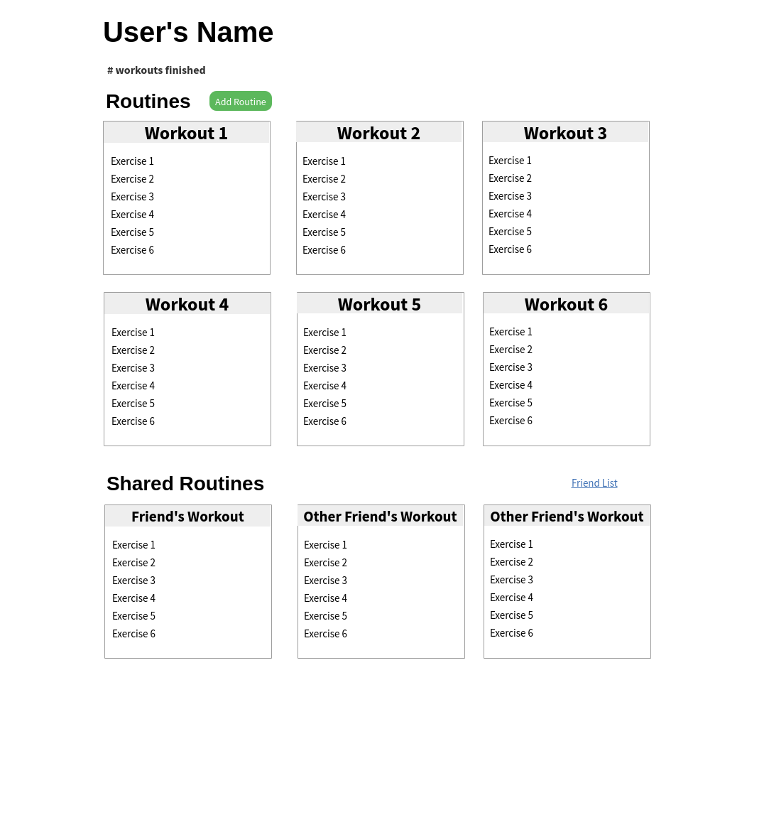**Figure 1**

The next screen we designed was the routine editor page (Figure 2). This page is very dynamic in nature as it allows the user to fully customize their routine. To add a new exercise, they would type in an exercise name, and autocomplete would run as they are typing to suggest common exercises. Once the user clicks add exercise, the exercise would appear at the bottom of the list. Exercises can be removed by clicking the “Remove Exercise” button. Exercises can be reordered by pressing the up/down arrow keys. Additionally, the number of sets, weight, and repetitions can be controlled via the text boxes and “Add Set” button, and sets can be removed by clicking the red ‘X’. Thus, the user can create a routine of any variety, maximizing usability, while also keeping the interface simple. Once the user clicks “Save Routine”, it is saved to that user’s list of routines shown in Figure 1.

**Figure 2**

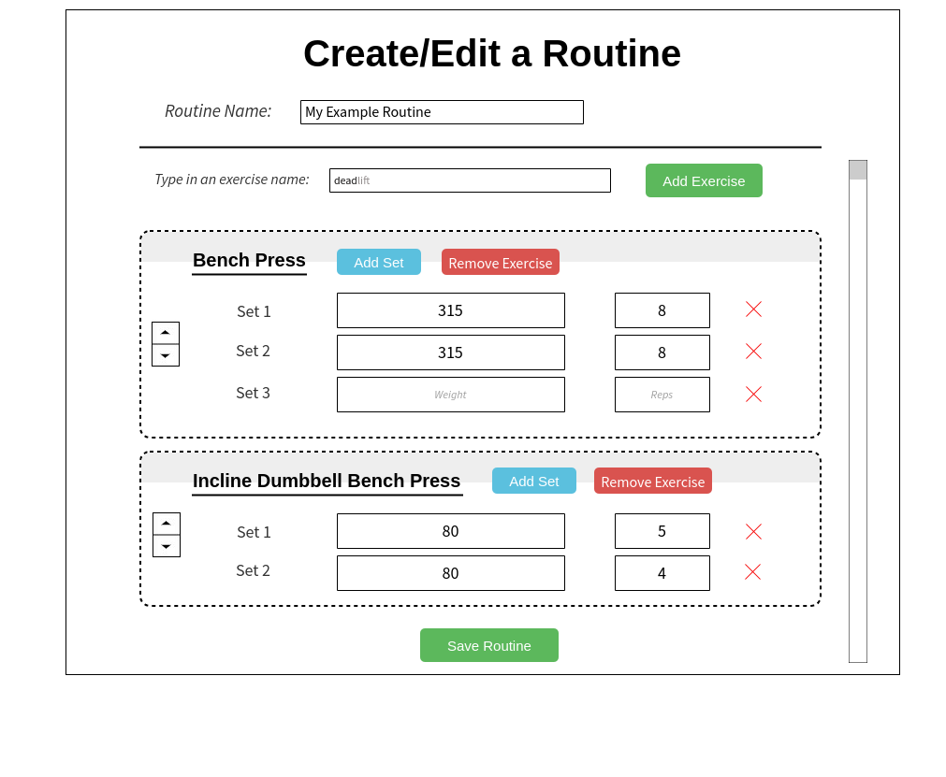

The next screen we designed was the active workout session page (Figure 3). This page is meant to be used while the user is completing a workout. The timer for the overall workout is displayed in the upper right, and the timer for each individual exercise is displayed next to each exercise name. The timer for an exercise will begin when the drop-down arrow is clicked. Each exercise is contained in a panel, and will only display the number of sets, weights, and repetitions if expanded via the drop-down arrow (exercises 1-4 show the collapsed view, and exercise 5 shows the expanded view). The collapsed and expanded views are included to increase organization on the page. Exercises can be added or removed during the workout by pressing the green or red buttons, respectively. Additionally, sets can be added with the “Add Set” button if the exercise is in the expanded view, and sets can be removed with the red ‘X’. This increases usability by allowing the user to make edits to the routine as they are completing the workout. Finally, if the user clicks “Save & Exit”, the workout session is recorded and placed in the user’s history.

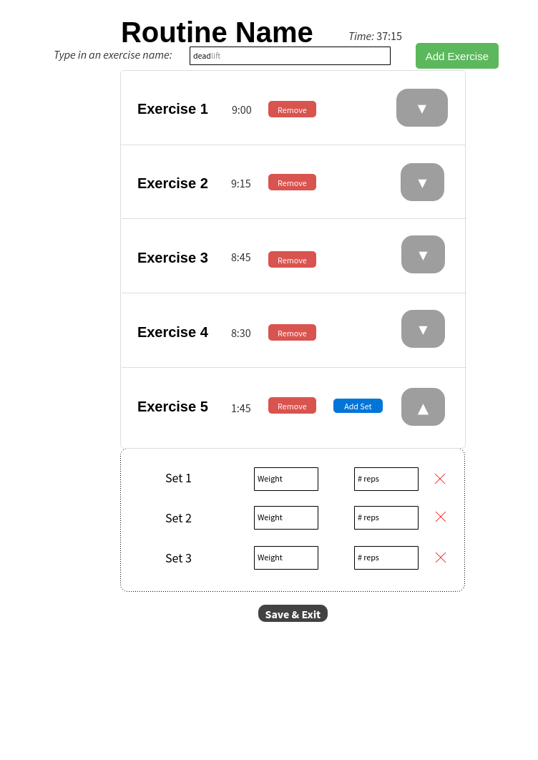**Figure 3**

The last screen we designed was the workout log (Figure 4). This page displays all of the user’s recorded workout sessions in chronological order. Chronological order was chosen as a user is more likely to view a workout that they recently completed. Each panel represents a workout session, and will display basic information such a workout title and date completed. Additionally, if the user clicks “View”, it will display the exercises completed during that workout, along with the sets/weights/repetitions for each exercise (this specific functionality is not shown). This is included so the user can view their history and track their progress.

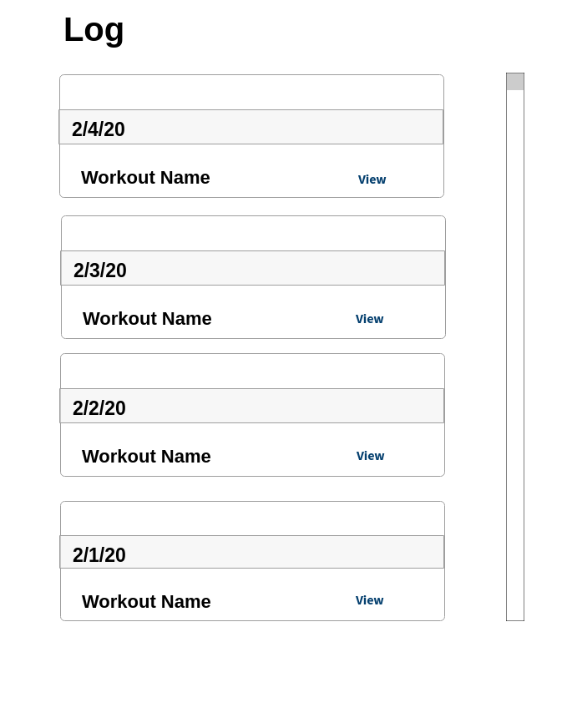**Figure 4**