Third Party Integration utilizing HTTPS:
Third Party Certificate Installation

- Need to define the third party external node.

- Navigate to Peopletools > Integration Broker > Integartion Setup >Node Definition
- Add New Node, Enter node name and click ADD
- Enter the required information
- Description
- Node Type: EXTERNAL
- Default User ID: (see definition at end of document)
- External User ID and External User Password if required by 3rd party

Example:
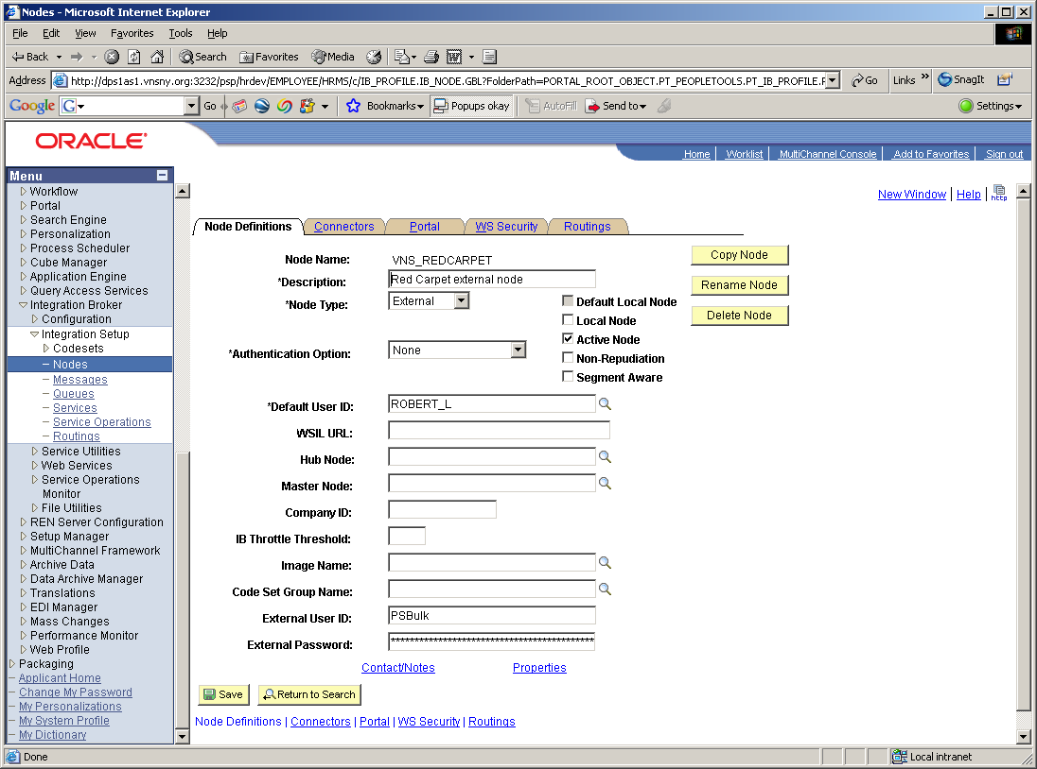

Go to the Connector Page:

Enter the Connector ID: HTTPTARGET
Enter the Primary URL: in this case it utilizes HTTPS

For example:
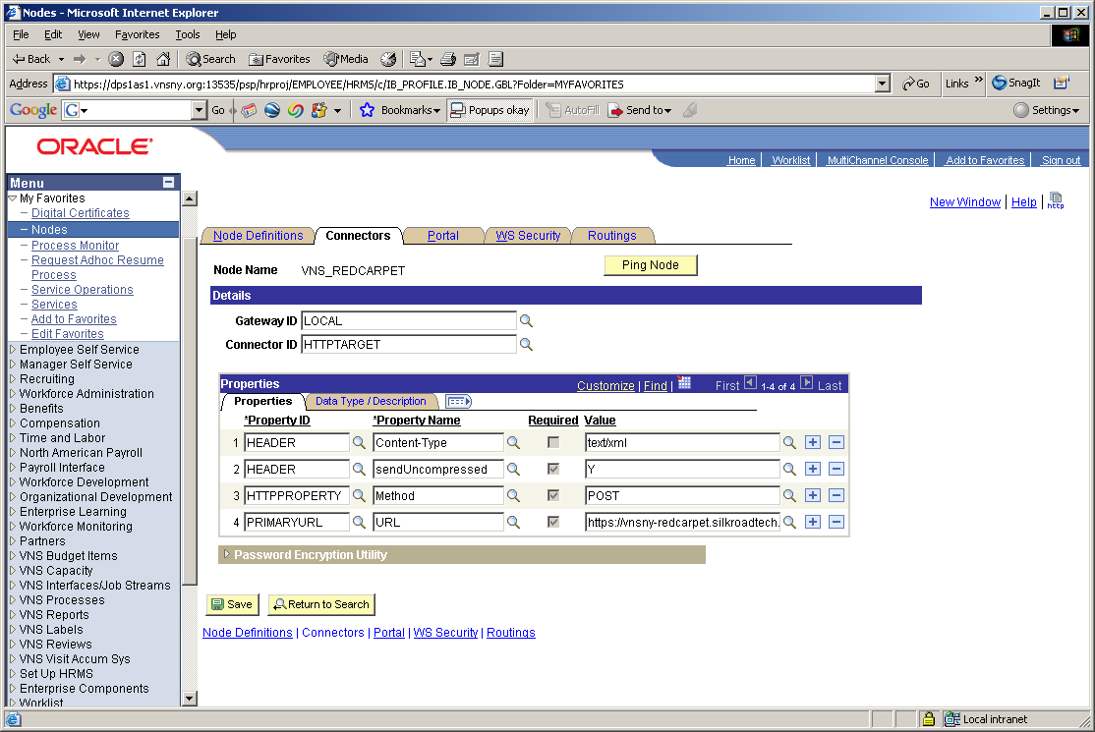

If you ping the node at this point, you will get an error message - Integration Gateway - External System Contact Error (158,10721). In the ErrorLog.html you may see the error: “HttpTargetConnector:ExternalSystemContactException unknown certificate”

This is due to the fact that you have not imported the digital certificate from the 3rd party external site.

- Installing Digital Root Certificate from 3rd party

  - You need to obtain the Root Certificate and copy it to a file. To do this, first take the primary URL specified on the Connector page of the external node definition. Copy it and paste into a browser URL address line.
  - Depending on the browser version you will see a padlock icon either to the right of the address line or in the lower right corner of the browse. Click on the Padlock to view the 3rd party server certificate. e.g. pstest.westwood.edu
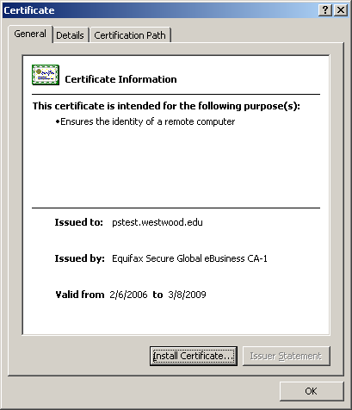
  - Click on the Certificate Path tab and highlight to top node. e.g. Equifax Secure Global Ebusiness CA-1
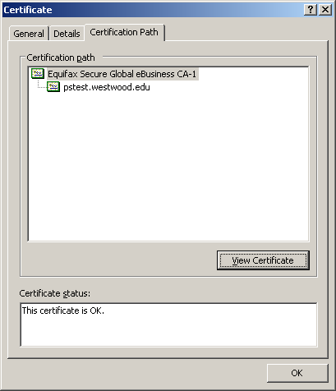
  - Click on View Certificate
  - Click on Details Tab
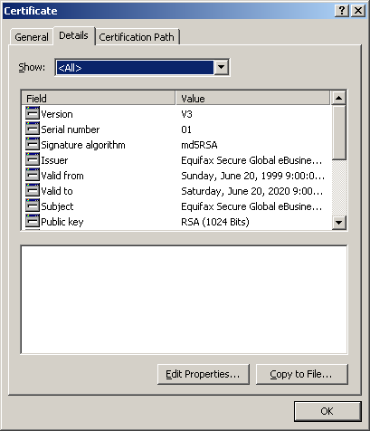

  - Click on ‘Copy to File’ button and it will pop up a certificate export wizard. Click ‘Next’ button.

  - Select 2nd option ‘Base-64 encoded X.509(.CER)’ and click ‘Next’
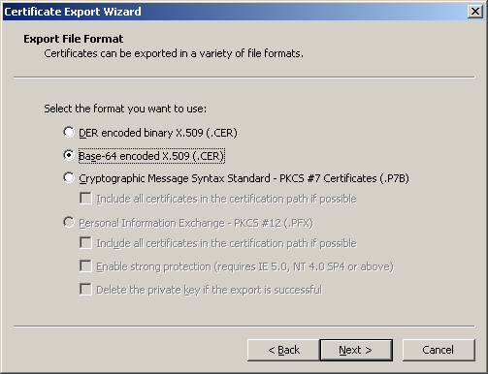
  - Browse to the location to place the certificate to and enter filename to which you want to export the certificate to.
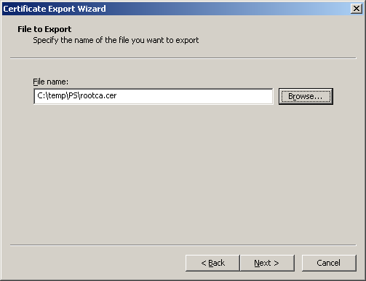
  - Click ‘Next’ and at the Export Completion Window, click ‘Finish’




The certificate was place and named in this example as c:\temp\rootca.cer

- Copy the c:\temp\ps\rootca.cer to <PS_HOME>\webserv\<Domain> on web server box.
- Open the command prompt on the web server box and cd to
PS_HOME\webserv\<Domain>.If on tools release 8.49+ the path is: PS_HOME\webserv\<Domain>\bin
- Type ‘pskeymanager – import’

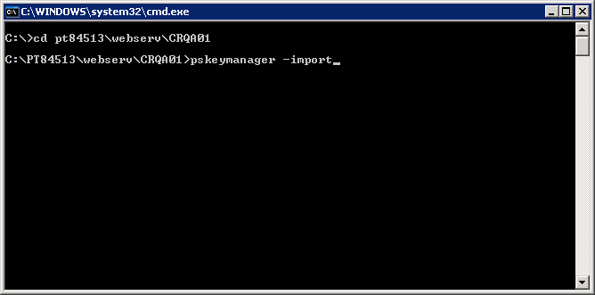

- It will prompt you for the password; type password as ‘password’ (it’s default, if you want to change it, you can type something you can remember)

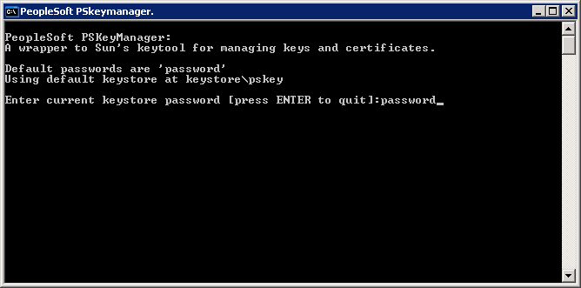

- It will prompt you for Alias

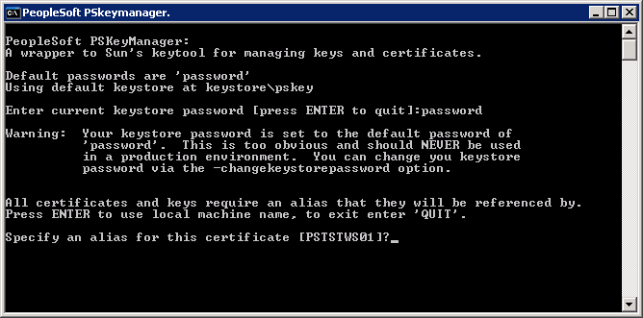

- Enter an alias name for the root certificate, e.g. ‘PTTEST’ or any other name (Make sure it does not already exist in your keystore) and in the next step enter the rootca file name ‘rootca.cer’ which you have copied to a file from the certificate sent by certificate provider and then click ‘Enter’
If necessary enter the file path to the certificate.

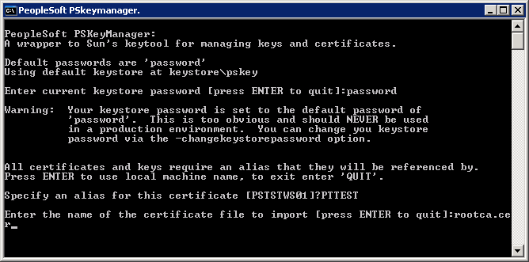

- You will see the ‘Trust this Certificate’ prompt as shown below; type ‘yes’

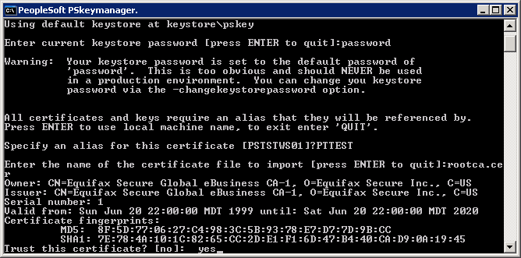

- It will complete the process and you will see ‘Certificate was added to keystore’

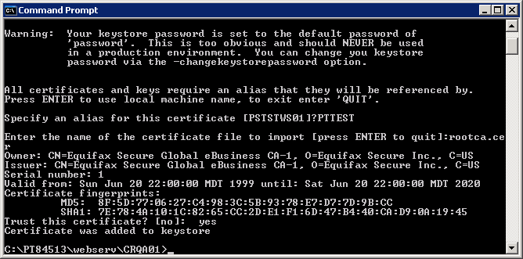

- Edit the integrationgateway.properties file
1. Edit integrationGateway.properties file.
Peopletools>Integration Broker>Configuration>Gateways and choose the gateway. Once there click on the Gateway Setup Properties link, enter the userid and password, Click OK. Now, click on the Advanced Properties Page and locate the following code and enter the path to pskey (<PS_HOME>\webserv\<Domain> /keystore/pskey) and the password.
Do NOT encrypt the password if pre-8.50. On tools release 8.50+ the password must be encrypted.
Uncomment following parameters and make sure they are correct.
secureFileKeystorePath=<path to pskey>
secureFileKeystorePasswd=password

- Reboot the webserver and Ping the Node to test

Go back to the external node definition and PING the node. You should get a SUCCESS!

Definition for Default User ID:
On inbound integrations, this is the user ID that the sender must specify to invoke a service operation, unless you have set up an external user ID for this purpose.
On outbound integrations, this is the default user ID sent with the service operation.

