**Name**: _______________

**Date**: _______________

Unit 8 Quiz

Answer all parts for the following questions. **Show your work (or explain your calculations)**.

1. **Setup**: In March 2015, 560 of 1077 Ohio voters randomly sampled said they favored legalizing marijuana (Higgs, 2015). At a 5% significance level, do the data provide sufficient evidence to conclude that the majority of registered Ohio voters favor legalizing marijuana?
2. Define parameter and state hypotheses.
3. Sketch rejection region (or describe the region in words if you decline to draw).

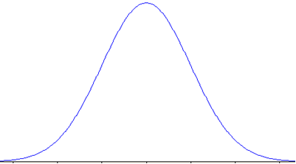

1. Calculate p-value and test statistic.
2. Conclude and interpret the results of this hypothesis test.
3. **Table

   Description automatically generatedSetup**: To the right is a random sample of 10 Homework grades (%) from this semester. Suppose Homework grades are normally distributed with unknown population standard deviation.

Last semester’s average was 88%. Do the data provide sufficient evidence to conclude that average homework grades have increased this semester?

Use $α=0.10$.

1. Define parameter and state hypotheses.
2. Sketch rejection region (or describe the region in words if you decline to draw).



1. Calculate p-value and test statistic.
2. Conclude and interpret the results of this hypothesis test.