**9.3 Comparing Investment Options**

Suppose that three individuals Alice, Ben, and Chantelle decide to invest $12,000 over the next 10 years. Here are the details of the investment choices they have made.

Alice has $12,000 to invest in an account earning 7% simple interest.

Ben invests $12,000 in an account earning 7% interest compounded annually.

Chantelle invests $100 each month into an account earning 7% interest compounded monthly.

**Question 1:**

What Future value will Alice have in 10 years?

**Question 2:**

What Future value will Ben have in 10 years?

**Question 3:**

What Future value will Chantelle have in 10 years?

The following graph shows how these three investor’s money grows over 10 years (and beyond).

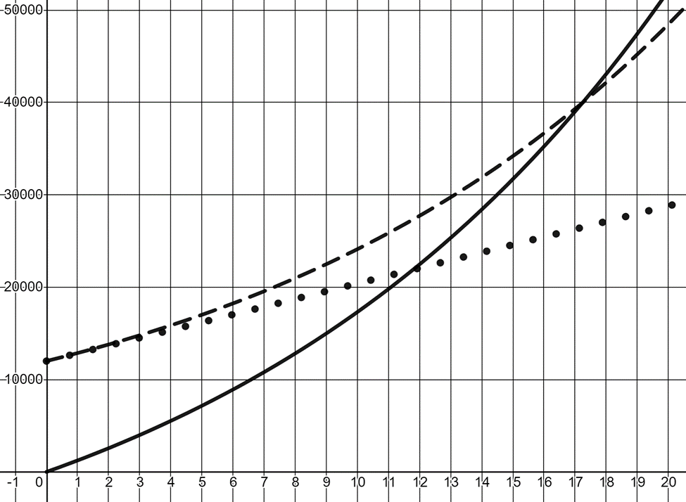

**Question 4**

Based on your previous work, label each investor on the graph.

**Question 5**

If Chantelle continues her investment strategy of depositing $100 each month beyond the 10 year mark, how long will it take for her investment to surpass Alice’s investment? How long will it take to surpass Ben’s investment?

Time to surpass A: _______

Time to surpass B: _______

**Question 6**

Which investment strategy do you think is the most advisable for a recent graduate? Explain your reasoning.