**10.6 Expected Value – Overview**

**Expected Value**

Definition: The **expected value** of an event *X* is the long term average (the value we would expect to happen if we performed the experiment many, many times).

How to calculate it:

* In words: Multiply each outcome (*x* value) by its probability and add them together.
* Formula:

$E\left(X\right)=x_{1 }P\left(X_{1}\right)+x_{2}P\left(X_{2}\right)+…+x_{n}P(X_{n})$,

where $x_{i}$ is the $i^{th}$ outcome and $P\left(x_{i}\right)$ is the probability of $x_{i}$.

**Example 1**: In soccer, you earn a certain number of points based on the result of a game. This is shown in the table below. Calculate the expected value of the number of points earned for a single game.

|  |  |
| --- | --- |
| ***X*** | ***P(X)*** |
| Win = 3 | 0.3 |
| Tie = 1 | 0.5 |
| Loss = 0 | 0.2 |

**Sum of Expected Values**: To find the combined expected value of multiple events, we can simply add the individual expected values.

$$E\left(X or Y\right)=E\left(X\right)+E(Y)$$

**Example 1 (continued)**: Find the expected value for the total number of points earned in a season if the season has 12 games.

**Example 2**: Jim likes to day-trade on the Internet. On a good day, he averages a $1400 gain. On a bad day, he averages a $900 loss. Suppose that he has good days 30% of the time, bad days 50% of the time, and the rest of the time he breaks even. What is the expected value for one day of Jim’s day-trading hobby?

*Strategy*: First make table

* Think about possible X values
* THEN the probabilities

**Example 3**: Suppose that you and a friend are playing cards and decide to make a bet. If your friend draws two hearts in succession from a standard deck of 52 cards without replacing the first card, you give him $10. Otherwise, he pays you $20. If the same bet was made 15 times, how much would you expect to win or lose? Round your answer to the nearest cent, if necessary.

**Example 4 (Calculator Fun Sess):** Calculate the expected value of the scenario:

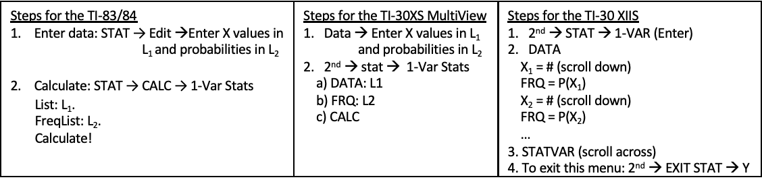

** Note: Unable to do this on the TI-30 XIIS

**Example 5:** A typical three-reel mechanical slot machine has different payoffs determined by the number and position of various pictures. Suppose the payoff (in dollars) has the probability distribution given in the table below. Find the expected payout.

