**Chapter 11 Statistics – Review**

**Problem 1:** You are collecting data for the EPA and need to test the concentration of a substance in samples of the ground water throughout different locations. Determine which type of sampling method is used based on each of the following scenarios.

1. You collected data from 50 locations over a week and want to test every 5th sample.
2. You need to collect data quickly and only sample locations from the region you are currently in.
3. You believe each region will have different concentrations. So you randomly select 6 locations to sample from for each region.
4. There are 50 possible locations to sample from and you believe there are no differences between locations. So you randomly select 10 locations to sample from.
5. Each region has a diverse locations in terms of concentration. So you randomly select 3 regions and sample from each possible location within the region.

**Problem 2**: The following table represents a grouped frequency distribution of the number of hours spent on the computer per week for 50 students.

1. How many students use the computer less than 7 hours per week?
2. What percent of students used the computer more than 10.4 hours per week?
3. What percent of students used the computer between 7.0 and 13.9 hours per week inclusive?

**Problem 3**: Create a frequency distribution for the following data on students’ favorite color:

Yellow, Blue, Red, Red, Blue, Yellow, Green, Green,

Blue, Red, Yellow, Yellow, Green, Blue, Green, Blue,

Red, Yellow, Yellow, Yellow, Blue, Red, Red, Blue.

**Problem 4:** Below is a dataset about the age of a giraffe and its height in meters.



1. Calculate the correlation for the dataset above and determine if it is statistically significant at a level of significance of $α=0.05$.
2. If appropriate, determine the regression equation.
3. If a giraffe is 3.5 years old, make a prediction for how tall it will be.
4. If a giraffe is 7 years old, make a prediction for how tall it will be.

**Problem 5**: The histogram to the right represents ages of attendees at a school fair.

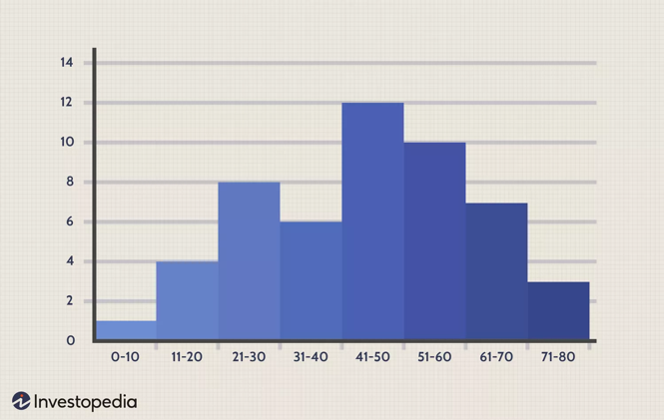

1. What age group had the highest frequency?
2. What is the frequency for the 61–70 year-old age group?
3. How many attendees were between the ages of 11 and 40 inclusive?
4. Which three age groups were the least represented at the fair?

**Problem 6**: Daily ticket sales for the local zoo have a normal distribution with mean $800 and standard deviation $50. Use the empirical rule to answer the following questions.

1. What percent of days have ticket sales between $750 and $850?
2. 99.7% of days have ticket sales between which two-dollar amounts?
3. What percent of days have ticket sales between $700 and $900?
4. What percent of days have ticket sales greater than $850?
5. What percent have days have ticket sales less than $700?
6. What percent of days have ticket sales greater than $950?

**Problem 7**: Rainfall per year in a country has a normal distribution with mean 40 inches and standard deviation 4 inches.

1. Find the z-score for a city that has yearly rainfall of 45 inches.
2. Find the probability a city has yearly rainfall more than 45 inches.
3. Find the probability a city has yearly rainfall less than 33.5 inches.
4. Find the probability a city has yearly rainfall between 32 and 42 inches per year.

**Problem 8:** Here are ages from a sample of attendees at the school fair: 5, 23, 38, 11, 4, 44, 57, 11, 28, 38, 45, 60, 8, 11.

1. Find the mean age.
2. Find the median age.
3. Find the mode of ages.
4. Find the range of ages.
5. Find the sample standard deviation of ages.
6. Calculate the 5-number summary of ages.
7. Sketch a boxplot of ages based on your answers from (f).

**Problem 9**: Two new species of walruses were discovered, one that is pink and one that is blue. From a sample of 15 of each kind, the following information was recorded and/or calculated.

* Pink walruses: Sample mean weight $\overline{x}=1,100$  lbs with standard deviation 200 lbs. Suppose the margin of error using a 85% level of confidence is $E=275$ lbs.
* Blue walruses: Sample mean weight $\overline{x}=1,300$  lbs with standard deviation 150 lbs. Suppose the margin of error using an 85% level of confidence is $E=215$ lbs.

Construct 95% confidence intervals for both types of species (and plot them). Can we conclude that one species is heavier than the other? Why or why not?

**Problem 10**: Suppose a sample of 975 spiders were asked if they prefer to dine on flies or butterflies and 600 responded “Butterflies are way better”. Calculate the point estimate to estimate the true proportion of spiders who prefer butterflies and construct a 95% confidence using the rule of thumb to calculate the margin of error.