**8.2 Displaying Data – Overview**

**Frequency Tables (Distributions)**

Summarize datasets by counting the number of observations for each category, distinct value or interval.

* Can be used for categorical data and quantitative (numerical) data.

Grouped Frequency Distribution

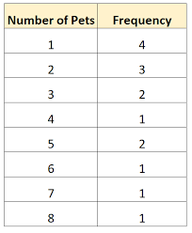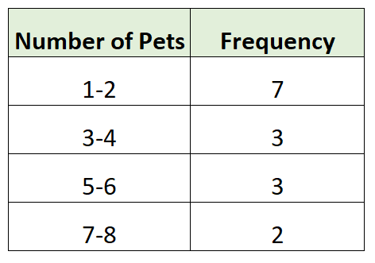

Find count between 4 and 7 inclusive:

**Example 1**: Construct a frequency table using the data below.

38, 33, 5, 5, 47, 29, 24, 42, 3, 18,

30, 46, 25, 44, 40, 42, 39, 44, 29, 13

Class width =

* All class widths must be equivalent

**Graphical Displays of Data**

**Pie Chart**

* Compare parts to a whole.
* Slices represent the proportion of a category **Type of Data: Categorical**

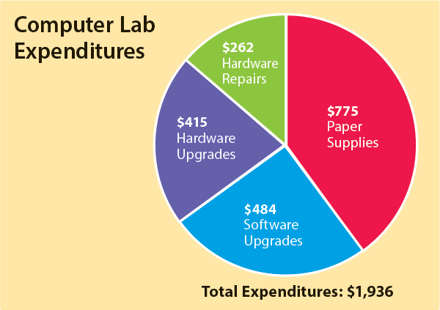

**Advantages:**

**\*** Simple and common

**Disadvantages:**

* Harder to compare area than heights

* Not useful when there are lots of categories

**\*** Easy to be misleading if visually distorted

(3D, one slice is larger) or labels are not clear

**Bar Graphs**

* Height of the bar represents the amount of data

in each category.

* Can be counts or relative frequencies.

**Type of Data: Categorical**

**Advantages:**

**\*** Simple and common and easy to read

**Disadvantages:**

* Misleading if:

- Bars are not equal width

- Inconsistent vertical scale

- Vertical scale is truncated (not start at 0)

**Histograms**

* Height of the bar represents the amount of data

in each class.

* Can be counts or relative frequencies.Chart, histogram

  Description automatically generated

**Type of Data: Quantitative**

**Advantages:**

* Simple

* Can show lots of data very concisely

* Shows “shape” or distribution of data

**Disadvantages:**

* Class width impacts the plot drastically

* Misleading if:

- Bars are not equal width

- Inconsistent horizontal / vertical scale

- Vertical scale is truncated (not start at 0)

**Line Graphs**

* Shows changes in a numerical variable over time.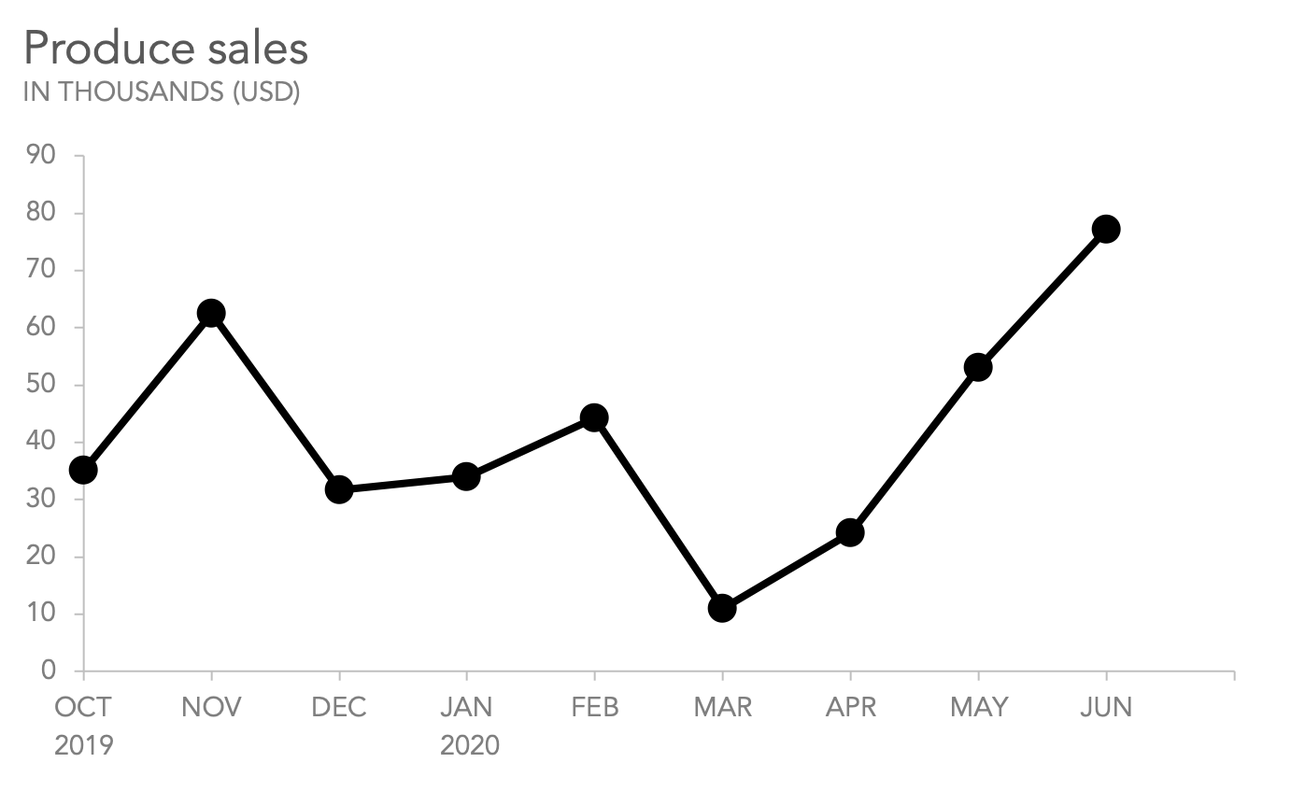

**Type of Data: Quantitative**

**Advantages:**

* Shows trends over time

**Disadvantages:**

* Misleading if:

- Inconsistent horizontal / vertical scale

- Vertical scale is truncated (not start at 0)

**Good Graphs:** A clear graph should have a title, labels on the vertical and horizontal axis, and should reference the source of the data.