**11.1 Statistical Studies – Overview**

**Statistics** – The science of gathering, describing, and analyzing data.

**Population vs Sample**

Ex) Lets say I want to figure out if Indiana is a cat or dog state.

**Population** – The particular group of interest in a study (the set of all individuals/objects of interest).

* Ex) Every person in ALL of Indiana.

**Sample** – A subset of individuals/objects from the population of interest.

* Ex) Everybody in Muncie ONLY.

**Parameter vs Statistic**

**Population parameter** – A fixed numerical value that describes the population.

* Ex) Overall percentage who prefer cats for IN
* Would have to take a **census** (ask everyone in the population) to know this value (or estimate it).

**Sample Statistic** – A numerical value that describes the sample that can vary from sample to sample.

* Ex) Percentage for Muncie (will be different than for Indy

**Observational Study vs Experiment**

**Observational study** – Observes existing data.

* Observe what happens without imposing any restraints (no random assignment).
* Can reveal association or correlation between variables, but not causation.

**Experiment** – Generates data to help identify cause-and-effect relationships.

* Imposes treatments and controls randomly to groups.
* More accurate to determine a relationship between the explanatory variable and response.

**Sampling Techniques**

**GOAL: Representative Sample** – A sample that has the same relevant characteristics as the population and does not favor one group of the population over another.

Matches / resembles the population

**1) Random Sample** – A random sample is one in which every member of the population has an equal chance of being selected.

* This is generally desirable but can be difficult to achieve.

**2) Stratified Random Sample** – Dividing population into homogeneous (similar characteristics) groups. This guarantees the sample is representative!

1. Stratify the population – Divide the population into similar groups (e.g. based on age or gender).
2. Take random sample from each group (strata).
3. Combine the groups from each strata to form your sample.

**3) Cluster Sample** – Dividing population into mini-populations. This gives us an unbiased sample and is often a more practical / affordable method.

1. Split the population into representative groupscalled clusters (resemble overall population).
2. Use random sampling to select several clusters.
3. Perform a census of each selected (collect data from every member).

**4) Systematic Sample** –Selecting every nth member of the population.

**5) Convenience Sample** – Include individuals who are convenient to sample (for the researcher); AVOID!

* The group may not be representative of the population 🡪 Frequently ends in biased results.

**Examples**: Describe how you could obtain a sample to answer each question below using each of the following types of sampling methods listed below.

**Example 1**

Scenario: I wish to determine the proportion of the MATH 125 class that has a Mac laptop.

* Random Sample:
* Stratified Random Sample:
* Cluster Sample:
* Systematic Sample:
* Convenience Sample:

**Example 2**

Scenario: You are tasked with conducting a survey to answer the question, “What is the favorite subject of students who attend East High School?”

* Random Sample:
* Stratified Random Sample:
* Cluster Sample:
* Systematic Sample:
* Convenience Sample:

**Experiments – Definitions**

**Explanatory Variable** – The variable(s) being used to explain a response (the variable doing the explaining).

**Response Variable** – The variable we are ultimately interested in (the one trying to be explained).

Our GOAL is to see if we can describe our response with an explanatory variable(s).

**Subjects** (also called **Experimental Units**) are what the treatment is being applied to.

**Treatment** is the experimental condition.

**Different Groups in an Experiment**

* Treatment Groups – The group the receives the treatment.
* Control Group
  + The group that does not receive the treatment.
  + We have a control group to compare our treatment groups to.
  + We have to know what the “base” level of our response is.

**Principles of Experimental Design**

1. 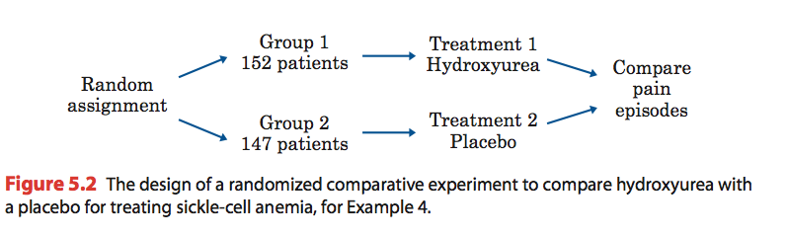Randomize the control and treatment groups.

* Equalize effects of known and unknown variation.

1. Control for outside effects on the variable.

* Make conditions as similar as possible for all groups so that the only difference is the imposed treatment

1. Replicate the experiment a significant number of times to see meaningful patterns.

* Apply each treatment to a number of subjects.

Experiments can get complicated, lots of things to consider. These include but are not limited to:

* Placebo and its effects
* Single- or double-blind studies
* Confounding variables
* Blocking

**Example 3**

Identify the response variable, subjects, and treatment for the following experiment:

The MATH 125 team is interested if the amount of sleep affects students’ memory of a 5-minute video shown in class. 25 students were randomly chosen to sleep for 6 hours, another 30 were randomly chosen to sleep for 8 hours; the rest of the class (28 students) were assigned to sleep for 10 hours. Students were then scored on the amount they were able to remember on the video.