Oct 10

Assignment 5

Comp 2230_02

Colton isles and kaylee crocker

2024



**COMP 2230 – Data Structures and Algorithm Analysis**

Assignment #4: Queues

## Due Date: Section 01 Oct 3rd, Section 02 Oct 4th

**Chapter 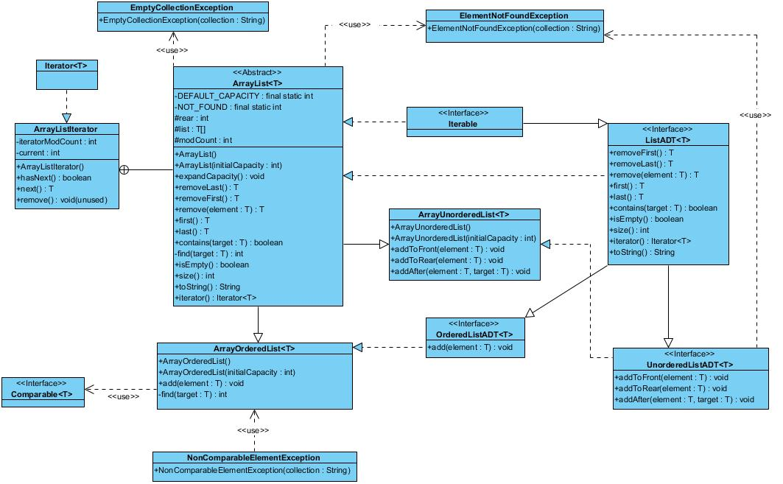15**

**Problem #1 Code**

|  |
| --- |
|  |

|  |
| --- |
|  |

**Problem #1 Test Output**

|  |
| --- |
|  |

**Problem #2 Code**

|  |
| --- |
|  |

**Problem #2 Test Output**

|  |
| --- |
|  |