Milestone 2

Project goal
We aim to display how the profile of a dominant ATP player has changed from 1968 to the present. Rather than producing a single all-time ranking, our website reveals which features best characterize elite performance across the various eras of play. The intended audience ranges from casual tennis followers to coaches, equipment engineers, and sports regulators.

Live prototype
The website with the basic skeleton of the visualizations can be found at: https://com-480-data-visualization.github.io/nadal-prime/.

Core visualization
The website should work as a scroll-based visual story about how elite ATP player profiles evolved across eras. The user experience starts with historical framing defining tennis eras and progressively moves to more focused analysis based on specific playstyle features compared across these eras. In the first section called “Defining the Eras”, the user can understand the major events in tennis history that led to important changes in the game, as well as the main actors of these eras (see Figure 1). The second part called “Playstyle Evolution” explains the changes in playstyle across eras by showing relevant play statistics for each era through scatterplots (see Figure 2) and Sankey diagrams (see Figure 3). At this stage, visuals and text should be synchronized so that users do not just see charts changing but also understand why those changes happened in tennis history. The central narrative is that dominance is not static: technology, tactics, physical preparation, and game style shift over time, and those shifts are visible in player-level data.
The interaction philosophy should be simple and consistent: begin with a global view for a feature (example : shot type statistics) and then narrow to era-specific highlights. Feature menus should let users switch analytical lenses such as serve, return, shot type, or net play, with each lens providing both a visualization and a historical explanation.

The MVP should already deliver a complete and understandable story, even if visually modest. It should include smooth transitions between major sections, two fully functional interactive charts in the playstyle area, synchronized explanatory text, and one feature selector that changes the view between some predefined feature families.
The interactive chart behavior should show all players visible at first, then scroll-driven emphasis on the active era while non-active eras are muted. The text panel should be updated at the same time and explain the key interpretation for that era under the selected feature.

Improvements on core visualization
To close the narrative, a third part could include full-timeline visualizations that summarizes long-term change across eras.
A comparison mode can allow direct side-by-side viewing of two eras under the same feature.
Context annotations can be added to mark major historical shifts, such as racket material changes or training evolution, directly on charts.

Required tools
For the current prototype, the bar charts use d3-scale and d3-axis. The scatterplots add d3-zoom for panning and zooming. The Sankey diagrams are rendered as static SVG skeletons.
For the improved version, the Sankey diagrams will be replaced with data-driven layouts using the d3-sankey plugin. The parallel coordinates and spider charts can be implemented in D3, and smooth scrolling between sections will be handled by GSAP's ScrollTrigger.
Relevant lectures are "D3.js”, “More interactive d3.js”, “Perception colors”, and “Storytelling”.
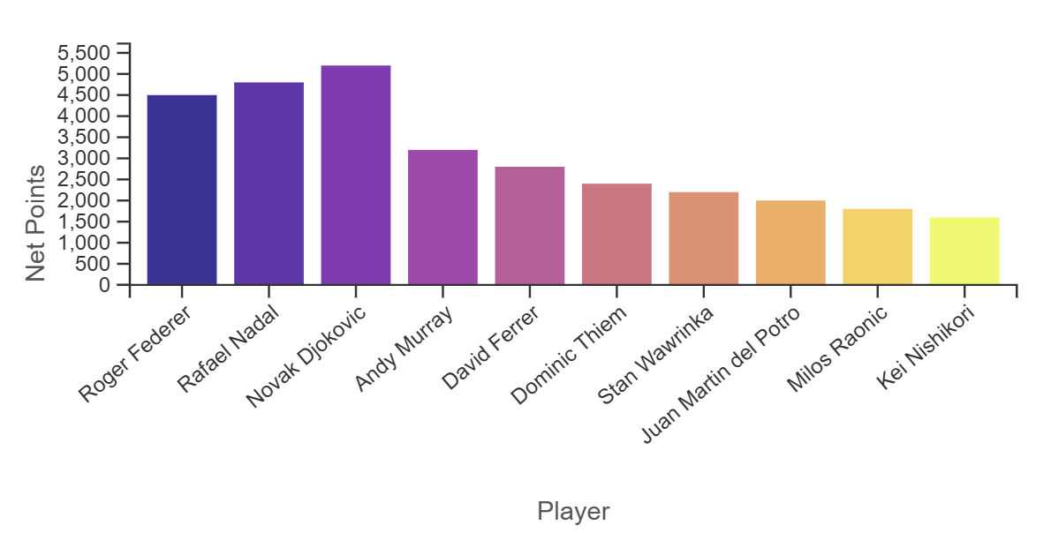  Figure 1: Bar chart showing the top 10 players by aggregated ranking points for a given era | 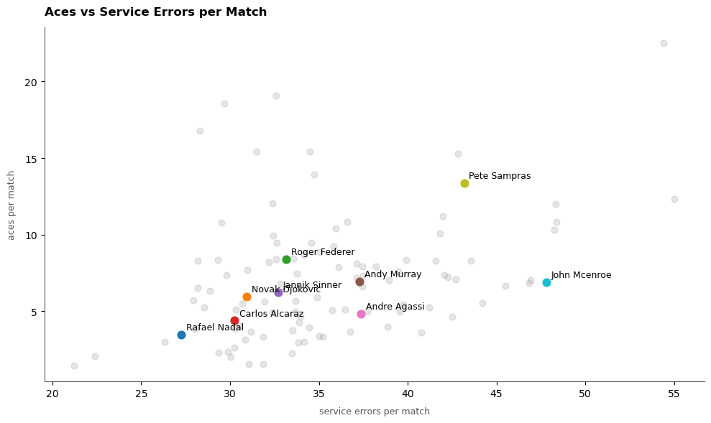  Figure 2: Scatter plot of volley shot percentage vs. ATP ranking points for players within a given era
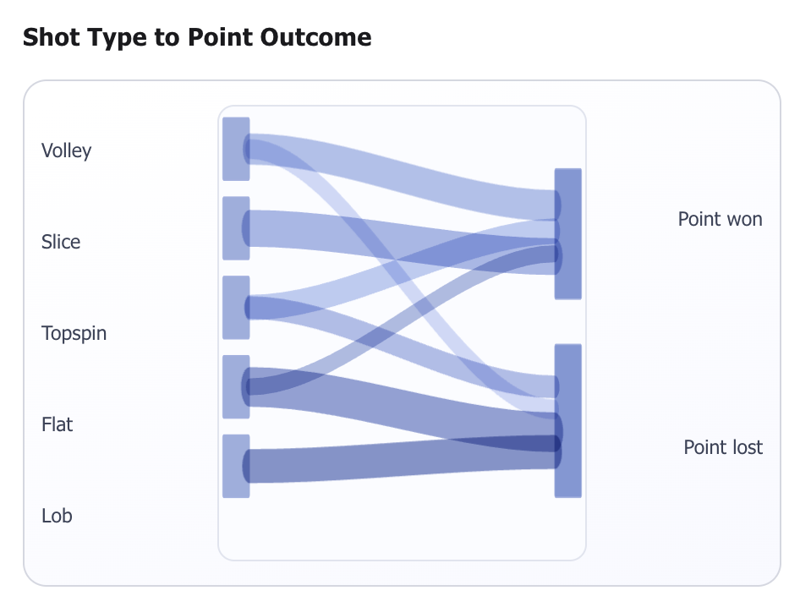  Figure 3: Sankey diagram skeleton showing shot type mapped to point outcome. | 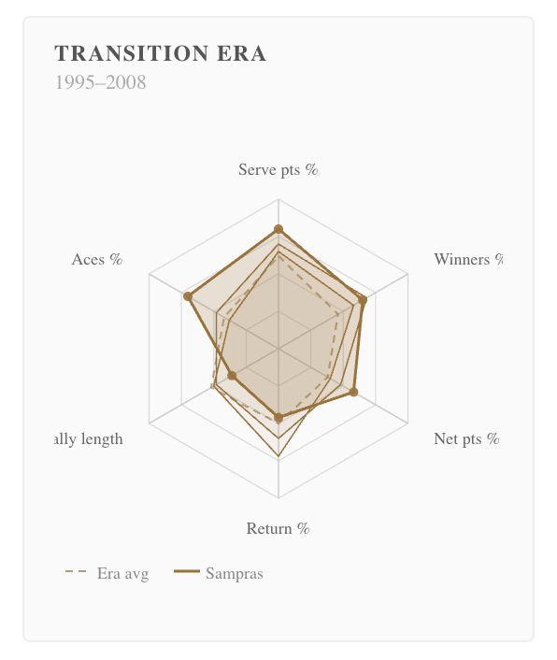  Figure 4: Spider chart example showing a top player's profile against the era average across six play statistics
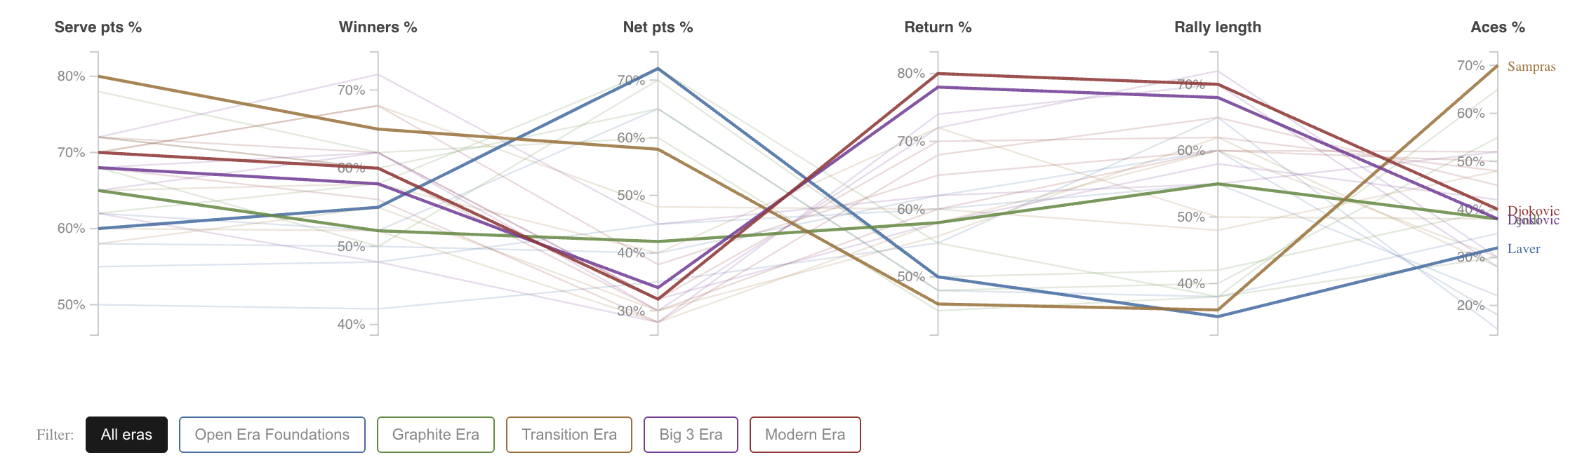
Figure 5: Parallel coordinates example showing player profiles across six statistics, color-coded by era, with era filtering

