Planar Zn-Porphyrin

Initial-State Core-Level Shifts
Completed Planar calculation and structural comparison with PLDC
1 August 2026
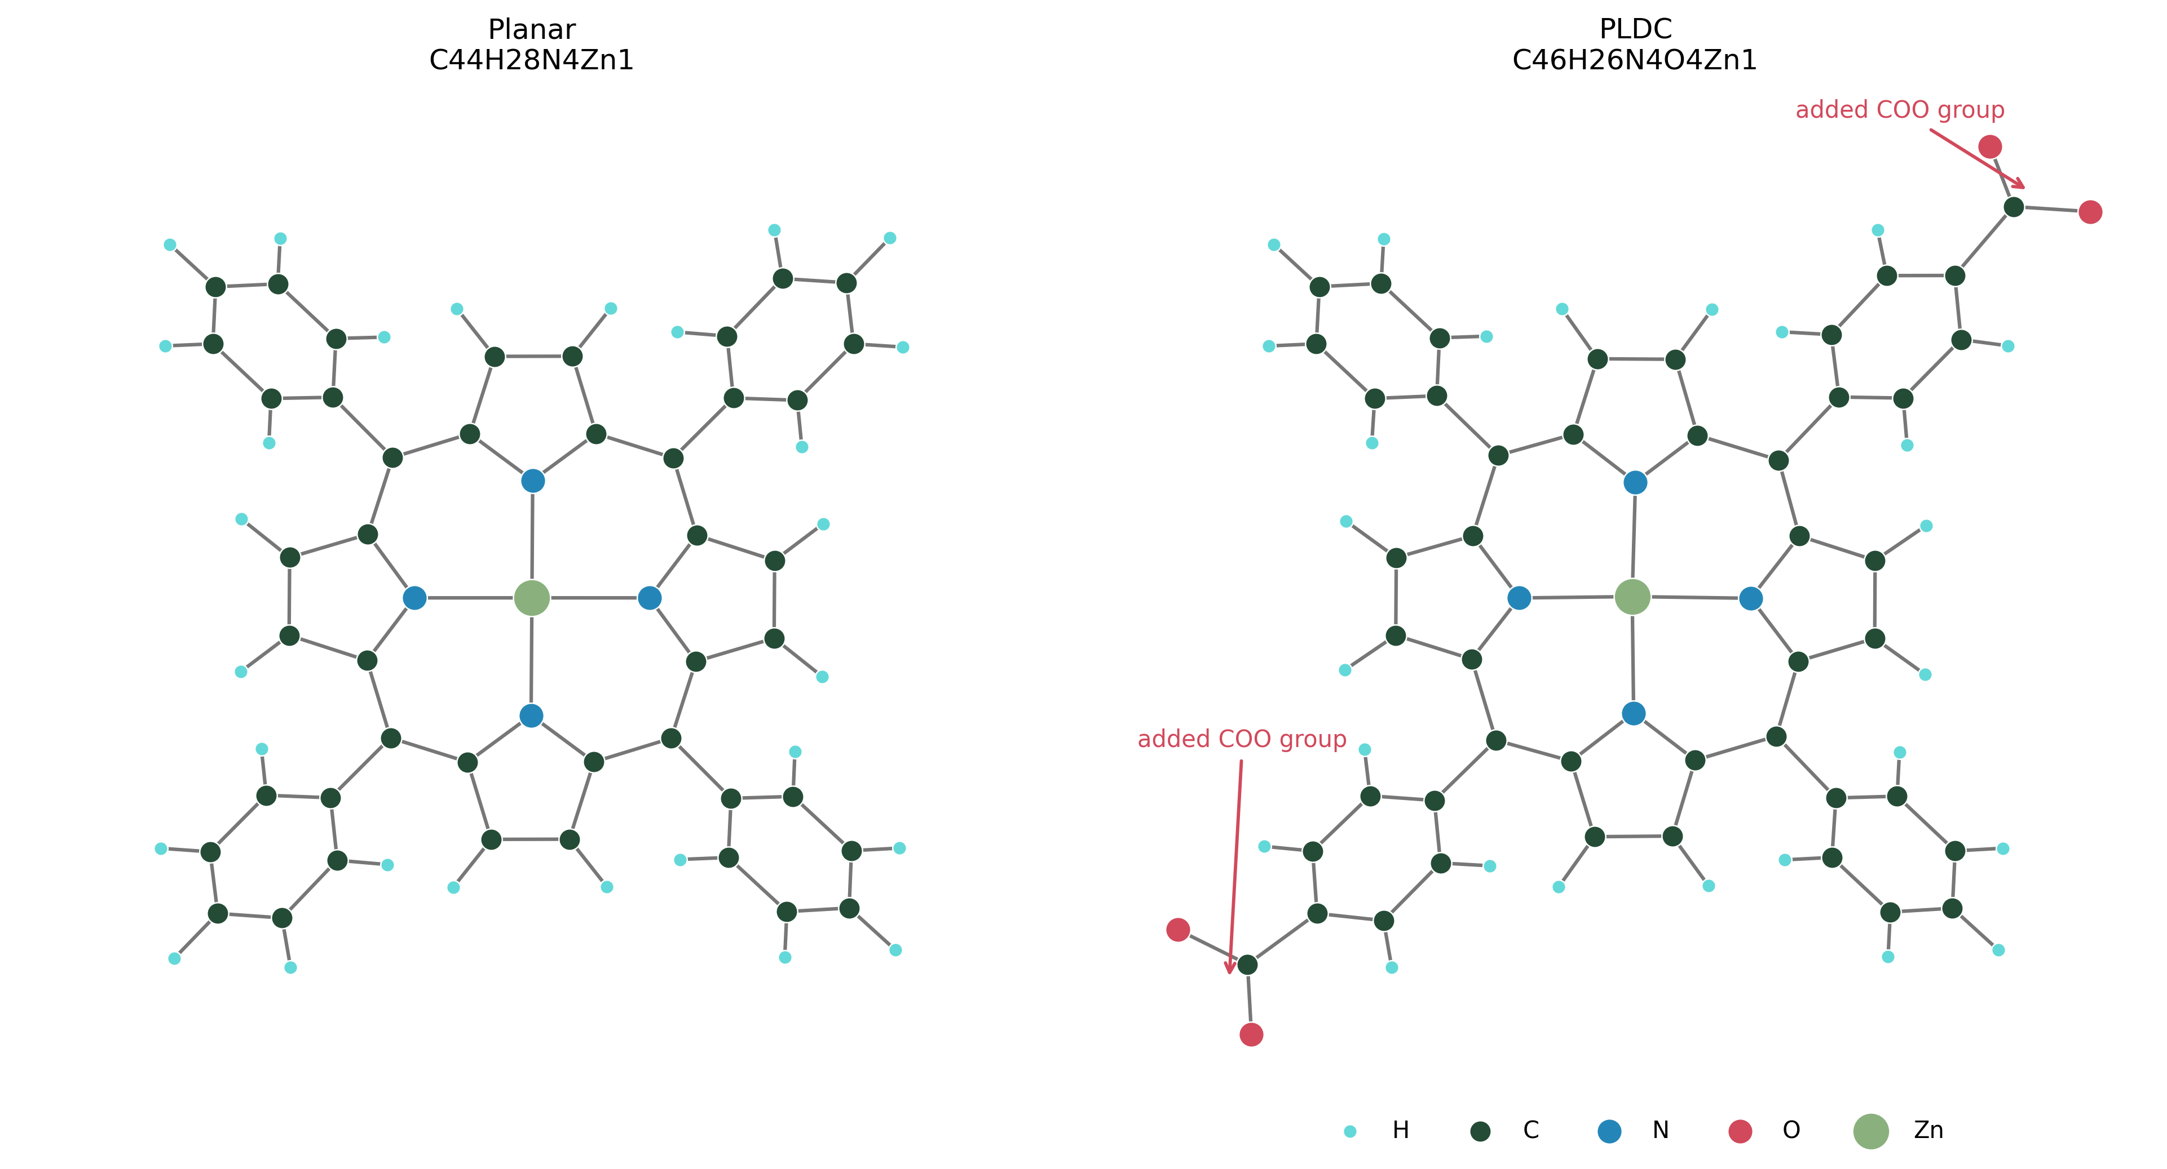

Executive summary
The Planar calculation is complete. Initial-state C 1s and N 1s shifts were evaluated for the requested carbon sites and all four nitrogen atoms. The twelve Cw atoms were deliberately excluded from the core-excited set.
The PLDC file is included and plotted structurally for comparison. A numerical PLDC core-level-shift spectrum is not reported because the supplied isolated-molecule geometry does not uniquely specify its charge/protonation state; this choice materially changes the electronic calculation.

Completed calculation at a glance
Structure | Planar ZnC44H28N4 (77 atoms)
Selected sites | 32 carbon atoms and all 4 nitrogen atoms
Excluded sites | 12 Cw carbon atoms: 7–12 and 36–41
SCF convergence | 35 electronic iterations; total energy −739.91432023 Ry
Runtime | SCF: 15 min 57 s; initial_state.x analysis: 13 s
References | Carbon shifts relative to mean(Cb); nitrogen shifts relative to mean(all N)

Method and calculation settings
The calculation follows the Quantum ESPRESSO initial-state core-level-shift workflow. Normal and core-excited pseudopotential species are present in a single self-consistent calculation. Each requested atom is mapped to its corresponding normal/core-excited pair by initial_state.x; Cw atoms remain mapped to a duplicate normal-carbon species and therefore are not excited.
Quantum ESPRESSO | Version 7.5; pw.x followed by initial_state.x
Exchange–correlation | PBE
Boundary conditions | 25 Å cubic cell; isolated-molecule Martyna–Tuckerman correction
Brillouin-zone sampling | Γ point
Plane-wave cutoffs | 30 Ry wave functions; 180 Ry charge density
Occupations | Marzari–Vanderbilt smearing, 0.02 Ry
Electronic convergence | conv_thr = 1×10⁻⁶; local-TF mixing, β = 0.20
Parallel execution | 4 MPI processes

Atom groups
The following assignments reproduce the requested indexing. Cw is intentionally absent from the calculated shift table.
Group | Atoms | Mean shift (eV) | Std. dev. (eV) | Atom indices
C L alpha | 4 | -0.789 | 0.010 | 4 5 42 43
C alpha | 4 | -0.786 | 0.011 | 20 21 26 27
C L beta | 4 | 0.260 | 0.001 | 2 3 44 45
C beta | 4 | 0.270 | 0.001 | 22 23 24 25
C M | 4 | -0.352 | 0.017 | 6 13 28 35
C b | 12 | 0.000 | 0.121 | 14 15 16 17 18 19 29 30 31 32 33 34

Nitrogen groups
Group | Atoms | Mean shift (eV) | Std. dev. (eV) | Atom indices
N L | 2 | -0.003 | 0.000 | 46 49
N | 2 | 0.003 | 0.000 | 47 48
All values are relative shifts, not absolute experimental binding energies. A positive value denotes a higher binding energy relative to the stated reference.

Planar C 1s spectral envelopes
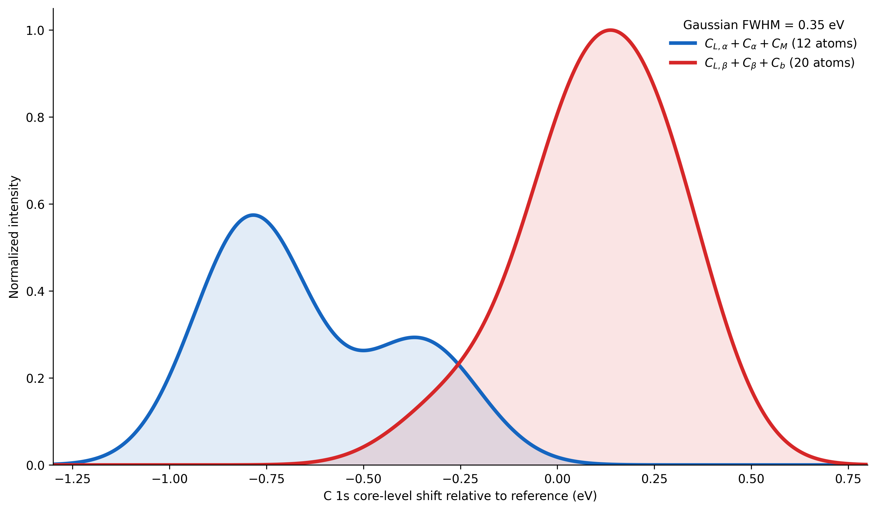
Blue envelope: CL,alpha + C alpha + CM. Red envelope: CL,beta + C beta + Cb. Each calculated atom contributes a unit-area Gaussian with FWHM = 0.35 eV, so the curves are a visualization of the discrete shifts rather than additional Quantum ESPRESSO data. Cw does not contribute.
The common normalization preserves the relative atom-count weighting across the two envelopes. The underlying per-atom values remain available in the CSV file for alternative broadening or referencing.

Planar versus PLDC structure

Planar: ZnC44H28N4. PLDC file: ZnC46H26N4O4. Relative to Planar, the PLDC coordinates contain two added COO groups and two fewer hydrogen atoms.

PLDC calculation status and required decision
The supplied PLDC XYZ file contains COO fragments without acidic hydrogen atoms. For an isolated calculation, the geometry can therefore represent a dianion (total charge −2), or it may require a different neutral/open-shell treatment; alternatively, two hydrogen atoms may need to be added to model two COOH groups. These choices are not interchangeable and cannot be inferred safely from XYZ coordinates alone.
Prepared PLDC input templates are included in the comparison folder, but no incomplete or unconverged PLDC result is presented as a core-level-shift spectrum. Once the intended chemical state is confirmed, the same selected-site workflow and the same spectral broadening can be applied for a defensible numerical comparison.

Convergence and interpretation notes
The 25 Å cell and 30/180 Ry cutoffs are working settings for this completed run. Before publication-quality absolute comparisons, verify convergence with respect to cell size, plane-wave cutoffs, pseudopotential family, smearing, and molecular charge/spin. Experimental XPS comparison may also require a uniform energy alignment and consideration of final-state screening.

Organized file package
structure/ | Planar XYZ file and molecular figures
inputs/ | Completed Planar SCF and initial_state.x inputs
outputs/ | Converged Planar SCF and initial_state.x outputs
results/ | Per-atom CSV, group summary CSV, and spectrum PNG/PDF
comparison/ | PLDC XYZ, structural comparison PNG/PDF, and prepared PLDC templates
scripts/ | Reproducible preparation, analysis, and plotting scripts
pseudopotentials/ | Pseudopotentials used by the Planar workflow
archive_full_C_N/ | Earlier all-C/all-N calculation retained for traceability

Reproducibility statement
The CSV tables are the numerical source of truth for the reported shifts. The figures can be regenerated from the included scripts without changing the Quantum ESPRESSO output files.

