Planar versus Protonated PLDC

All-Carbon Core-Level Shifts
Initial-state Quantum ESPRESSO comparison · all carbon groups
1 August 2026
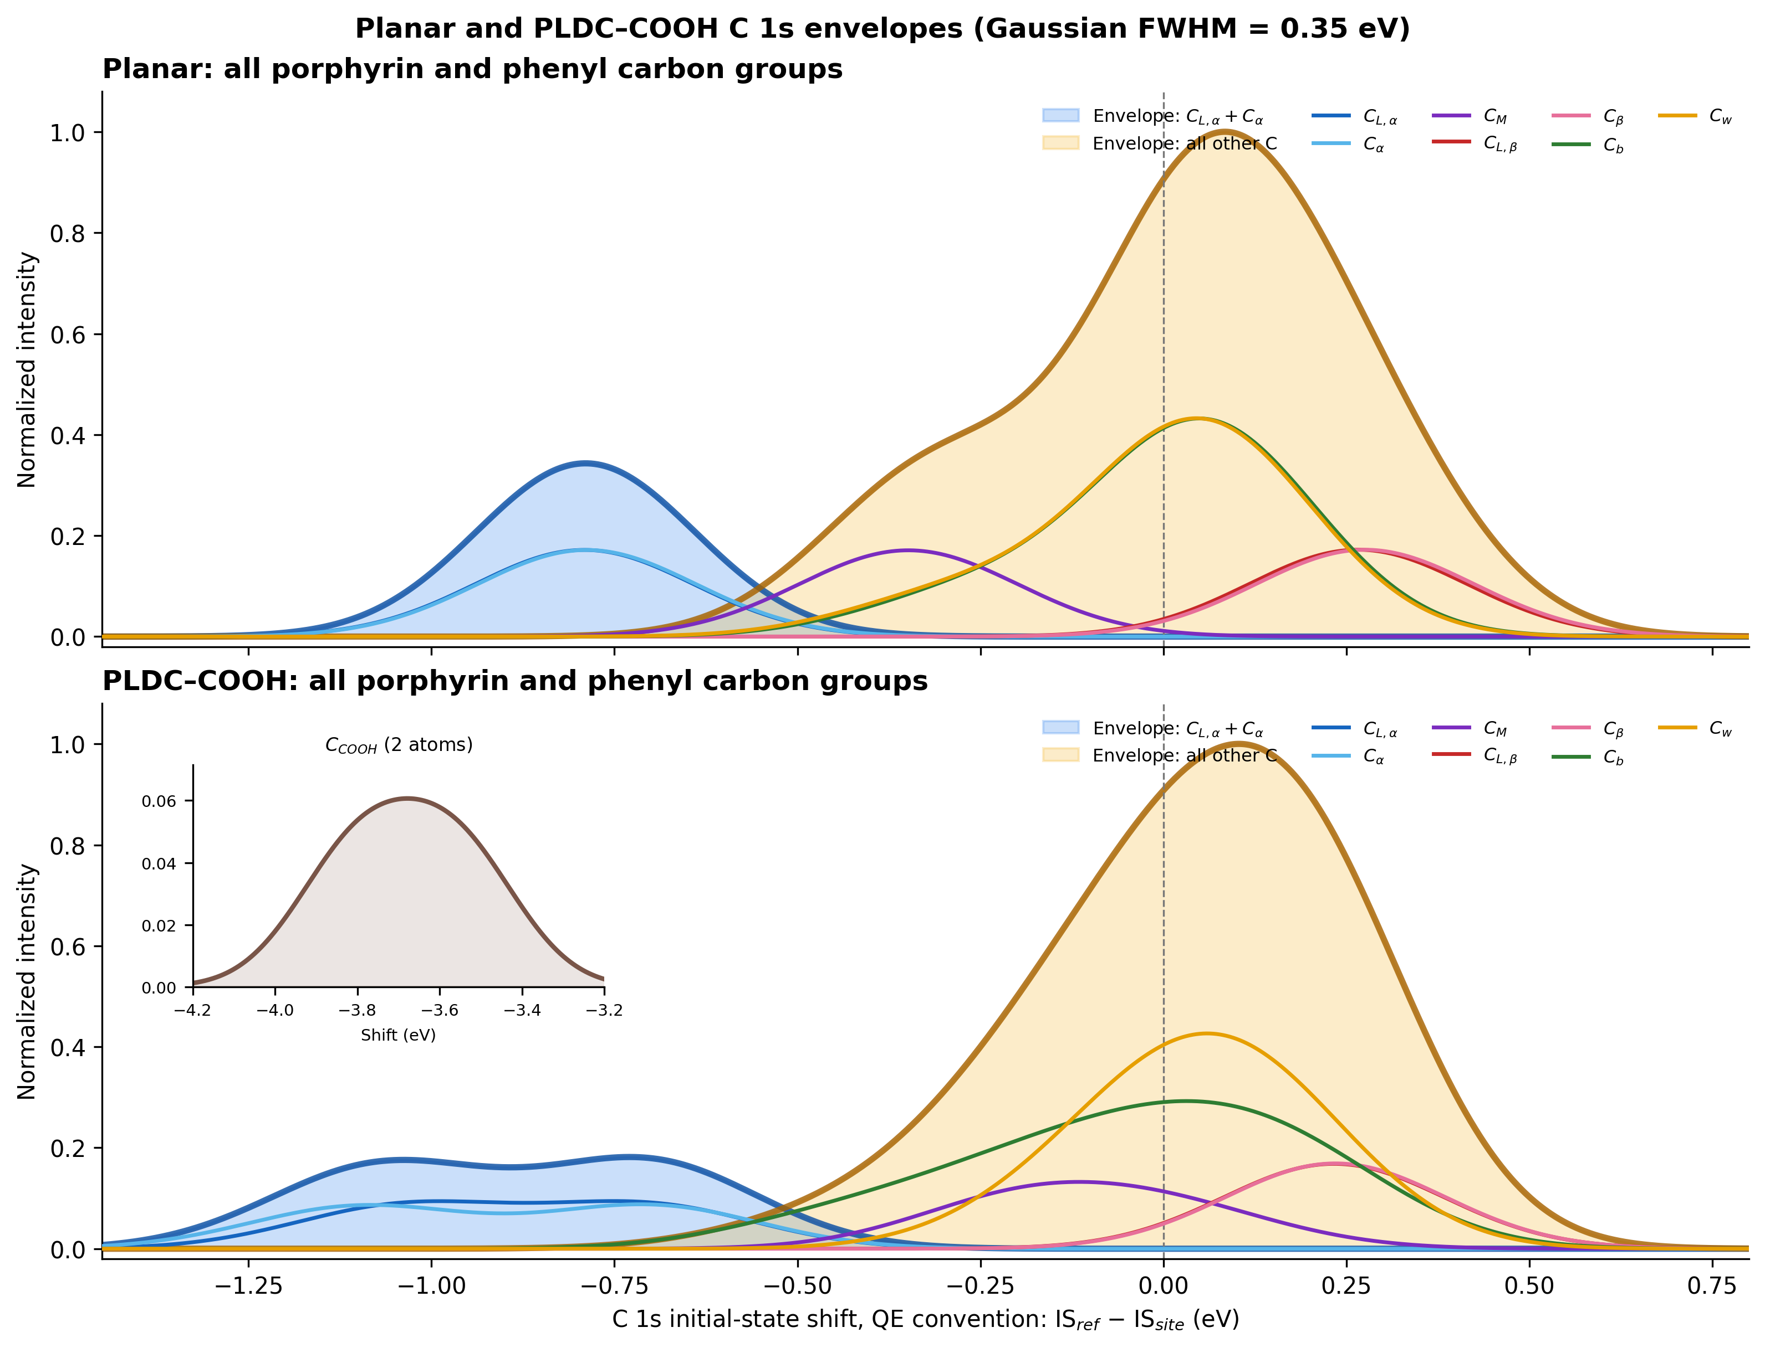

Result summary
The all-carbon Planar dataset and a new neutral protonated PLDC calculation are complete. The PLDC model contains two COOH groups, with H82 bonded to O78 and H83 bonded to O80. All 44 Planar and all 46 PLDC carbon atoms were evaluated.
Every atom contributes a unit-area Gaussian with FWHM = 0.35 eV. The blue background is the combined C_L,alpha + C_alpha envelope; the contrasting amber background contains all remaining carbon groups. Individual group curves are drawn in the foreground, and no total curve is shown. The CSV files contain the discrete Quantum ESPRESSO values.

Carbon-group shifts
Shifts use the Quantum ESPRESSO example convention: ΔE = IS(reference) − IS(site). The internal reference is the mean initial-state contribution of all Cb and Cw atoms in the same molecule.
Group | Planar n | Planar mean | PLDC n | PLDC mean | PLDC range (eV)
C_L,alpha | 4 | -0.791 | 4 | -0.870 | -1.048 to -0.697
C_alpha | 4 | -0.788 | 4 | -0.899 | -1.122 to -0.694
C_M | 4 | -0.348 | 4 | -0.102 | -0.208 to 0.050
C_L,beta | 4 | 0.266 | 4 | 0.233 | 0.202 to 0.261
C_beta | 4 | 0.275 | 4 | 0.235 | 0.210 to 0.257
C_b | 12 | 0.003 | 12 | -0.048 | -0.475 to 0.220
C_w | 12 | -0.003 | 12 | 0.048 | -0.158 to 0.172
C_COOH | — | — | 2 | -3.678 | -3.801 to -3.556
The two PLDC C_COOH atoms form a separated feature with mean shift −3.678 eV (range −3.801 to −3.556 eV). This sign follows the Quantum ESPRESSO initial-state convention above.
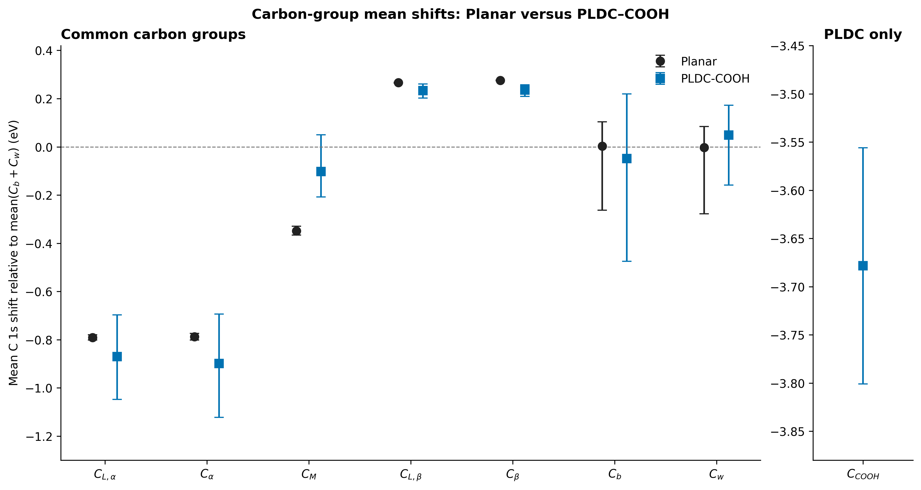

Calculation details
Structures | Planar ZnC44H28N4 (77 atoms); PLDC–COOH ZnC46H28N4O4 (83 atoms)
Electronic model | Neutral, closed-shell single-point calculations
Quantum ESPRESSO | Version 7.5; pw.x followed by initial_state.x
Exchange–correlation | PBE
Cell / isolation | 25 Å cubic cell; Martyna–Tuckerman isolated correction; Γ point
Plane-wave cutoffs | 30 Ry wave functions; 180 Ry charge density
Occupations | Marzari–Vanderbilt smearing, 0.02 Ry
Convergence | conv_thr = 1×10⁻⁶ Ry; local-TF mixing, β = 0.20
Execution | 4 MPI processes

Convergence and runtime
Planar SCF | 32 iterations; −739.91431933 Ry; 15 min 05 s wall
Planar initial_state.x | 13.14 s wall
PLDC–COOH SCF | 40 iterations; −890.04265055 Ry; final accuracy 5.6×10⁻⁷ Ry
PLDC–COOH SCF runtime | 1 h 38 min wall
PLDC–COOH initial_state.x | 1 min 06 s wall

Important modeling note
The two O–H positions were constructed with 0.98 Å bonds by extending the longer C–O direction in each supplied carboxyl group. No geometry optimization was performed after proton placement. The reported PLDC shifts are therefore single-point values for this constructed neutral geometry; geometry optimization and cutoff/cell convergence should precede publication-quality interpretation.

Files
inputs/ | PLDC SCF and initial_state.x input files
outputs/ | Converged pw.x and initial_state.x output files
restart_data/ | Quantum ESPRESSO save directory for restarting/post-processing
scripts/ | Preparation and all-carbon comparison scripts
CSV files | Per-atom Planar, PLDC, combined, and group-summary data
PNG/PDF files | Full-range, zoomed, and group-mean comparison figures

