**Applications of Classification Algorithms**

* Email spam classification
* Bank customers loan pay willingness prediction.
* Cancer tumor cells identification.
* Sentiment analysis
* Drugs classification
* Facial key points detection
* Pedestrians detection in an automotive car driving.

**Types of Classification Algorithms**

Classification Algorithms could be broadly classified as the following:

* ***Linear Classifiers***
  + Logistic regression
  + Naive Bayes classifier
  + Fisher’s linear discriminant
* ***Support vector machines***
  + Least squares support vector machines
* ***Quadratic classifiers***
* ***Kernel estimation***
  + k-nearest neighbor
* ***Decision trees***
  + Random forests
* ***Neural networks***
* ***Learning vector quantization***

Naïve Bayes

$$P\left(\frac{A}{B}\right)=\frac{P\left(\frac{B}{A}\right)*P(A)}{P(B)}$$

P($\frac{walks}{x})$ = $\frac{P\left(\frac{x}{walks}\right)*P(walks)}{P(X)}$

P(Walks)= $\frac{No of walks}{Total Observations}$ = $\frac{10}{30}$

P(X)= $\frac{No of Simultunious Observation}{Total Observations}$ = $\frac{4}{30}$

P($\frac{X}{Walks})$ = $\frac{No of Simi;ar Observations among who walk}{Total number of walks}$

$P(\frac{drives}{x})$ = $\frac{3}{10}$

P($\frac{walks}{x})$ = $\frac{\frac{3}{10}\frac{10}{30}}{\frac{4}{30}}$

P $(\frac{walks}{X})$ >P($\frac{drives}{X}$)

Support Vector Machines

Randome Forest classifaction

**Ensemble Learning**:

Step 1:Pick at random K data points from the Training set

Step 2:Build the decision tree associated to these K data points

Step 3:Choose the number N tree of tree you want to build and repeat

step 1 and step2

Step4:For a new data point ,make each one of your N tree predict category to which the data point belongs and assign the new data point to the category that contains the majority vote.

Decession Tree

**CART**:

**Classification Tress**:

Classification of data

Eg:Male,Female,Apple,Orange

**Regression Trees**:

Predication of data

Predict salary ,Temperature

K-Nearest Neighbourhood:

1.Choose number of K of neighbours.

2.Take the k nearest neighbours of the new data point, according to Euclidian distance.

3.Amoung these K -neighboures, count the number of data points in each category.

4.assign a new data point to new category.

Kernal SVM

**Linear separable**:

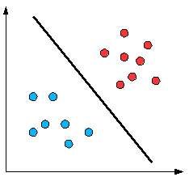

**Non Linear Separable**:

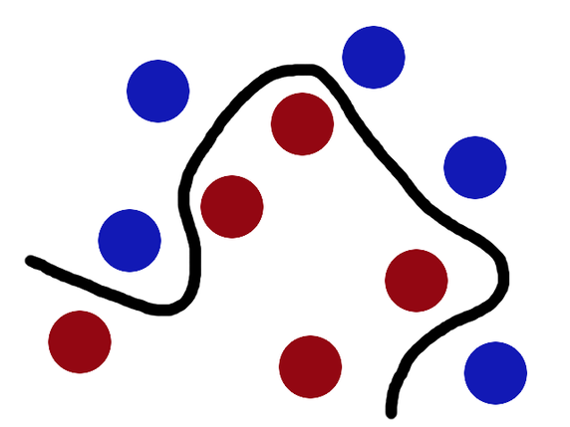

*Evoluting Classification Models*

1.False Positive and False Negative

2.Confussion Matrix

3.Accuracy Paradox

4.CAP curve