[1]

COM 599100 Deep Learning Final Project Report – Protein Family (Group 4)

Po-Yu Chou (team leader), Yi-Yu Zheng, Ya-Ting Yang, Yu-Chia Huang and Yu-Hsiu Huang

*Abstract*—In the field of bioinformatics, identifying protein function from amino acid sequence is a fundamental problem. With a thorough understanding of protein structures, the progress of drug design and genetic engineering will be significantly accelerated. Investigating protein functional often involves structural studies (crystallography) or biochemical studies, which require time consuming efforts. In this project, we explore how well we can represent biological function through examination of raw sequence alone. With the emerging study of deep neural networks, various fields have groundbreaking progress by incorporating the novel methods of DNN such as computer vision and natural language processing. Using a large corpus of protein sequences and their annotated protein families, many works have succeed in classifying the structure of protein for several datasets. In this work, we experiment two deep neural network architectures—GRU and 1D-CNN to train classifiers for protein family identification for the Research Collaboratory for Structural Bioinformatics (RCSB) Protein Data Bank (PDB) dataset.

*Index Terms*—classification, deep learning, protein family.

# INTRODUCTION

W

ith the development of advanced measuring techniques and instruments, we are able to retrieve a myriad of important information about the structure of biological macromolecules using X-ray crystallography, Nuclear Magnetic Resonance (NMR) spectroscopy and cryo-electron microscopy. Accurate identification of protein functions has applications in a wide variety of areas, such as understanding diseases, drug design and genetic engineering for agriculture. Nevertheless, high throughput experiments like the next generation sequencing technologies are resulting in a large number of new protein sequences uncharacterized [1].

Sequenced-based methods for protein fold recognition can be summarized into two categories: the sequence alignment methods and machine learning/deep learning based methods. The former one determines the unknown structure of sequences by calculating the alignment scores between sequences. Despite the success, the sequence alignment methods are essentially an indirect means of nearest neighbor methods, which cannot give an insightful explanation about the sequence-structure relationship. Consequently, we are motivated to propose a deep learning-based end-to-end protein structure classifier. We can expect our model not only have a decent performance in terms of classification accuracy but also obtain meaningful features extracted automatically from the neural networks without the bioinformatics expertise.

# Material and Method

To create a distributed representation of our protein sequences, we represent each sequence as a series of overlapping n-grams (a block of 3 or 4 amino acids) and create a distributed representation of each n-gram using vectors trained from model. The data was then split into training/validation folds at an 80/20 ratio preserving class stratification.

## CNN Approach without Gram

number of classes: 10

|  |  |
| --- | --- |
| hyper-parameter | value |
| maximum length | 500 |
| learning rate | 0.001 |
| embedding size | 11 |
| batch size | 128 |
| number of epochs | 16 (early stop) |
| optimizer | Adam |
| loss function | categorical cross entropy |

|  |
| --- |
| operation |
| word embedding |
| Conv1D(filters=256, kernel_size=6, activation='relu') |
| MaxPooling1D(pool_size=2) |
| Conv1D(filters=128, kernel_size=3, activation='relu') |
| MaxPooling1D(pool_size=2) |
| Flatten |
| Dense(256, activation='relu') |
| Dense(10, activation='softmax') |

## 1d-CNN Approach with 4-Gram

number of classes: 34

|  |  |
| --- | --- |
| hyper-parameter | value |
| maximum length | 2000 |
| learning rate | 0.001 |
| embedding size | 50 |
| batch size | 256 |
| number of epochs | 12 |
| optimizer | Adam |
| loss function | categorical cross entropy |

|  |
| --- |
| operation |
| word embedding (embedding dim=50) |
| Conv1D(filters=128, kernel_size=6, activation='relu') |
| MaxPooling1D(pool_size=2) |
| Conv1D(filters=64, kernel_size=3, activation='relu') |
| MaxPooling1D(pool_size=2) |
| Flatten |
| Dense(256, activation='relu') |
| Dense(34, activation='softmax') |

## 1d-CNN Approach with 4-Gram

number of classes: 10

|  |  |
| --- | --- |
| hyper-parameter | value |
| maximum length | 1024 |
| learning rate | 0.001 |
| embedding size | 22 |
| batch size | 256 |
| number of epochs | 12 |
| optimizer | Adam |
| loss function | categorical cross entropy |

|  |
| --- |
| operation |
| word embedding (embedding dim=22) |
| Conv1D(filters=128, kernel_size=6, activation='relu') |
| MaxPooling1D(pool_size=2) |
| Conv1D(filters=64, kernel_size=3, activation='relu') |
| MaxPooling1D(pool_size=2) |
| Flatten |
| Dense(256, activation='relu') |
| Dense(10, activation='softmax') |

## GRU Approach with 3-Gram

number of classes: 34, 10

|  |  |
| --- | --- |
| hyper-parameter | value |
| maximum length | 512 |
| learning rate | 0.001 |
| embedding size | 100 |
| Number of Hidden Units | 100 |
| Dropout rate | 0.5 |
| batch size | 512 |
| number of epochs | 50 (early stop) |
| optimizer | Adam |
| loss function | categorical cross entropy |

|  |
| --- |
| operation |
| word embedding |
| GRU |
| dropout |
| Dense(256, activation='relu') |
| Dense(34, activation='softmax') |

## GRU+CNN Approach with 3-Gram

number of classes: 10

|  |  |
| --- | --- |
| hyper-parameter | value |
| maximum length | 256 |
| learning rate | 0.0005 |
| embedding size | 100 |
| Dropout rate | 0.5 |
| batch size | 256 |
| number of epochs | 40 (early stop) |
| optimizer | Adam |
| loss function | categorical cross entropy |

|  |
| --- |
| operation |
| word embedding |
| Conv1D(filters=128, kernel_size=6, activation='relu') |
| MaxPooling1D(pool_size=2) |
| Conv1D(filters=64, kernel_size=3, activation='relu') |
| MaxPooling1D(pool_size=2) |
| GRU |
| Dropout |
| Dense(256, activation='relu') |
| Dense(10(34), activation='sigmoid') |

# Evaluation

For evaluation of our model, we calculate several performance measures, such as: precision, recall, accuracy, and F1 score defined as:

$$precision=\frac{tp}{tp+fp}$$

$$recall=\frac{tp}{tp+fn}$$

$$accuracy=\frac{tp+tn}{tp+tn+fp+fn}$$

$$F1 score=2×\frac{precision×recall}{precision+recall}$$

Where tp is the number of true positives, fp is the number of false positives, tn is the number of true negatives and fn is the number of false negatives. And we also plot the ROC curve (**receiver operating characteristic curve**), which represented by two parameters, true positive rate (y-axis) and false positive rate (x-axis).

# Results

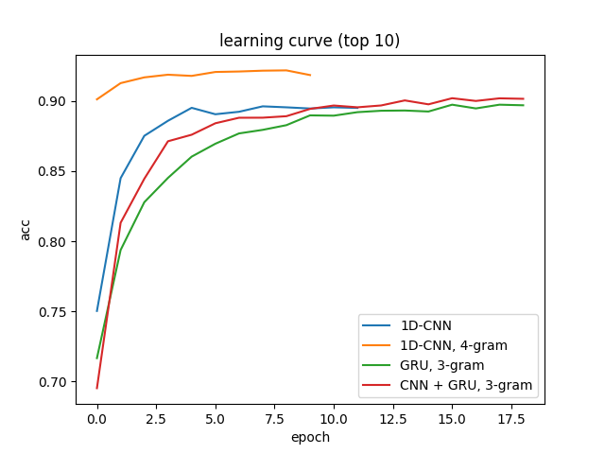

Figure 1 Learning Curve for top 10 classes

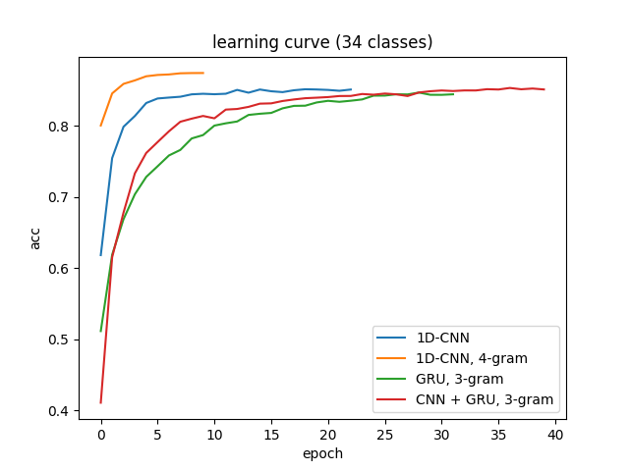

Figure 2 Learning Curve for 34 classes

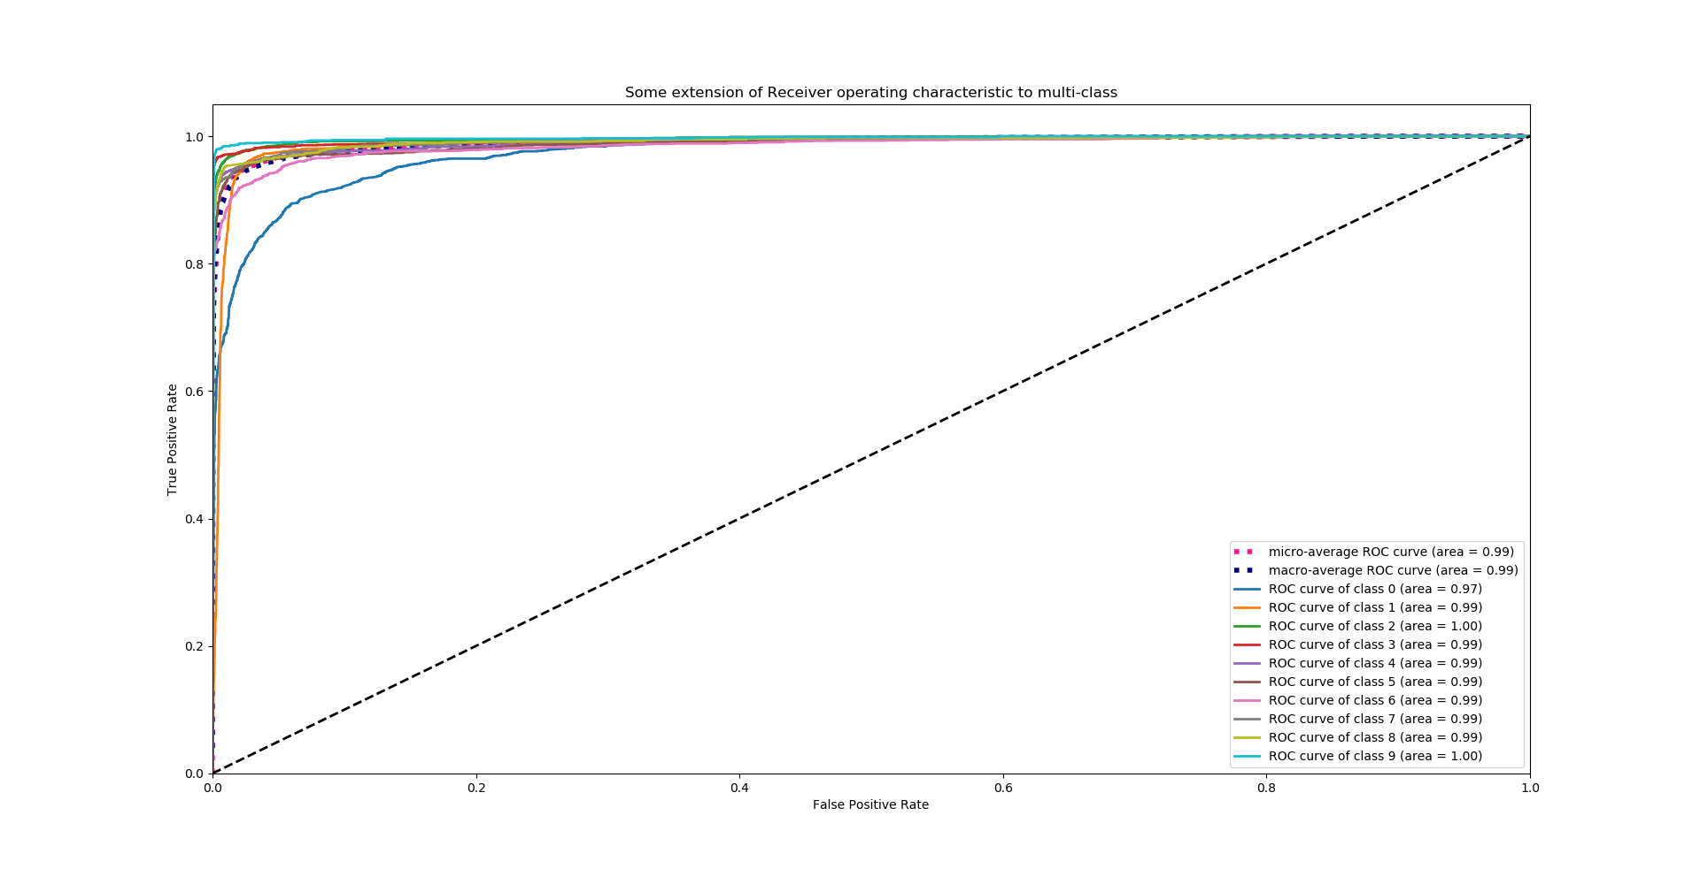

Figure 3 ROC for 1DCNN_4gram_top10

1DCNN_4gram_34

|  |  |  |  |
| --- | --- | --- | --- |
|  | Precision | Recall | F1-score |
| Macro Average | 0.85 | 0.83 | 0.84 |
| Weighted Average | 0.88 | 0.88 | 0.88 |
| Accuracy | 0.88 | | |

1DCNN_4gram_top10

|  |  |  |  |
| --- | --- | --- | --- |
|  | Precision | Recall | F1-score |
| Macro Average | 0.94 | 0.93 | 0.93 |
| Weighted Average | 0.94 | 0.94 | 0.94 |
| Accuracy | 0.94 | | |

CNN_GRU_3gram_34

|  |  |  |  |
| --- | --- | --- | --- |
|  | Precision | Recall | F1-score |
| Macro Average | 0.81 | 0.79 | 0.8 |
| Weighted Average | 0.85 | 0.85 | 0.85 |
| Accuracy | 0.85 | | |

CNN_GRU_3gram_top10

|  |  |  |  |
| --- | --- | --- | --- |
|  | Precision | Recall | F1-score |
| Macro Average | 0.90 | 0.91 | 0.90 |
| Weighted Average | 0.90 | 0.90 | 0.90 |
| Accuracy | 0.90 | | |

GRU_3gram_top10

|  |  |  |  |
| --- | --- | --- | --- |
|  | Precision | Recall | F1-score |
| Macro Average | 0.90 | 0.90 | 0.90 |
| Weighted Average | 0.90 | 0.90 | 0.90 |
| Accuracy | 0.90 | | |

GRU_3gram_34

|  |  |  |  |
| --- | --- | --- | --- |
|  | Precision | Recall | F1-score |
| Macro Average | 0.81 | 0.79 | 0.80 |
| Weighted Average | 0.85 | 0.84 | 0.84 |
| Accuracy | 0.84 | | |

naïve_bayes_ngram_34class (ngram=4-5)

|  |  |  |  |
| --- | --- | --- | --- |
|  | Precision | Recall | F1-score |
| Micro Accuracy | 0.83 | 0.83 | 0.83 |
| Macro Accuracy | 0.78 | 0.79 | 0.78 |
| Weighted Average | 0.84 | 0.83 | 0.83 |

naïve_bayes_ngram_top10 (ngram=4-5)

|  |  |  |  |
| --- | --- | --- | --- |
|  | Precision | Recall | F1-score |
| Micro Accuracy | 0.91 | 0.91 | 0.91 |
| Macro Accuracy | 0.89 | 0.91 | 0.90 |
| Weighted Average | 0.92 | 0.91 | 0.91 |

naïve_bayes_ngram_top10_undersample (ngram=4-5)

|  |  |  |  |
| --- | --- | --- | --- |
|  | Precision | Recall | F1-score |
| Micro Accuracy | 0.90 | 0.90 | 0.90 |
| Macro Accuracy | 0.90 | 0.90 | 0.90 |
| Weighted Average | 0.90 | 0.90 | 0.90 |

# Additional Simulation

GRU_3gram_top10, classification report

|  |  |  |  |
| --- | --- | --- | --- |
|  | Precision | Recall | F1-score |
| HYDROLASE | 0.83 | 0.73 | 0.78 |
| HYDROLASE/ HYDROLASE INHIBITOR | 0.82 | 0.91 | 0.86 |
| IMMUNE SYSTEM | 0.95 | 0.95 | 0.95 |
| LYASE | 0.92 | 0.96 | 0.94 |
| OXIDOREDUCTASE | 0.92 | 0.92 | 0.92 |
| TRANSCRIPTION | 0.89 | 0.91 | 0.90 |
| TRANSFERASE | 0.88 | 0.87 | 0.88 |
| TRANSPORT PROTEIN | 0.90 | 0.92 | 0.91 |
| VIRAL PROTEIN | 0.93 | 0.90 | 0.92 |
| VIRUS | 0.95 | 0.96 | 0.96xs |
| Macro Average | 0.90 | 0.90 | 0.90 |
| Weighted Average | 0.90 | 0.90 | 0.90 |
| Accuracy | 0.90 | | |

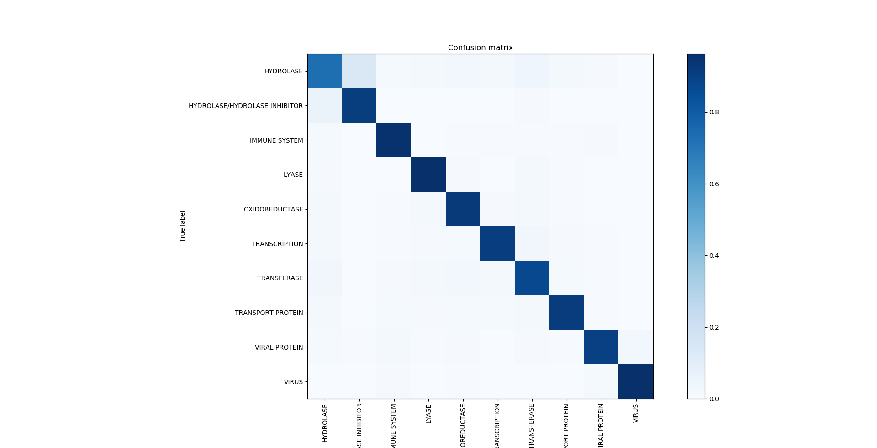

# Discussion & Conclusions

The first difficulty we may encounter is sequence encoding (choosing between different embedding methods) because different numeric representation of the amino acid sequence may influence our model performance. The second difficulty is that there may be a lot of information and classes of the protein families, so we delete some class with small samples and also choose the data with proper sequence length. Last but not least, no matter which model we use (GRU, 1dCNN,……), we do require a lot of computation resources to finish the training part.

For any preprocessed datasets, the 1D-CNN always get the best performance. What’s more, it cost the shortest tome to train.

# Work Distribution

# References

1. Nauman, M., Rehman, H. U., Politano, G., & Benso, A. (2018). Beyond Homology Transfer: Deep Learning for Automated Annotation of Proteins. Journal of Grid Computing. doi:10.1007/s10723-018-9450-6
2. Timothy K. Lee, Tuan Nguyen, "Protein Family Classification with Neural Networks", 2016.
3. Hou J, Adhikari B, Cheng J. DeepSF: deep convolutional neural network for mapping protein sequences to folds. Bioinformatics. 2017;34(8):1295-1303.

1. Po-Yu Chou (105061110) † Yi-Yu Zheng (105061108) †

   Ya-Ting Yang (105061210) † Yu-Chia Huang (105061236) †

   Yu-Hsiu Huang (104061249) †

   †Department of Electrical Engineering, National Tsing Hua University