Hi,
I want to give some more information for the team looking at Radio Network Management.
I met earlier last week with Alan Beach of Comtronix and the team creating the open source Digital Audio Broadcasting project including Matthias Brändli <matthias.braendli@mpb.li>

I have discussed with you last years student efforts to monitor radio equipment using SNMP and syslogs.
The full example is here https://github.com/gallenc/opennms-tutorials-1/tree/main/session6/kuwaiba-opennms-radio
This is part of the OpenNMS tutorial and is a good starting point for you to understand the business problem of monitoring a wireless network.

The key tasks for your group are to:
- Improve the Grafana representation of the network (if possible)
- do additional SNMP radio monitoring for another site ( possibly a DAB transmitter MIB - to be supplied by Alan)
- add monitoring of the end to end DAB network using another management interface

A typical radio site is shown in this diagram which is what we are currently monitoring:
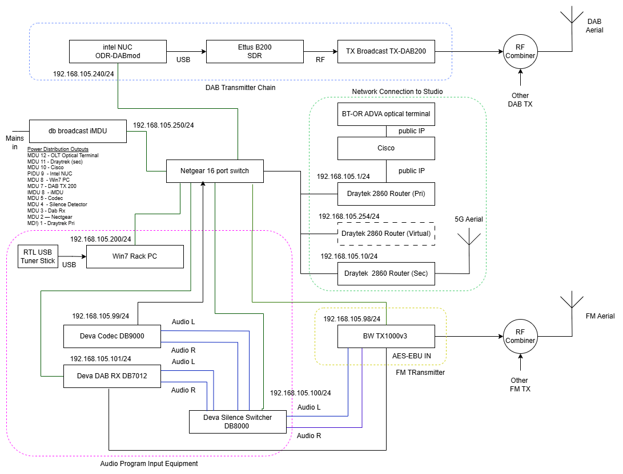

You are faced with a complex challenge.
- set up the DAB Mux and DAB Mod software chain ( Alan may be able to help with this)
- get the stats from the modulator and multiplexer and use these to indicate any problems
- also syslog messages from both above.
- create an OpenNMS integration which finds problems in the network end to end.

I have done some digging to get you started with the following information

A complete open source Digital Audio Broadcasting system is provided by the Open digital Radio project https://www.opendigitalradio.org/mmbtools. Reading the documentation here will explain the DAB radio chain.

The diagram below shows how a DAB multiplex operator works. Our project sponsor is becoming a DAB Multiplex operator and so needs to be able to monitor a DABMux running in the cloud along side a DAB modulator running on each radio site.

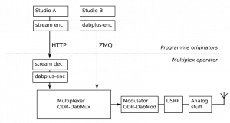
https://www.opendigitalradio.org/mmbtools

ODR DAB Mux https://github.com/Opendigitalradio/ODR-DabMux

ODR DAB Mod https://github.com/Opendigitalradio/ODR-DabMod

This ansible role may also be useful to package and deploy ODR https://github.com/Opendigitalradio/ansible-role-odr_mmbtools/tree/main
(possibly a bit complicated but shows you how to build the components)

The latest (next branch) ODR DAB Mux has a web server which publishes stats as JSON messages
https://github.com/Opendigitalradio/ODR-DabMux/blob/next/doc/STATS.md

See also the configuration at https://github.com/Opendigitalradio/ODR-DabMux/blob/next/doc/advanced.mux
```
; The management server is a simple TCP server that can present
; statistics data (buffers, overruns, underruns, etc)
; which can then be graphed a tool like Munin
; The doc/stats_dabmux_multi.py tool is a suitable
; plugin for that. The data fields are documented in doc/STATS.md
; If the port is zero, or the line commented, the server
; is not started.
managementport 12720
```
We need to extact the stats from the MUX to see if there is a problem with he incoming audio streams

Similarly the DAB mod project also produces stas which can be displayed from the remote control interface
https://github.com/Opendigitalradio/ODR-DabMod/blob/next/doc/README-RC.md?plain=1

