**Module 3**

**PRE-TEST**

1. 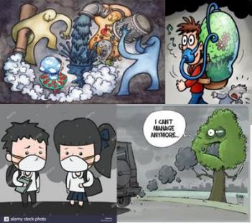In one word, describe the picture below. Discuss your answer
2. What do you think are the causes of water pollution? Write your answers on the space provided

**Self-Evaluation**

1.What are the sources of air pollution and how this pollution affects the human health?

2. Is the ozone hole causing climate change?

3. What are some effective ways to clean-up polluted water? Support your answer.

# POST-TEST

* Synthesize journal articles (at least 5 articles - local) related to species extinction (by group).

*Criteria:*

* + Composition- 13
  + Organization- 5
  + Originality/Citation- 5
  + Grammar- 2