**Pre-test.** Using the **bubble sheet on page 1**, shade the letter of your answer to the following:

1. It is a topic of applied ethics that examines the moral basis / moral foundation of environmental responsibility
   1. social ethics b. environmental ethics c. Christian ethics

*For question numbers 2 to 7, select your answer from the following choices:*

1. anthropocentrism
2. biocentrism
3. ecocentrism
4. The view that all environmental responsibility is based on human benefits alone
5. Sees humans as conquerors of the land
6. Sees land as a community to which we belong
7. “Mother Earth” should have the same right to life as any mother
8. The environment itself, not just the living organisms that inhabit it, has moral worth
9. All forms of life have an inherent right to exist

*For question numbers 8 to 10, select your answer from the following choices:*

a. development b. conservation c. preservation

1. Tends to strike a balance between unrestrained development and preservationism
2. Assumes that humans are the master of nature; Earth exists solely for humans
3. This view wants to see large portions of nature intact.

***Pause and ponder.*** *Answer this brief survey on your own and compare answers with your classmates when you are done.*

|  |  |  |  |  |  |
| --- | --- | --- | --- | --- | --- |
| **Put a mark under your rating**  **for the following:** | **Strongly**  **disagree** | **Disagree** | **Neutral** | **Agree** | **Strongly**  **agree** |
| 1. I bring my own eco-bag when  buying from stores / market. |  |  |  |  |  |
| 2. I bring my own water bottle to  avoid buying bottled water. |  |  |  |  |  |
| 3. I love taking care of plants. |  |  |  |  |  |
| 4. I love taking care of animals. |  |  |  |  |  |
| 5. I walk instead of ride short- distance errands to avoid  pollution. |  |  |  |  |  |

# Self-evaluation

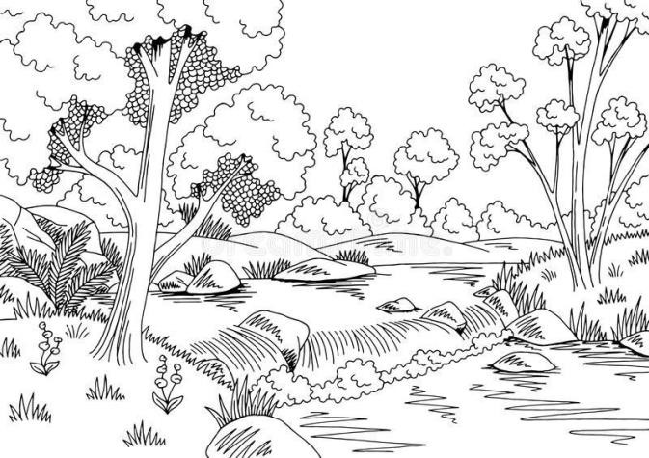

Imagine a forest like the picture on the right. Three people, with different environmental worldviews, are looking at it. How do you think each of them would view the forest? Why?

* 1. A developer
  2. A preservationist
  3. A conservationist

**Post-test**

1. Quiz and oral recitation during face-to-face meeting