# **Min Project 1 – SteelBox Inc.**

Assume that your customer, SteelBox Inc. , produces traction battery trays out of steel sheets (see the picture below). It is basically a box (rectangular prism). Some trays as, an option, might have a lid and/or a seprator in the middle of the tray (seprator is parallel to the shorter side).

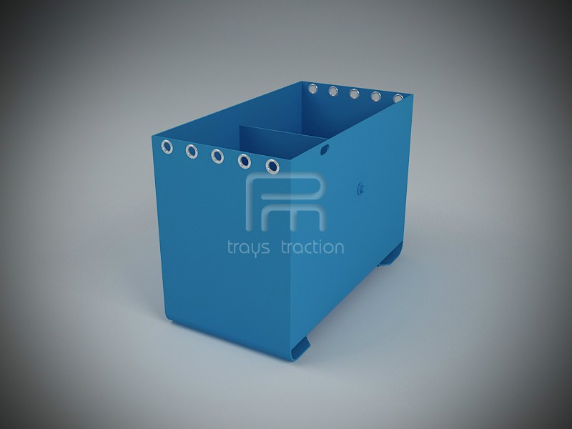

So, SteelBox Inc asks you to design a GUI (see the picture below for a sample GUI) in way that once the dimensions of the tray are given, GUI calculates and shows the cost of the tray.

The formula to calculate the cost is:

Cost = (Weight of the Tray) x (Price of the steel) (weight is in kg, price is TRL for 1 kg)

Weight = (Volume of the tray) x (Density of the steel) (you can take ds = 7.85 gr/cm3 )

Volume = (Surface Area of the tray) x thickness

Surface Area = 2 x ( WxH + LxH ) + WxL and you should add WxL if the lid is requested, and add WxH if the separator is requested.

Here W=width (shorter side), L = length (longer side), H = height. Even, by mistake, if the user enters W longer than L you should switch. All the dimensions are given in cm.

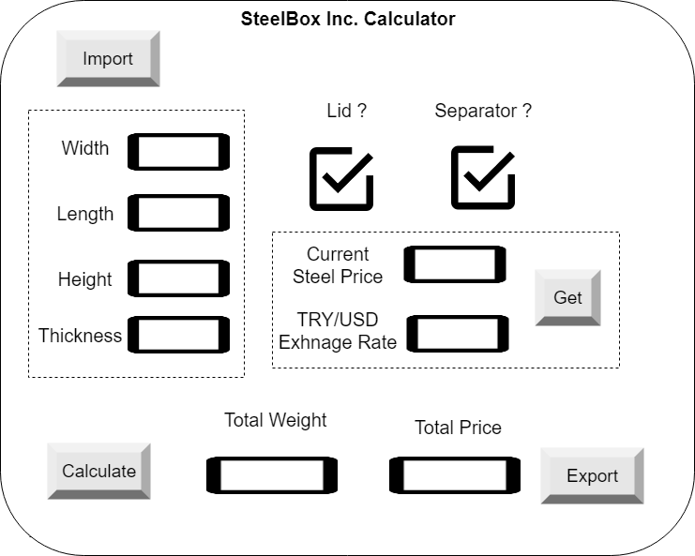

1. There are two ways to give the input to the GUI, either via by importing excel file using the import button, or entering numbers manually.
2. For now, you can just make an entry box for “Current Seel Price in USD”, and “TRY/USD” exchange rate and enter them manually, but if you implement the GET button and pull those numbers from the internet via an API or web scraping you will get 10pts bonus.
3. Once the “calculate” button is pressed, the results (Total Weight and Total Price) should be shown in the related boxes.
4. Once the export button is clicked, the GUI should create an excel file with the result. (please check the sample input and output files for the specifications)