COMandFIN
Financial Risk Management
Case Study Workbook
Value at Risk • Sensitivity Measures • RAROC • Regression & Variance Analysis

FACULTY EDITION — WITH DETAILED SOLUTIONS

32 industry case studies | Concept notes | Real-world examples | Graphs | Interview questions

Prepared by
CA Ankit Bajaj
Founder, COMandFIN Edutech Pvt. Ltd.
Suitable for MBA / BBA / B.Com (Hons.), FRM Part I & II aspirants, CFA candidates and banking professionals.
Confidential — for faculty use only. Do not circulate to students.

How to Use This Workbook
Each of the four modules opens with a concise concept note — what the concept is, why it matters, how industry applies it, key formulas, illustrative graphs, real-life examples, common mistakes and interview questions — followed by eight progressively harder case studies set in Indian banking, asset management and corporate contexts.
- Case structure: Background → Data → Required. Cases marked *Graph task* require students to draw a chart (Excel recommended).
- Tools: Excel functions are suggested throughout — NORM.S.INV, PERCENTILE.EXC, BINOM.DIST, SLOPE, INTERCEPT, RSQ, LINEST, VAR.S, STDEV.S, COVARIANCE.S, MMULT.
- Conventions: ₹ crore unless stated; 1 crore = 100 lakh; z₉₅ = 1.645, z₉₇.₅ = 1.960, z₉₉ = 2.326; 250 trading days a year; tax 25% and post-tax hurdle 15% in RAROC cases.
- Data: company names are illustrative and the figures are constructed for teaching; market references (Basel, RBI, SEBI, historical events) are factual.
Faculty note: Solutions appear in green-bordered panels directly after each case. A one-page answer key is provided at the end for quick checking. Suggested timing: concept note 45–60 minutes per module; 20–30 minutes per case (Cases 1–3 in class, 4–6 as group work, 7–8 as assignments).
CONTENTS
 | Topic | Content
Module 1 | Value at Risk (VaR) | Concept note + 8 cases
Module 2 | Sensitivity Measures | Concept note + 8 cases
Module 3 | Risk-Adjusted Return on Capital (RAROC) | Concept note + 8 cases
Module 4 | Regression & Variance Analysis | Concept note + 8 cases
Appendix | Formula sheet & Excel functions | Answer key

CASE MAP
Case | Title | Focus
1.1 | Parametric VaR for an Equity ETF Portfolio | Single-asset VaR | Confidence level | Time scaling
1.2 | Diversification Benefit in a Two-Asset Portfolio | Portfolio VaR | Correlation | Diversification
1.3 | Historical Simulation VaR and Expected Shortfall | Historical VaR | Expected Shortfall | Fat tails
1.4 | VaR Backtesting and the Basel Traffic-Light Test | Backtesting | Exceptions | Capital multiplier
1.5 | Interest-Rate VaR on a Government Securities Portfolio | Bond VaR | Modified duration | PV01
1.6 | FX VaR for an Importer’s USD Payable | Currency risk | Corporate VaR | Hedge decision
1.7 | VaR versus Expected Shortfall under FRTB | Expected Shortfall | Coherence | Regulation
1.8 | Market Risk Capital with VaR and Stressed VaR (Basel 2.5) | Regulatory capital | Stressed VaR | Multiplier
2.1 | Duration of a Corporate Bond | Macaulay & modified duration
2.2 | Convexity Adjustment for Large Rate Shocks | Convexity | IRRBB shocks | Graph
2.3 | PV01 Hedging with Interest Rate Futures | PV01 / DV01 | Hedge ratio
2.4 | Beta Hedging an Equity Portfolio with Nifty Futures | Beta | Index futures | Tactical de-risking
2.5 | Option Greeks using Black–Scholes | Delta | Gamma | Vega | Theta
2.6 | Delta–Gamma Neutral Hedging of an Options Book | Delta hedging | Gamma hedging
2.7 | Duration Gap Analysis — An SVB-Style Stress | ALM | Duration gap | Economic value of equity
2.8 | Effective Duration and Negative Convexity of a Callable Bond | Effective duration | Embedded options
3.1 | RAROC of a Corporate Term Loan | Basic RAROC | Accept / reject
3.2 | Risk-Based Pricing — Minimum Lending Rate | Break-even pricing | Hurdle
3.3 | Large Corporate vs SME — Which Customer Creates More Value? | Comparative RAROC | Yield vs risk
3.4 | Economic Capital from a Credit Loss Distribution | Credit VaR | EL vs UL | Regulatory comparison
3.5 | RAROC for Treasury Trading Desks | Market-risk capital | Desk comparison
3.6 | Relationship RAROC with Fee Cross-Sell | Relationship pricing | Fee income
3.7 | Capital Allocation with Diversification | Group EC | Diversification | Graph
3.8 | Impact of Collateral on RAROC | LGD | Credit risk mitigation
4.1 | Estimating Stock Beta by OLS Regression | Simple regression | Beta | R² | Graph
4.2 | Interpreting a Multiple Regression — NPA Stress Model | Multiple regression | t-test | Forecasting
4.3 | Minimum-Variance Hedge Ratio for an Airline | Cross-hedging | Hedge ratio | Effectiveness
4.4 | Portfolio Variance and Risk Contribution | Covariance matrix | Risk budgeting
4.5 | Systematic vs Idiosyncratic Variance | Variance decomposition | Diversification | Graph
4.6 | Variance, Volatility and Risk-Adjusted Performance of Two Funds | Sample variance | Annualisation | Sharpe ratio
4.7 | Regression-Based Flexible Budget and Cost Variance Analysis | Cost behaviour | Flexible budget | FP&A | Graph
4.8 | ANOVA Table and Goodness of Fit | ANOVA | F-test | Adjusted R²

MODULE 1

Value at Risk (VaR)

1. What is it?
Value at Risk is the maximum loss a portfolio is expected to suffer over a defined holding period, at a given confidence level, under normal market conditions. A statement such as “1-day 99% VaR is ₹5 crore” means that on 99 trading days out of 100 the loss should not exceed ₹5 crore — and on roughly one day in a hundred, it will. VaR therefore has three inputs: the confidence level, the holding period and the loss distribution of the portfolio.

2. Why is it important?
- Converts exposures in equities, bonds, currencies and commodities into one comparable rupee number for the Board.
- Basis for trading limits, risk appetite statements and desk-level capital allocation.
- Regulatory use: Basel market-risk capital (internal models), exchange margins (SEBI’s VaR margin in the cash segment), and ICAAP under Pillar 2.
- Communicates risk in plain language to non-specialists — one of the reasons J.P. Morgan’s “4:15 report” and its RiskMetrics methodology (1994) made VaR an industry standard.

3. How is it used in industry?
- Banks’ treasury and trading desks — daily VaR reports by desk, product and risk factor; limit breaches escalate to the ALCO/Risk Committee.
- Clearing corporations (NSE Clearing, ICCL) — VaR margins plus extreme-loss margins are collected from members on cash-market positions.
- Mutual funds, insurers and PMS — VaR and tracking-error limits in investment policy statements; stress tests alongside VaR.
- Corporates — Cash-flow-at-Risk / FX VaR for import–export exposures and commodity procurement.
KEY APPROACHES / BUILDING BLOCKS
Approach | How it works | Strengths | Limitations
Parametric (variance–covariance) | Assumes normally distributed returns; VaR = z × σ × Portfolio value | Fast, intuitive, handles large portfolios | Under-states fat tails; poor for options
Historical simulation | Re-prices today’s portfolio on actual past returns; VaR = chosen percentile loss | No distribution assumption; captures fat tails and correlations seen in history | Depends entirely on the look-back window
Monte Carlo simulation | Generates thousands of random scenarios from a stochastic model | Handles non-linear products (options) and path dependency | Computationally heavy; model risk

4. Key formulas
Measure | Formula
Parametric VaR | VaR = z_c × σ × V (z₉₅ = 1.645, z₉₉ = 2.326)
Mean-adjusted VaR | VaR = (z_c × σ − μ) × V
Square-root-of-time scaling | VaR_T-day = VaR_1-day × √T (assumes i.i.d. returns)
Two-asset portfolio VaR | VaR_p = √(VaR₁² + VaR₂² + 2ρ·VaR₁·VaR₂)
Diversification benefit | Σ standalone VaRs − Portfolio VaR
Expected Shortfall (normal) | ES_c = σ × V × φ(z_c) / (1 − c)
Bond VaR (delta-normal) | VaR = V × Modified Duration × σ(Δy) × z_c

5. Graphical illustration
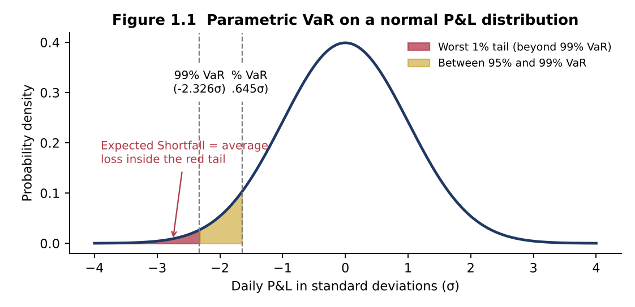
Shaded tails show what VaR measures (the threshold) and what Expected Shortfall measures (the average beyond it).
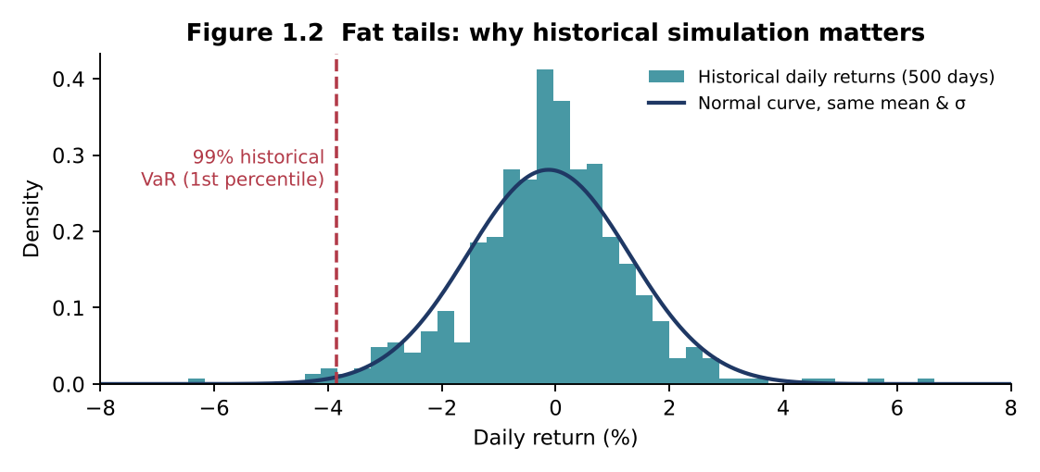
Real market returns have fatter tails than the normal curve, so parametric VaR can understate extreme losses.

6. Real-life examples
J.P. Morgan — “London Whale” (2012). The Chief Investment Office changed its VaR model in January 2012; the new model roughly halved the reported VaR of the synthetic credit portfolio. Positions grew, and losses eventually exceeded US$6 billion. Lesson: VaR model changes need independent validation and VaR must never be the only limit.
Long-Term Capital Management (1998). LTCM’s risk models, calibrated on calm historical data, implied a very low probability of large losses. After Russia’s default, correlations converged and liquidity vanished; a Federal Reserve-brokered consortium of 14 institutions injected about US$3.6 billion. Lesson: VaR says nothing about the size of losses beyond the threshold or about liquidity.
Basel FRTB — move from VaR to Expected Shortfall. Under the Fundamental Review of the Trading Book (final standard, January 2019), internal-model banks replace 99% VaR with 97.5% Expected Shortfall calibrated to a period of stress, because ES captures tail severity and is sub-additive.
Indian equity market margins. In India’s cash segment, clearing corporations collect a VaR-based margin together with an Extreme Loss Margin (ELM); scrips are grouped by liquidity and volatility, so illiquid stocks attract materially higher VaR margins.

7. Common mistakes
- Treating VaR as the “worst-case loss” — it is a threshold, not a maximum.
- Applying √T scaling to returns that are autocorrelated or to portfolios that change during the horizon.
- Adding standalone VaRs to get portfolio VaR (ignores correlation) — or assuming correlations stay stable during a crisis.
- Using parametric VaR for option-heavy books where P&L is non-linear.
- Ignoring backtesting results; a model with too many exceptions must be recalibrated.

8. Interview questions
Q1. What does a 10-day 99% VaR of ₹20 crore mean?
Model answer: There is a 1% probability that the portfolio will lose more than ₹20 crore over the next 10 trading days under normal market conditions.
Q2. Why is VaR not a coherent risk measure?
Model answer: It can violate sub-additivity: the VaR of a combined portfolio can exceed the sum of individual VaRs, which penalises diversification. Expected Shortfall is coherent.
Q3. How would you choose between historical and Monte Carlo VaR?
Model answer: Historical for linear books where recent history is representative; Monte Carlo for option-heavy or path-dependent books where full revaluation across many scenarios is required.
Q4. What is backtesting and the Basel traffic-light approach?
Model answer: Comparing actual daily P&L against predicted VaR. Over 250 days at 99%, 0–4 exceptions = green, 5–9 = yellow (capital multiplier rises from 3 towards 4), 10+ = red.
Q5. What is Stressed VaR?
Model answer: VaR computed with model inputs calibrated to a continuous 12-month period of significant financial stress, introduced in Basel 2.5 after 2008.

Module 1 Cases: Value at Risk (VaR)

Case 1.1 Parametric VaR for an Equity ETF Portfolio
Single-asset VaR | Confidence level | Time scaling
BACKGROUND
Shreeram Asset Managers runs a proprietary book holding ₹50 crore in a Nifty 50 ETF. The CRO wants a one-page risk summary for the Investment Committee meeting. Daily returns over the last year show a standard deviation of 1.20% and an average daily return of 0.05%.
DATA
Parameter | Value
Portfolio value | ₹50 crore
Daily volatility (σ) | 1.20%
Average daily return (μ) | 0.05%
z-value 95% / 99% | 1.645 / 2.326

REQUIRED
(a) Compute the 1-day VaR at 95% and 99% confidence.
(b) Compute the 10-day 99% VaR using square-root-of-time scaling.
(c) Recompute the 1-day 99% VaR after adjusting for the mean return. Is the adjustment material?
(d) Explain in one sentence, for the Investment Committee, what the 1-day 99% VaR figure means.
FACULTY SOLUTION
1-day 95% VaR = 1.645 × 1.20% × ₹50 crore = ₹0.99 crore
1-day 99% VaR = 2.326 × 1.20% × ₹50 crore = ₹1.40 crore
10-day 99% VaR = ₹1.40 crore × √10 = ₹1.40 crore × 3.1623 = ₹4.41 crore
Mean-adjusted VaR = (2.326 × 1.20% − 0.05%) × ₹50 crore = (2.7912% − 0.05%) × 50 = ₹1.37 crore
The mean adjustment reduces VaR by only ₹0.03 crore (1.8%). Over a 1-day horizon the mean is negligible relative to volatility, which is why regulators allow it to be ignored for short horizons.
Committee wording: “On 99 out of 100 trading days we do not expect to lose more than about ₹1.40 crore on this ETF position; on roughly 2–3 days a year the loss could be larger.”
Key answer: 95%: ₹0.99 crore; 99%: ₹1.40 crore; 10-day 99%: ₹4.41 crore

Case 1.2 Diversification Benefit in a Two-Asset Portfolio
Portfolio VaR | Correlation | Diversification
BACKGROUND
A family office holds ₹60 crore in Indian equities and ₹40 crore in Gold ETFs. The patriarch believes gold is a “hedge” and wants to know how much risk the gold allocation actually removes.
DATA
Asset | Value (₹ crore) | Daily σ | Correlation with equity
Equity | 60 | 1.40% | —
Gold ETF | 40 | 0.90% | −0.10

REQUIRED
(a) Compute the standalone 1-day 99% VaR of each asset.
(b) Compute the undiversified VaR and the diversified portfolio VaR.
(c) Quantify the diversification benefit in ₹ and as a % of undiversified VaR.
(d) Recompute portfolio VaR if correlation rises to +0.50 and to +1.00. What does this imply in a crisis?
FACULTY SOLUTION
Equity VaR = 2.326 × 1.40% × 60 = ₹1.95 crore
Gold VaR = 2.326 × 0.90% × 40 = ₹0.84 crore
Undiversified VaR = 1.9538 + 0.8374 = ₹2.79 crore
Portfolio VaR = √(1.9538² + 0.8374² + 2 × (−0.10) × 1.9538 × 0.8374) = ₹2.05 crore
Diversification benefit = ₹0.74 crore, i.e. 26.7% of undiversified VaR.
Correlation | Portfolio VaR | Benefit
−0.10 | ₹2.05 crore | ₹0.74 crore
+0.50 | ₹2.48 crore | ₹0.31 crore
+1.00 | ₹2.79 crore | ₹0.00 crore

At ρ = +1 VaR becomes simply additive. Correlations tend to rise in stressed markets (e.g. March 2020, when gold also fell sharply for a few days as investors sold liquid assets), so diversification benefits should be stress-tested rather than assumed.
Key answer: Diversified VaR ₹2.05 crore; benefit ₹0.74 crore

Case 1.3 Historical Simulation VaR and Expected Shortfall
Historical VaR | Expected Shortfall | Fat tails
BACKGROUND
The market risk unit of Konark Bank re-priced its ₹80 crore equity trading book over the last 500 trading days. The 15 worst daily returns (sorted) are shown below. Bank policy uses the 5th worst observation as the 99% VaR (500 × 1% = 5) and the average of the worst 12 observations as the 97.5% ES (500 × 2.5% = 12.5, rounded down).
DATA
Rank | Return | Rank | Return | Rank | Return
1 | -6.85% | 6 | -4.05% | 11 | -3.20%
2 | -5.92% | 7 | -3.88% | 12 | -3.12%
3 | -5.10% | 8 | -3.62% | 13 | -3.02%
4 | -4.78% | 9 | -3.45% | 14 | -2.95%
5 | -4.41% | 10 | -3.31% | 15 | -2.88%

REQUIRED
(a) Compute the 1-day 99% historical VaR in % and ₹.
(b) Compute the 1-day 99% Expected Shortfall (average of the worst 5) and the 97.5% ES (average of the worst 12).
(c) If the book’s daily σ is 1.50%, compute 99% parametric VaR and compare it with the historical estimate.
(d) Graph task: plot the 15 worst returns as a bar chart and mark the VaR cut-off.
(e) What does the gap between the two VaR numbers tell you about the return distribution?
FACULTY SOLUTION
99% VaR = 5th worst return = 4.41% × ₹80 crore = ₹3.53 crore
99% ES = average(6.85, 5.92, 5.10, 4.78, 4.41) = 5.412% → ₹4.33 crore
97.5% ES = average of worst 12 = 4.308% → ₹3.45 crore
Parametric 99% VaR = 2.326 × 1.50% = 3.489% → ₹2.79 crore
Historical VaR exceeds parametric VaR by ₹0.74 crore (26%). The empirical distribution has fatter left tails than the normal distribution, so the parametric model would understate capital and limits. Expected Shortfall adds information VaR omits: when losses breach VaR, they average about 5.4%.
Note for discussion: under the normal distribution 97.5% ES ≈ 99% VaR; here 97.5% ES (4.31%) is close to 99% historical VaR (4.41%), which is exactly the calibration logic behind FRTB.
Key answer: Hist VaR ₹3.53 crore; ES99 ₹4.33 crore; Parametric ₹2.79 crore

Case 1.4 VaR Backtesting and the Basel Traffic-Light Test
Backtesting | Exceptions | Capital multiplier
BACKGROUND
Over the last 250 trading days, Deccan Bank’s 1-day 99% VaR model recorded 8 days on which the actual trading loss exceeded the predicted VaR. The average 10-day 99% VaR over the last 60 days is ₹15 crore. The Head of Market Risk must present the backtesting result to the Risk Management Committee of the Board.
DATA
Basel zone | Exceptions (250 days) | Plus factor
Green | 0–4 | 0.00
Yellow | 5 | 0.40
Yellow | 6 | 0.50
Yellow | 7 | 0.65
Yellow | 8 | 0.75
Yellow | 9 | 0.85
Red | 10 or more | 1.00

REQUIRED
(a) How many exceptions would you expect for a correctly calibrated model?
(b) Using the binomial distribution, compute the probability of 8 or more exceptions if the model is correct.
(c) Identify the Basel zone and the capital multiplier.
(d) Compute the VaR-based capital charge (multiplier × average VaR) and the additional capital versus the green zone.
(e) Recommend two actions for the Risk Committee.
FACULTY SOLUTION
Expected exceptions = 250 × 1% = 2.5
P(X ≥ 8) = 1 − BINOM.DIST(7, 250, 0.01, TRUE) = 0.0040 (≈ 0.40%)
Such an outcome would occur only about 0.4% of the time if the model were accurate — strong evidence that the model underestimates risk. Eight exceptions fall in the yellow zone; multiplier = 3 + 0.75 = 3.75.
Capital charge = 3.75 × ₹15 crore = ₹56.25 crore
Green-zone charge = 3.00 × ₹15 crore = ₹45.00 crore; additional capital = ₹11.25 crore
- Investigate the exceptions: were they clustered (volatility regime shift), driven by one desk, or by missing risk factors such as basis or option gamma?
- Recalibrate (shorter or volatility-weighted look-back, EWMA), add stressed VaR / ES overlays and report a Kupiec/Christoffersen test going forward.
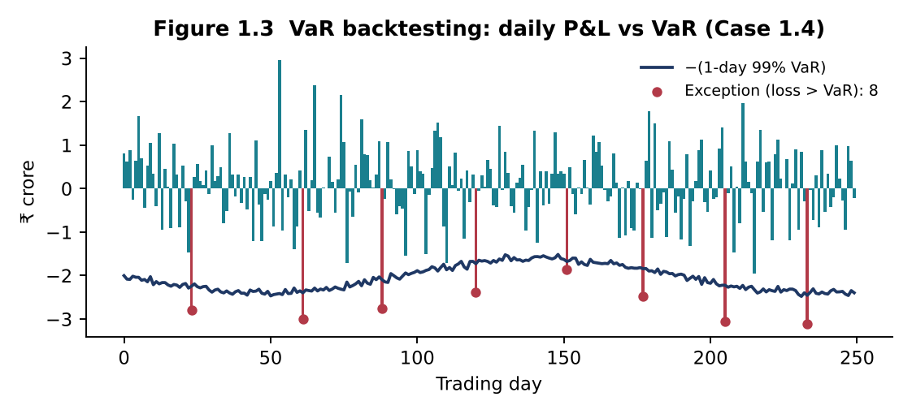
Illustrative backtesting chart: bars below the VaR line are exceptions.
Key answer: Expected 2.5; P(≥8) 0.40%; yellow zone, k = 3.75; capital ₹56.25 crore

Case 1.5 Interest-Rate VaR on a Government Securities Portfolio
Bond VaR | Modified duration | PV01
BACKGROUND
A cooperative bank’s treasury holds ₹200 crore of Government securities in its AFS book with a portfolio modified duration of 6.5. Historical analysis shows the daily standard deviation of the 10-year G-sec yield change is 6 bps. The Board wants to know the rupee risk arising from yield movements.
DATA
Parameter | Value
Market value | ₹200 crore
Modified duration | 6.5
Daily σ of yield change | 6 bps (0.06%)
Confidence | 99%

REQUIRED
(a) Compute the portfolio PV01 (value change for a 1 bp move).
(b) Compute the 1-day and 10-day 99% VaR.
(c) Express the 1-day VaR as an equivalent adverse yield move in bps.
(d) State two limitations of using modified duration for VaR.
FACULTY SOLUTION
PV01 = ₹200 crore × 6.5 × 0.0001 = ₹0.13 crore = ₹13 lakh per bp
1-day 99% VaR = 200 × 6.5 × 0.0006 × 2.326 = ₹1.81 crore
10-day 99% VaR = ₹1.81 crore × √10 = ₹5.74 crore
Equivalent yield shock = 2.326 × 6 bps = 13.96 bps; 13.96 × ₹13 lakh ≈ ₹1.81 crore.
- Duration is a linear approximation and ignores convexity, so large yield moves are mis-estimated.
- Assumes a parallel shift of the yield curve; steepening/flattening (key-rate risk) and spread risk on SDLs/corporate bonds are ignored.
Key answer: PV01 ₹13 lakh; VaR 1-day ₹1.81 crore; 10-day ₹5.74 crore

Case 1.6 FX VaR for an Importer’s USD Payable
Currency risk | Corporate VaR | Hedge decision
BACKGROUND
Bharat Electronics Components Ltd. (an unlisted importer) has a USD 10 million payable due in 10 trading days. Spot USD/INR is 84.00 and the daily volatility of USD/INR is 0.35%. The CFO wants to know the rupee risk at 95% confidence and the impact of hedging 70% of the exposure with a forward contract.
DATA
Parameter | Value
Exposure | USD 10 million (payable)
Spot USD/INR | 84.00
Daily σ | 0.35%
Horizon | 10 trading days
Confidence | 95% (z = 1.645)

REQUIRED
(a) Compute the INR value of the exposure.
(b) Compute the 1-day and 10-day 95% VaR in INR.
(c) Compute the residual 10-day VaR after hedging 70% with forwards.
(d) For an importer, which direction of the rupee creates the loss? Explain.
FACULTY SOLUTION
INR exposure = 10,000,000 × 84.00 = ₹84 crore
1-day 95% VaR = 1.645 × 0.35% × 84 = ₹0.48 crore
10-day 95% VaR = ₹0.48 crore × √10 = ₹1.53 crore
Residual VaR = ₹1.53 crore × 30% = ₹0.46 crore (risk reduced by ₹1.07 crore)
The importer loses if the rupee depreciates (USD/INR rises). A 10-day adverse move of about 1.82% would take USD/INR to roughly 85.53. Hedging is a policy decision: the forward locks in the cost (including the forward premium) and removes upside if the rupee appreciates.
Key answer: 10-day VaR ₹1.53 crore; after 70% hedge ₹0.46 crore

Case 1.7 VaR versus Expected Shortfall under FRTB
Expected Shortfall | Coherence | Regulation
BACKGROUND
A private bank’s ₹100 crore trading portfolio has a daily σ of 1.50%. The bank is preparing for the Basel FRTB transition, which replaces 99% VaR with 97.5% Expected Shortfall. The Board asks whether the change will increase capital.
DATA
Parameter | Value
Portfolio | ₹100 crore
Daily σ | 1.50%
φ(2.326) | 0.02665
φ(1.960) | 0.05845

REQUIRED
(a) Compute 1-day VaR at 97.5% and 99%.
(b) Compute 1-day ES at 97.5% and 99% assuming normality (ES = σ·V·φ(z)/(1 − c)).
(c) Compare 97.5% ES with 99% VaR. Why did regulators choose 97.5%?
(d) Give two reasons why ES is superior to VaR.
FACULTY SOLUTION
VaR 97.5% = 1.960 × 1.50% × 100 = ₹2.94 crore; VaR 99% = 2.326 × 1.50% × 100 = ₹3.49 crore
ES 97.5% = 1.50% × 100 × 0.05845 / 0.025 = 2.338σ → ₹3.51 crore
ES 99% = 1.50% × 100 × 0.02665 / 0.01 = 2.665σ → ₹4.00 crore
Under normality, 97.5% ES (₹3.51 crore) ≈ 99% VaR (₹3.49 crore). The 97.5% level was chosen so that capital is broadly comparable for normal distributions, while for fat-tailed portfolios ES rises — capturing the tail risk VaR ignores.
- ES is sub-additive (coherent) — it never penalises diversification.
- ES measures the severity of losses beyond the threshold; two portfolios with identical VaR can have very different ES.
Key answer: ES97.5 ₹3.51 crore ≈ VaR99 ₹3.49 crore

Case 1.8 Market Risk Capital with VaR and Stressed VaR (Basel 2.5)
Regulatory capital | Stressed VaR | Multiplier
BACKGROUND
A bank using the internal models approach reports the following 10-day 99% figures (₹ crore). The multiplier is 3.0 in the green zone; following a poor backtest, the regulator may raise it to 3.5.
DATA
Measure | Previous day | 60-day average
VaR | 12.0 | 10.0
Stressed VaR | 22.0 | 20.0

REQUIRED
(a) Compute the market-risk capital charge: max(VaRₜ₋₁, m × VaR_avg) + max(sVaRₜ₋₁, m × sVaR_avg) with m = 3.0.
(b) Recompute with m = 3.5 and quantify the increase.
(c) Convert the m = 3.0 capital into risk-weighted assets (RWA = capital × 12.5).
(d) Why was Stressed VaR introduced after 2008?
FACULTY SOLUTION
m = 3.0: max(12, 30) + max(22, 60) = 30 + 60 = ₹90.00 crore
m = 3.5: max(12, 35) + max(22, 70) = 35 + 70 = ₹105.00 crore → increase ₹15.00 crore
Market-risk RWA = 90 × 12.5 = ₹1,125.00 crore
Pre-2008 VaR models were calibrated on benign periods and produced pro-cyclically low capital. Stressed VaR uses a 12-month period of significant stress (e.g. 2008), roughly doubling market-risk capital and reducing pro-cyclicality.
Key answer: Capital ₹90.00 crore (m=3); ₹105.00 crore (m=3.5)

MODULE 2

Sensitivity Measures

1. What is it?
Sensitivity measures quantify how much the value of a position changes for a small change in one risk factor, holding others constant. They are the “first line” of market-risk management: duration, convexity and PV01/DV01 for interest rates; beta for equities; and the option Greeks — delta, gamma, vega, theta and rho — for derivatives. Unlike VaR, they do not need a probability distribution; they answer the question “what happens if this factor moves by one unit?”

2. Why is it important?
- They identify *which* risk factor drives P&L and therefore *what* to hedge and *how much*.
- They are additive across positions (PV01s and deltas can be summed), making limit-setting and aggregation simple.
- Inputs to VaR (delta-normal), stress tests and regulatory capital (the FRTB Standardised Approach is built on sensitivities).
- Essential for ALM: duration gap and earnings sensitivity drive Interest Rate Risk in the Banking Book (IRRBB).

3. How is it used in industry?
- Bank treasuries — PV01 limits per portfolio and tenor bucket; duration of AFS/HFT books reported daily.
- ALM / IRRBB — duration gap and economic value of equity (EVE) sensitivity to ±200 bps shocks.
- Options desks and market makers — delta-hedge continuously, manage gamma and vega limits.
- Portfolio managers — beta-adjust portfolios with index futures; duration-manage debt funds.
KEY APPROACHES / BUILDING BLOCKS
Measure | Risk factor | What it captures | Typical use
Modified duration / PV01 | Interest rates | % (or ₹) price change for a 1% (or 1 bp) yield change | Bond portfolios, ALM
Convexity | Interest rates (2nd order) | Curvature of the price–yield curve | Large rate moves, callable bonds
Beta | Equity market | Stock return sensitivity to index return | Equity hedging, CAPM
Delta / Gamma | Underlying price | Option price change / change in delta | Options hedging
Vega / Theta / Rho | Volatility / time / rates | Change in option value per unit change | Volatility trading, P&L attribution

4. Key formulas
Measure | Formula
Macaulay duration | D_Mac = Σ [t × PV(CFₜ)] / Price
Modified duration | D_Mod = D_Mac / (1 + y/m)
Price change (duration + convexity) | ΔP/P ≈ −D_Mod × Δy + ½ × Convexity × (Δy)²
PV01 / DV01 | PV01 = D_Mod × Price × 0.0001
Effective duration & convexity | ED = (P₋ − P₊)/(2·P₀·Δy); EC = (P₋ + P₊ − 2P₀)/(P₀·Δy²)
Beta hedge (futures) | N = (β_target − β_current) × Portfolio value / (Futures price × Lot size)
Delta–gamma approximation | ΔC ≈ Δ × ΔS + ½ × Γ × (ΔS)²
Duration gap | DGAP = D_A − (L/A) × D_L; ΔE ≈ −DGAP × A × Δy/(1 + y)

5. Graphical illustration
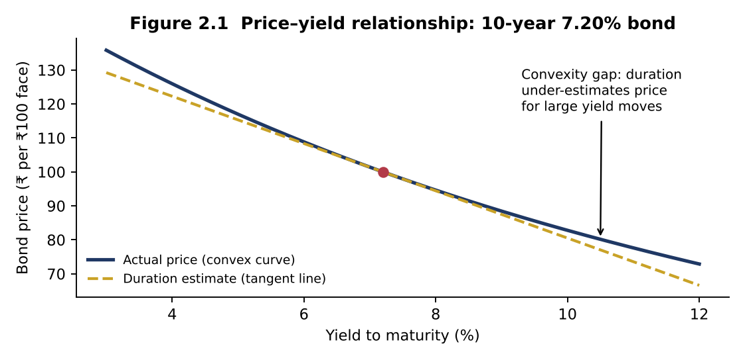
Duration is the slope (tangent) of the price–yield curve; convexity is its curvature.
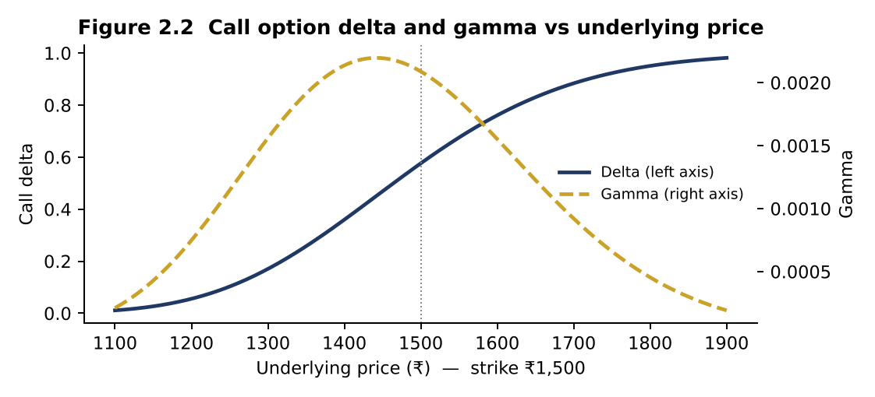
Delta rises from 0 to 1 as the option moves into the money; gamma peaks at-the-money near expiry, where hedges need the most frequent rebalancing.

6. Real-life examples
Silicon Valley Bank (March 2023). SVB invested deposit inflows in long-duration Treasuries and MBS. As the Fed raised rates by ~450 bps, unrealised losses on its securities exceeded its equity. A US$1.8 billion realised loss on sale of AFS securities triggered a deposit run and the bank failed on 10 March 2023 — a textbook duration-gap failure.
Orange County, California (1994). The county investment pool used leveraged reverse repos to buy rate-sensitive notes, effectively running a very high duration. When the Fed raised rates through 1994, losses of about US$1.7 billion forced the county into bankruptcy.
Indian banks’ MTM losses (2017–18). When the 10-year G-sec yield rose by roughly 100 bps between mid-2017 and early 2018, banks faced heavy mark-to-market losses on their bond books; the RBI permitted banks to spread these losses over four quarters. Banks subsequently tightened PV01 and duration limits.
Index options market-making in India. NSE is among the world’s largest derivatives exchanges by contracts traded, dominated by index options. Market makers manage net delta and gamma intraday; on expiry days gamma near the strike is extreme, which is why SEBI’s 2024 measures on index derivatives targeted expiry-day risk.

7. Common mistakes
- Using modified duration for bonds with embedded options — use effective duration instead.
- Ignoring convexity for large shocks such as the ±200 bps IRRBB scenarios.
- Confusing the sign of DV01 for long vs short positions when netting a hedge.
- Assuming a delta hedge is permanent — delta changes with price (gamma) and time (charm).
- Using beta estimated from a short or unrepresentative window when sizing hedges.

8. Interview questions
Q1. Why does a zero-coupon bond have the highest duration for a given maturity?
Model answer: All cash flow occurs at maturity, so Macaulay duration equals maturity; coupon bonds return cash earlier, reducing duration.
Q2. What is negative convexity?
Model answer: Price rises less than it falls for equal yield moves; seen in callable bonds and MBS because prepayment/call caps price gains when yields fall.
Q3. How do you make a portfolio delta- and gamma-neutral?
Model answer: First use another option to neutralise gamma (shares have zero gamma), then use the underlying to neutralise the resulting delta.
Q4. Explain PV01 vs modified duration.
Model answer: Modified duration is the % price sensitivity per 1% yield change; PV01 is the rupee change for a 1 bp move — PV01 = MD × value × 0.0001.
Q5. What caused SVB’s failure from a risk perspective?
Model answer: A large positive duration gap — long-duration assets funded by short-duration, run-prone deposits — with no hedging of rate risk.

Module 2 Cases: Sensitivity Measures

Case 2.1 Duration of a Corporate Bond
Macaulay & modified duration
BACKGROUND
An AAA-rated NBFC has issued a 5-year bond with a 7.50% annual coupon, face value ₹100. The current yield to maturity is 8.00%. A debt fund manager wants to understand the bond’s rate sensitivity before buying ₹25 crore of face value.
DATA
Parameter | Value
Coupon | 7.50% annual
Maturity | 5 years
YTM | 8.00%
Face value | ₹100

REQUIRED
(a) Compute the bond price.
(b) Compute Macaulay and modified duration.
(c) Estimate the % price change for a +50 bps yield rise using modified duration, and compare it with the actual change from full repricing.
(d) Estimate the rupee loss on ₹25 crore face value for a +50 bps move.
FACULTY SOLUTION
Year | Cash flow | DF @ 8% | PV | t × PV
1 | 7.50 | 0.9259 | 6.9444 | 6.9444
2 | 7.50 | 0.8573 | 6.4300 | 12.8601
3 | 7.50 | 0.7938 | 5.9537 | 17.8612
4 | 7.50 | 0.7350 | 5.5127 | 22.0509
5 | 107.50 | 0.6806 | 73.1627 | 365.8135
Total |  |  | 98.0036 | 425.5301

Price = ₹98.0036
Macaulay duration = 425.5301 / 98.0036 = 4.3420 years
Modified duration = 4.3420 / 1.08 = 4.0204
Estimated ΔP/P = −4.0204 × 0.50% = -2.010%
Actual: price at 8.50% = ₹96.0594 → -1.984% (difference = convexity effect of +0.026%)
Market value of ₹25 crore face = 25 × 98.0036/100 = ₹24.5009 crore
Estimated loss ≈ 24.5009 × 2.010% = ₹0.49 crore
Key answer: Price ₹98.00; MacD 4.342; ModD 4.020

Case 2.2 Convexity Adjustment for Large Rate Shocks
Convexity | IRRBB shocks | Graph
BACKGROUND
A bank’s ALM desk holds a 10-year 7.20% annual-coupon G-sec trading at par (YTM 7.20%). For IRRBB reporting it must estimate price changes under ±100 bps and ±200 bps parallel shocks.
DATA
Parameter | Value
Coupon / YTM | 7.20% / 7.20%
Maturity | 10 years, annual coupons
Price | ₹100.00

REQUIRED
(a) Compute Macaulay duration, modified duration and convexity.
(b) For shocks of −200, −100, +100 and +200 bps, estimate % price change using (a) duration only and (b) duration + convexity.
(c) Compare with the actual % change from full repricing.
(d) Graph task: plot the three estimates for each shock as a clustered bar chart and comment.
FACULTY SOLUTION
Macaulay duration = 7.4602 yrs; Modified duration = 6.9591; Convexity = 64.0215
Shock | Duration only | Duration + convexity | Actual | New price
-200 bps | +13.918% | +15.199% | +15.295% | ₹115.2946
-100 bps | +6.959% | +7.279% | +7.291% | ₹107.2908
+100 bps | -6.959% | -6.639% | -6.650% | ₹93.3500
+200 bps | -13.918% | -12.638% | -12.723% | ₹87.2769

Duration alone underestimates gains when rates fall and overestimates losses when rates rise; the error grows with the square of the shock. Adding convexity brings the estimate within about 0.1% of the actual — sufficient for IRRBB reporting, though full revaluation remains the benchmark.
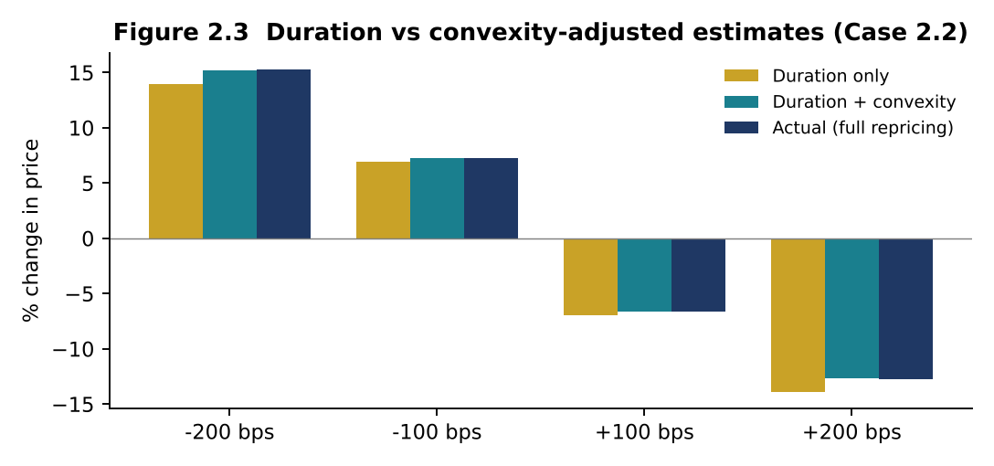
Solution graph: duration vs convexity-adjusted vs actual price change.
Key answer: ModD 6.959; Convexity 64.02

Case 2.3 PV01 Hedging with Interest Rate Futures
PV01 / DV01 | Hedge ratio
BACKGROUND
A bank holds ₹500 crore (market value) of G-secs with a modified duration of 5.2. The treasurer expects RBI to pause rate cuts and wants to neutralise rate risk for the next month using exchange-traded interest rate futures. The DV01 of one futures contract is ₹130 (assumed for this case).
DATA
Parameter | Value
Portfolio value | ₹500 crore
Modified duration | 5.2
DV01 per futures contract | ₹130

REQUIRED
(a) Compute the portfolio DV01.
(b) Compute the number of futures contracts to sell for a full hedge.
(c) Estimate the unhedged loss if yields rise by 25 bps and the net result after hedging.
(d) List two residual risks that remain after the hedge.
FACULTY SOLUTION
Portfolio DV01 = ₹500 crore × 5.2 × 0.0001 = ₹26,00,000 per bp
Contracts = ₹26,00,000 / ₹130 = 20,000 contracts (sell)
Unhedged loss for +25 bps = ₹26,00,000 × 25 = ₹6.50 crore; futures gain ≈ ₹6.50 crore → net ≈ nil
- Basis risk — the futures’ cheapest-to-deliver bond and the portfolio bonds can move differently (curve and spread risk).
- Non-parallel shifts and convexity mismatch; the hedge must be rebalanced as duration drifts.
Key answer: DV01 ₹26,00,000; sell 20,000 contracts

Case 2.4 Beta Hedging an Equity Portfolio with Nifty Futures
Beta | Index futures | Tactical de-risking
BACKGROUND
A PMS manager runs a ₹25 crore equity portfolio with a beta of 1.25 to the Nifty 50. Ahead of the Union Budget and a US Fed decision, the manager wants to reduce market exposure without selling stocks. Nifty futures trade at 24,500 with a lot size of 75 (assumed).
DATA
Parameter | Value
Portfolio value | ₹25 crore
Portfolio beta | 1.25
Nifty futures price | 24,500
Lot size | 75

REQUIRED
(a) Compute the value of one futures contract.
(b) How many contracts must be sold to make the portfolio beta zero?
(c) How many contracts to reduce beta to 0.60?
(d) If Nifty falls 8%, compute the portfolio loss unhedged and the futures gain on the full hedge.
FACULTY SOLUTION
Contract value = 24,500 × 75 = ₹18,37,500
Full hedge N = 1.25 × ₹25 crore / ₹18,37,500 = 170.07 ≈ 170 contracts (sell)
Partial hedge N = (1.25 − 0.60) × ₹25 crore / ₹18,37,500 = 88.44 ≈ 88 contracts (sell)
Unhedged loss = 1.25 × 8% × ₹25 crore = ₹2.50 crore; gain on 170 futures = 170 × ₹18,37,500 × 8% = ₹2.50 crore
The hedge removes systematic risk only; stock-specific (idiosyncratic) performance and beta-estimation error remain.
Key answer: 170 contracts (β→0); 88 (β→0.6)

Case 2.5 Option Greeks using Black–Scholes
Delta | Gamma | Vega | Theta
BACKGROUND
A derivatives desk has written at-the-money 3-month call options on a large-cap stock. Spot = ₹1,500, strike = ₹1,500, risk-free rate = 6.50% (continuous), volatility = 25%, time to expiry = 0.25 years. The desk head wants the Greeks to set hedges.
DATA
Parameter | Value
S / K | ₹1,500 / ₹1,500
r | 6.50%
σ | 25%
T | 0.25 years

REQUIRED
(a) Compute d₁, d₂, N(d₁), N(d₂) and the call price.
(b) Compute delta, gamma, vega (per 1% vol) and theta (per day).
(c) Estimate the change in call price for a ₹30 rise in the stock using (a) delta only and (b) delta + gamma. Compare with the actual Black–Scholes reprice.
(d) Why is gamma most dangerous for a short-option position close to expiry?
FACULTY SOLUTION
d₁ = [ln(1) + (0.065 + 0.03125) × 0.25] / (0.25 × 0.5) = 0.1925; d₂ = 0.0675
N(d₁) = 0.5763; N(d₂) = 0.5269
Call = 1,500 × 0.5763 − 1,500 × e^(−0.01625) × 0.5269 = ₹86.86
Greek | Value | Interpretation
Delta | 0.5763 | Call rises ~₹0.58 per ₹1 rise in stock
Gamma | 0.00209 | Delta rises ~0.0021 per ₹1
Vega | ₹2.94 | Per 1 percentage-point rise in volatility
Theta | ₹-0.54/day | Time decay (gain for the option writer)

Delta only: 0.5763 × 30 = ₹17.29
Delta + gamma: 17.29 + ½ × 0.00209 × 900 = ₹18.23
Actual reprice at S = 1,530: ₹18.21 → delta–gamma is accurate to within ₹0.02
Near expiry, ATM gamma becomes very large: small moves swing delta between 0 and 1, so the writer must re-hedge frequently, buying high and selling low — losses accumulate faster than theta income.
Key answer: Call ₹86.86; Δ 0.576; Γ 0.0021

Case 2.6 Delta–Gamma Neutral Hedging of an Options Book
Delta hedging | Gamma hedging
BACKGROUND
A dealer is short 50,000 call options (Option A) with delta 0.55 and gamma 0.0021 each. A second traded option (Option B) on the same stock has delta 0.40 and gamma 0.0030. The dealer wants a hedge that survives larger moves.
DATA
Instrument | Position | Delta | Gamma
Option A | −50,000 | 0.55 | 0.0021
Option B | to be decided | 0.40 | 0.0030
Stock | to be decided | 1.00 | 0.0000

REQUIRED
(a) How many shares are needed for a delta-only hedge?
(b) How many Option B contracts make the book gamma-neutral?
(c) After the gamma hedge, how many shares make the book delta-neutral as well?
(d) Why must the gamma hedge be done first?
FACULTY SOLUTION
Delta-only hedge: buy 50,000 × 0.55 = 27,500 shares
Gamma-neutral: buy 50,000 × 0.0021 / 0.0030 = 35,000 Option B
New delta = −27,500 + 35,000 × 0.40 = -13,500 → buy 13,500 shares
Shares have zero gamma, so they cannot fix gamma; but adding Option B changes delta. Neutralising gamma first and then correcting delta with stock avoids iteration.
Key answer: Buy 35,000 Option B + 13,500 shares

Case 2.7 Duration Gap Analysis — An SVB-Style Stress
ALM | Duration gap | Economic value of equity
BACKGROUND
A mid-sized bank has total assets of ₹10,000 crore (duration 4.5 years, largely fixed-rate bonds and home loans) and liabilities of ₹9,200 crore (duration 1.2 years, mostly term deposits and CASA). Equity is ₹800 crore and the average yield is 7%. The Board asks what a 200 bps rise in rates would do to the economic value of equity.
DATA
Item | Value (₹ crore) | Duration (yrs)
Assets | 10,000 | 4.5
Liabilities | 9,200 | 1.2
Equity | 800 | —

REQUIRED
(a) Compute the duration gap.
(b) Estimate the change in the economic value of equity for +200 bps.
(c) Express it as a % of equity and comment.
(d) What asset duration would immunise equity? Suggest two practical actions.
FACULTY SOLUTION
DGAP = 4.5 − (9,200/10,000) × 1.2 = 3.396 years
ΔE ≈ −3.396 × 10,000 × 0.02 / 1.07 = ₹-634.77 crore
As % of equity = -79.3%
A 200 bps shock would wipe out nearly four-fifths of economic equity — the same dynamic that sank SVB. Immunising asset duration = 0.92 × 1.2 = 1.104 years.
- Pay-fixed interest rate swaps to shorten asset duration; shift new lending to floating-rate (EBLR-linked) products.
- Lengthen liability duration (longer-tenor deposits, bonds) and set EVE-sensitivity limits under the IRRBB framework.
Key answer: DGAP 3.396; ΔE ₹-634.77 crore (-79.3%)

Case 2.8 Effective Duration and Negative Convexity of a Callable Bond
Effective duration | Embedded options
BACKGROUND
A callable corporate bond currently trades at ₹100.80. A pricing model (OAS) shows the price would be ₹102.10 if yields fell 50 bps and ₹99.30 if yields rose 50 bps. The issuer can call the bond at ₹102.
DATA
Scenario | Price (₹)
Yield −50 bps | 102.10
Current | 100.80
Yield +50 bps | 99.30

REQUIRED
(a) Compute effective duration.
(b) Compute effective convexity and interpret its sign.
(c) Estimate the % price change for a +100 bps shock.
(d) Why is modified duration inappropriate for this bond?
FACULTY SOLUTION
ED = (102.10 − 99.30) / (2 × 100.80 × 0.005) = 2.778
EC = (102.10 + 99.30 − 201.60) / (100.80 × 0.000025) = -79.37
ΔP/P (+100 bps) ≈ −2.778 × 1% + ½ × (-79.37) × (1%)² = -3.175%
Negative convexity: as yields fall, the call option caps price appreciation near the call price (₹102), so the price gains less than it loses. Modified duration assumes fixed cash flows; with a call option cash flows change with rates, so effective (option-adjusted) duration is required.
Key answer: ED 2.778; EC -79.4 (negative)

MODULE 3

Risk-Adjusted Return on Capital (RAROC)

1. What is it?
RAROC measures the return a business, product or customer earns on the economic capital it consumes. It adjusts profit for expected loss (the average cost of risk) and divides by economic capital (the buffer against unexpected loss). A loan that looks highly profitable on yield may destroy value once its credit risk and capital consumption are recognised.

2. Why is it important?
- Puts businesses with very different risk profiles — retail loans, corporate lending, treasury, fee businesses — on one comparable scale.
- Drives risk-based pricing: the minimum rate a bank should charge to meet shareholder expectations.
- Links risk management to value creation: Economic Value Added (EVA) = (RAROC − hurdle) × capital.
- Supports ICAAP, capital budgeting across divisions and performance-linked compensation.

3. How is it used in industry?
- Loan pricing — relationship managers use a RAROC calculator before sanctioning; deals below hurdle need higher pricing, collateral or fee cross-sell.
- Capital allocation — the Board allocates economic capital to business lines that earn above-hurdle RAROC.
- Performance measurement — business heads are measured on risk-adjusted profit rather than volumes.
- Portfolio strategy — exit or re-price segments where RAROC is persistently below the cost of equity.
KEY APPROACHES / BUILDING BLOCKS
RAROC building block | Definition | Practitioner note
Revenue | Interest + fees + other income | Includes cross-sell income in relationship RAROC
− Funding cost | Cost of funds on debt-funded portion | Often from the FTP (funds transfer pricing) curve
− Operating cost | Direct and allocated costs | Origination, monitoring, collections
− Expected loss | EL = PD × LGD × EAD | The average cost of credit risk, priced in like an insurance premium
÷ Economic capital | Unexpected loss at chosen confidence (e.g. 99.9%) | Credit, market and operational risk capital

4. Key formulas
Measure | Formula
RAROC | RAROC = (Revenue − Funding cost − Operating cost − Expected loss ± Other) × (1 − tax) / Economic Capital
Expected loss | EL = PD × LGD × EAD
Economic capital (credit) | EC = Credit VaR at 99.9% − EL (= Unexpected loss)
Value creation | EVA (SVA) = (RAROC − Hurdle rate) × Economic Capital
Decision rule | Accept if RAROC ≥ Hurdle (cost of equity)
Break-even loan rate | Rate = [Hurdle × EC/(1 − t) + Funding + Op. cost + EL] / Exposure

5. Graphical illustration
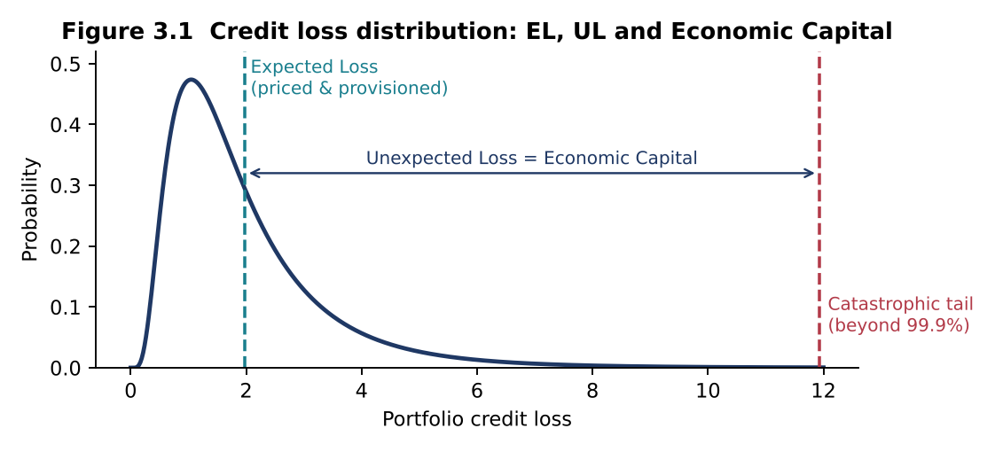
Expected loss is a cost of doing business (priced and provisioned); economic capital covers the unexpected loss up to the chosen confidence level.

6. Real-life examples
Bankers Trust — origin of RAROC (late 1970s). Under Charles Sanford, Bankers Trust developed RAROC to compare businesses with different risk levels and allocate capital accordingly. The framework became the template for economic-capital systems at global banks.
Indian banks — Basel III and ICAAP. RBI requires a minimum total capital ratio of 9% plus a 2.5% capital conservation buffer (11.5%) and an Internal Capital Adequacy Assessment Process. Large banks complement regulatory capital with economic-capital and RAROC models for pricing and allocation.
The low-rate corporate loan dilemma. Highly rated corporates borrow at thin spreads, often close to the cost of funds. On ROA they look unattractive, yet their low PD and capital consumption can deliver above-hurdle RAROC — especially with cash-management, FX and trade-finance cross-sell.
Unsecured retail and MSME lending. Personal loans and unsecured MSME credit carry high yields but also high EL and capital. RBI’s November 2023 increase in risk weights on consumer credit raised capital consumption and pushed banks to re-price these products — a direct RAROC effect.

7. Common mistakes
- Deducting unexpected loss in the numerator — UL is covered by capital, only EL is a cost.
- Comparing pre-tax RAROC with a post-tax hurdle (or vice versa).
- Ignoring the return earned on allocated capital, or double-counting it alongside full funding cost.
- Allocating stand-alone capital without diversification — penalises every business and distorts rankings.
- Using RAROC alone: high RAROC on a tiny capital base may add little absolute value — look at EVA too.

8. Interview questions
Q1. Why is expected loss deducted but unexpected loss used as the denominator?
Model answer: EL is predictable and priced like a cost; UL is uncertain and must be absorbed by capital, so it determines how much capital the activity consumes.
Q2. What is the difference between RAROC and RORAC?
Model answer: Strictly, RAROC risk-adjusts the numerator (deducts EL) while RORAC divides by risk-adjusted capital. In practice banks use “RAROC” for both adjustments.
Q3. How do you set the hurdle rate?
Model answer: Usually the cost of equity from CAPM (risk-free + β × equity risk premium), sometimes with a strategic premium.
Q4. Can a loan with RAROC below hurdle still be approved?
Model answer: Yes, if relationship-level RAROC including fees and cross-sell exceeds the hurdle, or for strategic reasons with explicit Board approval.
Q5. How does collateral affect RAROC?
Model answer: It lowers LGD, which reduces both EL (numerator) and economic capital (denominator) — usually improving RAROC sharply.

Module 3 Cases: Risk-Adjusted Return on Capital (RAROC)

Case 3.1 RAROC of a Corporate Term Loan
Basic RAROC | Accept / reject
BACKGROUND
Vindhya Bank is evaluating a ₹100 crore term loan to a BBB-rated auto-component manufacturer at 9.80%. Assume tax at 25% and a post-tax hurdle rate (cost of equity) of 15% unless stated otherwise. The debt-funded portion of a loan = exposure − economic capital.
DATA
Parameter | Value
Exposure (EAD) | ₹100 crore
Lending rate | 9.80%
Cost of funds | 7.00%
Operating cost | 0.60% of exposure
PD / LGD | 1.50% / 45%
Economic capital | 10% of exposure

REQUIRED
(a) Compute expected loss.
(b) Compute pre-tax and post-tax risk-adjusted profit.
(c) Compute RAROC and EVA.
(d) Should the loan be approved?
FACULTY SOLUTION
EL = 100 × 1.5% × 45% = ₹0.675 crore; Funding cost = (100 − 10) × 7% = ₹6.30 crore
₹ crore | Term loan
Revenue | 9.8000
Less: funding cost | (6.3000)
Less: operating cost | (0.6000)
Less: expected loss | (0.6750)
Risk-adjusted profit (pre-tax) | 2.2250
Less: tax @ 25% | (0.5562)
Risk-adjusted profit (post-tax) | 1.6687
Economic capital | 10.0000
RAROC | 16.69%
EVA = (RAROC − 15%) × EC | 0.1687

RAROC of 16.69% exceeds the 15% hurdle; EVA = ₹0.17 crore. Approve, but the margin of safety is thin — a one-notch rating downgrade (higher PD) could push it below hurdle.
Key answer: RAROC 16.69%; EVA ₹0.17 crore

Case 3.2 Risk-Based Pricing — Minimum Lending Rate
Break-even pricing | Hurdle
BACKGROUND
Using the facts of Case 3.1, the relationship manager has been asked by the client to match a competitor’s offer. The credit committee wants to know the lowest rate at which the loan still meets the hurdle. Assume tax at 25% and a post-tax hurdle rate (cost of equity) of 15% unless stated otherwise. The debt-funded portion of a loan = exposure − economic capital.
DATA
Parameter | Value
As in Case 3.1 | Exposure ₹100 cr, EC ₹10 cr, funding 7%, op cost 0.6%, EL ₹0.675 cr
Competitor offer | 9.40%

REQUIRED
(a) Compute the required post-tax and pre-tax profit to earn exactly 15% RAROC.
(b) Compute the minimum lending rate.
(c) Should the bank match the competitor’s 9.40%?
(d) Recompute the minimum rate if PD rises to 2.50%.
FACULTY SOLUTION
Required post-tax profit = 15% × 10 = ₹1.50 crore; pre-tax = 1.50 / 0.75 = ₹2.00 crore
Required revenue = 2.00 + 6.30 + 0.60 + 0.675 = ₹9.575 crore → minimum rate = 9.575%
With PD 2.50%: EL = ₹1.125 crore → minimum rate = 10.025%
At 9.40% the loan falls below hurdle. The bank should not match unless it secures cross-sell income of at least ₹0.175 crore p.a. (pre-tax) or obtains collateral that lowers LGD and capital.
Key answer: Minimum rate 9.575%

Case 3.3 Large Corporate vs SME — Which Customer Creates More Value?
Comparative RAROC | Yield vs risk
BACKGROUND
The business head wants to prioritise SME lending because it earns a spread of 5% versus 1.6% on large corporates. Assume tax at 25% and a post-tax hurdle rate (cost of equity) of 15% unless stated otherwise. The debt-funded portion of a loan = exposure − economic capital.
DATA
Parameter | Customer A — AAA corporate | Customer B — SME
Exposure | ₹200 crore | ₹50 crore
Lending rate | 8.60% | 12.00%
Cost of funds | 7.00% | 7.00%
Operating cost | 0.30% | 1.20%
PD / LGD | 0.30% / 40% | 3.50% / 55%
Economic capital | 5% of exposure | 12% of exposure

REQUIRED
(a) Compute RAROC for each customer.
(b) Compute EVA for each customer.
(c) Is the business head’s view correct? Explain.
FACULTY SOLUTION
₹ crore | A — AAA corporate | B — SME
Revenue | 17.2000 | 6.0000
Less: funding cost | (13.3000) | (3.0800)
Less: operating cost | (0.6000) | (0.6000)
Less: expected loss | (0.2400) | (0.9625)
Risk-adjusted profit (pre-tax) | 3.0600 | 1.3575
Less: tax @ 25% | (0.7650) | (0.3394)
Risk-adjusted profit (post-tax) | 2.2950 | 1.0181
Economic capital | 10.0000 | 6.0000
RAROC | 22.95% | 16.97%
EVA = (RAROC − 15%) × EC | 0.7950 | 0.1181

Both clear the hurdle, but the AAA corporate delivers a higher RAROC (22.95% vs 16.97%) and over six times the EVA. The SME’s higher spread is largely consumed by expected loss, operating cost and capital. Spread is not profitability; risk-adjusted return is.
Key answer: A 22.95%; B 16.97%

Case 3.4 Economic Capital from a Credit Loss Distribution
Credit VaR | EL vs UL | Regulatory comparison
BACKGROUND
Simulation of Sahyadri Bank’s ₹5,000 crore MSME loan portfolio gives an expected annual loss of ₹60 crore and a 99.9th-percentile loss of ₹420 crore. Portfolio net interest income is ₹240 crore and operating cost ₹90 crore. Risk-weighted assets are 70% of exposure and the regulatory capital requirement is 11.5% of RWA. Assume tax at 25% and a post-tax hurdle rate (cost of equity) of 15% unless stated otherwise. The debt-funded portion of a loan = exposure − economic capital.
DATA
Parameter | ₹ crore
Portfolio exposure | 5,000
Expected loss | 60
99.9% loss quantile | 420
Net interest income | 240
Operating cost | 90

REQUIRED
(a) Compute economic capital.
(b) Compute portfolio RAROC and EVA.
(c) Compute regulatory capital and the return on regulatory capital.
(d) Why can economic and regulatory capital differ?
FACULTY SOLUTION
EC = 420 − 60 = ₹360.00 crore
Post-tax risk-adjusted profit = (240 − 90 − 60) × 0.75 = ₹67.50 crore
RAROC = 67.5 / 360 = 18.75%; EVA = (18.75% − 15%) × 360 = ₹13.50 crore
Regulatory capital = 5,000 × 70% × 11.5% = ₹402.50 crore; return = 67.5 / 402.5 = 16.77%
Economic capital reflects the bank’s own portfolio concentration, correlations and chosen confidence level; regulatory capital uses standardised risk weights that ignore diversification. A bank must hold the higher of the two, so pricing should test both.
Key answer: EC ₹360 cr; RAROC 18.75%

Case 3.5 RAROC for Treasury Trading Desks
Market-risk capital | Desk comparison
BACKGROUND
The treasury head must decide which desk receives additional risk limits. For this case, annual economic capital is approximated as the 1-day 99% VaR scaled by √250. Assume tax at 25% and a post-tax hurdle rate (cost of equity) of 15% unless stated otherwise. The debt-funded portion of a loan = exposure − economic capital.
DATA
Desk | Annual revenue (₹ cr) | Annual cost (₹ cr) | 1-day 99% VaR (₹ cr)
Equity | 18.0 | 9.0 | 2.0
FX | 11.0 | 5.0 | 0.9

REQUIRED
(a) Compute economic capital for each desk.
(b) Compute RAROC and EVA.
(c) Which desk should receive the additional limit?
FACULTY SOLUTION
₹ crore | Equity desk | FX desk
Economic capital (VaR × √250) | 31.62 | 14.23
Pre-tax profit | 9.00 | 6.00
Post-tax profit | 6.75 | 4.50
RAROC | 21.35% | 31.62%
EVA | 2.01 | 2.37

The equity desk earns higher absolute profit, but the FX desk earns a materially higher RAROC and EVA per unit of risk. Additional limits should go to the FX desk, subject to capacity and client-flow constraints.
Key answer: Equity 21.35%; FX 31.62%

Case 3.6 Relationship RAROC with Fee Cross-Sell
Relationship pricing | Fee income
BACKGROUND
A ₹150 crore working-capital facility to a large FMCG distributor is priced at 8.90%. The client also offers cash-management (CMS) fees of ₹1.2 crore and FX conversion income of ₹0.8 crore annually, with incremental servicing cost of ₹0.4 crore and additional operational-risk capital of ₹0.5 crore. Assume tax at 25% and a post-tax hurdle rate (cost of equity) of 15% unless stated otherwise. The debt-funded portion of a loan = exposure − economic capital.
DATA
Parameter | Value
Exposure / rate | ₹150 crore @ 8.90%
Cost of funds / op cost | 7.00% / 0.50%
PD / LGD | 1.00% / 45%
Economic capital | 9% of exposure (₹13.5 crore)
Fees | ₹2.0 crore; servicing cost ₹0.4 crore; extra EC ₹0.5 crore

REQUIRED
(a) Compute the standalone loan RAROC.
(b) Compute the relationship RAROC including fee income.
(c) Recommend a decision.
FACULTY SOLUTION
₹ crore | Loan only | Full relationship
Revenue | 13.3500 | 15.3500
Less: funding cost | (9.5550) | (9.5550)
Less: operating cost | (0.7500) | (1.1500)
Less: expected loss | (0.6750) | (0.6750)
Risk-adjusted profit (pre-tax) | 2.3700 | 3.9700
Less: tax @ 25% | (0.5925) | (0.9925)
Risk-adjusted profit (post-tax) | 1.7775 | 2.9775
Economic capital | 13.5000 | 14.0000
RAROC | 13.17% | 21.27%
EVA = (RAROC − 15%) × EC | -0.2475 | 0.8775

Standalone the loan destroys value (13.17% < 15%), but the relationship earns 21.27%. Approve on a relationship basis, with a covenant/MIS to track that CMS and FX volumes actually materialise — otherwise re-price at renewal.
Key answer: Loan 13.17%; relationship 21.27%

Case 3.7 Capital Allocation with Diversification
Group EC | Diversification | Graph
BACKGROUND
A bank’s three business units have stand-alone economic capital totalling ₹1,300 crore, but group-level EC after diversification is only ₹1,000 crore. The CFO proposes allocating the diversification benefit pro-rata to stand-alone capital.
DATA
Business unit | Stand-alone EC (₹ cr) | Post-tax risk-adjusted profit (₹ cr)
Retail Banking | 400 | 70
Corporate Banking | 600 | 85
Treasury | 300 | 50
Group (diversified) | 1,000 | 205

REQUIRED
(a) Compute stand-alone RAROC for each unit.
(b) Allocate group EC pro-rata and compute diversified RAROC.
(c) Graph task: plot stand-alone vs diversified RAROC against the 15% hurdle.
(d) Which unit’s decision changes, and what allocation method is theoretically better?
FACULTY SOLUTION
Business unit | Stand-alone EC | RAROC (stand-alone) | Allocated EC | RAROC (diversified)
Retail Banking | 400 | 17.50% | 307.7 | 22.75%
Corporate Banking | 600 | 14.17% | 461.5 | 18.42%
Treasury | 300 | 16.67% | 230.8 | 21.67%

Allocation factor = 1,000 / 1,300 = 0.7692. Corporate Banking moves from below hurdle (14.17%) to above hurdle (18.42%). Group RAROC = 205/1,000 = 20.5%.
Pro-rata allocation is simple but ignores how much each unit actually contributes to group risk. Marginal or Euler (risk-contribution) allocation is theoretically superior — units that diversify the group receive more of the benefit.
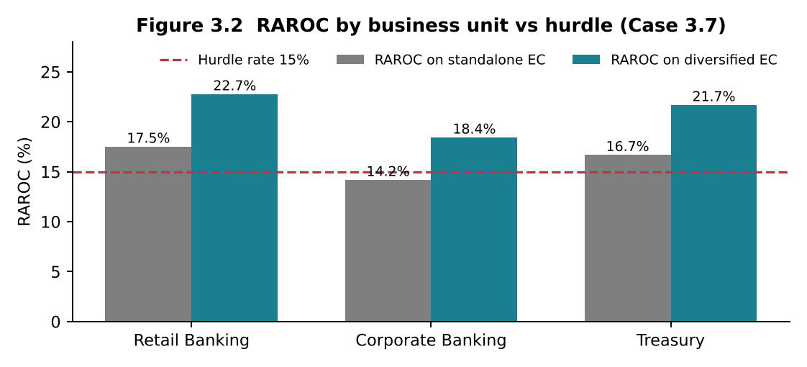
Solution graph: RAROC by business unit vs hurdle.
Key answer: Corporate: 14.17% → 18.42% (crosses hurdle)

Case 3.8 Impact of Collateral on RAROC
LGD | Credit risk mitigation
BACKGROUND
A ₹80 crore loan to a hotel chain can be structured unsecured at 11.00% or secured by property at 10.40%. Security reduces LGD and capital but adds valuation, legal and monitoring cost. Cost of funds is 7.00%. Assume tax at 25% and a post-tax hurdle rate (cost of equity) of 15% unless stated otherwise. The debt-funded portion of a loan = exposure − economic capital.
DATA
Parameter | Unsecured | Secured
Lending rate | 11.00% | 10.40%
Operating cost | 0.50% | 0.70%
PD | 2.00% | 2.00%
LGD | 60% | 25%
Economic capital | 12% (₹9.6 cr) | 6% (₹4.8 cr)

REQUIRED
(a) Compute RAROC and EVA for both structures.
(b) Which structure should the bank prefer and why?
(c) Identify two risks that could erode the collateral benefit.
FACULTY SOLUTION
₹ crore | Unsecured | Secured
Revenue | 8.8000 | 8.3200
Less: funding cost | (4.9280) | (5.2640)
Less: operating cost | (0.4000) | (0.5600)
Less: expected loss | (0.9600) | (0.4000)
Risk-adjusted profit (pre-tax) | 2.5120 | 2.0960
Less: tax @ 25% | (0.6280) | (0.5240)
Risk-adjusted profit (post-tax) | 1.8840 | 1.5720
Economic capital | 9.6000 | 4.8000
RAROC | 19.62% | 32.75%
EVA = (RAROC − 15%) × EC | 0.4440 | 0.8520

Despite a 60 bps lower rate, the secured structure nearly doubles EVA (₹0.85 crore vs ₹0.44 crore) and lifts RAROC to 32.75%, because lower LGD reduces both EL and capital.
- Collateral value volatility (hospitality real estate is cyclical) and wrong-way risk — property values fall when the borrower is stressed.
- Legal enforceability and time to recovery under SARFAESI / IBC; slow recovery raises effective LGD.
Key answer: Unsecured 19.62%; Secured 32.75%

MODULE 4

Regression & Variance Analysis

1. What is it?
Regression analysis estimates the relationship between a dependent variable (Y) and one or more explanatory variables (X). Ordinary Least Squares (OLS) fits the line that minimises the sum of squared residuals. Variance analysis measures and decomposes dispersion — how much a return, cost or portfolio value varies, and which sources drive that variation. Together they answer: How sensitive is Y to X? How much of the risk is explained? What remains unexplained?

2. Why is it important?
- Beta, hedge ratios, factor exposures and stress-test models are all regression outputs.
- Variance (σ²) is the core input to VaR, portfolio optimisation and risk budgeting.
- R² and the ANOVA decomposition show how much risk is systematic (hedgeable) versus idiosyncratic (diversifiable).
- Cost-behaviour regression supports flexible budgets and budget-vs-actual variance analysis in FP&A.

3. How is it used in industry?
- Equity research and fund management — beta estimation, factor models (Fama–French), performance attribution.
- Banks’ risk and stress testing — regressing NPAs on GDP growth and interest rates; the RBI’s Financial Stability Report uses macro-stress-test models of this type.
- Corporate treasury and commodities — minimum-variance hedge ratios for fuel, metals and currencies.
- FP&A and cost accounting — separating fixed and variable costs, building flexible budgets and explaining variances.
KEY APPROACHES / BUILDING BLOCKS
Regression output | Meaning | Rule of thumb
Coefficient (β) | Change in Y for a one-unit change in X | Sign and size matter
Standard error / t-stat | t = coefficient / SE | |t| > ~2 → significant at 5%
p-value | Probability of a coefficient this large if the true value is zero | p < 0.05 → reject H₀
R² / Adjusted R² | Share of variance of Y explained | Adjusted R² penalises extra variables
F-statistic | Joint significance of all regressors | Compare with F-critical
Residual diagnostics | Heteroskedasticity, autocorrelation, multicollinearity | Invalidate standard errors if ignored

4. Key formulas
Measure | Formula
Simple regression slope | β = Cov(X, Y) / Var(X) α = Ȳ − β·X̄
Coefficient of determination | R² = SSR/SST = 1 − SSE/SST (simple regression: R² = ρ²)
Adjusted R² | R̄² = 1 − (1 − R²)(n − 1)/(n − k − 1)
F-statistic | F = (SSR/k) / (SSE/(n − k − 1))
Sample variance | s² = Σ(xᵢ − x̄)² / (n − 1) Annualised σ = σ_monthly × √12
Portfolio variance | σₚ² = wᵀ Σ w = Σᵢ Σⱼ wᵢ wⱼ σᵢ σⱼ ρᵢⱼ
Variance decomposition | σᵢ² = βᵢ² σₘ² + σ²(ε)
Minimum-variance hedge ratio | h* = ρ × σ_S / σ_F; hedge effectiveness = ρ²

5. Graphical illustration
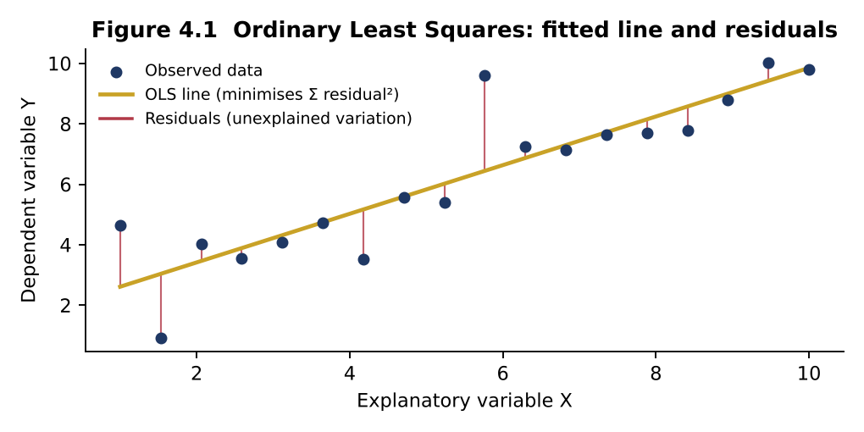
OLS picks the line that minimises the sum of squared vertical distances (residuals); the residual variance is the unexplained risk.

6. Real-life examples
CAPM beta and cost of equity. Analysts regress a stock’s returns on Nifty 50 or Sensex returns (typically 2–5 years of weekly or monthly data) to estimate beta, which feeds the cost of equity in DCF valuations and the hurdle rate in RAROC.
Airline fuel hedging. Jet fuel has no deep futures market in most regions, so airlines cross-hedge with crude oil futures sized by the minimum-variance hedge ratio. Southwest Airlines’ systematic fuel-hedging programme is widely cited for saving it billions of dollars during the 2000s oil price spike.
Macro stress testing of bank NPAs. Regulators and banks estimate regressions of gross NPA ratios on GDP growth, interest rates and credit growth, then feed in baseline, medium and severe macro scenarios — the approach behind the stress-test projections in the RBI’s Financial Stability Report.
Markowitz portfolio theory and risk budgeting. Harry Markowitz (1952) showed that portfolio variance depends on covariances, not just individual variances. Pension funds and multi-asset funds today run risk-budgeting frameworks that decompose total variance into each asset’s contribution.

7. Common mistakes
- Confusing correlation with causation; spurious regressions on trending (non-stationary) series such as price levels instead of returns.
- Using population variance (÷n) where sample variance (÷n−1) is required.
- Judging a model only by R²; a high R² with insignificant coefficients often signals multicollinearity.
- Extrapolating far outside the observed range of X.
- Ignoring heteroskedasticity and autocorrelation, which make t-statistics unreliable (use robust/Newey–West SEs).

8. Interview questions
Q1. What is the relationship between beta, correlation and volatility?
Model answer: β = ρ × σ_stock / σ_market. A stock can have low correlation but high beta if it is very volatile.
Q2. What does an R² of 0.30 for a stock-on-index regression mean?
Model answer: 30% of the stock’s return variance is explained by the market (systematic); 70% is stock-specific and diversifiable.
Q3. Why use adjusted R²?
Model answer: R² never falls when variables are added; adjusted R² penalises additional regressors that do not improve explanatory power.
Q4. What is multicollinearity and how do you detect it?
Model answer: High correlation among explanatory variables; detected by VIF > 5–10 or significant F with insignificant individual t-stats.
Q5. How is the minimum-variance hedge ratio derived?
Model answer: It is the slope from regressing spot price changes on futures price changes: h* = Cov(ΔS, ΔF)/Var(ΔF) = ρσ_S/σ_F.

Module 4 Cases: Regression & Variance Analysis

Case 4.1 Estimating Stock Beta by OLS Regression
Simple regression | Beta | R² | Graph
BACKGROUND
An equity research analyst covering a listed capital-goods company must estimate its beta for a DCF valuation. Monthly returns for the stock and the Nifty 50 for the last 12 months are given below. (Data are illustrative; in practice use 36–60 months.)
DATA
Month | M1 | M2 | M3 | M4 | M5 | M6 | M7 | M8 | M9 | M10 | M11 | M12
Nifty (%) | 2.1 | -1.5 | 3.4 | 0.8 | -2.7 | 1.9 | 4.2 | -0.6 | 1.1 | -3.3 | 2.6 | 0.5
Stock (%) | 3.6 | -1.2 | 3.5 | 1.9 | -2.6 | 1.4 | 6.3 | 0.4 | 0.2 | -5.3 | 4.4 | -0.8

REQUIRED
(a) Compute mean returns, the covariance of the stock with Nifty and the variance of Nifty (sample).
(b) Estimate beta and alpha. Verify with Excel’s SLOPE, INTERCEPT and RSQ.
(c) Compute R² and interpret it.
(d) Graph task: draw a scatter plot with the fitted regression line (characteristic line).
(e) Predict the stock’s return in a month when Nifty falls 5%.
FACULTY SOLUTION
Mean Nifty = 0.7083%; Mean stock = 0.9833%
Cov(stock, Nifty) = 7.1883; Var(Nifty) = 5.5317
β = 7.1883 / 5.5317 = 1.2995; α = 0.9833 − 1.2995 × 0.7083 = 0.0629% per month
R² = 0.8907 (correlation = 0.9438); t-stat of β = 9.03
Beta of 1.30 means the stock tends to move 1.30% for every 1% move in Nifty — an aggressive, cyclical stock, consistent with capital goods. About 89% of return variance is market-driven. The small positive alpha is not economically or statistically meaningful on 12 observations.
Predicted return = 0.0629 + 1.2995 × (−5) = -6.43%
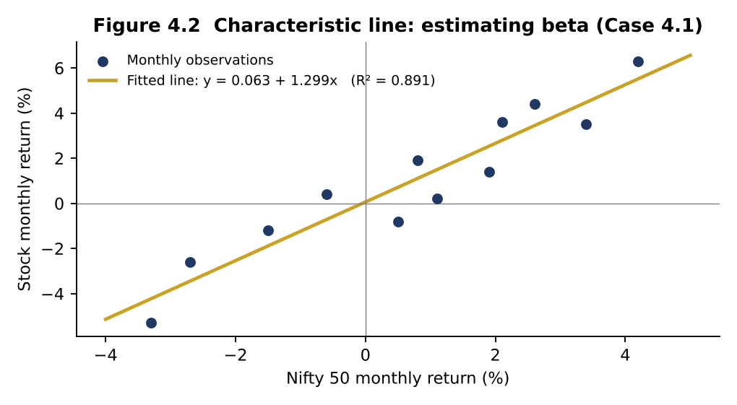
Solution graph: characteristic line.
Key answer: β 1.299; α 0.063%; R² 0.891

Case 4.2 Interpreting a Multiple Regression — NPA Stress Model
Multiple regression | t-test | Forecasting
BACKGROUND
The risk team of a public sector bank regressed its quarterly gross NPA ratio (%) on three macro variables using 40 quarters of data. The output is below. The CRO must present a baseline and a stress forecast to the Board.
DATA
Variable | Coefficient | Std. error
Intercept | 5.20 | 1.12
Real GDP growth (%) | -0.62 | 0.14
Repo rate (%) | 0.45 | 0.21
Credit growth, lagged 4Q (%) | 0.08 | 0.06
R² = 0.71; n = 40

REQUIRED
(a) Compute the t-statistic for each coefficient and identify which are significant at 5% (t-critical ≈ 2.03 for 36 df).
(b) Compute adjusted R² and the F-statistic.
(c) Interpret the GDP-growth and repo-rate coefficients in business terms.
(d) Forecast the GNPA ratio for a baseline (GDP 6.5%, repo 6.0%, credit growth 14%) and a stress scenario (GDP 3.0%, repo 7.0%, credit growth 14%).
(e) Should the credit-growth variable be retained? Discuss.
FACULTY SOLUTION
Variable | Coefficient | SE | t-stat | p-value | Significant at 5%?
Intercept | 5.20 | 1.12 | 4.64 | 0.0000 | Yes
Real GDP growth (%) | -0.62 | 0.14 | -4.43 | 0.0001 | Yes
Repo rate (%) | 0.45 | 0.21 | 2.14 | 0.0390 | Yes
Credit growth, lagged 4Q (%) | 0.08 | 0.06 | 1.33 | 0.1908 | No

Adjusted R² = 1 − (1 − 0.71) × 39/36 = 0.6858
F = (0.71/3) / (0.29/36) = 29.38 (p ≈ 8.8e-10) → model jointly significant
Each 1 pp fall in real GDP growth raises the GNPA ratio by 0.62 pp; each 1 pp rise in the repo rate adds 0.45 pp through higher debt-servicing burden.
Baseline = 5.20 − 0.62(6.5) + 0.45(6.0) + 0.08(14) = 4.99%
Stress = 5.20 − 0.62(3.0) + 0.45(7.0) + 0.08(14) = 7.61% (+2.62 pp)
Credit growth is insignificant (t = 1.33, p ≈ 0.19). It may still be retained on economic grounds (rapid credit growth historically precedes NPAs with a lag) if theory supports it, but the team should test alternative lags and check for multicollinearity with GDP growth.
Key answer: Baseline 4.99%; stress 7.61%

Case 4.3 Minimum-Variance Hedge Ratio for an Airline
Cross-hedging | Hedge ratio | Effectiveness
BACKGROUND
An Indian airline expects to purchase jet fuel equivalent to 2 million barrels over the next quarter. It will cross-hedge using Brent crude futures (contract size 1,000 barrels). A regression of monthly jet-fuel price changes on Brent futures price changes gives the statistics below.
DATA
Statistic | Value
σ of jet-fuel price changes (σ_S) | 6.0%
σ of Brent futures price changes (σ_F) | 7.5%
Correlation (ρ) | 0.82
Exposure | 2,000,000 barrels
Contract size | 1,000 barrels

REQUIRED
(a) Compute the minimum-variance hedge ratio.
(b) Compute the number of futures contracts to buy.
(c) Compute hedge effectiveness and the residual risk (σ) of the hedged position.
(d) Compare with a naïve 1:1 hedge.
FACULTY SOLUTION
h* = 0.82 × 6.0% / 7.5% = 0.656
Contracts = 0.656 × 2,000,000 / 1,000 = 1,312 (buy)
Hedge effectiveness = ρ² = 67.24%; residual σ = 6.0% × √(1 − 0.82²) = 3.43%
Naïve hedge (2,000 contracts): σ = √(6.0² + 7.5² − 2 × 0.82 × 6.0 × 7.5) = 4.30%
The naïve hedge over-hedges because Brent is more volatile than jet fuel; residual risk (4.30%) is higher than with the optimal hedge (3.43%). About 33% of variance remains as basis risk (crack-spread, INR/USD and pass-through effects).
Key answer: h* 0.656; 1,312 contracts; effectiveness 67.2%

Case 4.4 Portfolio Variance and Risk Contribution
Covariance matrix | Risk budgeting
BACKGROUND
A wealth manager’s model portfolio is 50% equity, 30% debt and 20% gold. Annual volatilities and correlations are given. The client assumes equity is “half the risk” because it is half the money.
DATA
Asset | Weight | Annual σ | ρ with Equity | ρ with Debt | ρ with Gold
Equity | 50% | 18% | 1.00 | 0.10 | −0.15
Debt | 30% | 6% | 0.10 | 1.00 | 0.20
Gold | 20% | 14% | −0.15 | 0.20 | 1.00

REQUIRED
(a) Build the covariance matrix.
(b) Compute portfolio variance and standard deviation (use MMULT in Excel).
(c) Compute each asset’s contribution to portfolio risk (% of total).
(d) Is the client’s assumption correct?
FACULTY SOLUTION
Covariance | Equity | Debt | Gold
Equity | 0.03240 | 0.00108 | -0.00378
Debt | 0.00108 | 0.00360 | 0.00168
Gold | -0.00378 | 0.00168 | 0.01960

σₚ² = wᵀΣw = 0.008978; σₚ = 9.48% (vs weighted-average σ of 13.6% → diversification)
Asset | Weight | Marginal contribution (Σw)ᵢ/σₚ | Risk contribution wᵢ × MC | % of portfolio risk
Equity | 50% | 16.64% | 8.32% | 87.8%
Debt | 30% | 2.06% | 0.62% | 6.5%
Gold | 20% | 2.67% | 0.53% | 5.6%

Equity is 50% of capital but about 88% of risk. Debt and gold together contribute only ~12%. Capital allocation is not risk allocation — the basis of risk-parity strategies.
Key answer: σₚ 9.48%; equity = 87.8% of risk

Case 4.5 Systematic vs Idiosyncratic Variance
Variance decomposition | Diversification | Graph
BACKGROUND
The Nifty 50 has an annual volatility of 15%. Stock X has beta 1.30 and total volatility 28%. A diversified large-cap fund has beta 0.95 and total volatility 15.2%.
DATA
Item | Beta | Total σ
Market (Nifty 50) | 1.00 | 15.0%
Stock X | 1.30 | 28.0%
Diversified fund | 0.95 | 15.2%

REQUIRED
(a) Decompose total variance of Stock X and the fund into systematic and idiosyncratic components.
(b) Compute the share of systematic variance (equivalent to R² of the market model).
(c) Graph task: show the decomposition as a stacked bar chart.
(d) Which component is rewarded by the market under CAPM and why?
FACULTY SOLUTION
Item | Total variance | Systematic β²σₘ² | Idiosyncratic | Idiosyncratic σ | Systematic share (R²)
Stock X | 0.078400 | 0.038025 | 0.040375 | 20.09% | 48.5%
Diversified fund | 0.023104 | 0.020306 | 0.002798 | 5.29% | 87.9%

Only systematic risk is rewarded under CAPM, because idiosyncratic risk can be diversified away at no cost. Stock X carries roughly half its variance as diversifiable risk; the diversified fund has eliminated most of it.
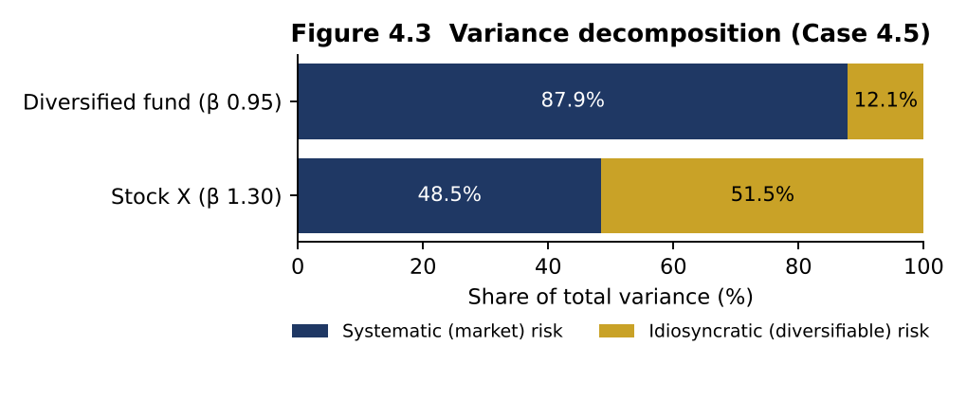
Solution graph: variance decomposition.
Key answer: Stock X systematic 48.5%; fund 87.9%

Case 4.6 Variance, Volatility and Risk-Adjusted Performance of Two Funds
Sample variance | Annualisation | Sharpe ratio
BACKGROUND
A distributor must recommend one of two equity funds to a conservative client. Monthly returns for the last 12 months are given. The annual risk-free rate is 6.5%.
DATA
Month | M1 | M2 | M3 | M4 | M5 | M6 | M7 | M8 | M9 | M10 | M11 | M12
Fund A (%) | 1.8 | 2.2 | -0.9 | 1.5 | 2.6 | -1.2 | 1.9 | 0.7 | 2.4 | -0.5 | 1.6 | 1.1
Fund B (%) | 3.5 | -2.8 | 4.9 | 1.2 | -3.6 | 5.2 | 2.1 | -1.9 | 4.4 | -2.2 | 3.8 | 0.6

REQUIRED
(a) Compute the mean monthly return, sample variance and standard deviation of each fund (VAR.S / STDEV.S).
(b) Annualise return (×12) and volatility (×√12).
(c) Compute the Sharpe ratio and coefficient of variation.
(d) Which fund suits the client? Justify.
FACULTY SOLUTION
Measure | Fund A | Fund B
Mean monthly return | 1.1000% | 1.2667%
Sample variance | 1.7000 | 10.3006
Monthly σ | 1.3038% | 3.2095%
Annualised return | 13.20% | 15.20%
Annualised σ | 4.52% | 11.12%
Sharpe ratio | 1.483 | 0.783
Coefficient of variation | 1.185 | 2.534

Fund B has a higher raw return but more than double the volatility; Fund A delivers almost twice the return per unit of risk. For a conservative client, Fund A. Caveat: 12 months is too short a sample — use 3–5 years and check downside measures (Sortino, maximum drawdown).
Key answer: Sharpe A 1.48 vs B 0.78

Case 4.7 Regression-Based Flexible Budget and Cost Variance Analysis
Cost behaviour | Flexible budget | FP&A | Graph
BACKGROUND
The FP&A team of a manufacturing plant uses regression to separate the fixed and variable elements of power cost. Eight months of data are below. For Month 9, the budget assumed 17,000 machine hours; actual activity was 19,000 hours and actual power cost was ₹13.90 lakh.
DATA
Month | M1 | M2 | M3 | M4 | M5 | M6 | M7 | M8
Machine hours ('000) | 12 | 15 | 10 | 18 | 14 | 20 | 16 | 11
Power cost (₹ lakh) | 9.8 | 11.6 | 8.7 | 12.4 | 11.2 | 13.9 | 11.5 | 9.6

REQUIRED
(a) Estimate the cost function (fixed cost + variable cost per '000 hours) and R².
(b) Graph task: plot the data with the fitted cost line and mark the Month 9 actual.
(c) Compute the static budget cost, flexible budget cost and actual cost for Month 9.
(d) Compute the volume variance and spending variance, and label each Favourable/Adverse.
(e) What should management investigate?
FACULTY SOLUTION
Cost = 4.1741 + 0.4768 × MH('000) (R² = 0.9718)
Fixed cost ≈ ₹4.17 lakh per month; variable cost ≈ ₹47.68 per machine hour
Item | ₹ lakh
Static budget (17,000 hrs) | 12.2795
Flexible budget (19,000 hrs) | 13.2330
Actual cost | 13.9000
Volume variance (flexible − static) | 0.9536 (A — higher activity)
Spending variance (actual − flexible) | 0.6670 (A)
Total variance (actual − static) | 1.6205 (A)

Most of the overrun is explained by higher activity, which is not a cost-control failure. The genuine spending overrun of ₹0.67 lakh (5.0% of flexible budget) warrants investigation: tariff revisions, peak-hour consumption, machine inefficiency or idle running.
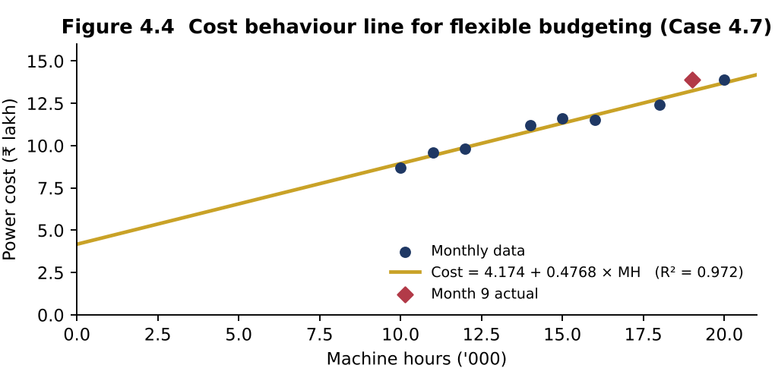
Solution graph: cost behaviour line.
Key answer: Cost = 4.17 + 0.477×MH; spending var ₹0.67 lakh (A)

Case 4.8 ANOVA Table and Goodness of Fit
ANOVA | F-test | Adjusted R²
BACKGROUND
A credit analyst built a regression explaining a corporate bond spread (bps) using leverage and interest coverage for 60 issuers. The software output was partially lost; only the totals below survived.
DATA
Item | Value
Observations (n) | 60
Explanatory variables (k) | 2
Total sum of squares (SST) | 450.0
Regression sum of squares (SSR) | 315.0

REQUIRED
(a) Reconstruct the full ANOVA table (SS, df, MS, F).
(b) Compute R², adjusted R² and the standard error of the regression.
(c) Test the overall significance of the model at 5% (F-critical ≈ 3.16).
(d) List three diagnostic checks before using the model for pricing.
FACULTY SOLUTION
Source | SS | df | MS | F
Regression | 315.0 | 2 | 157.5000 | 66.50
Residual | 135.0 | 57 | 2.3684
Total | 450.0 | 59

R² = 315/450 = 0.7000; Adjusted R² = 1 − (135/57)/(450/59) = 0.6895; SER = √2.3684 = 1.5390
F = 66.50 > 3.16 → reject H₀ that both slopes are zero; the model is jointly significant and explains 70% of the variation in spreads.
- Multicollinearity — leverage and interest coverage are naturally correlated (check VIF).
- Heteroskedasticity — spread variance is usually larger for weaker credits (Breusch–Pagan / White test; use robust SEs).
- Outliers and influential observations (Cook’s distance), plus out-of-sample validation.
Key answer: F 66.50; R² 0.70; adj R² 0.689

Appendix A — Formula Sheet & Excel Functions
STANDARD NORMAL CRITICAL VALUES (ONE-TAILED)
Confidence | 90% | 95% | 97.5% | 99% | 99.9%
z | 1.282 | 1.645 | 1.960 | 2.326 | 3.090

EXCEL FUNCTIONS USED IN THIS WORKBOOK
Function | Purpose | Example
NORM.S.INV(p) | z-value for a confidence level | =NORM.S.INV(0.99) → 2.326
PERCENTILE.EXC / SMALL | Historical VaR from a return series | =-PERCENTILE.EXC(Returns, 0.01)
BINOM.DIST | Backtesting exception probability | =1-BINOM.DIST(7,250,0.01,TRUE)
PRICE / MDURATION / DURATION | Bond price and duration | =MDURATION(settle, mat, 7.5%, 8%, 1)
NORM.S.DIST | N(d₁), N(d₂) in Black–Scholes | =NORM.S.DIST(d1, TRUE)
SLOPE / INTERCEPT / RSQ | Simple regression: beta, alpha, R² | =SLOPE(Stock, Nifty)
LINEST (dynamic array) | Full regression statistics | =LINEST(Y, X, TRUE, TRUE)
VAR.S / STDEV.S / COVARIANCE.S | Sample variance, σ and covariance | =STDEV.S(Returns)*SQRT(12)
MMULT / TRANSPOSE | Portfolio variance wᵀΣw | =MMULT(TRANSPOSE(w), MMULT(Cov, w))

RECOMMENDED READING
- Philippe Jorion — *Value at Risk: The New Benchmark for Managing Financial Risk*.
- John C. Hull — *Risk Management and Financial Institutions* and *Options, Futures, and Other Derivatives*.
- Frank J. Fabozzi — *Bond Markets, Analysis and Strategies*.
- Basel Committee on Banking Supervision — *Minimum capital requirements for market risk* (FRTB, January 2019).
- Reserve Bank of India — Master Circular on Basel III Capital Regulations; Financial Stability Report (half-yearly).
- GARP — FRM Part I (Quantitative Analysis, Valuation & Risk Models) and Part II (Market Risk, Credit Risk) readings.

Appendix B — Answer Key (Faculty Only)
Case | Title | Key answer
1.1 | Parametric VaR for an Equity ETF Portfolio | 95%: ₹0.99 crore; 99%: ₹1.40 crore; 10-day 99%: ₹4.41 crore
1.2 | Diversification Benefit in a Two-Asset Portfolio | Diversified VaR ₹2.05 crore; benefit ₹0.74 crore
1.3 | Historical Simulation VaR and Expected Shortfall | Hist VaR ₹3.53 crore; ES99 ₹4.33 crore; Parametric ₹2.79 crore
1.4 | VaR Backtesting and the Basel Traffic-Light Test | Expected 2.5; P(≥8) 0.40%; yellow zone, k = 3.75; capital ₹56.25 crore
1.5 | Interest-Rate VaR on a Government Securities Portfolio | PV01 ₹13 lakh; VaR 1-day ₹1.81 crore; 10-day ₹5.74 crore
1.6 | FX VaR for an Importer’s USD Payable | 10-day VaR ₹1.53 crore; after 70% hedge ₹0.46 crore
1.7 | VaR versus Expected Shortfall under FRTB | ES97.5 ₹3.51 crore ≈ VaR99 ₹3.49 crore
1.8 | Market Risk Capital with VaR and Stressed VaR (Basel 2.5) | Capital ₹90.00 crore (m=3); ₹105.00 crore (m=3.5)
2.1 | Duration of a Corporate Bond | Price ₹98.00; MacD 4.342; ModD 4.020
2.2 | Convexity Adjustment for Large Rate Shocks | ModD 6.959; Convexity 64.02
2.3 | PV01 Hedging with Interest Rate Futures | DV01 ₹26,00,000; sell 20,000 contracts
2.4 | Beta Hedging an Equity Portfolio with Nifty Futures | 170 contracts (β→0); 88 (β→0.6)
2.5 | Option Greeks using Black–Scholes | Call ₹86.86; Δ 0.576; Γ 0.0021
2.6 | Delta–Gamma Neutral Hedging of an Options Book | Buy 35,000 Option B + 13,500 shares
2.7 | Duration Gap Analysis — An SVB-Style Stress | DGAP 3.396; ΔE ₹-634.77 crore (-79.3%)
2.8 | Effective Duration and Negative Convexity of a Callable Bond | ED 2.778; EC -79.4 (negative)
3.1 | RAROC of a Corporate Term Loan | RAROC 16.69%; EVA ₹0.17 crore
3.2 | Risk-Based Pricing — Minimum Lending Rate | Minimum rate 9.575%
3.3 | Large Corporate vs SME — Which Customer Creates More Value? | A 22.95%; B 16.97%
3.4 | Economic Capital from a Credit Loss Distribution | EC ₹360 cr; RAROC 18.75%
3.5 | RAROC for Treasury Trading Desks | Equity 21.35%; FX 31.62%
3.6 | Relationship RAROC with Fee Cross-Sell | Loan 13.17%; relationship 21.27%
3.7 | Capital Allocation with Diversification | Corporate: 14.17% → 18.42% (crosses hurdle)
3.8 | Impact of Collateral on RAROC | Unsecured 19.62%; Secured 32.75%
4.1 | Estimating Stock Beta by OLS Regression | β 1.299; α 0.063%; R² 0.891
4.2 | Interpreting a Multiple Regression — NPA Stress Model | Baseline 4.99%; stress 7.61%
4.3 | Minimum-Variance Hedge Ratio for an Airline | h* 0.656; 1,312 contracts; effectiveness 67.2%
4.4 | Portfolio Variance and Risk Contribution | σₚ 9.48%; equity = 87.8% of risk
4.5 | Systematic vs Idiosyncratic Variance | Stock X systematic 48.5%; fund 87.9%
4.6 | Variance, Volatility and Risk-Adjusted Performance of Two Funds | Sharpe A 1.48 vs B 0.78
4.7 | Regression-Based Flexible Budget and Cost Variance Analysis | Cost = 4.17 + 0.477×MH; spending var ₹0.67 lakh (A)
4.8 | ANOVA Table and Goodness of Fit | F 66.50; R² 0.70; adj R² 0.689

ASSESSMENT RUBRIC (SUGGESTED, PER CASE)
Criterion | Weight | What good looks like
Correct computation | 40% | Right formula, correct inputs, units and signs
Method & workings | 20% | Steps shown clearly; Excel model linked, no hard-coding
Interpretation | 25% | Business meaning explained in plain language for a Board / client
Limitations & judgement | 15% | Identifies model assumptions, risks and next steps

