CS 319 UI/UX Design and Development
Module 3 Paper Prototype Milestone
Sean Fitzpatrick
1/21/2026

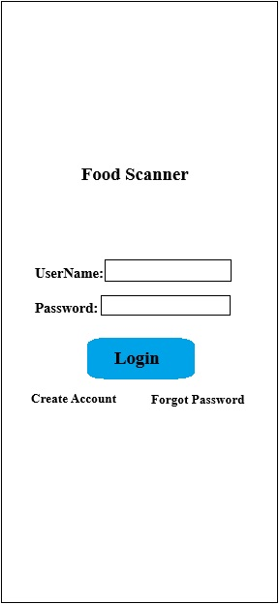
Using the Paint program in Windows, a paper prototype was designed and printed to be tested by potential users. The screens for the primary function of the application were created, with an ‘under construction’ screen added for options that have not yet been implemented in the design process.
Screen 1: Login
Users will be able to create an account with the service and save personal preferences within the application. They will be able to favorite specific products, save their relevant health information and any other personal information that can be used by the application when searching for healthier food alternatives.
The screen consists of the application logo (shown in the image as ‘Food Scanner’), two text boxes for entering a unique username and password combination, a login button to execute the login process, and links to create an account or reset a password if the user forgot it.
Once the user has an account, they will be able to enter their username and password combination and press the login button to be taken to their personalized Meal Tracker screen. This will require a connection to a database to store relevant information (user data, saved preferences, health information, favorited food products or grocery stores, et cetera).
Screen 2: Meal Tracker
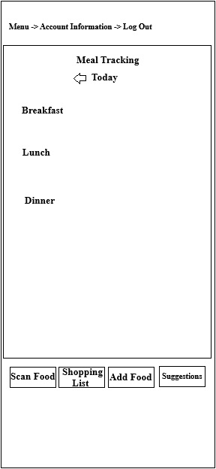
This screen is the primary focus of the application. It provides a method of tracking a user’s caloric intake throughout the day, enabling them to track their eating habits and help them maintain a healthier diet.
The screen consists of a general menu at the top. This will be an overlay that is hidden until the user presses the menu button. Menu options will include, but are not limited to, viewing/editing account and profile information, personal application preferences (font sizes, image usage) and the ability to exit or log out of the application. The main window of the tracker will show the current day’s information, with an arrow that can take the user back to a previous day to view or edit an entry. The window will be divided into daily meal periods (breakfast, lunch, dinner) with a running count of tracked calories displayed on the screen. It will show total calories allowed for the day and how many have been consumed so far as well as how many are available for the rest of the day.
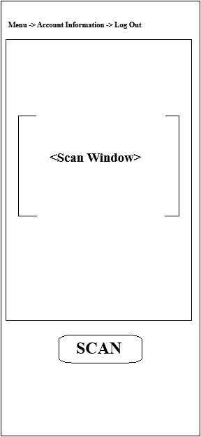
Beneath the tracking window are four buttons. In this early design phase, they are labeled as features that are or will be available at some point during development. They are labeled as Scan Food, Shopping List, Add Food, and Suggestions. When pressed, the Scan Food button will take the user to the actual product scanning screen. The Shopping List will allow the user to either import/upload or create a shopping list of products/brands they wish to buy. The Add Food button will allow a user to manually add a food product or set of ingredients to the meal tracker. Finally, the Suggestions button will take the user to a screen that will have a list of suggested products or recipes that have been compiled based on the user’s preferences and previously scanned products. All these features will require access to a database of food products that can be accessed by barcode scan or search.
Screen 3: Scan Food
The scanner screen is a very simple screen that will allow the user to scan a product barcode and find the nutritional information for. The same menu from the Meal Tracker screen is carried over to this screen with the same options. Beneath that menu is the main scanner window. This window utilizes the mobile device’s onboard camera. The viewport has a bracketed area that will be the placement area for the product barcode. Once a barcode is within the brackets, the user can press the scan button, located below the window, and scan the product. This will then take the user to the Results screen.

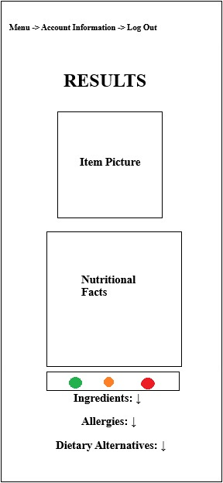
Screen 4: Results
The Results screen will be loaded directly from the Scanning screen when a product barcode is scanned. It will display the nutritional information about the product, including the calories, serving size, and other facts broken down in the standardized white box of information on the packages.
Once again, the menu from the previous screens is carried over. A picture of the product will be displayed at the top of the screen allowing the user to confirm that the scanned product matches the results. Beneath the picture will be the nutritional facts displayed in the standardized white boxes on most packages. Information such as calories and serving size, as well as portioning of key nutrients and minerals (sodium, potassium, magnesium, et cetera) will be showcased. Beneath the information will be the color-coded nutritional rating of the product. The exact design and detail of this display have not been decided on, however it will include the color-coding system of Green is good, Orange is neutral, Red is bad and should only be included in a diet sparingly.
Beneath the rating will be the more detailed ingredients section. It will be a section that can be hidden or shown by pressing the small chevron/arrow next to the header. The ingredients list will be displayed in a way that is easy to read and not crammed together like it can be on food packaging.
Two more headers will be included to provide further information for the user. They can also be hidden or shown by pressing the chevron next to the header label. The information provided will be regarding Allergies and Dietary Alternatives. If a product contains any ingredients that are connected to known allergies, this section will show that information. If a user has previously input that they have a specific food allergy, such as a nut allergy, and a scanned product contains nuts, the allergy would not only be listed in the section but also highlighted in red to bring attention to it. As for Dietary Alternatives, if a user has previously input that they are following a specific and known diet plan, the application may suggest an alternative product that is like the one scanned but is more suitable for the chosen diet plan.
Realizations:
It was noted that several obvious features were not included in the design of the initial paper prototype for the application. These included a color scheme as well as navigation buttons to return to previous screens from other screens. Another item that had not been included on the results screen was an option to add the item to the meal tracker or a button to compare the scanned item to application suggested alternatives. These will be included in any future design iterations.
While a full color scheme was not implemented in this iteration, user feedback made it clear that color differentiation is necessary for usability. A suggested color scheme would include green or shades of green to promote a healthy, organic feel to the application. Color Psychology is the study of how colors can affect human behavior, emotions and moods and says that green is often associated with growth, harmony and nature. It is calming and often used to convey a sense of balance and tranquility.
Follow-up Interviews
Interview 1
Setting: I had set up the interview in a kitchen so that the user could pick and choose random food products to test the application on.
Duration: Approximately 10 minutes (focused task-based session).
Tasks Given: The user (47-year-old, single male) was given the scenario that he had decided to track his diet and attempt to eat healthier. He was also working with a time constraint due to having to eat before going to work. This made it necessary for him to find something around the kitchen to eat that would be healthier for him. He has no significant health issues aside from being overweight and no allergies.
What went well: Having used a similar application in the past, he understood the general concept of the design. After some instruction on how to work with the paper prototype, along with assistance “loading screens”, he was able to work it on his own.
Problems: As expected, there was some initial difficulty working with a paper prototype that really couldn’t respond like an actual mobile device application. It took some getting used to. It was also discovered that the absence of any navigational buttons made it “difficult to pretend that it was an actual app.” (Actual quote from user).
Interview 2
Setting: Big chain grocery store.
Duration: Approximately 10 minutes.
Tasks Given: The user (74-year-old, married female) was given the task of finding something for her grandson (8-years-old) to eat for lunch when he was off from school. Knowing that he is a picky eater, she wanted to find healthy alternatives to the foods he had been eating recently.
What went well: After a few minutes of practice and instruction, the user was able to use the prototype as if it were an actual application.
Problems: The user is not tech savvy and has difficulty using her mobile device normally. Asking her to pretend that a paper prototype was a real application was difficult for her. Because of the absence of navigational buttons, it was difficult for her to know where to go with each step. Also, the basic coloring of the design made it difficult for her to see the screens clearly and differentiate between the features and buttons.
Results:
Ultimately it was determined that there was still a lot of work that could be done for this paper prototype. Adding a color scheme and navigational buttons/options was seen as the most important features to add. Also, including options to directly add scanned products to the tracker or favorite products was requested. Both users mentioned that it felt natural to have those options and not seeing them on the results screen seemed wrong and off.

