CS319 UI/UX Design and Development
Module 4: Project 1
Sean Fitzpatrick
1/28/2026

For the food scanning application, I chose to create wireframes for the login, meal tracker, food scanner and results screens. These are primarily the main features that the application needs before it can be considered functional. I chose to keep my designs as simple as possible without losing any of the functionality, limiting my use of images and colors in this iteration of the design process. My functional buttons (ones that would lead to one of the wireframe screens created) were colored light green. Green will also be chosen as the primary color of any headers if it is determined that more color is needed to differentiate between different sections of the screens. It is a color that is known to evoke positive feelings of growth and harmony, something that may help people struggling to watch their diets or be healthy may find helpful. Inactive buttons are indicated by yellow. I chose this instead of a color like red because I see red as being a color that is meant to warn or alert someone to a problem. Buttons that don’t bring a user to another screen and only affect the screen they are currently on are colored light brown/orange. This mainly pertains to the RESET button on the scanner screen.
Screen Functions
[01] – Login Screen
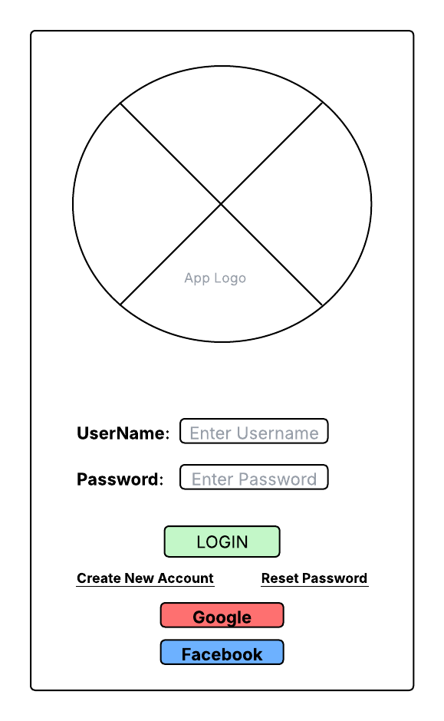
Users begin their journey on the Login Screen. They are greeted by a large logo image for the company/application. They are prompted to enter a username and password combination that will allow them to access their personal profile, preferences and records. If this is their first time using the application, they can click the “Create New Account” link beneath the login button, which will bring them to the new account creation page in their device’s browser. If they can’t remember their chosen password, they can use the “Reset Password” link to be transferred to the password reset page in the browser. Other login options that they have include using a Google or Facebook account to login.
This design does not overwhelm the user and gives them simple options for logging in. The larger image showing the application or company logo reassures the user that they are in the right application. Requesting login with a username option instead of an email makes it easier and faster for someone to log in. Instead of having to type out their entire email address, they can simply enter a shorter username that is unique to them. Having the options to use Facebook or Google to log in also simplifies it by allowing one-click access to the application. The “Create New Account” and “Reset Password” links are visible, but not the first part of the screen that your eyes are drawn to.
[02] – Meal Tracker Screen
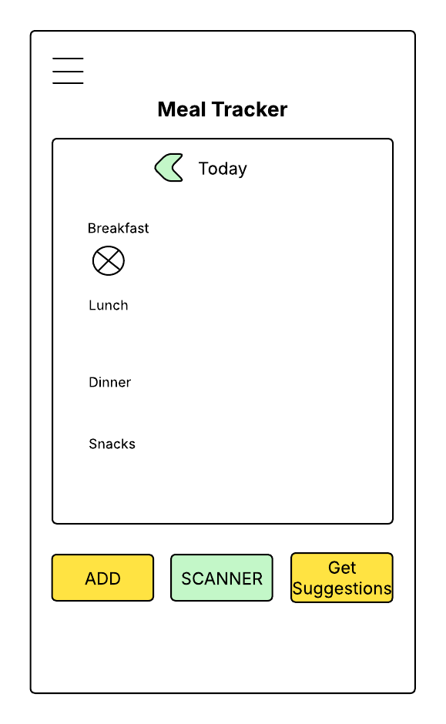
After logging in to the application, the user is brought to the second screen which is the Meal Tracker screen. Here is where they will be able to see the meals/food products they have added for the day, tracking their caloric intake based on the scanned/manually added foods. In the upper left hand corner of the screen is the standard “hamburger” icon, denoting a drop down menu that will contain other options that aren’t frequently used. These options will include access to the user’s personal profile, their preferences, and give them the option to log out of the application. Essentially any option that is not a main, day-to-day usage feature of the application will be put in this menu. The header text is larger and bold to make sure the user’s eyes are immediately brought to the center of the screen, informing them of where they are in the application. The tracker itself will take up most of the screen with sections for breakfast, lunch, dinner and snacks. Beneath each meal will be a circular picture of the scanned product or a default picture if the food is entered manually by the user. This will be a clickable link that can pop up an information bubble that will give the user basic information about the product (name, serving for this meal, calories). Beneath the tracker are buttons to the other major features of the application. The ADD and GET SUGGESTIONS buttons are colored yellow to show that they are currently inactive. The SCANNER button, however, is green and when pressed will take the user to the Scanner Screen.
This design is straightforward which will help the user avoid confusion. The buttons are large enough that they will be easy to click without needing special tools like a stylus and are clearly labeled so the user knows exactly what they will get when they press them. This was a feature suggested by some of the interviewed individuals earlier in the development process.
[03] – Product Scanner Screen
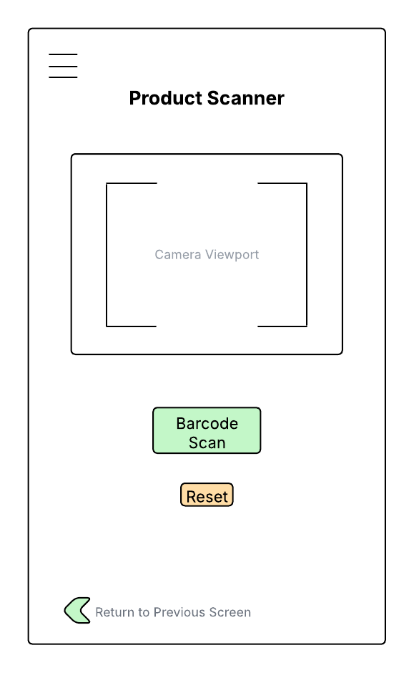
After pressing the Scan button on the Meal Tracker screen, the user is taken to the product scanner screen. The same “hamburger” menu is in the upper left of the screen. It’s important to keep consistent with the design across the different screens so that the user won’t be confused and have difficulty trying to find important features. This screen is also of very simple design with bold and larger font header text indicating that this is the Product Scanner screen. Beneath it is the scanner itself which uses the mobile device’s onboard camera. A larger green button to scan the barcode located on the product packaging is beneath the viewport with a light brown Reset button beneath it. The Barcode Scan button will attempt to scan any barcode within the viewport brackets of the camera. The Reset button will refresh the screen in case of an issue with the camera or product scan. This will help to avoid frozen camera screens or errors in the scanning process. At the bottom of the screen the user will have an arrow button that will allow them to return to the previous screen (in this case, the meal tracker screen). This is so that they can go back and manually add a product if the scanner is not working properly, or the product does not have a barcode.
Keeping with the simple design of the application, this screen only has what is necessary for it to complete its function. Users have stated that having unnecessary features can distract from the function of an application, so keeping the design of this screen as simple as possible was of paramount importance.
[04] – Scan Results Screen
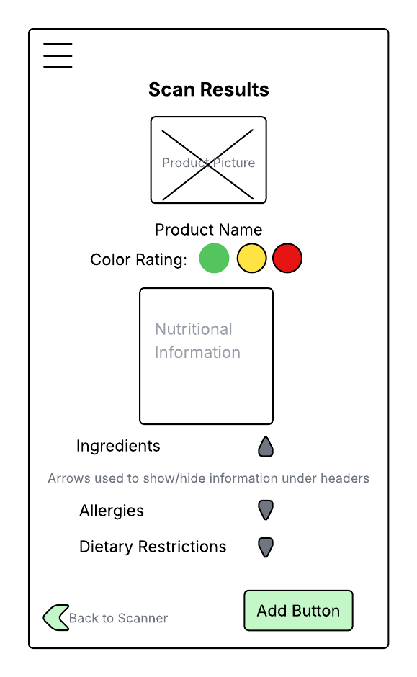
The final wireframe is the Scan Results screen. For consistency, the “hamburger” menu is included in the same spot as other screens. The header text is also larger and bold. Beneath the header is an image of the product that has been scanned. This is smaller so it doesn’t take up a lot of space. Beneath the image is the name of the product. These two features will confirm to the user that the product they have in their hands is what was scanned and the results are accurate. Beneath the product name is the color-coded health rating of the product. There are three colors in the wireframe, but only one color will be seen when an actual product is scanned. This will continue the theme of simplicity, including only relevant information about the product. Beneath the color rating will be the nutritional information that is usually found in white boxes on the product packages. This will contain information like calories, sodium count, serving size, and so on. Then we will have three header categories that will be able to be shown or hidden by the user. A list of ingredients, allergies involving ingredients and any dietary restrictions that are associated with the product. Some information will be relevant to the user, while others will not. Having the ability to hide/show this information will bring in a level of customization that will make the results feel more personal to the user. The arrow button to return to the previous screen will be in the lower left of the screen. This is helpful if the user scans a product but decides not to add it to the meal tracker. Opposite the back navigational button is the Add button that, when pressed, will add the product to the tracker.
One innovative solution implemented in this wireframe design is the use of fallback options when technology limitations arise. For example, if barcode scanning fails due to camera or product limitations, users are given a clear path to manually add food items without disrupting their workflow. Additionally, the ability to expand or collapse nutritional categories on the results screen allows users to personalize the amount of information displayed, reducing cognitive overload while still providing access to detailed data when needed.
Discuss how your product could be adapted to a digital watch.
When adapting this application for a digital watch, priority is given to quick, glanceable information and minimal interaction steps. Due to hardware limitations such as the lack of an onboard camera, barcode scanning would not be supported directly on the watch. Instead, the watch version would focus on high-value features such as viewing daily calorie totals, meal summaries, and simplified health ratings.
Information displayed on the watch could be condensed to essential data points, including calorie count, serving size, and color-coded health indicators. Manual food entry could be supported through voice-to-text input, allowing users to quickly search for and log items without typing. This adaptation aligns with wearable design best practices by being timesaving, easy to interact with, and optimized for short user interactions rather than extended use.
Discuss how your wireframe could be adapted to a touch-based kiosk.
When adapting the mobile application wireframe for a touch-based kiosk with a large stand-alone display, the design would prioritize visibility, ease of navigation, and accessibility. Due to the larger screen size, content could be displayed with increased spacing, larger typography, and oversized touch targets to accommodate varying heights and abilities.
Navigation would be simplified by replacing the “hamburger” menu with clearly visible on-screen navigation buttons, allowing uses to move between primary features without needing to open secondary menus. The kiosk layout would likely use a landscape orientation to better display meal tracking summaries, nutritional information, and product results side-by-side, reducing the number of steps required to complete tasks.
Features included on the kiosk would focus on quick product lookup, nutritional review, and dietary guidance rather than account management, as kiosks are typically for short, goal-oriented interactions. This approach follows established design best practices for large touch screens by minimizing navigation depth, maintaining clear focus selection, and ensuring that all interactive elements are easily reachable and clearly labeled.

