Software Requirements Specification

February 15, 2016

For

Socialites Hub- Networking for Welfare

**Team Members-**

Evi Agarwal (IPG-2014108)

Kriti Singhal (IPG-2014050)

Mona Singh (IPG-2014056)

**Under the guidance of-**

Dr. Anurag Srivastava

**Institute Name-**

ABV- Indian Institute of Information Technology & Management, Gwalior

Table of Contents

**1.** **Introduction**

1.1 Purpose

1.2 Product Scope

1.3 Tools & Technologies Used

1.4 References

**2. System Description**

2.1 Problem Description

2.2 Our Solution

2.3 Overview Flowchart

**3. Overall Description**

* 1. Product Perspective
  2. User Classes
  3. Benefit as a mobile application
  4. Operating Environment
  5. E-R Diagram

**4. Use- Cases**

4.1 My Profile

4.2 News Feed

4.3 Issues

4.4 Events

**1. INTRODUCTION**

**Socialites Hub** is a new self-contained product originated from the idea of creating an interface for the givers and takers of the society.

**1.1 PURPOSE**

It is a social networking app that provides people having social welfare motives to interact and figure out relevant activities that would help in the development of the society.

It helps people with different areas to collectively help and organize various types of charity events and create awareness among the underprivileged ones. Moreover, it also allows people with benevolent feelings to locate “people-in-need” areas of different cities in order to provide a helping hand to them.

**1.2 PRODUCT SCOPE**

* Likewise a conventional online social networking service, it also allows users to create public profiles by signing up.
* Cities of interest are asked at the time of sign up and can be updated anytime in the further usage. This will help in personalizing the application by providing information and posts only related to the selected cities.
* A search bar at the top of the app page.
* The application design features four tabs, namely – News Feed, Issues, Events and My Profile.
* By default fields for city, issue etc. present at the time of posting an update so that they can serve as keywords while using search option.
* Provision of filters for each tab page. Filters include date, issue, city etc.
* Features like Recommend a Friend, Suggestions and Favorites associated with posts. (Issues, stories, events etc.)
* Recommend a Friend lets user advice or share with a friend a particular news feed story, issue or event.
* Suggestions feature allows users to provide ideas and proposals for a posted problem or an event.
* Favorites lets you bookmark a particular kind of post for further referral.
* News Feed displays the constantly updating list of stories in the home page.
* Every post in the News Feed contains “Recommend a Friend”, “Suggestions” & “Favorites” option.
* Issues tab displays all the problems posted by the users which may include a garbage filled area, child labor instance, distressing conditions of a slum etc.
* A problem posted contains “Recommend a Friend”, “Suggestions”, “Favorites” and “Create an Event” options with it. Create an Event feature lets an interested user to organize a problem solving event for the particular issue into consideration.
* All the events being organized by the users will be listed under Event tab.
* Events post contains “Recommend a Friend”, “Suggestions”, “Favorites” and “Join the Event” options. Join the Event allows any of the user to participate in the particular event.
* Reminders will be sent as notifications to the users for the events they are participating in.
* A personal city page will list all the activities, posts, stories, issues and events related to the city. It will consist of a database of orphanages, old age homes, and polluted areas of the cities as well.
* The city page’s admin is a “City Ambassador” who is chosen by comparing the highest “Service Points” of all users within a city.
* Service Points are the credits earned by the users for their participation in the welfare events and other activities. These points act as a measure of the social contribution by a user.
* Users can send friend requests to each other and also can avail the chat facility.
* FAQ section is also included for users’ facility

**1.3 Tools & Technologies Used**

1. **Java-:** Android programming is based on Java programming language that is concurrent, class-based, object-oriented and especially designed to have as few implementation dependencies as possible.
2. **Java** **Development Kit (JDK)-:** It is an implementation of either one of the Java SE, Java EE or Java ME platforms released by Oracle Corporation.
3. **Adobe Flash and Adobe AIR-:** It enables developers to consistently deliver expressive content, applications and video to the widest possible audience across a broad range of mobile devices.
4. **Android SDK (Software Development Kit)-:** It includes a comprehensive set of development tools which include debugger, libraries, a handset emulator, sample code and tutorials.
5. **Eclipse IDE-:** An integrated developing environment which contains a base workspace and an extensible plug-in system for customizing the environment.
6. **Android Development Tools (ADT) Plugin-:** It is a plugin for the Eclipse IDE that is designed to give you a powerful, integrated environment in which to build Android applications.
7. **Extensive Markup Language (XML) -:** It is a markup language that defines a set of rules for encoding documents in a format which is both human-readable and machine-readable.
8. **J2EE-:** Application Architecture
9. **DB2-:** IBM Database
10. **Bluemix-:** IBM Bluemix is an open standards cloud platform for building, running and managing apps and services.

**1.4 References**

* IEEE SRS Format
* Project specification requirement (provided by IBM)

**2. SYSTEM DESCRIPTION**

**Socialites Hub**- system is an online community of philanthropists, charity clubs and various other do-gooders worldwide. The system provides a platform for all such people to collectively function and accomplish the task of service to humanity.

It allows users to provide solutions for problems faced by people sitting at altogether different locations. It helps in generating workforce and mass awareness for different social events and issues.

**2.1 PROBLEM DESCRIPTION**

There are people willing to serve humanity but couldn’t find ways and proper guidance to do so. Also, there are certain social clubs who need large amount of contributors (individuals or other such social clubs) in their locality to assist and aid them. Many a times people who are the most down at heel remain deprived of the social services provided by the charity givers.

**2.2 OUR SOLUTION**

From production and management of services to workforce development and community engagement strategy, the potential of social media can be utilized for co-production and enhancement of social services.

The fast pace of technology means greater and more powerful means of collaboration and transformation of services and the workforce. As social media becomes more ingrained in society, so its adoption and acceptance in social work and social care will become more normalized.

By considering the above fact, social media should be an essential part of new social workers’ toolkits. We are introducing an application that would serve as a hub for carrying out all social care and welfare activities.

* Through our application, users can interact with other group of people having the same welfare motives by creating a public profile and connecting with other social clubs.
* Users can post the pictures of garbage filled areas, child labor instances, distressing conditions of a slum which can then be promptly acted upon by the corresponding users of that particular area.
* A special feature of service points is introduced in order to create a competitive environment and motivation among users.

**2.4 Overview Flowchart**

Cities of Interest

Register

Recommend a friend, Suggestions, Favorites, Create an Event

Recommend a friend, Suggestions, Favorites

Recommend a friend, Suggestions, Favorites

Events

Issues

News Feed

My Profile

Quit

Filters (city, issue, date etc.)

Main Page

Log in

New or member?

Join the event?

View Profile

Edit Profile

Friends Friend Requests

Notifications/ Reminders

Service Points

My City Pages

Settings

Log out

No

Yes

**3. OVERALL DESCRIPTION**

**3.1 PRODUCT PERSPECTIVE**

The idea of the development of the **Socialites Hub** evolved by taking into consideration the problems faced by various college level social clubs in organizing events which requires reaching out to mass and involve their participation. Hence, a technology with solutions of above mentioned problems was created.

**3.2 USER CLASSES**

The product can be used by people of any educational level, experience and technical expertise. The anticipated users of the application are all public-spirited, humanitarian and charitable people. The individual may or may not be a part of any social service club.

**3.3 BENEFIT AS A MOBILE APPLICATION**

* Recent surveys have shown that most of the people favor apps due to convenience, speed and ease of use.
* Through a mobile application the number of target audience increases.
* Being a mobile application, it increases promptness. For example when a user finds a garbage dumped area, he/she can instantly click a photograph and post it on the app.
* The application contains database of all the orphanages or old-age-homes which can be accessed easily whenever required due to the mobile’s portability.

**3.4 OPERATING ENVIRONMENT**

* Being an android application, it operates on mobiles and tablets with Android versions 2.2 and above.
* No other software components or applications are required for the installation of the application.

**4. USE CASES**

* 1. **UC1: MY PROFILE**

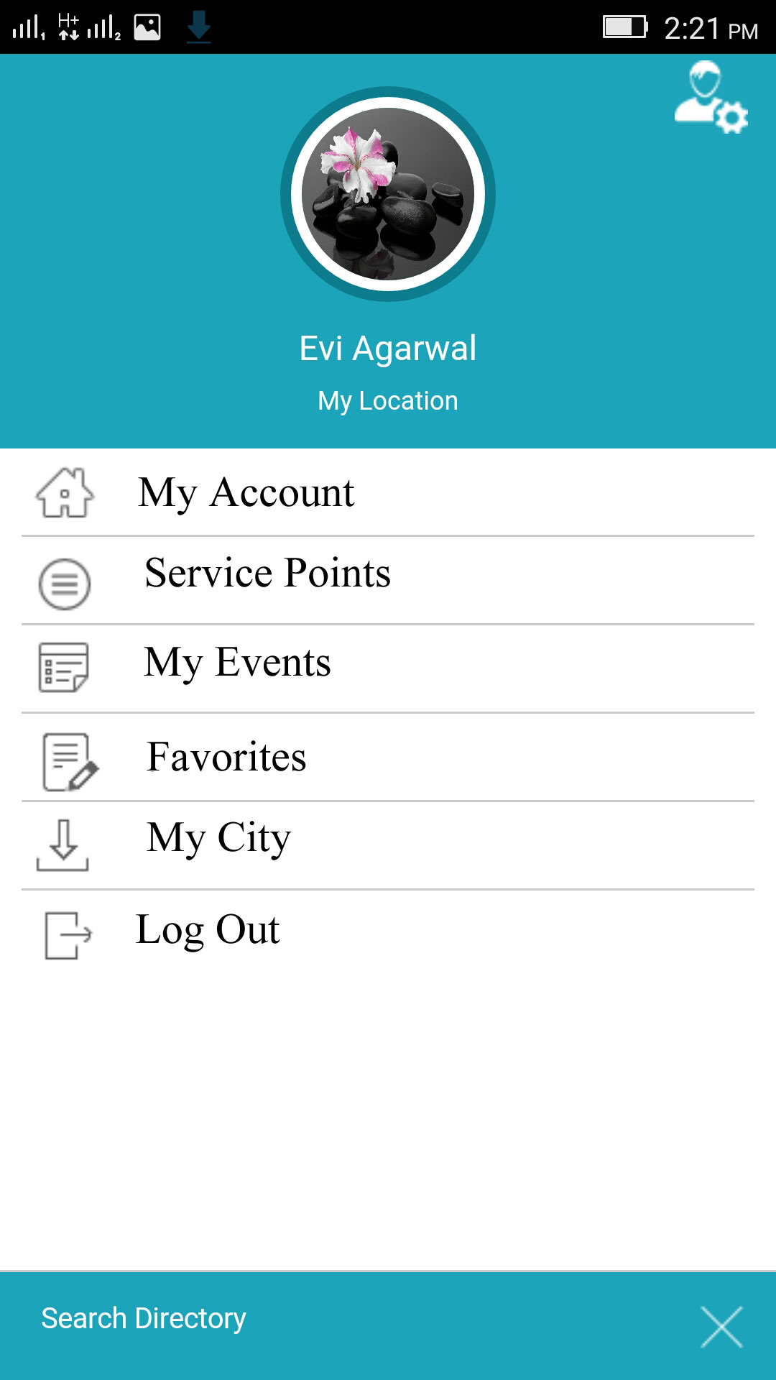

* 1. **UC2: News Feed**

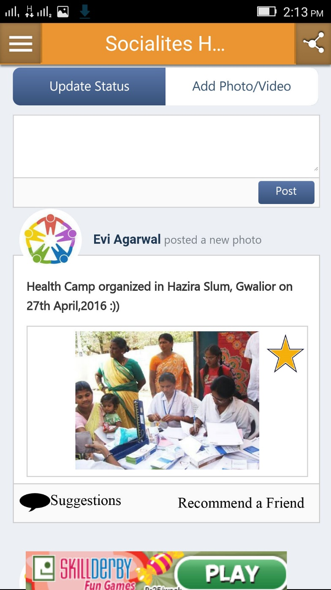

* 1. **UC3: ISSUES**

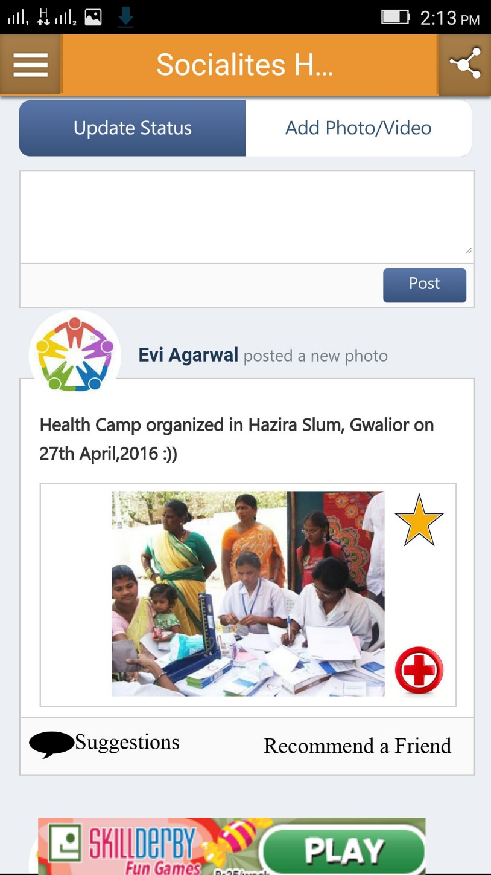

* 1. **UC4: EVENTS**

