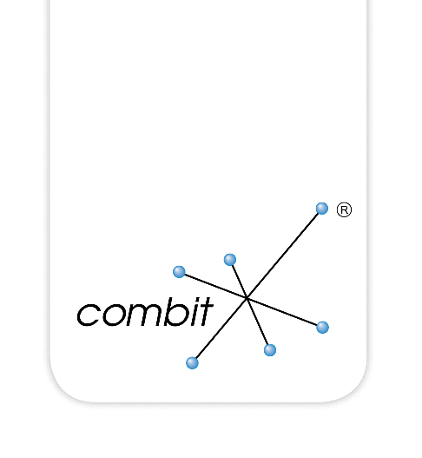

Examples for COBOL

Inhalt

Foreword 3

Invoking the Designer 4

Printing a Label 5

# Foreword

The following samples are not ready to compile or run. The function calls to open / close a List & Label job, error handling and much more is missing. The samples are only for informational purpose, they should just show how to integrate List & Label into a COBOL application.

The used List & Label constants have to be defined in COBOL syntax. The easiest way is to transfer them from the C/C++ header file "cmbtLL??.h" (?? indicates the List & Label version number, e.g. 14, 15, …) to COBOL. The header file can be found in the Visual C++ subdirectory and can be opened with any text editor.

A sample for a C++ definition of a constant:

#define LL_PROJECT_LABEL (1)

This has to be translated to COBOL syntax. For instance:

78 LL-PROJECT-LABEL value 1.

There might exist a tool in the COBOL development environment that could do this job automatically (it might be called "H2CPY").

# Invoking the Designer

*\*\*\*\*\*\*\*\*\*\*\*\*\*\*\*\*\*\*\*\*\*\*\*\*\*\*\*\*\*\*\*\*\*\*\*\*\*\*\*\*\*\*\*\*\*\*\*\*\*\*\*\*\*\*\*\*\*\*\*\*\*\*\*\*\*\*\*\*\*\*\*\*\*\*\*\*\*\*\*\*\**

*\* This COBOL Sample starts the Designer of List & Label.*

*\* Two fields will be defined: 'Itemnumber' and 'Description'*

*\**

*\* Copyright (c) combit GmbH*

*\*\*\*\*\*\*\*\*\*\*\*\*\*\*\*\*\*\*\*\*\*\*\*\*\*\*\*\*\*\*\*\*\*\*\*\*\*\*\*\*\*\*\*\*\*\*\*\*\*\*\*\*\*\*\*\*\*\*\*\*\*\*\*\*\*\*\*\*\*\*\*\*\*\*\*\*\*\*\*\*\**

[...]

MOVE "**LLDEMO.LBL**" & X"00" TO PROJECTNAME

MOVE LL-PROJECT-LABEL TO PROJECTTYPE

MOVE "Label Designer" & X"00" TO WINDOWTITLE

*\* Define 'Itemnumber' and 'Description' and povide dummy date*

MOVE "**Itemnumber**" TO VARIABLE-NAME

MOVE "SampleItemnumber" TO VARIABLE-CONTENTS

CALL WINAPI "**LlDefineVariableA**"

USING BY VALUE JOB-HANDLE

BY REFERENCE VARIABLE-NAME

BY REFERENCE VARIABLE-CONTENTS

RETURNING RC-INT

END-CALL

MOVE "**Description**" TO VARIABLE-NAME

MOVE "SampleDescription" TO VARIABLE-CONTENTS

CALL WINAPI "**LlDefineVariableA**"

USING BY VALUE JOB-HANDLE

BY REFERENCE VARIABLE-NAME

BY REFERENCE VARIABLE-CONTENTS

RETURNING RC-INT

END-CALL

*\* Start Designer*

CALL WINAPI "**LlDefineLayoutA**"

USING BY VALUE JOB-HANDLE

BY VALUE WINDOW-HANDLE

BY REFERENCE WINDOWTITLE

BY REFERENCE PROJECTNAME

BY VALUE PROJECTTYPE

RETURNING RC-INT

END-CALL

[...]

# Printing a Label

*\*\*\*\*\*\*\*\*\*\*\*\*\*\*\*\*\*\*\*\*\*\*\*\*\*\*\*\*\*\*\*\*\*\*\*\*\*\*\*\*\*\*\*\*\*\*\*\*\*\*\*\*\*\*\*\*\*\*\*\*\*\*\*\*\*\*\*\*\*\*\*\*\*\*\*\*\*\*\*\*\**

*\* This COBOL sample prints 1 Label using List & Label. For demon-*

*\* stration purposes data is being fetched from an array MYDATA*

*\* (normally a record set access would happen there).*

*\**

*\* Copyright (c) combit GmbH*

*\*\*\*\*\*\*\*\*\*\*\*\*\*\*\*\*\*\*\*\*\*\*\*\*\*\*\*\*\*\*\*\*\*\*\*\*\*\*\*\*\*\*\*\*\*\*\*\*\*\*\*\*\*\*\*\*\*\*\*\*\*\*\*\*\*\*\*\*\*\*\*\*\*\*\*\*\*\*\*\*\**

[...]

*\* Start preview print process of label "****LLDEMO.LBL****":*

MOVE "**LLDEMO.LBL**" & X"00" TO PROJECTNAME

MOVE **LL-PRINT-PREVIEW** TO PRINTOPTIONS

MOVE LL-PROJECT-LABEL TO PROJECTTYPE

MOVE LL-BOXTYPE-BRIDGEMETER TO BOXTYPE

MOVE "Label Printing" & X"00" TO WINDOWTITLE

CALL WINAPI "**LlPrintWithBoxStartA**"

USING BY VALUE JOB-HANDLE

BY VALUE PROJECTTYPE

BY REFERENCE PROJECTNAME

BY VALUE PRINTOPTIONS

BY VALUE BOXTYPE

BY VALUE WINDOW-HANDLE

BY REFERENCE WINDOWTITLE

RETURNING RC-INT

END-CALL

*\* Define all variables of the record to be printed (in this case Itemnumber + Description):*

*\* fetch data from data source (in this case for demonstration the contents of array MYDATA)*

MOVE "**Itemnumber**" TO VARIABLE-NAME

MOVE MYDATA (1) TO VARIABLE-CONTENTS

CALL WINAPI "**LlDefineVariableA**"

USING BY VALUE JOB-HANDLE

BY REFERENCE VARIABLE-NAME

BY REFERENCE VARIABLE-CONTENTS

RETURNING RC-INT

END-CALL

MOVE "**Description**" TO VARIABLE-NAME

MOVE MYDATA (2) TO VARIABLE-CONTENTS

CALL WINAPI "**LlDefineVariableA**"

USING BY VALUE JOB-HANDLE

BY REFERENCE VARIABLE-NAME

BY REFERENCE VARIABLE-CONTENTS

RETURNING RC-INT

END-CALL

*\* Print label*

CALL WINAPI "**LlPrint**"

USING BY VALUE JOB-HANDLE

RETURNING RC-INT

END-CALL

*\* Finish print process*

MOVE 0 TO PAGES

CALL WINAPI "**LlPrintEnd**"

USING BY VALUE JOB-HANDLE

BY VALUE PAGES

RETURNING RC-INT

END-CALL

*\* Show preview*

MOVE "." & X"00" TO PATH.

CALL WINAPI "**LlPreviewDisplayA**"

USING BY VALUE JOB-HANDLE

BY REFERENCE PROJECTNAME

BY REFERENCE PATH

BY VALUE WINDOW-HANDLE

RETURNING RC-INT

END-CALL

[...]

combit GmbH Bücklestr. 3-5 78467 Konstanz Germany

© combit GmbH, combit does not make any statements about a particular suitability of the above information. Errors and omissions are expressly reserved. The information is provided without guarantee and does not contain any assurances. The information may also be an attempt to help you with a task, even if the product was not intended for this special purpose. All mentioned products and product designations as well as logos are trademarks, registered trademarks or property of the respective manufacturers.

[combit.com](https://www.combit.com/)