Министерство образования Республики Беларусь

Учреждение образования

«Брестский государственный технический университет»

Кафедра ИИТ

Лабораторная работа №8

По дисциплине: «КСиС»

Тема: «Настройка статической маршрутизации на устройствах Cisco»

Выполнил:

Студент 2 курса

Группы ПО-7

Комиссаров А.Е.

Проверил:

Савицкий Ю. В.

2022

**ЧАСТЬ 1**

Топология сети:

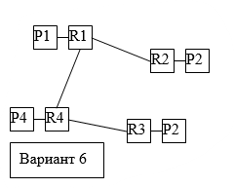

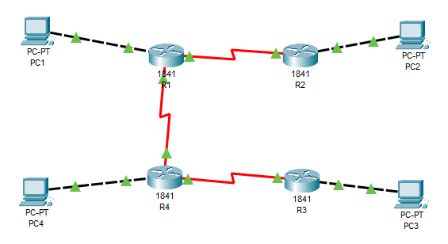

Таблица сетевых адресов:

|  |  |  |  |  |
| --- | --- | --- | --- | --- |
| Device | Interface | IP Address | Mask | Def. Gateway |
| PC1 | N/A | 192.168.1.16 | 255.255.255.0 | 192.168.1.7 |
| PC2 | N/A | 192.168.2.16 | 255.255.255.0 | 192.168.2.7 |
| PC3 | N/A | 192.168.3.16 | 255.255.255.0 | 192.168.3.7 |
| PC4 | N/A | 192.168.4.16 | 255.255.255.0 | 192.168.4.7 |
| R1 | Fa0/0 | 192.168.1.7 | 255.255.255.0 | N/A |
| Se0/0/1 | 192.168.5.7 | 255.255.255.0 | N/A |
| Se0/0/0 | 192.168.6.7 | 255.255.255.0 | N/A |
| R2 | Fa0/0 | 192.168.2.7 | 255.255.255.0 | N/A |
| Se0/0/0 | 192.168.5.8 | 255.255.255.0 | N/A |
| R3 | Fa0/0 | 192.168.3.7 | 255.255.255.0 | N/A |
| Se0/0/0 | 192.168.5.9 | 255.255.255.0 | N/A |
| R4 | Fa0/0 | 192.168.4.7 | 255.255.255.0 | N/A |
| Se0/0/1 | 192.168.5.10 | 255.255.255.0 | N/A |
| Se0/0/0 | 192.168.6.10 | 255.255.255.0 | N/A |

Начальная конфигурация маршрутизатора R1:

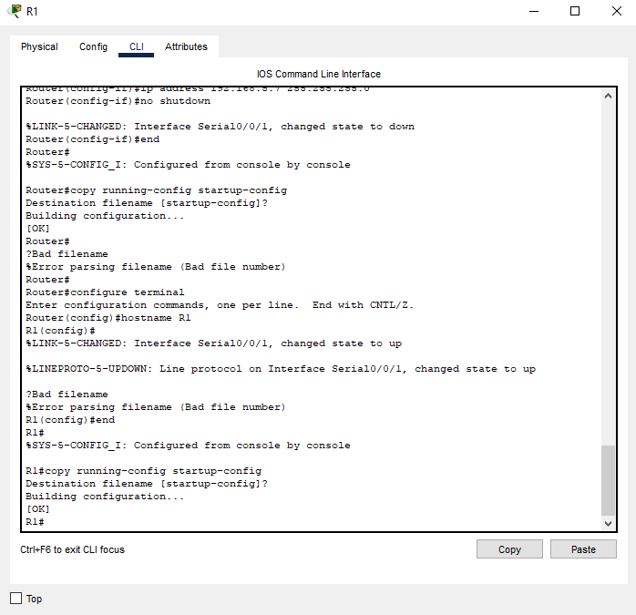

Начальная конфигурация маршрутизатора R2:

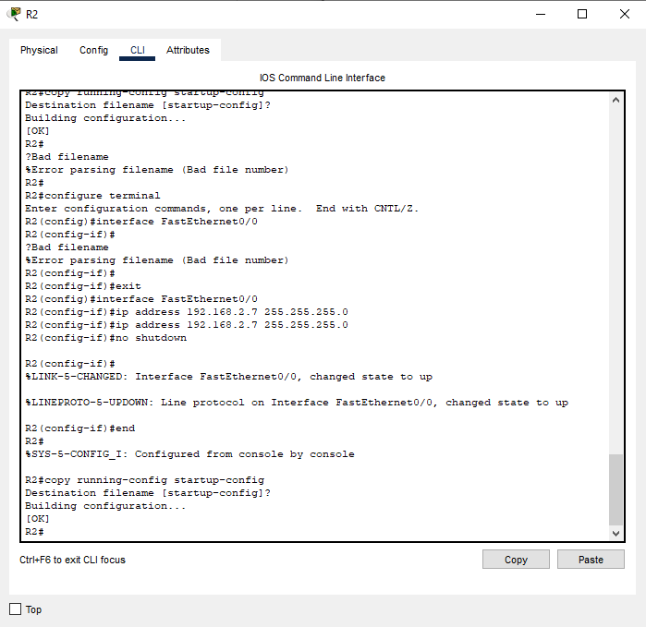

Начальная конфигурация маршрутизатора R3:

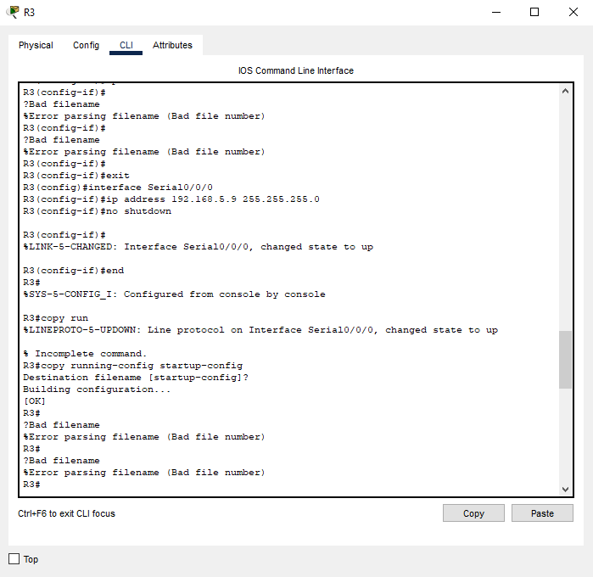

Начальная конфигурация маршрутизатора R4:

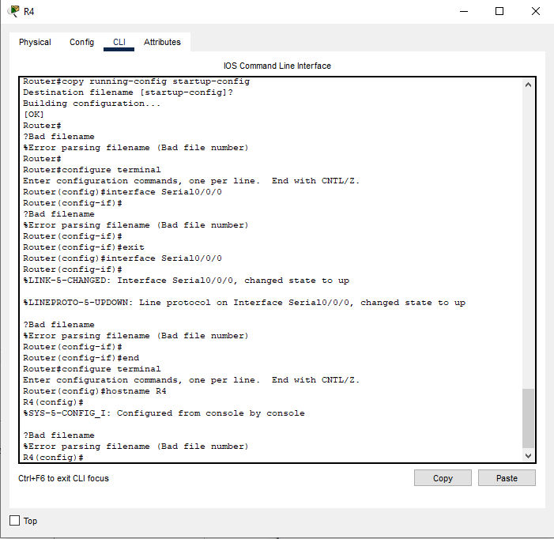

Начальная конфигурация PC1, PC2, PC3, PC4:

PC1:

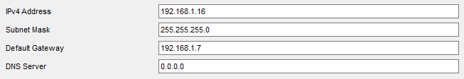

PC2:

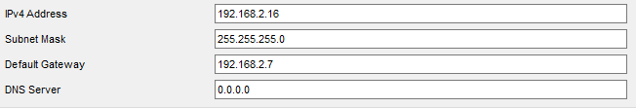

PC3:

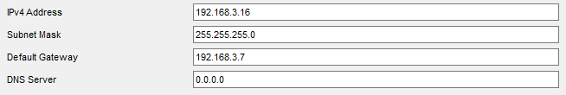

PC4:

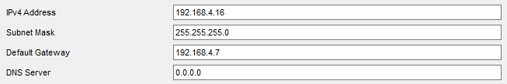

Проверка конфигурации маршрутизатора R1:

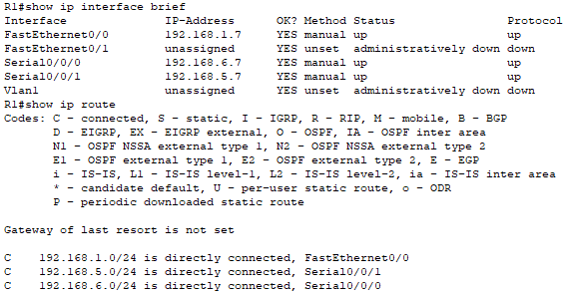

Проверка конфигурации маршрутизатора R2:

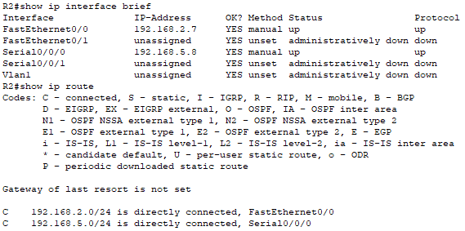

Проверка конфигурации маршрутизатора R3:

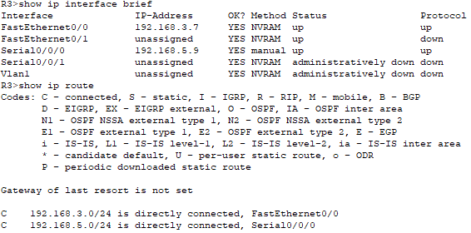

Проверка конфигурации маршрутизатора R4:

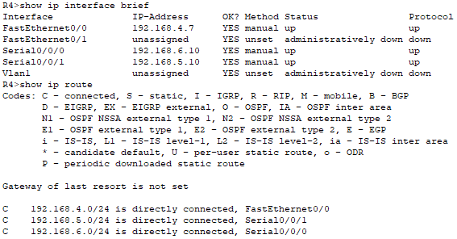

Настройка статической маршрутизации на устройстве R1:

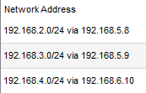

Настройка статической маршрутизации на устройстве R2:

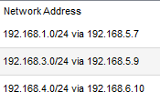

Настройка статической маршрутизации на устройстве R3:

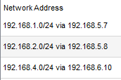

Настройка статической маршрутизации на устройстве R4:

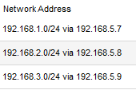

Проверка конфигурации маршрутизатора R1:

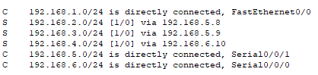

Проверка конфигурации маршрутизатора R2:

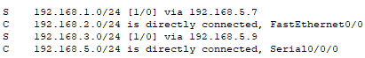

Проверка конфигурации маршрутизатора R3:

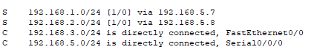

Проверка конфигурации маршрутизатора R4:

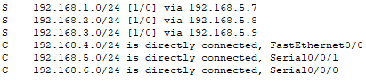

Тестирование:

**PC1:**

C:\>ping 192.168.2.16

Pinging 192.168.2.16 with 32 bytes of data:

Reply from 192.168.2.16: bytes=32 time=1ms TTL=128

Reply from 192.168.2.16: bytes=32 time<1ms TTL=128

Reply from 192.168.2.16: bytes=32 time<1ms TTL=128

Reply from 192.168.2.16: bytes=32 time=4ms TTL=128

Ping statistics for 192.168.2.16:

Packets: Sent = 4, Received = 4, Lost = 0 (0% loss),

Approximate round trip times in milli-seconds:

Minimum = 0ms, Maximum = 4ms, Average = 1ms

C:\>ping 192.168.3.16

Pinging 192.168.3.16 with 32 bytes of data:

Reply from 192.168.3.16: bytes=32 time=2ms TTL=128

Reply from 192.168.3.16: bytes=32 time=2ms TTL=128

Reply from 192.168.3.16: bytes=32 time<1ms TTL=128

Reply from 192.168.3.16: bytes=32 time=3ms TTL=128

Ping statistics for 192.168.3.16:

Packets: Sent = 4, Received = 4, Lost = 0 (0% loss),

Approximate round trip times in milli-seconds:

Minimum = 0ms, Maximum = 3ms, Average = 1ms

C:\>ping 192.168.4.16

Pinging 192.168.4.16 with 32 bytes of data:

Reply from 192.168.4.16: bytes=32 time=2ms TTL=128

Reply from 192.168.4.16: bytes=32 time=2ms TTL=128

Reply from 192.168.4.16: bytes=32 time=3ms TTL=128

Reply from 192.168.4.16: bytes=32 time=2ms TTL=128

Ping statistics for 192.168.4.16:

Packets: Sent = 4, Received = 4, Lost = 0 (0% loss),

Approximate round trip times in milli-seconds:

Minimum = 2ms, Maximum = 3ms, Average = 2ms

**PC2:**

C:\>ping 192.168.1.16

Pinging 192.168.1.16 with 32 bytes of data:

Reply from 192.168.1.16: bytes=32 time<1ms TTL=128

Reply from 192.168.1.16: bytes=32 time=4ms TTL=128

Reply from 192.168.1.16: bytes=32 time=3ms TTL=128

Reply from 192.168.1.16: bytes=32 time=4ms TTL=128

Ping statistics for 192.168.1.16:

Packets: Sent = 4, Received = 4, Lost = 0 (0% loss),

Approximate round trip times in milli-seconds:

Minimum = 0ms, Maximum = 4ms, Average = 2ms

C:\>ping 192.168.3.16

Pinging 192.168.3.16 with 32 bytes of data:

Reply from 192.168.3.16: bytes=32 time=2ms TTL=128

Reply from 192.168.3.16: bytes=32 time=3ms TTL=128

Reply from 192.168.3.16: bytes=32 time=4ms TTL=128

Reply from 192.168.3.16: bytes=32 time=2ms TTL=128

Ping statistics for 192.168.3.16:

Packets: Sent = 4, Received = 4, Lost = 0 (0% loss),

Approximate round trip times in milli-seconds:

Minimum = 2ms, Maximum = 4ms, Average = 2ms

C:\>ping 192.168.4.16

Pinging 192.168.4.16 with 32 bytes of data:

Reply from 192.168.4.16: bytes=32 time=8ms TTL=128

Reply from 192.168.4.16: bytes=32 time=3ms TTL=128

Reply from 192.168.4.16: bytes=32 time=3ms TTL=128

Reply from 192.168.4.16: bytes=32 time=4ms TTL=128

Ping statistics for 192.168.4.16:

Packets: Sent = 4, Received = 4, Lost = 0 (0% loss),

Approximate round trip times in milli-seconds:

Minimum = 3ms, Maximum = 8ms, Average = 4ms

**PC3:**

C:\>ping 192.168.1.16

Pinging 192.168.1.16 with 32 bytes of data:

Reply from 192.168.1.16: bytes=32 time<1ms TTL=128

Reply from 192.168.1.16: bytes=32 time=4ms TTL=128

Reply from 192.168.1.16: bytes=32 time=3ms TTL=128

Reply from 192.168.1.16: bytes=32 time=2ms TTL=128

Ping statistics for 192.168.1.16:

Packets: Sent = 4, Received = 4, Lost = 0 (0% loss),

Approximate round trip times in milli-seconds:

Minimum = 0ms, Maximum = 4ms, Average = 2ms

C:\>ping 192.168.2.16

Pinging 192.168.2.16 with 32 bytes of data:

Reply from 192.168.2.16: bytes=32 time=7ms TTL=128

Reply from 192.168.2.16: bytes=32 time=2ms TTL=128

Reply from 192.168.2.16: bytes=32 time<1ms TTL=128

Reply from 192.168.2.16: bytes=32 time=2ms TTL=128

Ping statistics for 192.168.2.16:

Packets: Sent = 4, Received = 4, Lost = 0 (0% loss),

Approximate round trip times in milli-seconds:

Minimum = 0ms, Maximum = 7ms, Average = 2ms

C:\>ping 192.168.4.16

Pinging 192.168.4.16 with 32 bytes of data:

Reply from 192.168.4.16: bytes=32 time=2ms TTL=128

Reply from 192.168.4.16: bytes=32 time=3ms TTL=128

Reply from 192.168.4.16: bytes=32 time<1ms TTL=128

Reply from 192.168.4.16: bytes=32 time<1ms TTL=128

Ping statistics for 192.168.4.16:

Packets: Sent = 4, Received = 4, Lost = 0 (0% loss),

Approximate round trip times in milli-seconds:

Minimum = 0ms, Maximum = 3ms, Average = 1ms

**PC4:**

C:\>ping 192.168.1.16

Pinging 192.168.1.16 with 32 bytes of data:

Reply from 192.168.1.16: bytes=32 time<1ms TTL=128

Reply from 192.168.1.16: bytes=32 time=3ms TTL=128

Reply from 192.168.1.16: bytes=32 time=3ms TTL=128

Reply from 192.168.1.16: bytes=32 time=2ms TTL=128

Ping statistics for 192.168.1.16:

Packets: Sent = 4, Received = 4, Lost = 0 (0% loss),

Approximate round trip times in milli-seconds:

Minimum = 0ms, Maximum = 3ms, Average = 2ms

C:\>ping 192.168.2.16

Pinging 192.168.2.16 with 32 bytes of data:

Reply from 192.168.2.16: bytes=32 time=6ms TTL=128

Reply from 192.168.2.16: bytes=32 time<1ms TTL=128

Reply from 192.168.2.16: bytes=32 time=2ms TTL=128

Reply from 192.168.2.16: bytes=32 time=3ms TTL=128

Ping statistics for 192.168.2.16:

Packets: Sent = 4, Received = 4, Lost = 0 (0% loss),

Approximate round trip times in milli-seconds:

Minimum = 0ms, Maximum = 6ms, Average = 2ms

C:\>ping 192.168.3.16

Pinging 192.168.3.16 with 32 bytes of data:

Reply from 192.168.3.16: bytes=32 time=6ms TTL=128

Reply from 192.168.3.16: bytes=32 time=3ms TTL=128

Reply from 192.168.3.16: bytes=32 time<1ms TTL=128

Reply from 192.168.3.16: bytes=32 time=3ms TTL=128

Ping statistics for 192.168.3.16:

Packets: Sent = 4, Received = 4, Lost = 0 (0% loss),

Approximate round trip times in milli-seconds:

Minimum = 0ms, Maximum = 6ms, Average = 3ms

**ЧАСТЬ 2**

Топология сети:

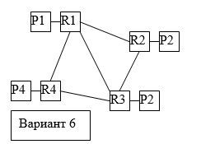

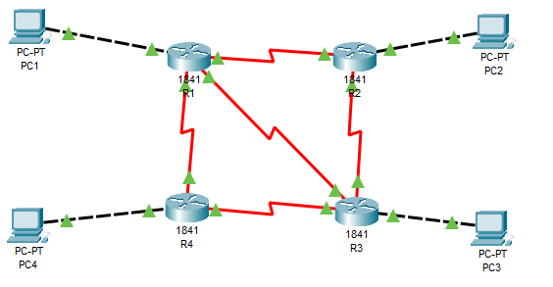

Таблица сетевых адресов:

|  |  |  |  |  |
| --- | --- | --- | --- | --- |
| Device | Interface | IP Address | Mask | Def. Gateway |
| PC1 | N/A | 192.168.1.16 | 255.255.255.0 | 192.168.1.7 |
| PC2 | N/A | 192.168.2.16 | 255.255.255.0 | 192.168.2.7 |
| PC3 | N/A | 192.168.3.16 | 255.255.255.0 | 192.168.3.7 |
| PC4 | N/A | 192.168.4.16 | 255.255.255.0 | 192.168.4.7 |
| R1 | Fa0/0 | 192.168.1.7 | 255.255.255.0 | N/A |
| Se0/0/1 | 192.168.5.7 | 255.255.255.0 | N/A |
| Se0/0/0 | 192.168.6.7 | 255.255.255.0 | N/A |
| Se0/1/1 | 192.168.8.7 | 255.255.255.0 | N/A |
| R2 | Fa0/0 | 192.168.2.7 | 255.255.255.0 | N/A |
| Se0/0/0 | 192.168.5.8 | 255.255.255.0 | N/A |
| Se0/0/1 | 192.168.7.8 | 255.255.255.0 | N/A |
| R3 | Fa0/0 | 192.168.3.7 | 255.255.255.0 | N/A |
| Se0/0/0 | 192.168.5.9 | 255.255.255.0 | N/A |
| Se0/0/1 | 192.168.7.9 | 255.255.255.0 | N/A |
| Se0/1/1 | 192.168.8.8 | 255.255.255.0 | N/A |
| R4 | Fa0/0 | 192.168.4.7 | 255.255.255.0 | N/A |
| Se0/0/1 | 192.168.5.10 | 255.255.255.0 | N/A |
| Se0/0/0 | 192.168.6.10 | 255.255.255.0 | N/A |

Начальная конфигурация R1:

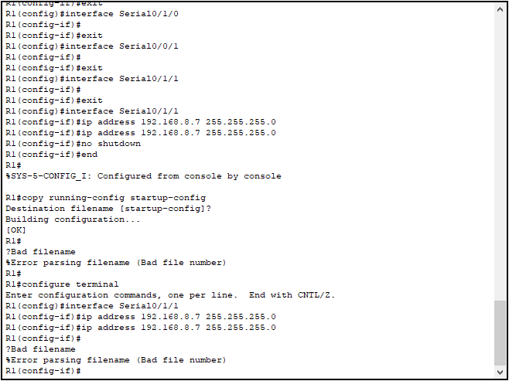

Начальная конфигурация R2:

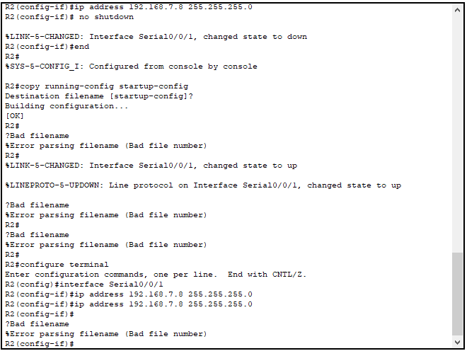

Начальная конфигурация R3:

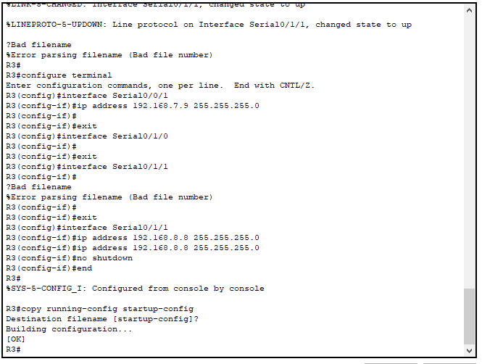

Начальная конфигурация R4:

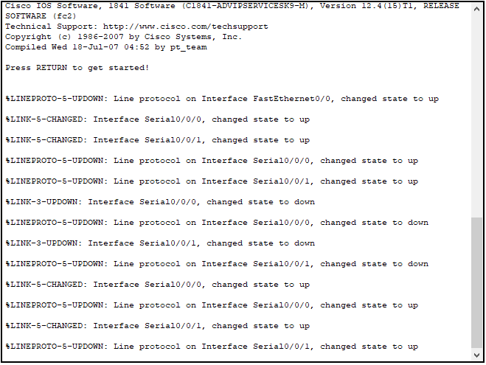

Проверка конфигурации маршрутизатора R1:

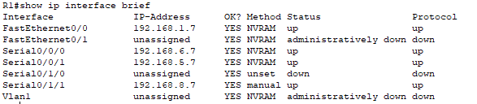

Проверка конфигурации маршрутизатора R2:

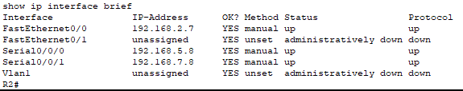

Проверка конфигурации маршрутизатора R3:

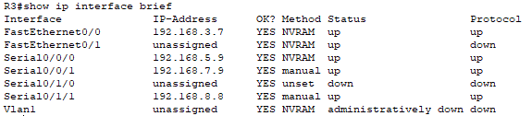

Проверка конфигурации маршрутизатора R4:

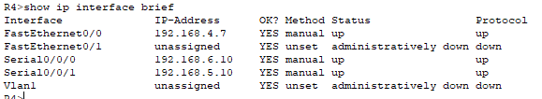

Динамическая маршрутизация R.I.P:

Настройка маршрутизатора R1:

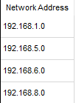

Настройка маршрутизатора R2:

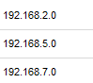

Настройка маршрутизатора R3:

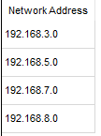

Настройка маршрутизатора R4:

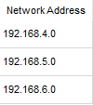

Тестирование:

**PC1:**  
C:\>ping 192.168.2.16

Pinging 192.168.2.16 with 32 bytes of data:

Reply from 192.168.2.16: bytes=32 time<1ms TTL=128

Reply from 192.168.2.16: bytes=32 time=3ms TTL=128

Reply from 192.168.2.16: bytes=32 time=3ms TTL=128

Reply from 192.168.2.16: bytes=32 time=2ms TTL=128

Ping statistics for 192.168.2.16:

Packets: Sent = 4, Received = 4, Lost = 0 (0% loss),

Approximate round trip times in milli-seconds:

Minimum = 0ms, Maximum = 3ms, Average = 2ms

C:\>ping 192.168.3.16

Pinging 192.168.3.16 with 32 bytes of data:

Reply from 192.168.3.16: bytes=32 time<1ms TTL=128

Reply from 192.168.3.16: bytes=32 time=2ms TTL=128

Reply from 192.168.3.16: bytes=32 time=4ms TTL=128

Reply from 192.168.3.16: bytes=32 time=3ms TTL=128

Ping statistics for 192.168.3.16:

Packets: Sent = 4, Received = 4, Lost = 0 (0% loss),

Approximate round trip times in milli-seconds:

Minimum = 0ms, Maximum = 4ms, Average = 2ms

C:\>ping 192.168.4.16

Pinging 192.168.4.16 with 32 bytes of data:

Reply from 192.168.4.16: bytes=32 time=2ms TTL=128

Reply from 192.168.4.16: bytes=32 time=4ms TTL=128

Reply from 192.168.4.16: bytes=32 time=3ms TTL=128

Reply from 192.168.4.16: bytes=32 time=3ms TTL=128

Ping statistics for 192.168.4.16:

Packets: Sent = 4, Received = 4, Lost = 0 (0% loss),

Approximate round trip times in milli-seconds:

Minimum = 2ms, Maximum = 4ms, Average = 3ms

**PC2:**

C:\>ping 192.168.1.16

Pinging 192.168.1.16 with 32 bytes of data:

Reply from 192.168.1.16: bytes=32 time<1ms TTL=128

Reply from 192.168.1.16: bytes=32 time=4ms TTL=128

Reply from 192.168.1.16: bytes=32 time=3ms TTL=128

Reply from 192.168.1.16: bytes=32 time=4ms TTL=128

Ping statistics for 192.168.1.16:

Packets: Sent = 4, Received = 4, Lost = 0 (0% loss),

Approximate round trip times in milli-seconds:

Minimum = 0ms, Maximum = 4ms, Average = 2ms

C:\>ping 192.168.3.16

Pinging 192.168.3.16 with 32 bytes of data:

Reply from 192.168.3.16: bytes=32 time=2ms TTL=128

Reply from 192.168.3.16: bytes=32 time=3ms TTL=128

Reply from 192.168.3.16: bytes=32 time=4ms TTL=128

Reply from 192.168.3.16: bytes=32 time=2ms TTL=128

Ping statistics for 192.168.3.16:

Packets: Sent = 4, Received = 4, Lost = 0 (0% loss),

Approximate round trip times in milli-seconds:

Minimum = 2ms, Maximum = 4ms, Average = 2ms

C:\>ping 192.168.4.16

Pinging 192.168.4.16 with 32 bytes of data:

Reply from 192.168.4.16: bytes=32 time=8ms TTL=128

Reply from 192.168.4.16: bytes=32 time=3ms TTL=128

Reply from 192.168.4.16: bytes=32 time=3ms TTL=128

Reply from 192.168.4.16: bytes=32 time=4ms TTL=128

Ping statistics for 192.168.4.16:

Packets: Sent = 4, Received = 4, Lost = 0 (0% loss),

Approximate round trip times in milli-seconds:

Minimum = 3ms, Maximum = 8ms, Average = 4ms

**PC3:**

C:\>ping 192.168.1.16

Pinging 192.168.1.16 with 32 bytes of data:

Reply from 192.168.1.16: bytes=32 time<1ms TTL=128

Reply from 192.168.1.16: bytes=32 time=4ms TTL=128

Reply from 192.168.1.16: bytes=32 time=3ms TTL=128

Reply from 192.168.1.16: bytes=32 time=2ms TTL=128

Ping statistics for 192.168.1.16:

Packets: Sent = 4, Received = 4, Lost = 0 (0% loss),

Approximate round trip times in milli-seconds:

Minimum = 0ms, Maximum = 4ms, Average = 2ms

C:\>ping 192.168.2.16

Pinging 192.168.2.16 with 32 bytes of data:

Reply from 192.168.2.16: bytes=32 time=7ms TTL=128

Reply from 192.168.2.16: bytes=32 time=2ms TTL=128

Reply from 192.168.2.16: bytes=32 time<1ms TTL=128

Reply from 192.168.2.16: bytes=32 time=2ms TTL=128

Ping statistics for 192.168.2.16:

Packets: Sent = 4, Received = 4, Lost = 0 (0% loss),

Approximate round trip times in milli-seconds:

Minimum = 0ms, Maximum = 7ms, Average = 2ms

C:\>ping 192.168.4.16

Pinging 192.168.4.16 with 32 bytes of data:

Reply from 192.168.4.16: bytes=32 time=2ms TTL=128

Reply from 192.168.4.16: bytes=32 time=3ms TTL=128

Reply from 192.168.4.16: bytes=32 time<1ms TTL=128

Reply from 192.168.4.16: bytes=32 time<1ms TTL=128

Ping statistics for 192.168.4.16:

Packets: Sent = 4, Received = 4, Lost = 0 (0% loss),

Approximate round trip times in milli-seconds:

Minimum = 0ms, Maximum = 3ms, Average = 1ms

**PC4:**

C:\>ping 192.168.1.16

Pinging 192.168.1.16 with 32 bytes of data:

Reply from 192.168.1.16: bytes=32 time<1ms TTL=128

Reply from 192.168.1.16: bytes=32 time=3ms TTL=128

Reply from 192.168.1.16: bytes=32 time=3ms TTL=128

Reply from 192.168.1.16: bytes=32 time=2ms TTL=128

Ping statistics for 192.168.1.16:

Packets: Sent = 4, Received = 4, Lost = 0 (0% loss),

Approximate round trip times in milli-seconds:

Minimum = 0ms, Maximum = 3ms, Average = 2ms

C:\>ping 192.168.2.16

Pinging 192.168.2.16 with 32 bytes of data:

Reply from 192.168.2.16: bytes=32 time=6ms TTL=128

Reply from 192.168.2.16: bytes=32 time<1ms TTL=128

Reply from 192.168.2.16: bytes=32 time=2ms TTL=128

Reply from 192.168.2.16: bytes=32 time=3ms TTL=128

Ping statistics for 192.168.2.16:

Packets: Sent = 4, Received = 4, Lost = 0 (0% loss),

Approximate round trip times in milli-seconds:

Minimum = 0ms, Maximum = 6ms, Average = 2ms

C:\>ping 192.168.3.16

Pinging 192.168.3.16 with 32 bytes of data:

Reply from 192.168.3.16: bytes=32 time=6ms TTL=128

Reply from 192.168.3.16: bytes=32 time=3ms TTL=128

Reply from 192.168.3.16: bytes=32 time<1ms TTL=128

Reply from 192.168.3.16: bytes=32 time=3ms TTL=128

Ping statistics for 192.168.3.16:

Packets: Sent = 4, Received = 4, Lost = 0 (0% loss),

Approximate round trip times in milli-seconds:

Minimum = 0ms, Maximum = 6ms, Average = 3ms

Проверка маршрутов:

R1:

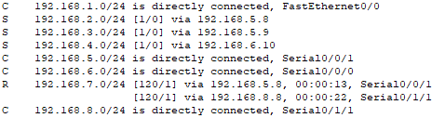

R2:

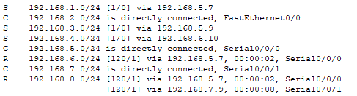

R3:

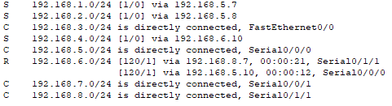

R4:

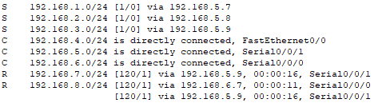

Вывод: в результате выполнения работы были приобретены практические навыки построения и организации сетей.