Учреждение образования

«Брестский государственный технический университет»

Кафедра ИИТ

Лабораторная работа №2

По дисциплине: «ООТПиСП»

Тема: «Основы Qt»

Выполнил:

Студент 3 курса

Группы ПО-7

Комиссаров А.Е.

Проверила:

Хацкевич М.В.

2022

**Цель:** развить понимание структуры приложения на Qt и получить опыт использования стандартной документации Qt.

**Задание:** разработка законченного оконного приложения — текстового редактора, работающего с несколькими документами с возможностями открытия и сохранения, отмены действий, работы с буфером обмена и другими.

**Ход выполнения задания:**

**Файл main.cpp**

#include "texteditor.h"

#include <QApplication>

#include <QIcon>

int main(int argc, char *argv[])

{

QApplication a(argc, argv);

a.setApplicationName("Text Editor");

a.setApplicationVersion("0.1");

a.setOrganizationName("ExampleSoft");

a.setOrganizationDomain("example.com");

TextEditor w;

w.show();

return a.exec();

}

**Файл texteditor.h**

#ifndef TEXTEDITOR_H

#define TEXTEDITOR_H

#include <QMainWindow>

#include <QString>

QT_BEGIN_NAMESPACE

namespace Ui { class TextEditor; }

QT_END_NAMESPACE

class TextEditor : public QMainWindow

{

Q_OBJECT

public:

TextEditor(const QString &fileName = QString(), QWidget *parent = nullptr);

~TextEditor();

private slots:

bool saveFile();

bool saveFileAs();

void on_actionNew_triggered();

void on_actionClose_triggered();

void on_actionExit_triggered();

void documentModified();

void on_textEdit_textChanged();

void on_actionSelectFont_triggered();

void on_actionAboutQt_triggered();

void on_actionCut_triggered();

void on_actionCopy_triggered();

void on_actionPaste_triggered();

void on_actionUndo_triggered();

void on_actionRedo_triggered();

void on_textEdit_copyAvailable(bool b);

void on_textEdit_redoAvailable(bool b);

void on_textEdit_undoAvailable(bool b);

void on_actionAbout_triggered();

void on_actionOpen_triggered();

void on_actionSave_triggered();

void on_actionSaveAs_triggered();

private:

void loadFile(const QString &fileName);

void setFileName(const QString &fileName);

Ui::TextEditor *ui;

QString m_fileName;

protected:

void closeEvent(QCloseEvent *e);

};

#endif // TEXTEDITOR_H

**Файл texteditor.cpp**

#include "texteditor.h"

#include "./ui_texteditor.h"

#include <QTextEdit>

#include <QMessageBox>

#include <QCloseEvent>

#include <QIcon>

#include <QFontDialog>

#include <QFont>

#include <QFile>

#include <QString>

#include <QFileInfo>

#include <QDir>

#include <QFileDialog>

#include <QTextStream>

#include <iostream>

#include <stdio.h>

TextEditor::TextEditor(const QString &fileName, QWidget *parent)

: QMainWindow(parent)

, ui(new Ui::TextEditor)

{

ui->setupUi(this);

this->setAttribute(Qt::WA_DeleteOnClose);

this->setWindowTitle("Text Editor[*]");

ui->actionCopy->setEnabled(false);

ui->actionCut->setEnabled(false);

ui->actionRedo->setEnabled(false);

ui->actionUndo->setEnabled(false);

loadFile(fileName);

}

void TextEditor::loadFile(const QString &fileName){

if (fileName.isEmpty()){

setFileName(QString());

return;

}

QString fileContents;

QFile file(fileName);

if (!file.open(QIODevice::ReadOnly | QIODevice::Text))

return;

while (!file.atEnd()) {

QByteArray line = file.readLine();

fileContents = fileContents + line + "\n";

}

ui->textEdit->setText(fileContents);

file.close();

setFileName(fileName);

this->setWindowModified(false);

}

void TextEditor::setFileName(const QString &fileName){

this->m_fileName = fileName;

this->setWindowTitle(QString("%1[*] - %2")

.arg(m_fileName.isNull()?"untitled":QFileInfo(m_fileName).fileName())

.arg(QApplication::applicationName()));

}

bool TextEditor::saveFileAs(){

QString fileName = QFileDialog::getSaveFileName(this, "Save document", m_fileName.isNull()?QDir::currentPath():m_fileName, "Text documents (*.txt)");

if(fileName.isNull()){return false;

}else{setFileName(fileName);

return saveFile();}

}

bool TextEditor::saveFile(){

if(this->m_fileName.isNull()){

return saveFileAs();

}else{

QFile file(m_fileName);

if (!file.open(QIODevice::WriteOnly | QIODevice::Text)){

QMessageBox msgBox;

msgBox.setIcon(QMessageBox::Warning);

msgBox.setText("File could not be saved properly, try again.");

msgBox.exec();

setFileName(QString());

return false;

}else{

QTextStream out(&file);

out << ui->textEdit->toPlainText();

file.close();

this->setWindowModified(false);

return true;

}

}

}

TextEditor::~TextEditor()

{

delete ui;

}

void TextEditor::on_actionNew_triggered()

{

TextEditor *new_editor = new TextEditor;

new_editor->show();

}

void TextEditor::on_actionClose_triggered()

{

this->close();

}

void TextEditor::on_actionExit_triggered()

{

qApp->closeAllWindows();

}

void TextEditor::documentModified(){

this->setWindowModified(true);

}

void TextEditor::closeEvent(QCloseEvent *e){

if (this->isWindowModified() == true){

QMessageBox msgBox;

msgBox.setIcon(QMessageBox::Warning);

msgBox.setText("The document has been modified.");

msgBox.setInformativeText("This document has been modified, do you want to save your changes?");

msgBox.setStandardButtons(QMessageBox::Yes | QMessageBox::No | QMessageBox::Cancel);

msgBox.setDefaultButton(QMessageBox::Cancel);

int ret = msgBox.exec();

switch(ret){

case QMessageBox::Yes :

saveFile();

break;

case QMessageBox::No :

e->accept();

break;

case QMessageBox::Cancel :

e->ignore();

break;

default :

e->ignore();

break;

}

}else{

e->accept();

}

}

void TextEditor::on_textEdit_textChanged()

{

this->documentModified();

}

void TextEditor::on_actionSelectFont_triggered()

{

this->setFont(QFontDialog::getFont(0, this->font()));

}

void TextEditor::on_actionAboutQt_triggered()

{

qApp->aboutQt();

}

void TextEditor::on_actionCut_triggered()

{

ui->textEdit->cut();

}

void TextEditor::on_actionCopy_triggered()

{

ui->textEdit->copy();

}

void TextEditor::on_actionPaste_triggered()

{

ui->textEdit->paste();

}

void TextEditor::on_actionUndo_triggered()

{

ui->textEdit->undo();

}

void TextEditor::on_actionRedo_triggered()

{

ui->textEdit->redo();

}

void TextEditor::on_textEdit_copyAvailable(bool b)

{

ui->actionCopy->setEnabled(b);

ui->actionCut->setEnabled(b);

}

void TextEditor::on_textEdit_redoAvailable(bool b)

{

ui->actionRedo->setEnabled(b);

}

void TextEditor::on_textEdit_undoAvailable(bool b)

{

ui->actionUndo->setEnabled(b);

}

void TextEditor::on_actionAbout_triggered()

{

QMessageBox msgBox;

msgBox.setText("Laboratornaya rabota 2 Qt.");

msgBox.exec();

}

void TextEditor::on_actionOpen_triggered()

{

QString fileName = QFileDialog::getOpenFileName(this,"Open document", QDir::currentPath(), "Text documents (*.txt)");

if (fileName.isNull()){return;}

if (!fileName.isNull() && !this->isWindowModified()){

loadFile(fileName);

} else {

TextEditor *new_editor = new TextEditor(fileName);

new_editor->show();

}

}

void TextEditor::on_actionSave_triggered()

{

saveFile();

}

void TextEditor::on_actionSaveAs_triggered()

{

saveFileAs();

}

**Файл texteditor.qrc**

<!DOCTYPE RCC>

<RCC version="1.0">

<qresource prefix="icons">

<file>images/copy.png</file>

<file>images/cut.png</file>

<file>images/new.png</file>

<file>images/open.png</file>

<file>images/paste.png</file>

<file>images/save.png</file>

</qresource>

</RCC>

**Файл texteditor.ui**

<?xml version="1.0" encoding="UTF-8"?>

<ui version="4.0">

<class>TextEditor</class>

<widget class="QMainWindow" name="TextEditor">

<property name="geometry">

<rect>

<x>0</x>

<y>0</y>

<width>800</width>

<height>600</height>

</rect>

</property>

<property name="minimumSize">

<size>

<width>800</width>

<height>600</height>

</size>

</property>

<property name="windowTitle">

<string>TextEditor</string>

</property>

<property name="windowIcon">

<iconset>

<normalon>:/icons/images/new.png</normalon>

</iconset>

</property>

<widget class="QWidget" name="centralwidget">

<widget class="QTextEdit" name="textEdit">

<property name="geometry">

<rect>

<x>0</x>

<y>0</y>

<width>800</width>

<height>550</height>

</rect>

</property>

</widget>

</widget>

<widget class="QMenuBar" name="menubar">

<property name="geometry">

<rect>

<x>0</x>

<y>0</y>

<width>800</width>

<height>21</height>

</rect>

</property>

<widget class="QMenu" name="menuFile">

<property name="title">

<string>File</string>

</property>

<addaction name="actionOpen"/>

<addaction name="actionNew"/>

<addaction name="separator"/>

<addaction name="actionSave"/>

<addaction name="actionSaveAs"/>

<addaction name="actionClose"/>

<addaction name="actionExit"/>

</widget>

<widget class="QMenu" name="menuView">

<property name="title">

<string>View</string>

</property>

<addaction name="actionSelectFont"/>

</widget>

<widget class="QMenu" name="menuAbout">

<property name="title">

<string>About...</string>

</property>

<addaction name="actionAbout"/>

<addaction name="actionAboutQt"/>

</widget>

<widget class="QMenu" name="menuEdit">

<property name="title">

<string>Edit</string>

</property>

<addaction name="actionOpen"/>

<addaction name="actionUndo"/>

<addaction name="actionRedo"/>

<addaction name="actionCut"/>

<addaction name="actionCopy"/>

<addaction name="actionPaste"/>

</widget>

<addaction name="menuFile"/>

<addaction name="menuEdit"/>

<addaction name="menuView"/>

<addaction name="menuAbout"/>

</widget>

<widget class="QStatusBar" name="statusbar"/>

<action name="actionNew">

<property name="icon">

<iconset resource="texteditor.qrc">

<normaloff>:/icons/images/new.png</normaloff>:/icons/images/new.png</iconset>

</property>

<property name="text">

<string>New File</string>

</property>

<property name="shortcut">

<string>Ctrl+N</string>

</property>

</action>

<action name="actionClose">

<property name="text">

<string>Close</string>

</property>

</action>

<action name="actionExit">

<property name="text">

<string>Exit</string>

</property>

</action>

<action name="actionSelectFont">

<property name="text">

<string>Select Font...</string>

</property>

<property name="toolTip">

<string>Select the display font</string>

</property>

</action>

<action name="actionAbout">

<property name="text">

<string>About</string>

</property>

</action>

<action name="actionAboutQt">

<property name="text">

<string>About Qt</string>

</property>

</action>

<action name="actionCut">

<property name="icon">

<iconset resource="texteditor.qrc">

<normaloff>:/icons/images/cut.png</normaloff>:/icons/images/cut.png</iconset>

</property>

<property name="text">

<string>Cut</string>

</property>

<property name="shortcut">

<string>Ctrl+X</string>

</property>

</action>

<action name="actionCopy">

<property name="icon">

<iconset resource="texteditor.qrc">

<normaloff>:/icons/images/copy.png</normaloff>:/icons/images/copy.png</iconset>

</property>

<property name="text">

<string>Copy</string>

</property>

<property name="shortcut">

<string>Ctrl+C</string>

</property>

</action>

<action name="actionPaste">

<property name="icon">

<iconset resource="texteditor.qrc">

<normaloff>:/icons/images/paste.png</normaloff>:/icons/images/paste.png</iconset>

</property>

<property name="text">

<string>Paste</string>

</property>

<property name="shortcut">

<string>Ctrl+V</string>

</property>

</action>

<action name="actionUndo">

<property name="text">

<string>Undo</string>

</property>

<property name="shortcut">

<string>Ctrl+Z</string>

</property>

</action>

<action name="actionRedo">

<property name="text">

<string>Redo</string>

</property>

<property name="shortcut">

<string>Ctrl+Y</string>

</property>

</action>

<action name="actionOpen">

<property name="icon">

<iconset resource="texteditor.qrc">

<normaloff>:/icons/images/open.png</normaloff>:/icons/images/open.png</iconset>

</property>

<property name="text">

<string>Open</string>

</property>

<property name="toolTip">

<string>Open a document</string>

</property>

<property name="shortcut">

<string>Ctrl+O</string>

</property>

</action>

<action name="actionSave">

<property name="icon">

<iconset resource="texteditor.qrc">

<normaloff>:/icons/images/save.png</normaloff>:/icons/images/save.png</iconset>

</property>

<property name="text">

<string>Save</string>

</property>

<property name="shortcut">

<string>Ctrl+S</string>

</property>

</action>

<action name="actionSaveAs">

<property name="text">

<string>Save as</string>

</property>

<property name="shortcut">

<string>Ctrl+Shift+S</string>

</property>

</action>

</widget>

<resources>

<include location="texteditor.qrc"/>

</resources>

<connections/>

</ui>

**Результат работы программы:**

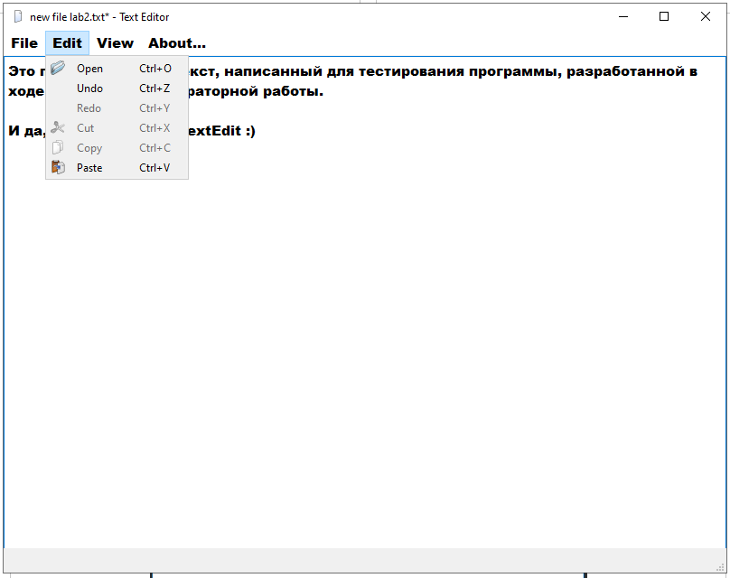

Рис. 1 – Результат работы программы

**Вывод:** я развил понимание структуры приложения на Qt и получил опыт использования стандартной документации Qt.