Министерство образования Республики Беларусь

Учреждение образования

«Брестский государственный технический университет»

Кафедра ИИТ

Лабораторная работа №1

По дисциплине: «ПИС»

Тема: “Сценарий транзакции”

Выполнил:

Студент 3 курса

Группы ПО-7

Комиссаров А.Е.

Проверил:

Михняев А.Л.

2023

**Цель работы:** реализовать минимальный функционал без детального проектирования согласно паттерну «сценарий транзакции».

**Задание:**

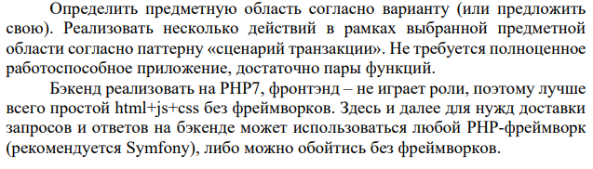

**Ход работы.**

**Файл addClient.php**

**<?php**

**$firstName = $_POST['firstName'];$lastName = $_POST['lastName'];$documentID = $_POST['documentID'];**

**$number = $_POST['number'];**

**$connection = mysqli_connect('localhost', 'root', '', 'pis_1');**

**$query = "INSERT INTO clients (clients_id, firstName, lastName, documentID, numberTel) VALUES (NULL, '$firstName', '$lastName', '$documentID', '$number')";**

**try { $result = mysqli_query($connection, $query);**

**echo '<div class="SuccessText">Client "'.$firstName.'" added to database.</div>';**

**} catch (mysqli_sql_exception $e) {**

**echo '<div class="FailText">There was an error processing your request. ('.$e->getMessage().')</div>';**

**}**

**?>**

**Файл addProduct.php**

**<?php**

**$title = $_POST['title'];$firm = $_POST['firm'];$price = $_POST['price'];**

**$connection = mysqli_connect('localhost', 'root', '', 'pis_1');**

**$query = "INSERT INTO products (products_id, title, firm, price) VALUES (NULL, '$title', '$firm', '$price')";**

**try { $result = mysqli_query($connection, $query);**

**echo '<div class="SuccessText">Product "'.$title.'" added to database.</div>';**

**} catch (mysqli_sql_exception $e) {**

**echo '<div class="FailText">There was an error processing your request. ('.$e->getMessage().')</div>';**

**}**

**?>**

**Файл addPurchase.php**

**<?php**

**$products_id = $_POST['products_id'];$clients_id = $_POST['clients_id'];**

**$connection = mysqli_connect('localhost', 'root', '', 'pis_1');**

**$query_getClients = "SELECT clients_id FROM clients WHERE clients_id = '$clients_id'";**

**$query_getProducts = "SELECT products_id FROM products WHERE products_id = '$products_id'";**

**$result_clients = mysqli_query($connection, $query_getClients);**

**$result_products = mysqli_query($connection, $query_getProducts);**

**if($result_clients->num_rows !== 0){**

**if($result_products->num_rows !== 0){**

**$query = "INSERT INTO purchases (purchases_id, clients_id, products_id) VALUES (NULL, '$clients_id', '$products_id')";**

**try { $result = mysqli_query($connection, $query);**

**echo '<div class="SuccessText">Purchase added to database.</div>';**

**} catch (mysqli_sql_exception $e) {**

**echo '<div class="FailText">There was an error processing your request. ('.$e->getMessage().')</div>';**

**}**

**} else {**

**echo '<div class="FailText">There was an error processing your request. (no such product)</div>';**

**}**

**} else {**

**echo '<div class="FailText">There was an error processing your request. (no such client)</div>';}?>**

**Файл editClients.php**

**<?php**

**if (isset($_POST['firstName'])) {  include "addClient.php";  }**

**?>**

**<!doctype html>**

**<html><head><link rel="stylesheet" href="css/style.css"></head>**

**<body>**

**<div class=header><a href=index.php class=button>Go back</a> Lab 1. Add client</div>**

**<div class="container">**

**<form action="editClients.php" method="post">**

**<p>Firstname: <input required type="text" name="firstName" /></p>**

**<p>Lastname: <input required type="text" name="lastName" /></p>**

**<p>Document ID: <input required type="number" name="documentID" /></p>**

**<p>Phone number: <input type="tel" name="number" /></p>**

**<p><input type="submit" value="Add client"></input></p>**

**</form>**

**<?php**

**include "output.php";**

**clientsOut();**

**?>**

**</div></body></html>**

**Файл editProduct.php**

**<?php**

**if (isset($_POST['title'])) {include "addProduct.php";}**

**?>**

**<!doctype html>**

**<html><head><link rel="stylesheet" href="css/style.css"></head>**

**<body>**

**<div class=header><a href=index.php class=button>Go back</a> Lab 1. Add client</div>**

**<div class="container">**

**<form action="editProduct.php" method="post">**

**<p>Product name: <input required type="text" name="title" /></p>**

**<p>Manufacturer: <input required type="text" name="firm" /></p>**

**<p>Price: <input required type="number" step="0.01" name="price" /></p>**

**<p><input type="submit" value="Add client"></input></p>**

**</form>**

**<?php**

**include "output.php";**

**productsOut();**

**?>**

**</div></body></html>**

**Файл editPurchase.php**

**<?php**

**if (isset($_POST['clients_id'])) {include "addPurchase.php";}**

**?>**

**<!doctype html>**

**<html><head><link rel="stylesheet" href="css/style.css"></head>**

**<body>**

**<div class=header><a href=index.php class=button>Go back</a> Lab 1. Add client</div>**

**<div class="container">**

**<form action="editPurchase.php" method="post">**

**<p>Client ID: <input required type="number" name="clients_id" /></p>**

**<p>Product ID: <input required type="number" name="products_id" /></p>**

**<p><input type="submit" value="Add purchase"></input></p>**

**</form>**

**<?php**

**include "output.php";**

**purchasesOut();**

**?>**

**</div></body></html>**

**Файл index.php**

**<!doctype html>**

**<html><head><link rel="stylesheet" href="css/style.css"></head>**

**<body>**

**<div class=header>Lab 1. Index</div>**

**<div class=menuContainer>**

**<a href=editClients.php class=button>Add client</a>**

**<a href=editProduct.php class=button>Add product</a>**

**<a href=editPurchase.php class=button>Add purchase</a>**

**<a href=viewItems.php class=button>View tables</a>**

**</div></body></html>**

**Файл output.php**

**<?php**

**function productsOut(){**

**$connection = mysqli_connect('localhost', 'root', '', 'pis_1');**

**$query = "SELECT * FROM `products`";**

**$result = mysqli_query($connection, $query) or die("Error in query productsOut()");**

**echo '<table><tr><th>ID</th><th>Title</th><th>Firm</th><th>Price</th></tr>';**

**while($row = mysqli_fetch_array($result)){**

**echo '<tr><td>'.$row['products_id'].'</td><td>'.$row['title'].'</td><td>'.$row['firm'].'</td><td>'.$row['price'].'</td></tr>';**

**}**

**echo '</table>';**

**}**

**function clientsOut(){**

**$connection = mysqli_connect('localhost', 'root', '', 'pis_1');**

**$query = "SELECT * FROM `clients`";**

**$result = mysqli_query($connection, $query) or die("Error in query clientsOut()");**

**echo '<table><tr><th>ID</th><th>First name</th><th>Last Name</th><th>Document ID</th><th>Number</th></tr>';**

**while($row = mysqli_fetch_array($result)){**

**echo '<tr><td>'.$row['clients_id'].'</td><td>'.$row['firstName'].'</td><td>'.$row['lastName'].'</td><td>'.$row['documentID'].'</td><td>'.$row['numberTel'].'</td></tr>';**

**}**

**echo '</table>';**

**}**

**function purchasesOut(){**

**$connection = mysqli_connect('localhost', 'root', '', 'pis_1');**

**$query = "SELECT * FROM `purchases`";**

**$result = mysqli_query($connection, $query) or die("Error in query purchasesOut()");**

**echo '<table><tr><th>Purchases_id</th><th>Clients_id</th><th>Products_id</th></tr>';**

**while($row = mysqli_fetch_array($result)){**

**echo '<tr><td>'.$row['purchases_id'].'</td><td>'.$row['clients_id'].'</td><td>'.$row['products_id'].'</td></tr>';**

**}**

**echo '</table>';**

**}**

**?>**

**Файл viewItems.php**

**<!doctype html>**

**<html>**

**<head>**

**<link rel="stylesheet" href="css/style.css">**

**</head>**

**<body>**

**<div class=header><a href=index.php class=button>Go back</a> Lab 1. View all</div>**

**<div class="container" id="viewAll">**

**<?php**

**include "output.php";**

**clientsOut();**

**productsOut();**

**purchasesOut();**

**?>**

**</div>**

**</body>**

**</html>**

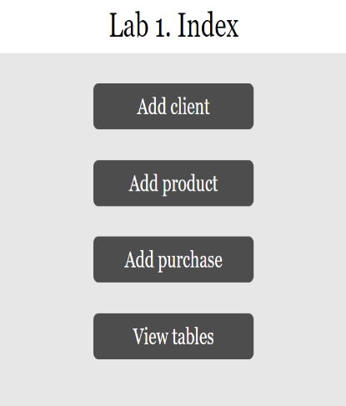**Результат работы программы:**

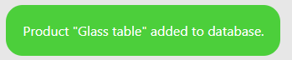



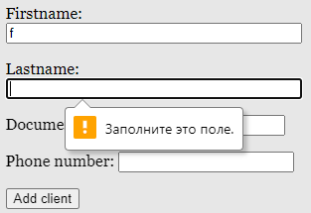

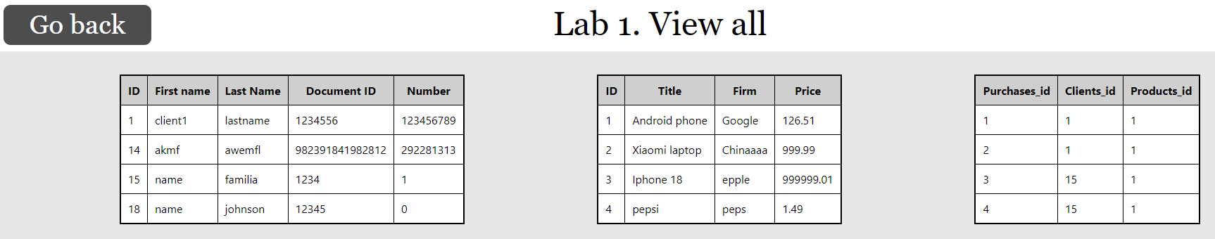

**Вывод:** я реализовал минимальный функционал без детального проектирования согласно паттерну «сценарий транзакции».