Министерство образования Республики Беларусь

Учреждение образования

«Брестский государственный технический университет»

Кафедра ИИТ

Лабораторная работа №4

По дисциплине: «СПП»

Тема: “Многооконные приложения. JDBC.”

Выполнил:

Студент 3 курса

Группы ПО-7

Комиссаров А.Е.

Проверил:

Монтик Н.С.

2023

**Цель работы:** приобрести практические навыки разработки многооконных приложений на JavaFX для работы с базами данных.

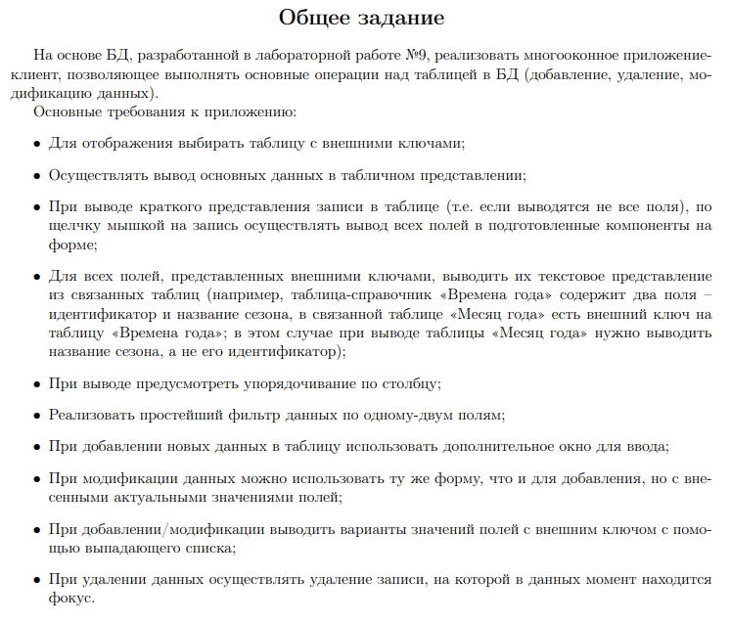



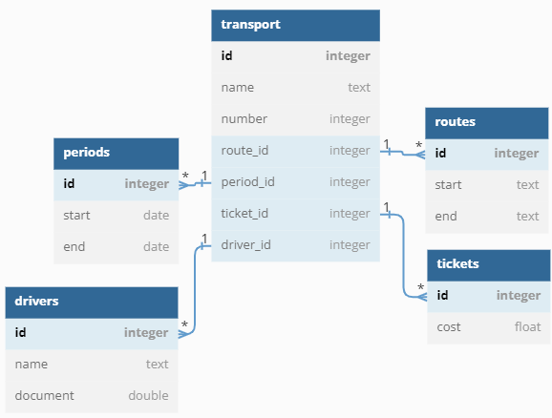

Рис. 1 – Схема базы данных.

**Ход работы.**

**Модуль Connector. - Файл MysqlConnector.java**

**package com.example.lab4_new.Connector;**

**import com.example.lab4_new.Controllers.HelloController;**

**import com.example.lab4_new.Model.Info;**

**import java.sql.*;**

**import java.util.ArrayList;**

**import java.util.List;**

**public class MysqlConnector {**

**public static HelloController mHelloController;**

**public MysqlConnector(HelloController helloController) throws SQLException, ClassNotFoundException {**

**mHelloController = helloController;**

**}**

**public List<Info> connection() throws ClassNotFoundException, SQLException {**

**String url = "jdbc:mysql://localhost:3306/spp", user = "root", passwd = "";**

**Class.forName("com.mysql.cj.jdbc.Driver");**

**try (Connection connection = DriverManager.getConnection(url, user, passwd)) {**

**System.out.println("Connected to " + url + " as " + user + " (no passwd)");**

**Statement statement = connection.createStatement();**

**try {**

**List<Info> list = new ArrayList<>();**

**ResultSet result;**

**System.out.println("Executing query...");**

**result = statement.executeQuery(**

**"SELECT " +**

**"transport.id, " +**

**"transport.name, " +**

**"transport.number, " +**

**"routes.start, " +**

**"routes.end, " +**

**"periods.start, " +**

**"periods.end, " +**

**"tickets.cost, " +**

**"drivers.name " +**

**"FROM transport " +**

**"INNER JOIN routes ON transport.route_id = routes.id " +**

**"INNER JOIN periods ON transport.period_id = periods.id " +**

**"INNER JOIN tickets ON transport.ticket_id = tickets.id " +**

**"INNER JOIN drivers ON transport.driver_id = drivers.id ") ;**

**System.out.println("Received stuff from db, reading...");**

**while (result.next()) {**

**System.out.println("Creating info object from transport with id="+result.getInt("transport.id"));**

**list.add(**

**new Info(**

**result.getInt("transport.id"),**

**result.getString("routes.start"),**

**result.getString("routes.end"),**

**result.getString("periods.start"),**

**result.getString("periods.end"),**

**result.getString("tickets.cost"),**

**result.getString("transport.name"),**

**result.getString("transport.number"),**

**result.getString("drivers.name")**

**)**

**);**

**}**

**return list;**

**} catch (Exception exception) {**

**System.out.println(exception.getMessage());**

**}**

**}**

**return null;**

**}**

**public static List<String> getRoute() throws ClassNotFoundException {**

**System.out.println("Getting available routes.");**

**List<String> list = new ArrayList<>();**

**String url = "jdbc:mysql://localhost:3306/spp", user = "root", passwd = "";**

**Class.forName("com.mysql.cj.jdbc.Driver");**

**String sql = "SELECT * FROM routes";**

**try (Connection connection = DriverManager.getConnection(url, user, passwd)) {**

**Statement statement = connection.createStatement();**

**ResultSet resultSet = statement.executeQuery(sql);**

**while (resultSet.next()) {**

**list.add(resultSet.getString("start") + "-" + resultSet.getString("end"));**

**}**

**} catch (SQLException throwables) {**

**throwables.printStackTrace();**

**}**

**System.out.println("Successfully got routes.");**

**return list;**

**}**

**public static List<String> getTime() throws ClassNotFoundException {**

**System.out.println("Getting available time.");**

**List<String> list = new ArrayList<>();**

**String url = "jdbc:mysql://localhost:3306/spp", user = "root", passwd = "";**

**Class.forName("com.mysql.cj.jdbc.Driver");**

**String sql = "SELECT * FROM periods";**

**try (Connection connection = DriverManager.getConnection(url, user, passwd)) {**

**Statement statement = connection.createStatement();**

**ResultSet resultSet = statement.executeQuery(sql);**

**while (resultSet.next()) {**

**list.add(resultSet.getString("start") + "-" + resultSet.getString("end"));**

**}**

**} catch (SQLException throwables) {**

**throwables.printStackTrace();**

**}**

**System.out.println("Time receive success.");**

**return list;**

**}**

**public static List<String> getCost() throws ClassNotFoundException {**

**System.out.println("Getting available cost.");**

**List<String> list = new ArrayList<>();**

**String url = "jdbc:mysql://localhost:3306/spp", user = "root", passwd = "";**

**Class.forName("com.mysql.cj.jdbc.Driver");**

**String sql = "SELECT * FROM tickets";**

**try (Connection connection = DriverManager.getConnection(url, user, passwd)) {**

**Statement statement = connection.createStatement();**

**ResultSet resultSet = statement.executeQuery(sql);**

**while (resultSet.next()) {**

**list.add(resultSet.getString("cost"));**

**}**

**} catch (SQLException throwables) {**

**throwables.printStackTrace();**

**}**

**System.out.println("Cost receive success.");**

**return list;**

**}**

**public static List<String> getDriver() throws ClassNotFoundException {**

**System.out.println("Getting available drivers.");**

**List<String> list = new ArrayList<>();**

**String url = "jdbc:mysql://localhost:3306/spp", user = "root", passwd = "";**

**Class.forName("com.mysql.cj.jdbc.Driver");**

**String sql = "SELECT * FROM drivers";**

**try (Connection connection = DriverManager.getConnection(url, user, passwd)) {**

**Statement statement = connection.createStatement();**

**ResultSet resultSet = statement.executeQuery(sql);**

**while (resultSet.next()) {**

**list.add(resultSet.getString("name"));**

**}**

**} catch (SQLException throwables) {**

**throwables.printStackTrace();**

**}**

**System.out.println("Driver names receive success.");**

**return list;**

**}**

**public static int getLastId() {**

**return 0;**

**}**

**public static void insertInfo(Info info) throws ClassNotFoundException {**

**System.out.println("insertInfo called.");**

**String url = "jdbc:mysql://localhost:3306/spp", user = "root", passwd = "";**

**Class.forName("com.mysql.cj.jdbc.Driver");**

**String sql = "insert into transport (name, number, route_id, period_id, ticket_id, driver_id) " +**

**"values ((?), (?),"+**

**"(SELECT id FROM routes where start = ? AND end = ?)," +**

**"(SELECT id FROM periods where start = ? AND end = ?)," +**

**"(SELECT id FROM tickets where cost = ?)," +**

**"(SELECT id FROM drivers where name = ?))";**

**try(Connection connection = DriverManager.getConnection(url, user, passwd)) {**

**System.out.println("Connected, inserting info...");**

**PreparedStatement preparedStatement = connection.prepareStatement(sql);**

**preparedStatement.setString(1, info.getTransportName());**

**preparedStatement.setString(2, info.getTransportNumber());**

**preparedStatement.setString(3, info.getPathStart());**

**preparedStatement.setString(4, info.getPathEnd());**

**preparedStatement.setString(5, info.getTimeStart());**

**preparedStatement.setString(6, info.getTimeEnd());**

**preparedStatement.setString(7, info.getCost());**

**preparedStatement.setString(8, info.getDriverName());**

**preparedStatement.executeUpdate();**

**System.out.println("Success. Refreshing...");**

**mHelloController.onClickRefresh();**

**} catch (SQLException throwables) {**

**throwables.printStackTrace();**

**}**

**}**

**public static void updateInfo(Info info) throws ClassNotFoundException {**

**System.out.println("updateInfo called.");**

**String url = "jdbc:mysql://localhost:3306/spp", user = "root", passwd = "";**

**Class.forName("com.mysql.cj.jdbc.Driver");**

**String sql = "UPDATE transport SET name = ?, number = ?, " +**

**"route_id = (SELECT id FROM routes where start = ? AND end = ?)," +**

**"period_id = (SELECT id FROM periods where start = ? AND end = ?)," +**

**"ticket_id = (SELECT id FROM tickets where cost = ?)," +**

**"driver_id = (SELECT id FROM drivers where name = ?) " +**

**"WHERE id = ?";**

**try(Connection connection = DriverManager.getConnection(url, user, passwd)) {**

**System.out.println("Connected, updating info...");**

**PreparedStatement preparedStatement = connection.prepareStatement(sql);**

**preparedStatement.setString(1, info.getTransportName());**

**preparedStatement.setString(2, info.getTransportNumber());**

**preparedStatement.setString(3, info.getPathStart());**

**preparedStatement.setString(4, info.getPathEnd());**

**preparedStatement.setString(5, info.getTimeStart());**

**preparedStatement.setString(6, info.getTimeEnd());**

**preparedStatement.setString(7, info.getCost());**

**preparedStatement.setString(8, info.getDriverName());**

**preparedStatement.setInt(9, info.getId());**

**preparedStatement.executeUpdate();**

**System.out.println("Success. Refreshing...");**

**mHelloController.onClickRefresh();**

**} catch (SQLException throwables) {**

**throwables.printStackTrace();**

**}**

**}**

**public static void deleteInfo(int ID) throws ClassNotFoundException {**

**System.out.println("deleteInfo called.");**

**String url = "jdbc:mysql://localhost:3306/spp", user = "root", passwd = "";**

**Class.forName("com.mysql.cj.jdbc.Driver");**

**String sql = "DELETE FROM transport WHERE id = ?";**

**try (Connection connection = DriverManager.getConnection(url, user, passwd)) {**

**System.out.println("Connected, deleting...");**

**PreparedStatement preparedStatement = connection.prepareStatement(sql);**

**preparedStatement.setInt(1, ID);**

**preparedStatement.executeUpdate();**

**System.out.println("Success. Refreshing...");**

**mHelloController.onClickRefresh();**

**} catch (SQLException throwables) {**

**throwables.printStackTrace();**

**}**

**}**

**}**

**Модуль Controllers. - Файл EditController.java**

**package com.example.lab4_new.Controllers;**

**import com.example.lab4_new.Connector.MysqlConnector;**

**import com.example.lab4_new.Model.Info;**

**import javafx.collections.FXCollections;**

**import javafx.collections.ObservableList;**

**import javafx.event.ActionEvent;**

**import javafx.fxml.FXML;**

**import javafx.scene.control.Button;**

**import javafx.scene.control.ComboBox;**

**import javafx.scene.control.TextField;**

**import javafx.stage.Stage;**

**public class EditController {**

**@FXML**

**public Button bottonOk;**

**@FXML**

**public TextField Name;**

**@FXML**

**public TextField Number;**

**@FXML**

**public ComboBox<String> Route;**

**@FXML**

**public ComboBox<String> Time;**

**@FXML**

**public ComboBox<String> Cost;**

**@FXML**

**public ComboBox<String> DriverName;**

**public static int id;**

**public static String name;**

**public static String number;**

**public static String route;**

**public static String time;**

**public static String cost;**

**public static String driverName;**

**Info insertableInfo;**

**public static void setInfo(int ID, String Name, String Number, String Route, String Time, String Cost, String DriverName) {**

**id = ID;**

**name = Name;**

**number = Number;**

**route = Route;**

**time = Time;**

**cost = Cost;**

**driverName = DriverName;**

**}**

**@FXML**

**void initialize() {**

**try {**

**Name.setText(name);**

**Number.setText(number);**

**ObservableList<String> RouteList = FXCollections.observableArrayList(MysqlConnector.getRoute());**

**Route.setItems(RouteList);**

**Route.setValue(route);**

**ObservableList<String> TimeList = FXCollections.observableArrayList(MysqlConnector.getTime());**

**Time.setItems(TimeList);**

**Time.setValue(time);**

**ObservableList<String> CostList = FXCollections.observableArrayList(MysqlConnector.getCost());**

**Cost.setItems(CostList);**

**Cost.setValue(cost);**

**ObservableList<String> DriverList = FXCollections.observableArrayList(MysqlConnector.getDriver());**

**DriverName.setItems(DriverList);**

**DriverName.setValue(driverName);**

**} catch (Exception e) {**

**System.out.println(e.getMessage());**

**}**

**}**

**public void onClickUpdate(ActionEvent actionEvent) throws ClassNotFoundException {**

**if(Name.getText() == null || Number.getText() == null || Route.getValue() == null || Time.getValue() == null || Cost.getValue() == null || DriverName.getValue() == null) return;**

**String[] pathTokens = Route.getValue().split("-");**

**String[] timeTokens = Time.getValue().split("-");**

**System.out.println(pathTokens[0]);**

**System.out.println(pathTokens[1]);**

**System.out.println(timeTokens[0]);**

**System.out.println(timeTokens[1]);**

**if(pathTokens.length == 2 && timeTokens.length == 2){**

**insertableInfo = new Info(**

**id,**

**pathTokens[0],**

**pathTokens[1],**

**timeTokens[0],**

**timeTokens[1],**

**Cost.getValue(),**

**Name.getText(),**

**Number.getText(),**

**DriverName.getValue());**

**MysqlConnector.updateInfo(insertableInfo);**

**}**

**Stage stage = (Stage) bottonOk.getScene().getWindow();**

**stage.close();**

**}**

**}**

**Модуль Controllers. - Файл HelloController.java**

**package com.example.lab4_new.Controllers;**

**import com.example.lab4_new.Connector.MysqlConnector;**

**import com.example.lab4_new.Model.Info;**

**import javafx.beans.value.ChangeListener;**

**import javafx.beans.value.ObservableValue;**

**import javafx.collections.FXCollections;**

**import javafx.collections.ObservableList;**

**import javafx.event.ActionEvent;**

**import javafx.fxml.FXML;**

**import javafx.fxml.FXMLLoader;**

**import javafx.scene.Scene;**

**import javafx.scene.control.Button;**

**import javafx.scene.control.TableColumn;**

**import javafx.scene.control.TableView;**

**import javafx.scene.control.cell.PropertyValueFactory;**

**import javafx.stage.Stage;**

**import java.io.IOException;**

**import java.sql.SQLException;**

**import java.util.logging.Level;**

**import java.util.logging.Logger;**

**public class HelloController {**

**public HelloController() throws SQLException, ClassNotFoundException {**

**System.out.println("Creating new DBConnector object.");**

**bdController = new MysqlConnector(this);**

**}**

**public TableView<Info> table;**

**@FXML**

**private TableColumn<Info, String> idColumn;**

**@FXML**

**private TableColumn<Info, String> transportNameColumn;**

**@FXML**

**private TableColumn<Info, String> transportNumberColumn;**

**@FXML**

**private TableColumn<Info, String> pathStartColumn;**

**@FXML**

**private TableColumn<Info, String> pathEndColumn;**

**@FXML**

**private TableColumn<Info, String> timeStartColumn;**

**@FXML**

**private TableColumn<Info, String> timeEndColumn;**

**@FXML**

**private TableColumn<Info, String> costColumn;**

**@FXML**

**private TableColumn<Info, String> driverNameColumn;**

**public ObservableList<Info> listview = FXCollections.observableArrayList();**

**public int id;**

**public String transportName;**

**public String transportNumber;**

**public String pathStart;**

**public String pathEnd;**

**public String timeStart;**

**public String timeEnd;**

**public String cost;**

**public String driverName;**

**private final MysqlConnector bdController;**

**@FXML**

**public Button Add;**

**@FXML**

**public Button Change;**

**@FXML**

**public Button Delete;**

**@FXML**

**public Button Refresh;**

**@FXML**

**public Button AllInfo;**

**@FXML**

**void initialize() throws SQLException, ClassNotFoundException {**

**try {**

**System.out.println("Initializing HelloController...");**

**listview.addAll(bdController.connection());**

**for(Info i: listview ){**

**System.out.println("- - - - - - - - - - - - - -");**

**System.out.println(" ID : " + i.getId());**

**System.out.println("NAME: " + i.getTransportName());**

**System.out.println("NUMB: " + i.getTransportNumber());**

**System.out.println("PSTR: " + i.getPathStart());**

**System.out.println("PEND: " + i.getPathEnd());**

**System.out.println("TSRT: " + i.getTimeStart());**

**System.out.println("TEND: " + i.getTimeEnd());**

**System.out.println("COST: " + i.getCost());**

**System.out.println("DNME: " + i.getDriverName());**

**}**

**} catch (ClassNotFoundException | SQLException e) {**

**throw new RuntimeException(e);**

**}**

**idColumn.setCellValueFactory(new PropertyValueFactory<Info, String>("id"));**

**transportNameColumn.setCellValueFactory(new PropertyValueFactory<Info, String>("transportName"));**

**transportNumberColumn.setCellValueFactory(new PropertyValueFactory<Info, String>("transportNumber"));**

**pathStartColumn.setCellValueFactory(new PropertyValueFactory<Info, String>("pathStart"));**

**pathEndColumn.setCellValueFactory(new PropertyValueFactory<Info, String>("pathEnd"));**

**timeStartColumn.setCellValueFactory(new PropertyValueFactory<Info, String>("timeStart"));**

**timeEndColumn.setCellValueFactory(new PropertyValueFactory<Info, String>("timeEnd"));**

**costColumn.setCellValueFactory(new PropertyValueFactory<Info, String>("cost"));**

**driverNameColumn.setCellValueFactory(new PropertyValueFactory<Info, String>("driverName"));**

**table.setItems(listview);**

**table.getSortOrder().add(idColumn);**

**TableView.TableViewSelectionModel<Info> selectionModel = table.getSelectionModel();**

**selectionModel.selectedItemProperty().addListener(new ChangeListener<Info>(){**

**@Override**

**public void changed(ObservableValue<? extends Info> observableValue, Info oldval, Info newVal) {**

**if(newVal != null) {**

**System.out.println("New row selected. ID="+newVal.getId());**

**id = newVal.getId();**

**transportName = newVal.getTransportName();**

**transportNumber = newVal.getTransportNumber();**

**pathStart = newVal.getPathStart();**

**pathEnd = newVal.getPathEnd();**

**timeStart = newVal.getTimeStart();**

**timeEnd = newVal.getTimeEnd();**

**cost = newVal.getCost();**

**driverName = newVal.getDriverName();**

**}**

**}**

**});**

**}**

**public void onClickRefresh() throws SQLException, ClassNotFoundException {**

**System.out.println("Refresh called, clearing and re-adding elements.");**

**listview.clear();**

**listview.addAll(bdController.connection());**

**table.setItems(listview);**

**table.getSortOrder().add(idColumn);**

**}**

**public void onClickAdd(ActionEvent actionEvent) {**

**System.out.println("Add clicked, creating scene.");**

**try {**

**FXMLLoader fxmlLoader = new FXMLLoader();**

**fxmlLoader.setLocation(getClass().getResource("/com/example/lab4_new/insert.fxml"));**

**Scene scene = new Scene(fxmlLoader.load(), 400, 400);**

**Stage stage = new Stage();**

**stage.setTitle("Add Element");**

**stage.setScene(scene);**

**stage.show();**

**} catch (IOException e) {**

**System.out.println(e.getMessage());**

**Logger logger = Logger.getLogger(getClass().getName());**

**logger.log(Level.SEVERE, "Failed to create new Window.", e.getMessage());**

**}**

**}**

**public void onClickChange(ActionEvent actionEvent) {**

**System.out.println("Change clicked, creating scene and setting up info.");**

**try {**

**FXMLLoader fxmlLoader = new FXMLLoader();**

**EditController.setInfo(id, transportName, transportNumber, pathStart + "-" + pathEnd, timeStart + "-" + timeEnd, cost, driverName);**

**fxmlLoader.setLocation(getClass().getResource("/com/example/lab4_new/update.fxml"));**

**Scene scene = new Scene(fxmlLoader.load(), 400, 400);**

**Stage stage = new Stage();**

**stage.setTitle("Update Element");**

**stage.setScene(scene);**

**stage.show();**

**} catch (IOException e) {**

**System.out.println(e.getMessage());**

**Logger logger = Logger.getLogger(getClass().getName());**

**logger.log(Level.SEVERE, "Failed to create new Window.", e.getMessage());**

**}**

**}**

**public void onClickDelete(ActionEvent actionEvent) throws SQLException, ClassNotFoundException {**

**System.out.println("Delete clicked, calling deleteInfo(id).");**

**if(id < 1) return;**

**MysqlConnector.deleteInfo(id);**

**id = 0;**

**}**

**}**

**Модуль Controllers. - Файл InsertController.java**

**package com.example.lab4_new.Controllers;**

**import com.example.lab4_new.Connector.MysqlConnector;**

**import com.example.lab4_new.Model.Info;**

**import javafx.collections.FXCollections;**

**import javafx.collections.ObservableList;**

**import javafx.event.ActionEvent;**

**import javafx.fxml.FXML;**

**import javafx.scene.control.Button;**

**import javafx.scene.control.ComboBox;**

**import javafx.scene.control.TextField;**

**import javafx.stage.Stage;**

**public class InsertController {**

**@FXML**

**public Button bottonOk;**

**@FXML**

**public TextField Name;**

**@FXML**

**public TextField Number;**

**@FXML**

**public ComboBox<String> Route;**

**@FXML**

**public ComboBox<String> Time;**

**@FXML**

**public ComboBox<String> Cost;**

**@FXML**

**public ComboBox<String> DriverName;**

**Info insertableInfo;**

**@FXML**

**void initialize() {**

**try {**

**ObservableList<String> RouteList = FXCollections.observableArrayList(MysqlConnector.getRoute());**

**Route.setItems(RouteList);**

**ObservableList<String> TimeList = FXCollections.observableArrayList(MysqlConnector.getTime());**

**Time.setItems(TimeList);**

**ObservableList<String> CostList = FXCollections.observableArrayList(MysqlConnector.getCost());**

**Cost.setItems(CostList);**

**ObservableList<String> DriverList = FXCollections.observableArrayList(MysqlConnector.getDriver());**

**DriverName.setItems(DriverList);**

**} catch (Exception e) {**

**System.out.println(e.getMessage());**

**}**

**}**

**public void onClickInsert(ActionEvent actionEvent) throws ClassNotFoundException {**

**if(Name.getText() == null || Number.getText() == null || Route.getValue() == null || Time.getValue() == null || Cost.getValue() == null || DriverName.getValue() == null) return;**

**String[] pathTokens = Route.getValue().split("-");**

**String[] timeTokens = Time.getValue().split("-");**

**System.out.println(pathTokens[0]);**

**System.out.println(pathTokens[1]);**

**System.out.println(timeTokens[0]);**

**System.out.println(timeTokens[1]);**

**if(pathTokens.length == 2 && timeTokens.length == 2){**

**insertableInfo = new Info(**

**MysqlConnector.getLastId() + 1,**

**pathTokens[0],**

**pathTokens[1],**

**timeTokens[0],**

**timeTokens[1],**

**Cost.getValue(),**

**Name.getText(),**

**Number.getText(),**

**DriverName.getValue());**

**MysqlConnector.insertInfo(insertableInfo);**

**}**

**Stage stage = (Stage) bottonOk.getScene().getWindow();**

**stage.close();**

**}**

**}**

**Модуль Model - Файл Info.java**

**package com.example.lab4_new.Model;**

**public class Info {**

**int id;**

**String transportName;**

**String transportNumber;**

**String pathStart;**

**String pathEnd;**

**String timeStart;**

**String timeEnd;**

**String cost;**

**String driverName;**

**public Info(int id, String pathStart, String pathEnd, String timeStart, String timeEnd, String cost, String transportName, String transportNumber, String driver) {**

**this.id = id;**

**this.pathStart = pathStart;**

**this.pathEnd = pathEnd;**

**this.timeStart = timeStart;**

**this.timeEnd = timeEnd;**

**this.cost = cost;**

**this.transportName = transportName;**

**this.transportNumber = transportNumber;**

**this.driverName = driver;**

**}**

**public String getDriverName() {**

**return driverName;**

**}**

**public void setDriverName(String driverName) {**

**this.driverName = driverName;**

**}**

**public int getId() {**

**return id;**

**}**

**public void setId(int id) {**

**this.id = id;**

**}**

**public String getPathStart() {**

**return pathStart;**

**}**

**public void setPathStart(String pathStart) {**

**this.pathStart = pathStart;**

**}**

**public String getPathEnd() {**

**return pathEnd;**

**}**

**public void setPathEnd(String pathEnd) {**

**this.pathEnd = pathEnd;**

**}**

**public String getTimeStart() {**

**return timeStart;**

**}**

**public void setTimeStart(String timeStart) {**

**this.timeStart = timeStart;**

**}**

**public String getTimeEnd() {**

**return timeEnd;**

**}**

**public void setTimeEnd(String timeEnd) {**

**this.timeEnd = timeEnd;**

**}**

**public String getCost() {**

**return cost;**

**}**

**public void setCost(String cost) {**

**this.cost = cost;**

**}**

**public String getTransportName() {**

**return transportName;**

**}**

**public void setTransportName(String transportName) {**

**this.transportName = transportName;**

**}**

**public String getTransportNumber() {**

**return transportNumber;**

**}**

**public void setTransportNumber(String transportNumber) {**

**this.transportNumber = transportNumber;**

**}**

**}**

**Файл HelloApplication.java**

**package com.example.lab4_new;**

**import javafx.application.Application;**

**import javafx.fxml.FXMLLoader;**

**import javafx.scene.Scene;**

**import javafx.stage.Stage;**

**import java.io.IOException;**

**public class HelloApplication extends Application {**

**@Override**

**public void start(Stage stage) throws IOException {**

**FXMLLoader fxmlLoader = new FXMLLoader(HelloApplication.class.getResource("/com/example/lab4_new/hello-view.fxml"));**

**Scene scene = new Scene(fxmlLoader.load(), 1000, 540);**

**stage.setTitle("Lab4");**

**stage.setScene(scene);**

**stage.show();**

**}**

**public static void main(String[] args) {**

**launch();**

**}**

**}**

**Файл module-info.java**

**module com.example.lab4_new {**

**requires javafx.controls;**

**requires javafx.fxml;**

**requires java.sql;**

**requires mysql.connector.java;**

**opens com.example.lab4_new to javafx.fxml;**

**exports com.example.lab4_new;**

**exports com.example.lab4_new.Controllers;**

**opens com.example.lab4_new.Controllers to javafx.fxml;**

**exports com.example.lab4_new.Connector;**

**opens com.example.lab4_new.Connector to javafx.fxml;**

**exports com.example.lab4_new.Model;**

**opens com.example.lab4_new.Model to javafx.fxml;**

**}**

**Файл hello-view.fxml**

**<?xml version="1.0" encoding="UTF-8"?>**

**<?import javafx.scene.control.*?>**

**<?import javafx.scene.layout.*?>**

**<AnchorPane maxHeight="-Infinity" maxWidth="-Infinity" minHeight="-Infinity" minWidth="-Infinity" prefHeight="544.0" prefWidth="1000.0" xmlns="http://javafx.com/javafx/16" xmlns:fx="http://javafx.com/fxml/1" fx:controller="com.example.lab4_new.Controllers.HelloController">**

**<children>**

**<TableView fx:id="table" layoutX="7.0" layoutY="6.0" prefHeight="525.0" prefWidth="782.0">**

**<columns>**

**<TableColumn fx:id="idColumn" prefWidth="75.0" text="ID" />**

**<TableColumn fx:id="transportNameColumn" prefWidth="75.0" text="Name" />**

**<TableColumn fx:id="transportNumberColumn" prefWidth="75.0" text="Number" />**

**<TableColumn fx:id="pathStartColumn" prefWidth="75.0" text="Route start" />**

**<TableColumn fx:id="pathEndColumn" prefWidth="75.0" text="Route end" />**

**<TableColumn fx:id="timeStartColumn" prefWidth="75.0" text="Time start" />**

**<TableColumn fx:id="timeEndColumn" prefWidth="75.0" text="Time end" />**

**<TableColumn fx:id="costColumn" prefWidth="75.0" text="Cost" />**

**<TableColumn fx:id="driverNameColumn" prefWidth="75.0" text="Driver" />**

**</columns>**

**</TableView>**

**<Button fx:id="Add" layoutX="815.0" layoutY="101.0" mnemonicParsing="false" onAction="#onClickAdd" prefHeight="34.0" prefWidth="114.0" text="Add" />**

**<Button fx:id="Change" layoutX="815.0" layoutY="171.0" mnemonicParsing="false" onAction="#onClickChange" prefHeight="34.0" prefWidth="114.0" text="Change" />**

**<Button fx:id="Delete" layoutX="815.0" layoutY="252.0" mnemonicParsing="false" onAction="#onClickDelete" prefHeight="34.0" prefWidth="114.0" text="Delete" />**

**<Button fx:id="Refresh" layoutX="815.0" layoutY="337.0" mnemonicParsing="false" onAction="#onClickRefresh" prefHeight="34.0" prefWidth="114.0" text="Refresh" />**

**</children>**

**</AnchorPane>**

**Файл insert.fxml**

**<?xml version="1.0" encoding="UTF-8"?>**

**<?import javafx.scene.control.Button?>**

**<?import javafx.scene.control.ComboBox?>**

**<?import javafx.scene.control.TextField?>**

**<?import javafx.scene.layout.AnchorPane?>**

**<AnchorPane maxHeight="-Infinity" maxWidth="-Infinity" minHeight="-Infinity" minWidth="-Infinity" prefHeight="450.0" prefWidth="518.0" xmlns="http://javafx.com/javafx/16" xmlns:fx="http://javafx.com/fxml/1" fx:controller="com.example.lab4_new.Controllers.InsertController">**

**<children>**

**<AnchorPane layoutX="126.0" layoutY="14.0" prefHeight="389.0" prefWidth="266.0">**

**<children>**

**<TextField fx:id="Name" layoutY="70.0" promptText="Name" />**

**<TextField fx:id="Number" layoutY="110.0" promptText="Number" />**

**<ComboBox fx:id="Route" layoutY="150.0" prefHeight="24.0" prefWidth="171.0" promptText="Route" />**

**<ComboBox fx:id="Time" layoutY="190.0" prefHeight="24.0" prefWidth="171.0" promptText="Time" />**

**<ComboBox fx:id="Cost" layoutY="230.0" prefHeight="24.0" prefWidth="171.0" promptText="Ticket cost" />**

**<ComboBox fx:id="DriverName" layoutY="270.0" prefHeight="24.0" prefWidth="171.0" promptText="Driver name" />**

**<Button fx:id="bottonOk" layoutX="35.0" layoutY="321.0" mnemonicParsing="false" onAction="#onClickInsert" prefHeight="24.0" prefWidth="99.0" text="ok" />**

**</children>**

**</AnchorPane>**

**</children>**

**</AnchorPane>**

**Файл update.fxml**

**<?xml version="1.0" encoding="UTF-8"?>**

**<?import javafx.scene.control.Button?>**

**<?import javafx.scene.control.TextField?>**

**<?import javafx.scene.layout.AnchorPane?>**

**<?import javafx.scene.control.ComboBox?>**

**<AnchorPane maxHeight="-Infinity" maxWidth="-Infinity" minHeight="-Infinity" minWidth="-Infinity" prefHeight="450.0" prefWidth="518.0" xmlns="http://javafx.com/javafx/16" xmlns:fx="http://javafx.com/fxml/1" fx:controller="com.example.lab4_new.Controllers.EditController">**

**<children>**

**<AnchorPane layoutX="126.0" layoutY="14.0" prefHeight="389.0" prefWidth="222.0">**

**<children>**

**<TextField fx:id="Name" layoutY="70.0" promptText="Name" />**

**<TextField fx:id="Number" layoutY="110.0" promptText="Number" />**

**<ComboBox fx:id="Route" layoutY="150.0" prefHeight="24.0" prefWidth="171.0" promptText="Route" />**

**<ComboBox fx:id="Time" layoutY="190.0" prefHeight="24.0" prefWidth="171.0" promptText="Time" />**

**<ComboBox fx:id="Cost" layoutY="230.0" prefHeight="24.0" prefWidth="171.0" promptText="Ticket cost" />**

**<ComboBox fx:id="DriverName" layoutY="270.0" prefHeight="24.0" prefWidth="171.0" promptText="Driver name" />**

**<Button fx:id="bottonOk" layoutX="35.0" layoutY="321.0" mnemonicParsing="false" onAction="#onClickUpdate" prefHeight="24.0" prefWidth="99.0" text="ok" />**

**</children>**

**</AnchorPane>**

**</children>**

**</AnchorPane>**

**Результат работы программы:**

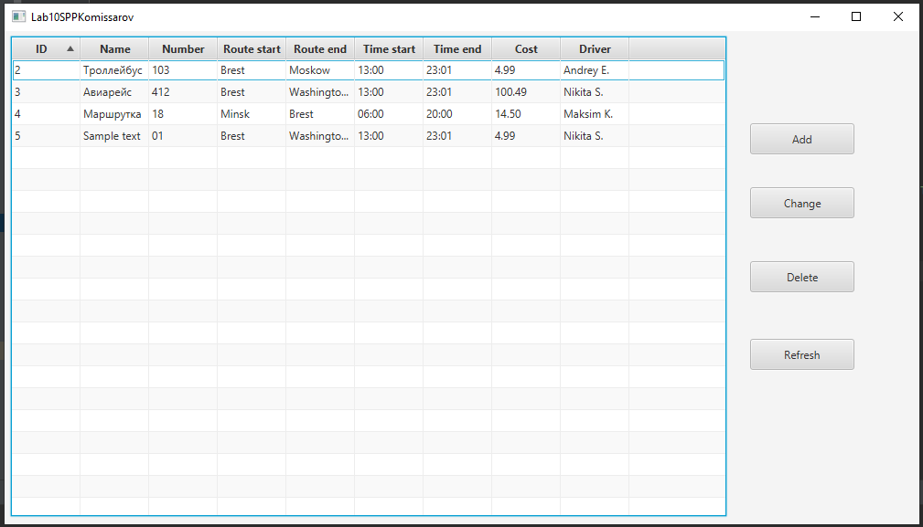

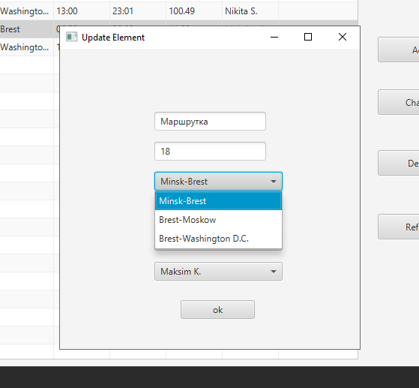

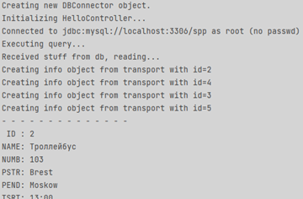

**Вывод:** я приобрёл практические навыки разработки многооконных приложений на JavaFX для работы с базами данных.