1. Visual example – Hawaii false alarm

The basic lessons taught in these first dozen modules, especially those in 7-9 and 11, reminded me a great deal of the 2018 false Civil Danger Warning in Hawaii. For those who may need a reminder of what happened: on January 13, 2018, a mistakenly clicked link during a routine Emergency Alert System test caused the EAS to instead issue a Civil Danger Warning, causing just over half an hour worth of panic and evacuation (doubly so, in the midst of heightened tensions with the North Korean government).   
  
A subsequent investigation from the FCC found that the web interfaces for drills and real alerts were remarkably similar, making it easier than ideal to confuse the two, especially in the adrenaline-heavy moments of needing to issue an alert. A subsequent review by The Verge of the relevant alert-issuing software reveals some rather flawed web design in two of the possible templates for issuing alerts and tests alike:  
  
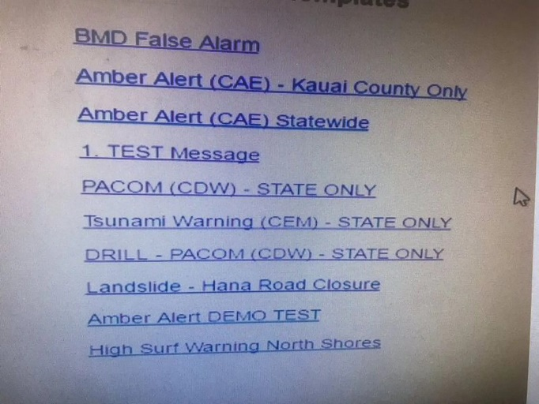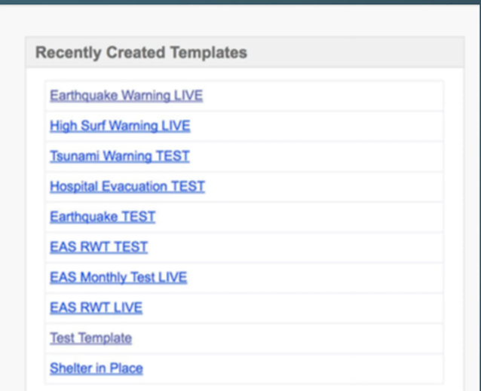

Likely violating the advice on affordance cues learned in Thing 7, and the ideas of togetherness in Thing 9 – especially with so many blue hyperlinks with wildly different functions crammed together – the nearly indistinguishable interface was ripe for an accident such as that which occurred in January 2018. A CNN article paraphrases the FCC as finding it “troubling” that the interface and confirmation question of alerts and tests were remarkably similar. Even within this overly simplistic interface, a simple change, such as differentiating colors or emphasis between tests and alerts, could go a long way in preventing a mix up, even to the usually inattentive.

Relevant links:

<https://www.cnn.com/2018/01/31/us/hawaii-false-alarm-investigation-findings/index.html>

<https://www.theverge.com/2018/1/18/16905512/hawaii-missile-software-false-alarm-emergency-alert>

1. A comparison and contrast of medicare.gov, then and now.

In Thing 6, the medicare.gov website is mentioned as an example of a site that pulls users in immediately, with a pair of standout links that option the user to either “Get Started With Medicare”, or “Log In/Create Account”. Consolidating what most who may visit the site into these two links, taking the prior experience of users into account, is presented as an example of easy-to-use web design, alongside the detailed menu bar.

Looking at the March 2024 build of the website, there’s a different, but still seemingly effective, means of using the top 30% of the site to make use easy and familiar to users. Where eight links originally stood at the top of the site, five now stand, with three menus that cover most relevant details that users may seek, along with a technical support link, and login. In addition, two pieces standout for peripheral vision: a search bar with the almost-universal magnifying glass symbol, and a stark red alert bubble, standing out to deliver breaking news of a recently signed prescription drug law, and the major changes it brings. Closely incorporating Things 6-9, as well as 12, this effective use of appealing to human vision patterns, as well as color and symbol recognition, helps to create an easy to use and effective website, something that eases the otherwise consuming process of maintaining health insurance. While these two designs are modestly different in their delivery of information, nonetheless, they both serve as examples of how to make an efficient homepage that is manageable to user and producer alike.

Relevant links: www.medicare.gov