

We are the human capital and we take the governing -

Lowering prices while raising small businesses. https://hopeisback.com/

Example of a project in a liquid union (where each project is defined according to its budget, population and purpose) - the potato project:

Those interested create or participate in their different groups (of right-wing, left-wing, meat-eaters, vegan, etc) to buy together potatoes distributed to the branches of the project, branches like greengrocers (small businesses) or in retail chains (while the chains are forced to act better with us), such that the movement of buyers between the branches moves the discounted potatoes respectively.

The potatoes are discounted because they were bought in large quantities.

How It Works? Simply put, buyers, according to their decision, prepay membership fees through their branch, until they have moved to another such branch in our chain.

We organize in two stages, the grouping and then the realization:

The grouping phase is done in independent groups until they are linked with professionals.

At this stage, people apply to the opening group, but do not stay in it, instead from it they choose or create their group, when the managers of the created groups are members of another group - the information group.

And hence, in the information group, we can target the requirements of the members of all our groups, for example by time, location and purchasing power, in relation to the required product and service, to allow connecting professionals with those groups.

In addition, at this grouping stage - we are creating accessories, such as masks, hats, scarves, plates and more, using our network symbol together with the symbol of some specific group/s (and possibly with the desired qr code), while the price of the accessories for individuals will be for example production cost + 30%, for rewarding 5% the producers and 25% the group. This way we can be rewarded while being formed, while our diversity is maintained and our groups are independent.

The stage of group realization is with the professionals until forming and then already within liquid unions and/or platforms of static common companies.

Paste your group logo here.

The QR code for the opening group on WhatsApp to Create or find Your group.



The QR code to the terms of the Buyers and Suppliers Liquid Union.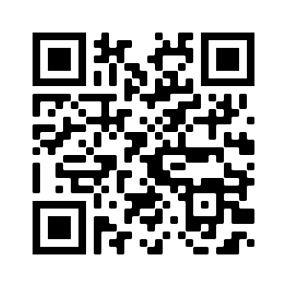

The QR code to the terms of the Static Common Companies Platform.