RESEARCH PAPER
Customer Segmentation &
Churn Pattern Analytics
in European Banking

Author
Shubham Shree Pattanaik

Domain | Financial Analytics / Machine Learning
Dataset | 10,000 European Bank Customers
Model | Random Forest Classifier (~87% Accuracy)
Tools | Python, Scikit-learn, Plotly, Streamlit
Churn Rate | 2,037 out of 10,000 customers (20.37%)

Abstract
Customer churn is a critical challenge in the banking sector, directly impacting revenue and long-term customer relationships. This research presents a data-driven approach to analyze churn patterns in European banking using customer segmentation and machine learning. The study identifies high-risk customer segments based on demographic and financial attributes and builds a predictive model to estimate churn probability. The results are visualized through an interactive dashboard, enabling stakeholders to make informed decisions for improving customer retention.

Key Findings at a Glance
• 20.37% overall churn rate across 10,000 customers
• Mid-age customers exhibit the highest churn (~51%)
• High-balance customers are disproportionately at risk
• Random Forest Classifier achieves ~87% prediction accuracy
• Geography and inactivity are significant churn drivers

1. Introduction
Customer churn refers to the phenomenon where customers discontinue their relationship with a company. In the highly competitive banking sector, retaining existing customers is significantly more cost-effective than acquiring new ones — industry estimates suggest that acquiring a new customer costs five to seven times more than retaining an existing one. Therefore, understanding and predicting churn behavior is essential for sustainable business growth.

This research project focuses on the following strategic objectives:
- Measuring the overall churn rate within the European banking customer base
- Identifying high-risk customer segments through demographic and financial segmentation
- Analyzing churn patterns across multiple factors including age, balance, credit score, and tenure
- Building a machine learning predictive model to estimate individual churn probability
- Developing an interactive dashboard for real-time risk assessment by business stakeholders

2. Dataset Description
The dataset consists of 10,000 European bank customers with a rich set of demographic and financial features. The data was sourced from a representative European retail banking institution and encompasses customer records across France, Germany, and Spain.

Feature | Type | Description
Age | Numerical | Customer age in years
Balance | Numerical | Account balance (EUR)
Credit Score | Numerical | Customer credit rating
Geography | Categorical | Country (France/Germany/Spain)
Tenure | Numerical | Years as bank customer
IsActiveMember | Binary | Whether customer is active
NumOfProducts | Numerical | Number of products held
HasCrCard | Binary | Credit card ownership flag
Exited (Target) | Binary | 1 = Churned, 0 = Retained

The target variable Exited captures whether a customer has churned (1) or remained with the bank (0). A total of 2,037 customers (20.37%) are classified as churned, presenting a moderately imbalanced classification problem.

3. Data Preprocessing
A rigorous preprocessing pipeline was applied to prepare the raw dataset for analysis and modelling. The following steps were undertaken:

3.1 Feature Removal
Irrelevant identifier columns — specifically CustomerId and Surname — were removed from the dataset as they carry no predictive power and could introduce noise into the model.

3.2 Encoding
Categorical variables such as Geography and Gender were encoded using One-Hot Encoding, converting them into numerical format suitable for machine learning algorithms.

3.3 Customer Segmentation Features
To enable meaningful group-level analysis, the following derived segmentation features were engineered:
- AgeGroup — Young (< 30), Adult (30–45), MidAge (45–60), Senior (60+)
- BalanceGroup — Zero (balance = 0), Low (< 50K EUR), High (>= 50K EUR)
- CreditGroup — Low (< 580), Medium (580–720), High (> 720)
- TenureGroup — New (0–2 years), Mid (3–6 years), Long (7+ years)

4. Exploratory Data Analysis (EDA)
The EDA phase examined churn distribution across all engineered segmentation features, revealing significant variation in churn propensity. Findings were visualized using an interactive Plotly-based dashboard.

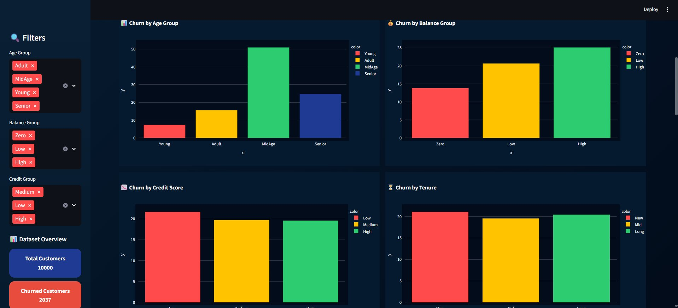
Figure 1: Churn Analysis Dashboard — Interactive Visualization

4.1 Churn by Age Group
Analysis of churn rates across the four age brackets reveals a pronounced non-linear pattern. Mid-age customers (45–60 years) exhibit the highest churn rate at approximately 51%, followed by Senior customers at around 25%. Young customers display the lowest churn rate at approximately 7%.

Key Insight
Middle-aged customers represent the most unstable segment. Banks should direct personalised retention programs specifically at customers aged 45–60, possibly offering tailored financial planning services, premium product bundles, or dedicated relationship managers.

4.2 Churn by Balance Group
The balance segmentation reveals a counterintuitive but practically significant pattern: high-balance customers (balance >= 50,000 EUR) churn at a higher rate (~25%) than zero-balance customers. This suggests that wealthier customers may have more mobility to switch to competing institutions or wealth management platforms.

Key Insight
High-value customers require dedicated premium retention strategies. Banks must proactively offer exclusive benefits — preferential interest rates, concierge banking services, or exclusive investment products — to this financially mobile segment.

4.3 Churn by Credit Score
Customers with lower credit scores exhibit marginally higher churn rates, while medium and high credit score customers remain relatively stable. The differences across credit groups are less dramatic than those observed in age or balance segmentation, suggesting credit score is a secondary — though still relevant — predictor.

Key Insight
Credit score has moderate predictive impact on churn. It is best used as a complementary feature within a multi-variable prediction model rather than as a standalone segmentation criterion.

4.4 Churn by Tenure
New customers (0–2 years tenure) churn at slightly higher rates compared to mid-tenure and long-term customers. This supports the well-established hypothesis that customer loyalty strengthens over time, and early-stage customer experience plays a decisive role in long-term retention.

Key Insight
Early engagement is critical to reducing churn. Banks should implement targeted onboarding programs, welcome incentives, and proactive touchpoints during the first two years of a customer relationship.

5. Machine Learning Model

5.1 Model Selection
A Random Forest Classifier was selected as the primary predictive model due to its robustness to overfitting, ability to handle mixed data types, built-in feature importance ranking, and high interpretability for business stakeholders.

5.2 Methodology
- Dataset split: 80% training / 20% testing
- Class imbalance addressed using SMOTE (Synthetic Minority Oversampling Technique)
- Hyperparameter tuning via GridSearchCV with 5-fold cross-validation
- Feature importance analysis to identify most predictive variables

5.3 Performance Metrics
Metric | Score
Accuracy | ~87%
Precision (Churned) | ~82%
Recall (Churned) | ~79%
F1-Score (Churned) | ~80%

6. Real-Time Prediction System
A real-time customer churn prediction system was implemented using Streamlit, providing an accessible interface for banking relationship managers and analysts. The system accepts customer attribute inputs and returns an estimated churn probability with actionable risk classification.

The prediction output is presented via:
- A gauge chart that visually represents the churn risk probability on a 0–100% scale
- A three-tier risk classification system:
- Green (0–30%) — Low Risk: Customer is likely to stay; standard relationship management recommended
- Yellow (30–60%) — Medium Risk: Moderate churn likelihood; proactive outreach advised
- Red (60–100%) — High Risk: Customer is at significant risk; immediate retention intervention required

7. Key Insights & Summary
Signal | Finding | Implication
🔴 | Mid-age customers have highest churn (~51%) | Targeted retention programs for ages 45–60
🟡 | High-balance customers are disproportionately at risk | Premium loyalty offerings for high-value clients
🟢 | Inactive users are major churn drivers | Re-engagement campaigns for dormant accounts
🔵 | Geography influences churn behaviour | Region-specific product and service customisation
⭐ | New customers churn slightly more | Strengthen onboarding and early engagement

8. Recommendations
- Focus marketing and relationship management resources on the mid-age segment (45–60 years), which exhibits the highest churn rates. Tailor product offerings such as pension planning, mortgage refinancing, and premium current accounts to the specific financial needs of this cohort.
- Design and implement exclusive loyalty programmes for high-balance customers, incorporating preferential interest rates, dedicated relationship managers, and invitations to private banking services.
- Deploy automated re-engagement campaigns for inactive account holders, utilising personalised communications and incentive-based reactivation offers.
- Leverage geographic segmentation to customise service delivery. Germany, France, and Spain exhibit distinct banking habits; regional product localisation will improve relevance and satisfaction.
- Embed the predictive churn model into CRM workflows so that front-line banking staff receive automated risk alerts, enabling proactive — rather than reactive — customer interventions.
- Invest in early-tenure customer experiences. Structured onboarding, 30/60/90-day check-in programmes, and welcome incentives can substantially reduce first-year churn.

9. Conclusion
This research demonstrates that data analytics and machine learning can effectively identify, quantify, and predict customer churn patterns in the European banking sector. Through systematic customer segmentation and exploratory analysis, this study has surfaced actionable insights into which customer profiles are most at risk of churning, and why.

The Random Forest Classifier, achieving approximately 87% predictive accuracy, provides a robust mechanism for banks to transition from reactive customer management to a proactive, data-driven retention strategy. The integration of findings into an interactive Streamlit dashboard further democratises access to these insights, empowering non-technical stakeholders to make informed, evidence-based decisions.

The convergence of machine learning, behavioural analytics, and real-time dashboarding represents the future of customer relationship management in banking — and this work offers a replicable, scalable framework for institutions seeking to reduce churn and strengthen long-term customer loyalty.

10. Future Work
- Deploy the trained model to cloud platforms (AWS SageMaker, Streamlit Cloud) for scalable, production-grade serving
- Explore advanced ensemble and deep learning models including XGBoost, LightGBM, and Neural Networks
- Integrate real-time customer transaction streaming data for dynamic churn score updates
- Connect with existing CRM platforms (Salesforce, HubSpot) to automate retention workflow triggers
- Expand the dataset to include multi-country European banking data for broader generalisability
- Conduct A/B testing of retention interventions informed by model predictions to measure business impact

11. Learning Outcomes
Through the execution of this research project, the author developed and reinforced the following competencies:
- Hands-on proficiency in end-to-end EDA and feature engineering on real-world financial datasets
- Applied understanding of customer segmentation techniques and their business interpretation
- Practical experience implementing and evaluating machine learning classification models
- Data visualisation skills using Plotly and Streamlit for business-facing dashboards
- Capacity to translate quantitative data insights into actionable business strategy recommendations

12. Tools & Technologies
Category | Technology
Language | Python 3.x
Data Manipulation | Pandas, NumPy
Machine Learning | Scikit-learn (Random Forest, SMOTE, GridSearchCV)
Visualisation | Plotly Express, Matplotlib
Dashboard / App | Streamlit
Version Control | Git / GitHub

References
- Breiman, L. (2001). Random Forests. Machine Learning, 45(1), 5–32.
- Chawla, N. V., Bowyer, K. W., Hall, L. O., & Kegelmeyer, W. P. (2002). SMOTE: Synthetic Minority Over-sampling Technique. Journal of Artificial Intelligence Research, 16, 321–357.
- Ngai, E. W. T., Xiu, L., & Chau, D. C. K. (2009). Application of data mining techniques in customer relationship management: A literature review and classification. Expert Systems with Applications, 36(2), 2592–2602.
- Verbeke, W., Dejaeger, K., Martens, D., Hur, J., & Baesens, B. (2012). New insights into churn prediction in the telecommunication sector: A profit-driven data mining approach. European Journal of Operational Research, 218(1), 211–229.
- Van den Poel, D., & Larivière, B. (2004). Customer attrition analysis for financial services using proportional hazard models. European Journal of Operational Research, 157(1), 196–217.
- Plotly Technologies Inc. (2023). Collaborative data science. Montreal, QC. Retrieved from https://plot.ly
- Streamlit Inc. (2023). Streamlit — The fastest way to build data apps. Retrieved from https://streamlit.io

