**Computer Vision HW2 Report**

Student ID: R09942171

Name: 黃繼綸

**Part 1. (10%)**

**• Plot confusion matrix of two settings. (i.e. Bag of sift and tiny image representation) (5%)**

**Ans:**

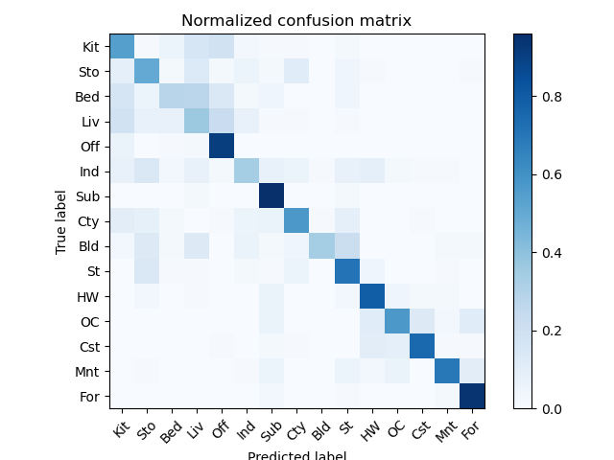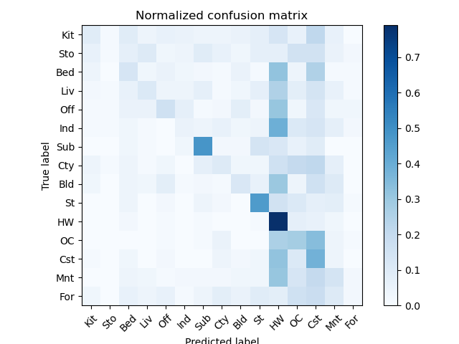

Left figure: Bag of sift

Right figure: Tiny image representation

**• Compare the results/accuracy of both settings and explain the result. (5%)Ans:**

The accuracy of the tiny image representation is obviously lower than the representation extracted by sift. The tiny image representation only resizes the original image into a smaller size and uses these pixel-level features to image classification. Instead, the sift can capture the key point of an image, the features are more representative than the pixel-level features. As a result, the features extracted by sift can be more accurate than the tiny image representation on the image classification task.

**Part 2. (35%)**

**• Compare the performance on residual networks and LeNet. Plot the learning curve (loss and accuracy) on both training and validation sets for both 2 schemes. 8 plots in total. (20%)**

**Ans:**

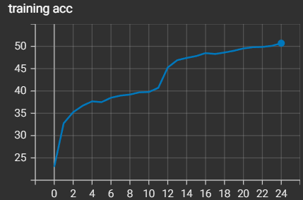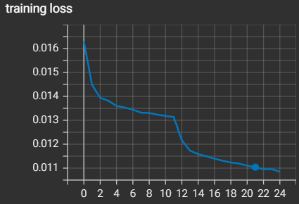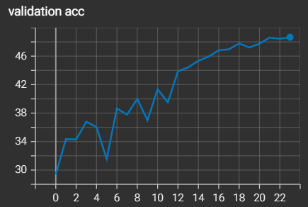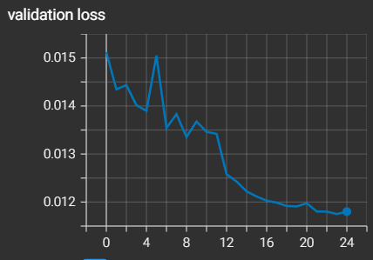

**▲**myLenet learning curve

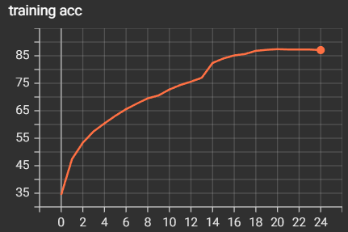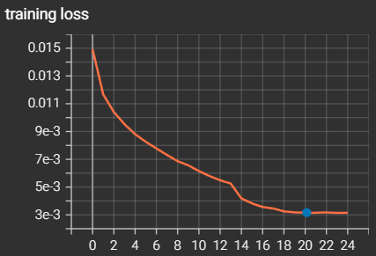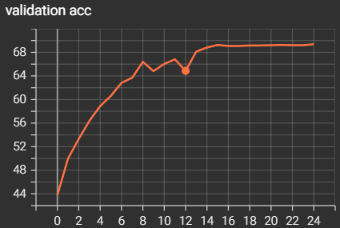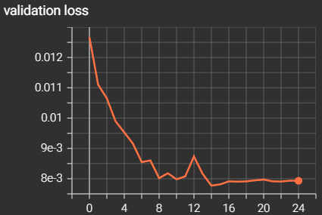

**▲**myResnet learning curve

**• Attach basic information of the model you use including model architecture and the number of the parameters. Besides, report the accuracy you performed on the public test set. (5%)**

**Ans:**

Public test set ACC: 80.82%

Number of parameters: 4,535,882

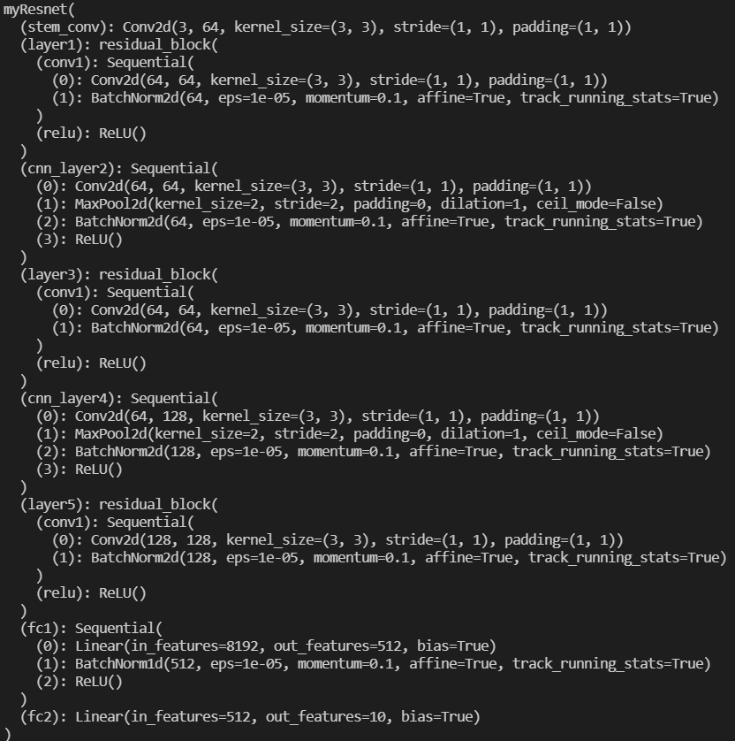

**• Briefly describe what method do you apply? (e.g. data augmentation, model architecture, loss function, semi-supervised etc.) (10%)**

**Ans:**

**I compute the mean and std of the whole training data set:**

Mean=[0.500, 0.478, 0.433],

Std = [0.248, 0.246, 0.264]

**Data augmentation:**

Randomrotaion(30), RandomHorizontalFlip(p=0.5)

**Model architecture:** The same as TA.

**Loss function:** Cross entropy loss

**Data cleaning:**

First, I trained the myResnet model on the whole training data. I took the model saved on the epoch 7th to do data cleaning. If the predicted confidence is lower than 0.26, I dropped this data out. Then, I trained the myResnet model on the cleaned dataset as the teacher model of semi-supervised learning.

**Semi-supervised learning:**

After training the myResnet model on the cleaned dataset, I applied the model having the best performance on the cleaned dataset to generate the pseudo labels of the unlabeled data. If the predicted confidence is higher than 0.9, I added it as my training data.