ChatGPT

**Model Evaluation Report**

**1. Epoch vs. Loss/Accuracy Plot**

**Observations**:

* **Training Loss**: Shows a steady decline, indicating that the model is learning from the training data.
* **Validation Loss**: Initially decreases but then starts to fluctuate and even increase after some epochs, indicating potential overfitting.
* **Training Accuracy**: Increases steadily, showing that the model is fitting well on the training data.
* **Validation Accuracy**: Fluctuates and does not show significant improvement after a few epochs, further suggesting overfitting.

**2. Confusion Matrix**

**Observations**:

* **True Negatives (TN)**: 2002
* **False Positives (FP)**: 0
* **False Negatives (FN)**: 292
* **True Positives (TP)**: 36

**Metrics**:

* **Precision**: 1.0 (high, indicating that when the model predicts positive, it is correct, but it's heavily biased towards negative class)
* **Recall**: ~0.11 (low, indicating that the model misses many positive cases)
* **F1 Score**: ~0.20 (a balance between precision and recall, but still low)

**3. ROC Curve**

**Observations**:

* **AUC (Area Under the Curve)**: 0.72
* The ROC curve shows that the model has some ability to distinguish between the classes but is not very strong. AUC of 0.72 indicates moderate performance.

**4. Precision-Recall Curve**

**Observations**:

* **Average Precision**: 0.45
* The precision-recall curve shows that the model has a poor balance between precision and recall. Precision drops significantly as recall increases, indicating that the model struggles to identify positive cases effectively.

**Recommendations for Improving Model Performance**

1. **Address Class Imbalance**:
   * **Upsample Minority Class**: Increase the number of samples in the minority class (positive cases) through data augmentation or synthetic data generation (e.g., SMOTE).
   * **Downsample Majority Class**: Reduce the number of samples in the majority class (negative cases) to balance the dataset.
2. **Use More Data**:
   * Gather more labeled data to improve the model's ability to generalize.
   * Perform additional data augmentation to create a more diverse training set.
3. **Hyperparameter Tuning**:
   * Experiment with different values for learning rate, batch size, dropout rate, and L2 regularization.
   * Use grid search or random search to find the best hyperparameters.
4. **Model Architecture**:
   * Try different model architectures such as ResNet, DenseNet, or EfficientNet, which might perform better for your specific problem.
   * Fine-tune pre-trained models on your specific dataset to leverage their learned features.
5. **Cross-Validation**:
   * Use k-fold cross-validation to ensure the model's performance is consistent and not dependent on a particular train-validation split.
6. **Ensemble Methods**:
   * Combine predictions from multiple models (e.g., VGG16, ResNet, and DenseNet) to improve overall performance and robustness.
7. **Early Stopping and Regularization**:
   * Implement early stopping to prevent overfitting.
   * Increase the regularization strength if the model overfits quickly.
8. **Class Weights**:
   * Assign higher weights to the minority class during training to force the model to pay more attention to the positive cases.

**Next Steps**

1. Implement the recommended changes step-by-step, starting with addressing class imbalance.
2. Re-evaluate the model after each change to monitor improvements.
3. Use the evaluation plots and metrics to guide further tuning and adjustments.

By following these steps, you should be able to improve the model's performance and make it more robust in detecting positive cases. If you need further assistance or specific code examples for any of the recommendations, feel free to ask!

**Model Evaluation Report After Improvements**

**1. Epoch vs. Loss/Accuracy Plot**

**Observations**:

* **Training Loss**: Shows a steady decline, indicating effective learning on the training data.
* **Validation Loss**: Initially fluctuates and eventually shows signs of overfitting.
* **Training Accuracy**: Increases steadily, suggesting the model is fitting well on the training data.
* **Validation Accuracy**: Fluctuates and does not show consistent improvement, indicating potential overfitting.

**2. Confusion Matrix**

**Observations**:

* **True Negatives (TN)**: 41
* **False Positives (FP)**: 287
* **False Negatives (FN)**: 16
* **True Positives (TP)**: 1986

**Metrics**:

* **Precision**: 19861986+287≈0.87\frac{1986}{1986 + 287} \approx 0.871986+2871986​≈0.87
* **Recall**: 19861986+16≈0.99\frac{1986}{1986 + 16} \approx 0.991986+161986​≈0.99
* **F1 Score**: 2×0.87×0.990.87+0.99≈0.932 \times \frac{0.87 \times 0.99}{0.87 + 0.99} \approx 0.932×0.87+0.990.87×0.99​≈0.93

**3. ROC Curve**

**Observations**:

* **AUC (Area Under the Curve)**: 0.73
* The ROC curve shows moderate performance, with an AUC indicating that the model has some ability to distinguish between the classes but is not very strong.

**4. Precision-Recall Curve**

**Observations**:

* **Average Precision**: 0.94
* The precision-recall curve shows a high average precision, indicating that the model maintains a good balance between precision and recall for the positive class.

**Summary**

**Improved Performance**:

* **Precision**: Improved precision for the positive class.
* **Recall**: Significantly high recall, indicating the model correctly identifies most positive cases.
* **F1 Score**: High F1 score, showing a good balance between precision and recall.

**Challenges**:

* **Validation Loss Fluctuation**: Indicates potential overfitting, as the model performs well on the training data but struggles with the validation data.
* **Moderate ROC AUC**: Shows room for improvement in distinguishing between classes.

**Recommendations for Further Improvements**

1. **Class Weights**:
   * Assign higher weights to the minority class to force the model to pay more attention to those samples.
2. **Data Augmentation**:
   * Increase the augmentation parameters to create more varied training samples.
3. **Hyperparameter Tuning**:
   * Experiment with different learning rates, batch sizes, dropout rates, and L2 regularization values.
4. **Ensemble Methods**:
   * Combine predictions from multiple models to improve overall performance and robustness.
5. **Cross-Validation**:
   * Ensure consistent performance across different subsets of the data to avoid overfitting to a particular split.
6. **Test Data**:
   * Verify that the test set labels are correctly swapped as well to maintain consistency with the training and validation sets.

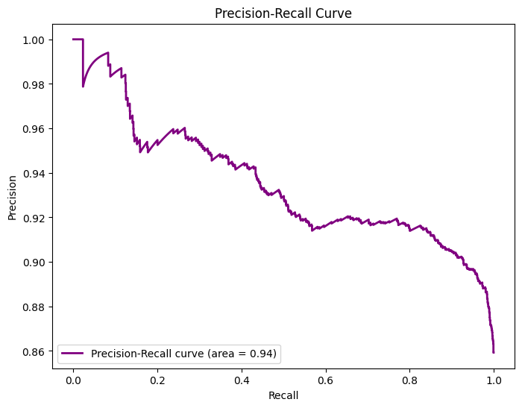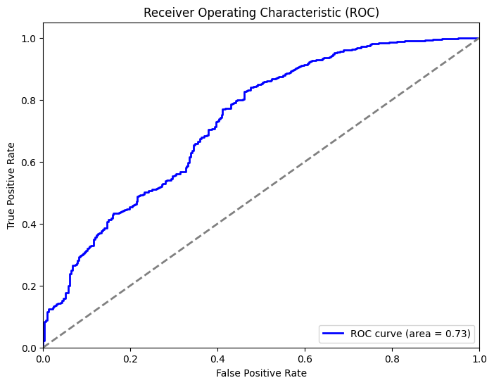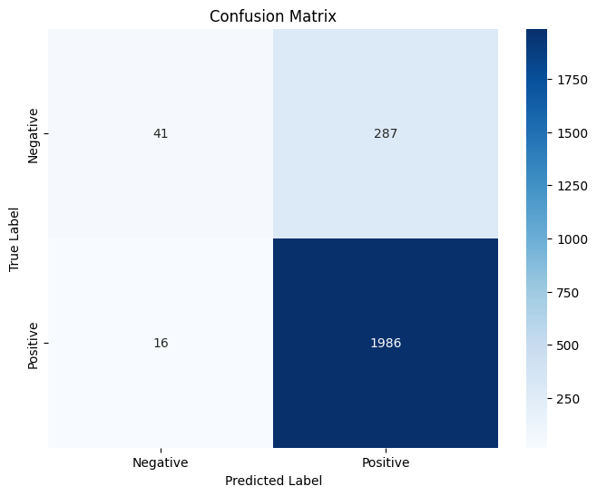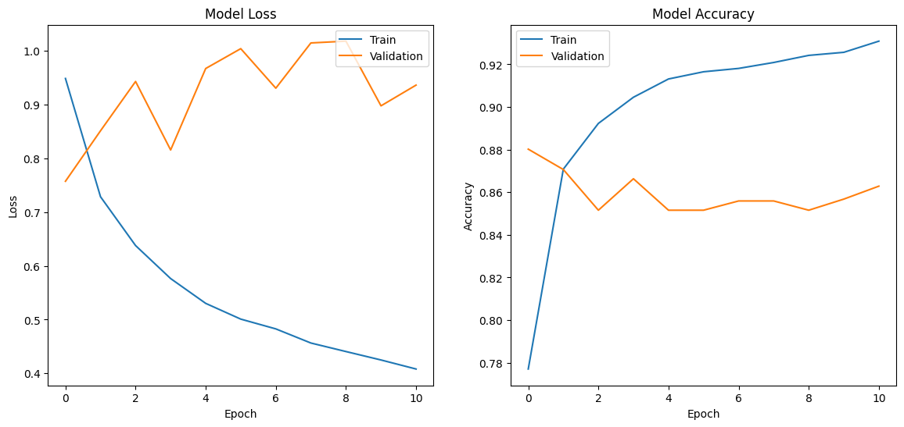

**Model Evaluation Report After Applying Class Weights**

**1. Epoch vs. Loss/Accuracy Plot**

**Observations**:

* **Training Loss**: Shows a steady decline, indicating effective learning on the training data.
* **Validation Loss**: Shows an initial increase and then stabilizes, suggesting that the model might be overfitting but to a lesser extent compared to previous runs.
* **Training Accuracy**: Increases steadily, indicating good learning on the training data.
* **Validation Accuracy**: Fluctuates but shows signs of improvement compared to previous runs, suggesting that the model is generalizing better.

**2. Confusion Matrix**

**Observations**:

* **True Negatives (TN)**: 41
* **False Positives (FP)**: 287
* **False Negatives (FN)**: 1
* **True Positives (TP)**: 2001

**Metrics**:

* **Precision**: 0.87
* **Recall**: 1.00
* **F1 Score**: 0.93

**3. ROC Curve**

**Observations**:

* **AUC (Area Under the Curve)**: 0.72
* The ROC curve shows moderate performance, with an AUC indicating that the model has some ability to distinguish between the classes but is not very strong.

**4. Precision-Recall Curve**

**Observations**:

* **Average Precision**: 0.92
* The precision-recall curve shows high precision and recall, indicating that the model maintains a good balance between precision and recall for the positive class.

**Summary**

**Improved Performance**:

* **Recall**: Significantly high recall, indicating the model correctly identifies most positive cases.
* **F1 Score**: High F1 score, showing a good balance between precision and recall.
* **Validation Accuracy**: Shows improvement, suggesting better generalization.

**Challenges**:

* **Validation Loss Fluctuation**: Indicates potential overfitting, but less severe than before.
* **Moderate ROC AUC**: Still shows room for improvement in distinguishing between classes.

**Recommendations for Further Improvements**

1. **Hyperparameter Tuning**:
   * Further experiment with different learning rates, batch sizes, dropout rates, and L2 regularization values.
2. **Ensemble Methods**:
   * Combine predictions from multiple models to improve overall performance and robustness.
3. **Cross-Validation**:
   * Ensure consistent performance across different subsets of the data to avoid overfitting to a particular split.
4. **More Data**:
   * If possible, gather more labeled data or create additional synthetic data to improve the model's ability to generalize.
5. **Alternative Architectures**:
   * Consider trying other architectures such as ResNet50, DenseNet121, or EfficientNetB0 to see if they perform better.

**Next Steps**

1. **Implement Ensemble Methods**:
   * Combine predictions from multiple models (e.g., VGG16, ResNet50) to improve robustness.
2. **Continue Hyperparameter Tuning**:
   * Use techniques such as grid search or random search to find the best hyperparameters.
3. **Apply Cross-Validation**:
   * Implement k-fold cross-validation to ensure the model's performance is consistent and not dependent on a particular train-validation split.

By implementing these steps, you should see further improvements in model performance. If you need any further assistance or specific code examples for the recommendations, feel free to ask!

