Example 1: Hello

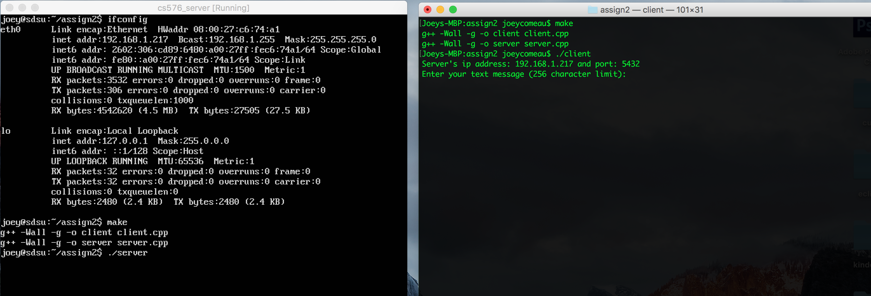

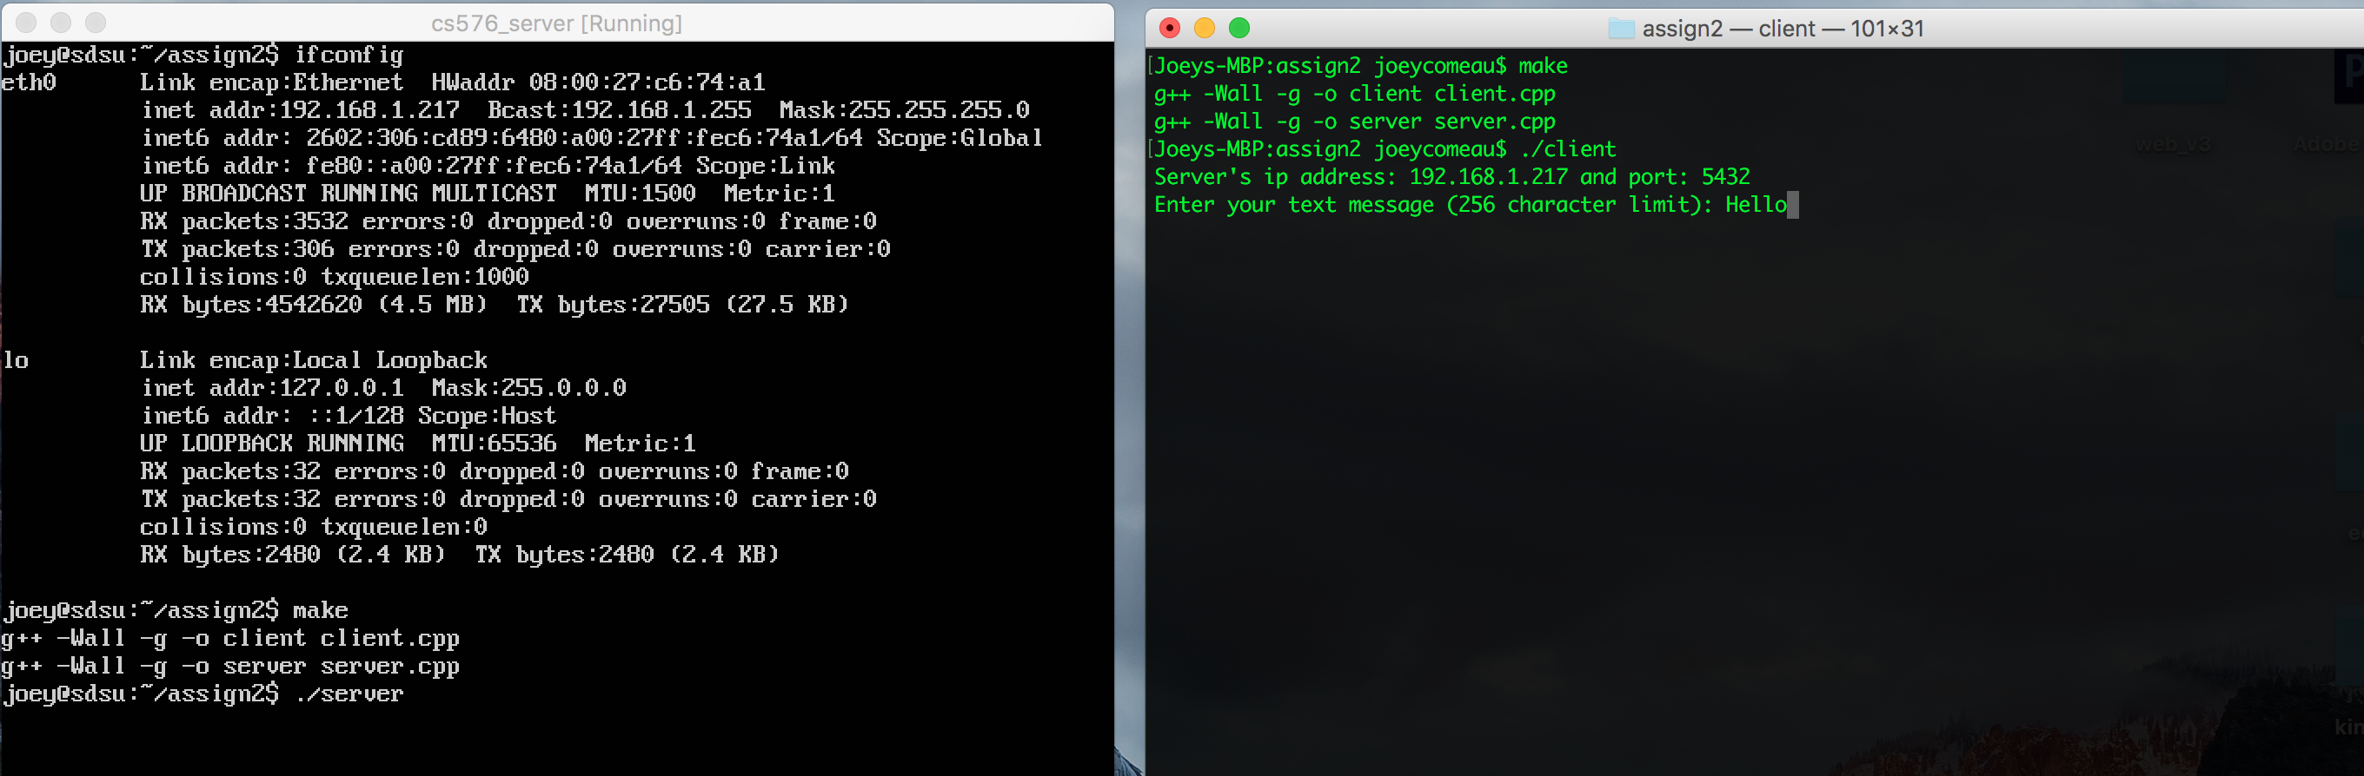

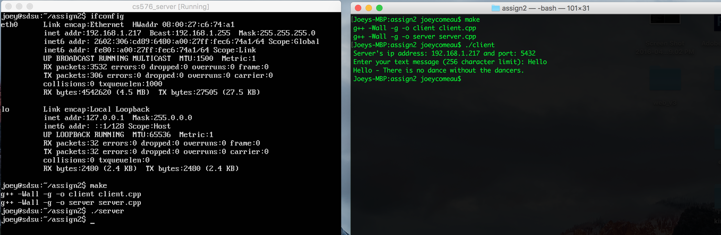

Example 2: Computer Science

