Week 1 Report: Product Research and Validation
Squad Hunza
Comeback Pakistan, Cohort 1, Product Challenge
AI-Powered Gmail Agent for HR Recruiters

Overview
This week we ran direct research with recruiters and hiring professionals to validate the problem before building anything. We collected 10 structured survey responses along with additional open-ended text responses from recruiters across different company sizes and hiring volumes. This report documents our findings, the resulting MVP, the features we are building, and how the product works.

Product Research: Survey Data

On a busy hiring day, how many messages and applications hit you?
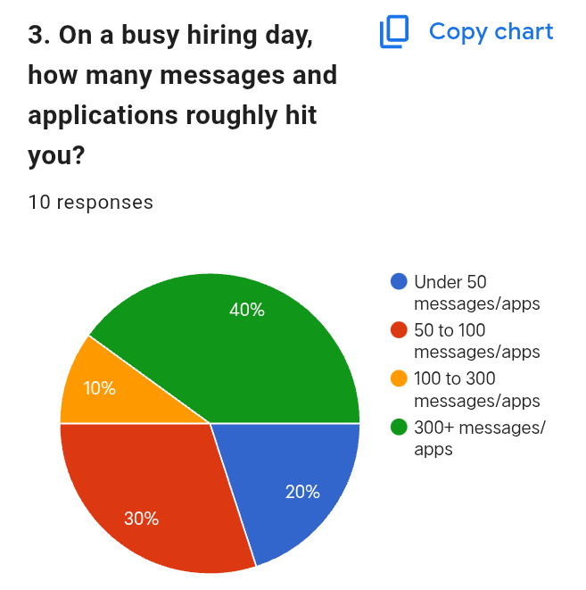

What is the most repetitive thing you reply to manually?
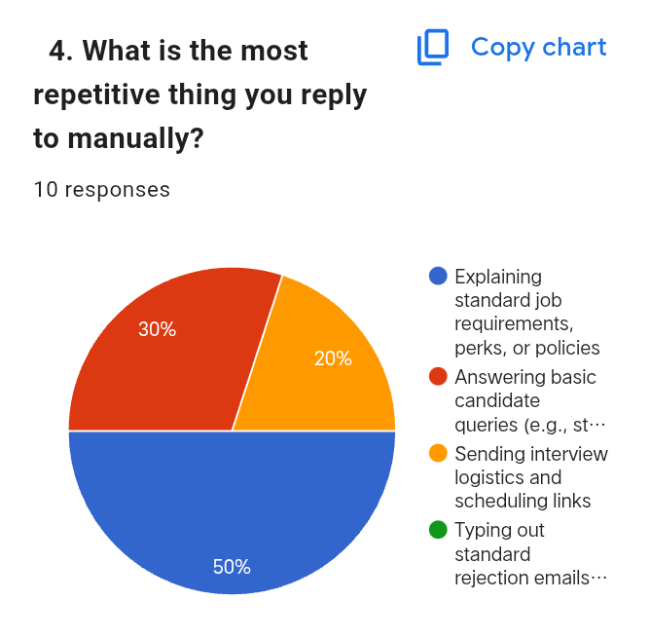

Do you ever miss good candidates because you were too slow to reply?
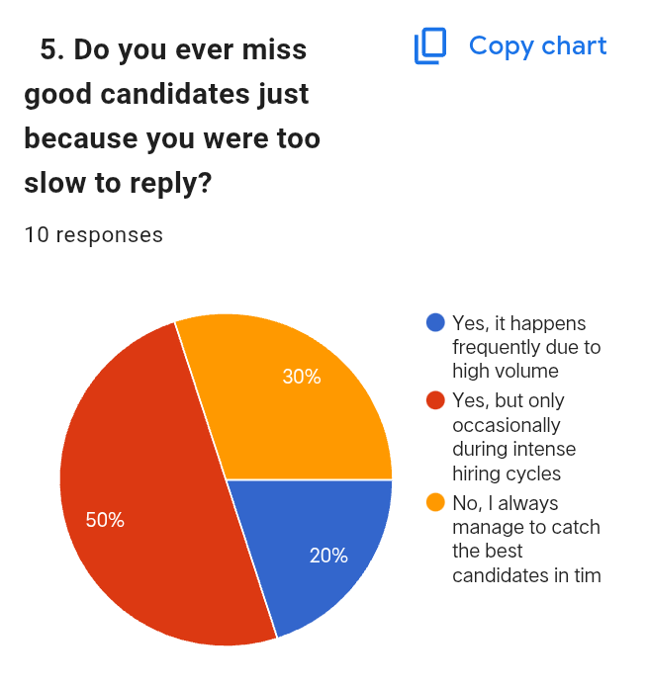

What tool or hack do you currently use to manage the volume?
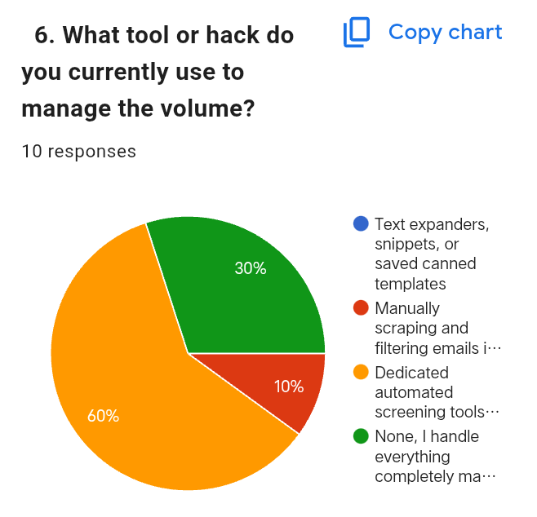

If you had 300 unread recruiting messages right now, what would you do first?
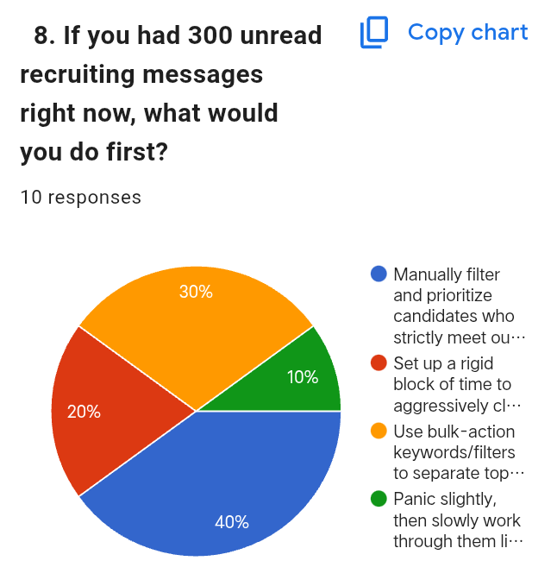

Product Research: Open-Ended Responses
Recruiters described their actual daily volume in concrete terms. One recruiter who previously handled full-cycle tech recruitment at a Pakistani company reported reviewing 400 to 600 applications a day for high-volume roles, with their own business averaging closer to 100 applications a day. Another recruiter reported a range of 300 to 400 applications depending on the marketing channel and target hiring area.
On repetitive replies, recruiters consistently pointed to answering questions that are already covered in the job description, such as role details or remote work status, along with the same recurring candidate questions being asked over and over.
On current tooling, recruiters described relying on Google Sheets or Excel to track applicants manually, describing it as simple and functional but requiring manual organization with no automation layer.
On what they wished handled itself, recruiters asked for automatic summarization of long messages into key points, and smarter automatic labeling that separates job applications, follow-ups, personal email, and internal communication without manual sorting.
On handling a sudden backlog of unread messages, responses varied by recruiter. Some prioritize by portfolio quality first, then LinkedIn background, then resume, and finally application thoroughness. Others prioritize filtering by role fit and criteria match first, while still preferring to keep every applicant visible in a tracking sheet for full screening rather than discarding any automatically.

Key Findings
- Recruiters across both survey and open-ended responses consistently manage high email and application volume, with a large share handling 300 or more messages on busy days.
- The biggest recurring time cost is not writing replies from scratch, it is repetitive manual work: scheduling logistics, answering questions already covered in the job post, and manually sorting or labeling incoming messages.
- Most recruiters currently rely on either full ATS platforms or basic manual tools like Excel and Google Sheets, with a clear gap in between for lighter-weight, inbox-native automation.
- Automatic summarization and smart labeling came up directly and independently across open-ended responses as the feature recruiters want most, which lines up with sorting and prioritization scoring highest in the structured survey as well.
- Draft reply generation is wanted, but recruiters want to review and approve it rather than have it fully automated, supporting a one-click approval model over full automation.
- There is a real willingness to pay for a tool that saves meaningful time daily, split across pricing tiers depending on team size and current spend on tools.

The MVP We Figured Out
Our original assumption was that recruiters wanted help drafting replies to candidates. The data shows draft reply support is wanted, but it ranks below sorting, prioritization, and summarization as the core need. Recruiters are more consistently blocked by not knowing what is in their inbox and what needs attention first, rather than by the effort of writing replies.
The MVP wedge is an AI agent that connects to a recruiter's Gmail account and automatically sorts, prioritizes, and summarizes candidate emails. Draft reply generation with one-click approval is included as a secondary feature, matching how recruiters described wanting review and control rather than full automation.

Features Based on User Pain Points
Every feature below traces back to something a recruiter told us directly, not something we assumed they would like.
- Automatic email sorting and labeling: directly requested across both survey and open-ended responses, addressing the need to separate candidate emails from noise without manual work.
- Prioritization: recruiters said not every message carries equal urgency, and currently rely on manual criteria checklists or ad hoc filtering to find top candidates in a backlog.
- Summarization: recruiters independently asked for long messages to be condensed into key points so nothing important gets missed while scanning quickly.
- Draft reply generation with one-click approval: recruiters want to save time on replies but want to review before sending, so this is built as a review-and-approve step, not full automation.

How the Product Will Look
The core experience is a dashboard connected to the recruiter's Gmail account through OAuth. On login, the recruiter sees an overview of what came in overnight: new emails, pending drafts, new applicants, and spam filtered out automatically, along with a 7-day email volume view and a list of items that need attention first.
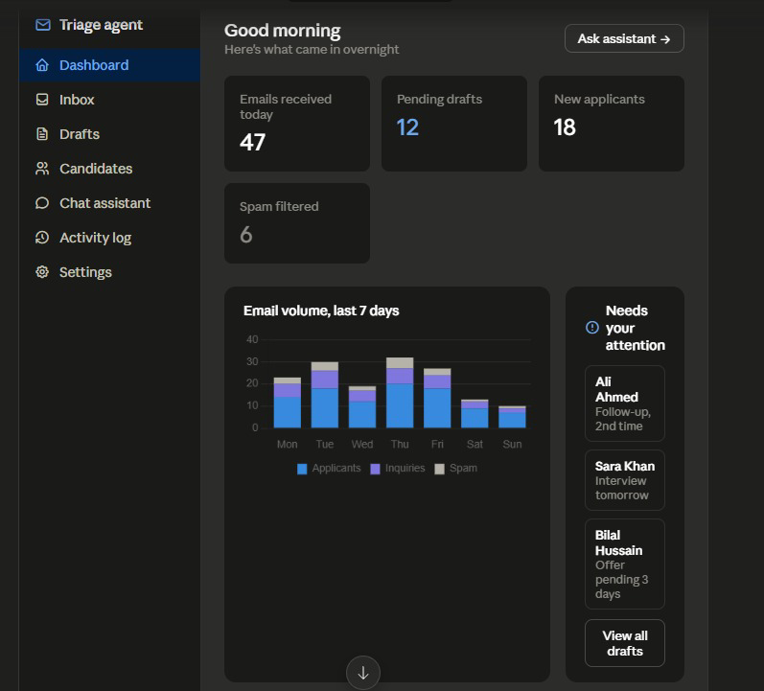
Early dashboard build, daily overview and priority queue
Candidate emails and resumes are organized into a searchable library, filterable by role and date, so a recruiter can find a candidate's resume and linked email thread without digging through the raw inbox.
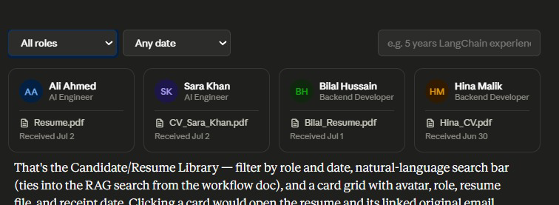
Candidate and resume library, filterable by role and date
The dashboard and inbox-sorting experience are being built first, since that is the core value confirmed by our research. Draft reply approval is built after that is working end to end.

Security and Data Protection
Since the agent works with real recruiter Gmail accounts and candidate resumes, security is built into the product from the start. The system uses Google OAuth, so recruiters never share their Gmail passwords, and it only requests the permissions needed to read emails, apply labels, and create draft replies. Candidate resumes are stored securely in private storage, while each recruiter's data is isolated using Row-Level Security to ensure no user can access another's information. OAuth tokens are encrypted, never stored in logs, and are removed when a recruiter disconnects their Gmail account. Every important action is recorded in an audit log for transparency, and candidate data follows a clear retention policy instead of being stored indefinitely.

What's Next
Week 2 moves from validation into build. We are finalizing the product name, the split of work between our AI Studio build and our backend stack, and the tech stack itself. Once that is settled, we start building the dashboard and inbox sorting experience as our core deliverable.

Team: Squad Hunza
- Huziafa : Backend, system design, RAG and AI automation
- Mahnoor : Backend development
- Saman : AI, cybersecurity, UI/UX
- Misbah : Business development, lead coordination, AI, team leadership

