finMate AI
Build Brief & System Design
WhatsApp-first AI bookkeeping agent for Pakistani SMEs
Engineering specification for implementation
Version 1.0 • Prepared for Claude Code

Contents

1. What we are building
finMate AI is a WhatsApp-first AI bookkeeping agent for small Pakistani businesses. A business owner forwards a photo of a receipt, invoice, or payment screenshot to a WhatsApp number. The system reads it with AI vision, extracts the financial details, maintains a running customer/supplier ledger, and answers the one question the owner actually cares about: “who owes me money and how much?” It also drafts payment reminders (owner-approved before sending) and produces a monthly, tax-ready summary.
The MVP wedge is deliberately narrow: receivables tracking for small B2B traders who sell on credit over WhatsApp. This is not a full accounting app — resist scope creep. The magic is zero-typing intake: the owner forwards the same photo they already send, and gets a clean udhar list back.

Core design principle — the confidence-routed trust pipeline
Money mistakes break trust instantly, so extraction never posts blindly. Every extracted entry carries a confidence score that routes it down one of three paths. This routing logic is the heart of the product and must be implemented exactly:
Confidence | Route | Behaviour
≥ 0.90 (high) | Auto-post | Entry is posted to the ledger automatically; owner sees it in the summary.
0.70 – 0.90 (medium) | Owner confirm | System asks the owner to confirm/correct via WhatsApp before posting.
< 0.70 (low) | Human review | Entry goes to a human reviewer queue; reviewer fixes and posts.
Thresholds must be configuration values, not hardcoded constants. Every routing decision and every owner correction must be logged — this correction data is the long-term data moat and the signal used to improve extraction accuracy over time.

2. Use case diagram
Actors and what each can do. The business owner drives intake, confirmation, reminder approval, and reporting. The human reviewer handles only the low-confidence queue and corrections. Claude API and WhatsApp API are external system actors.
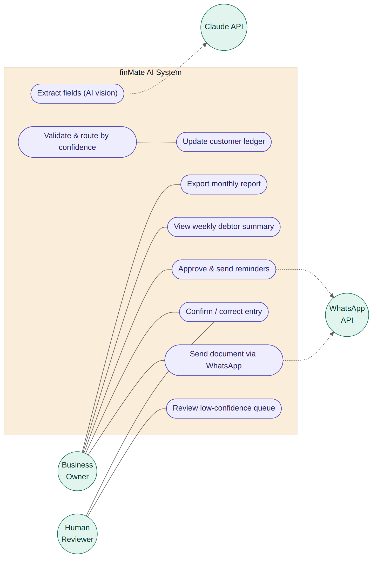
Figure 1 — Use case diagram: actors and system use cases

3. Sequence diagram — document intake
End-to-end flow of a single document from WhatsApp upload through extraction, validation, confidence routing, ledger posting, and reminders. The alt block shows the three confidence branches; note that reminders are always owner-approved before they are sent to a customer.
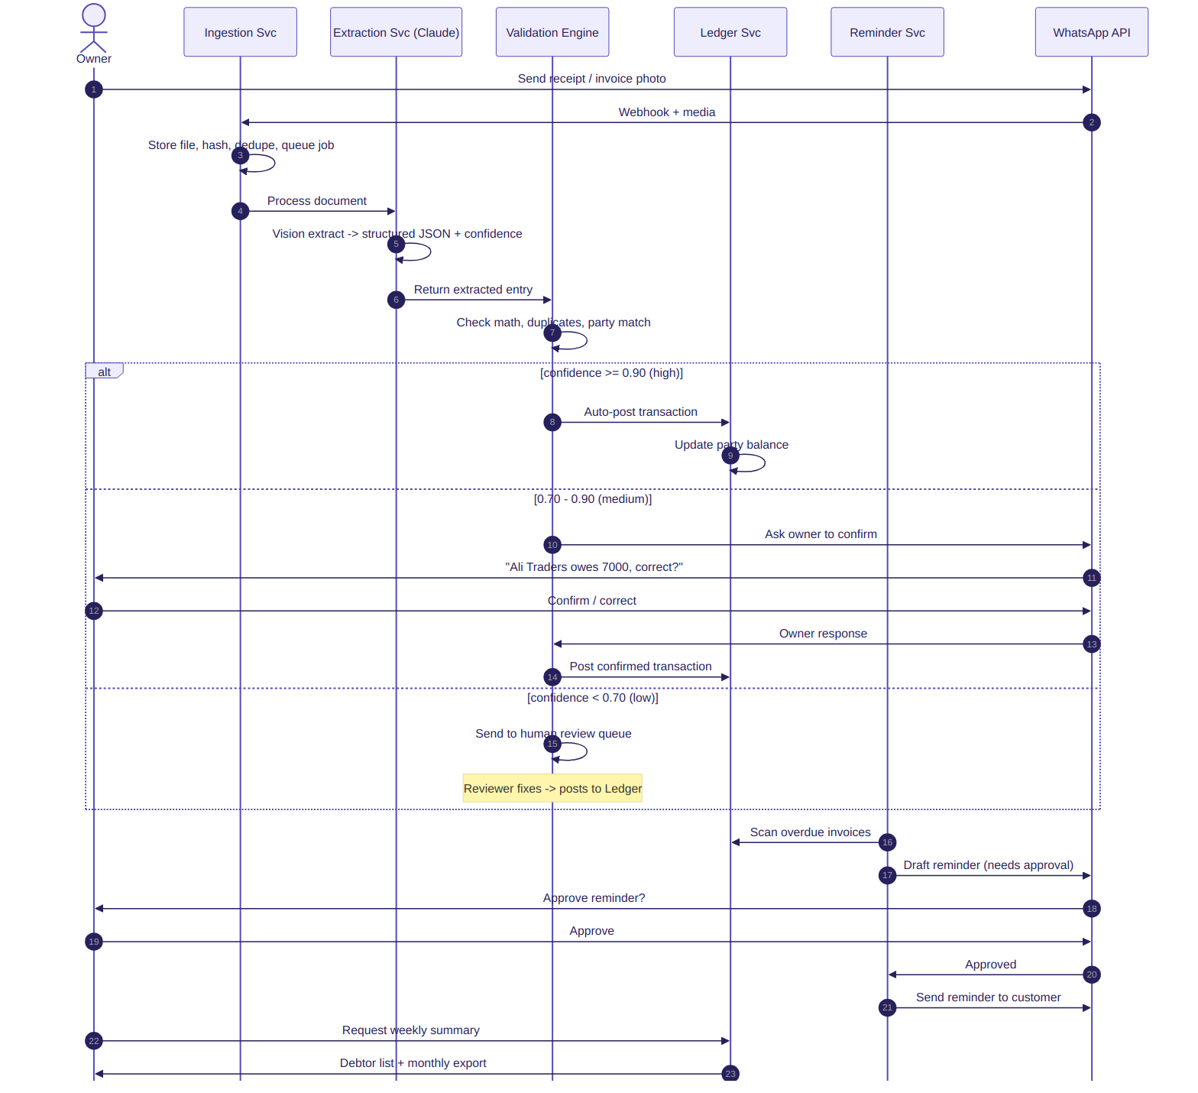
Figure 2 — Sequence diagram: intake, routing, ledger, and reminders

4. Activity diagram — processing pipeline
The full processing pipeline as a decision flow, including duplicate detection at intake, the three-way confidence branch, correction/audit logging, and the overdue-reminder sub-flow.
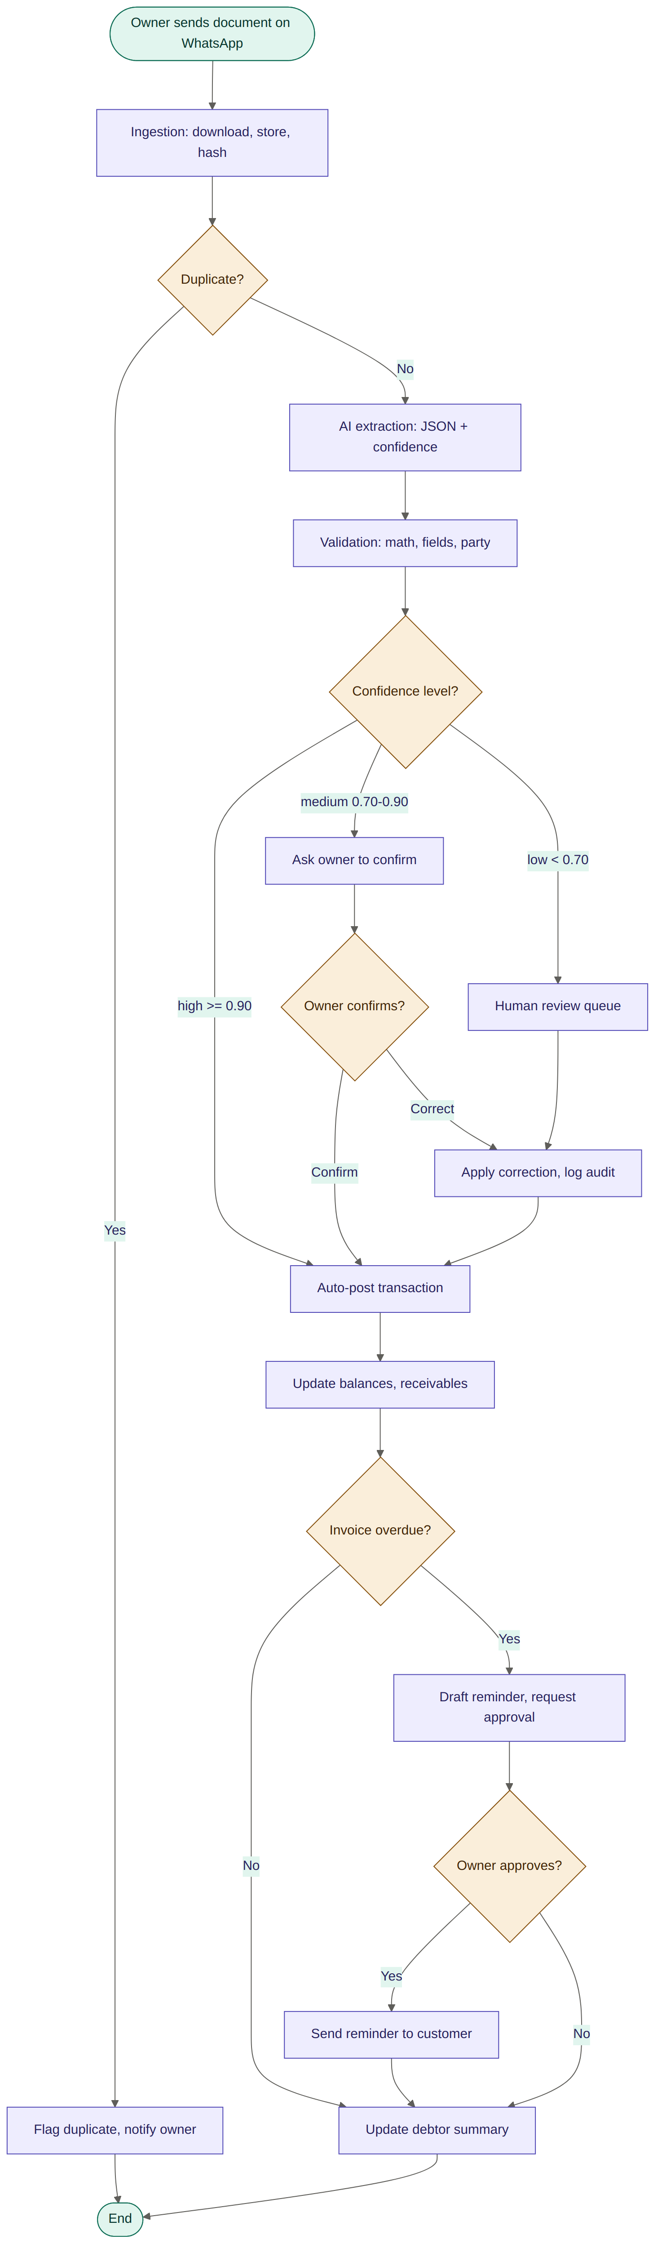
Figure 3 — Activity diagram: end-to-end processing logic

5. Class diagram — domain model
The core domain objects. Document and Transaction are kept as a one-to-one pair so the original evidence (photo + file hash) stays linked to the posted entry — this is what makes the audit trail defensible and duplicate detection reliable. Party.balance is the running total derived from its transactions. AuditEntry records before/after/actor/timestamp for every change.
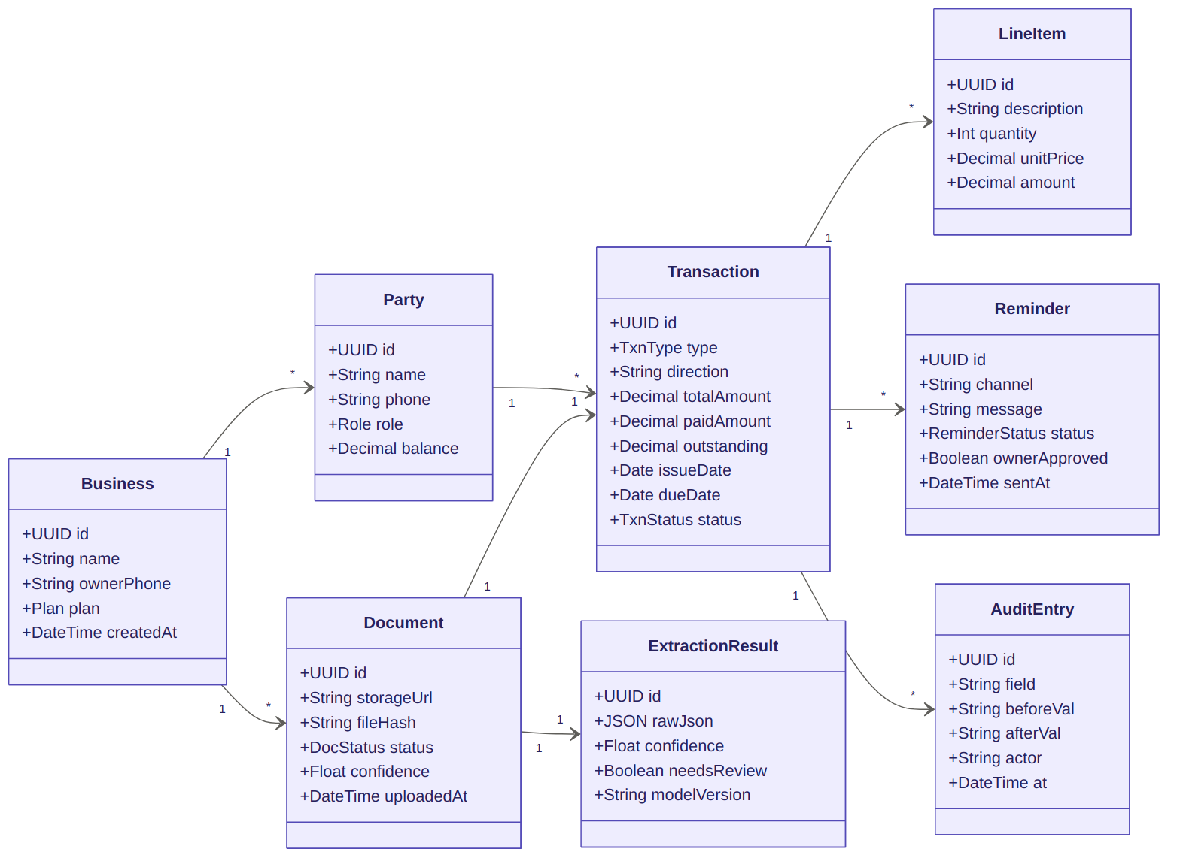
Figure 4 — Class diagram: domain model

6. Data flow diagram
How data moves between the owner, external services (WhatsApp, Claude, object storage), the six backend services, and the data stores. Read this alongside the architecture diagram in section 7.
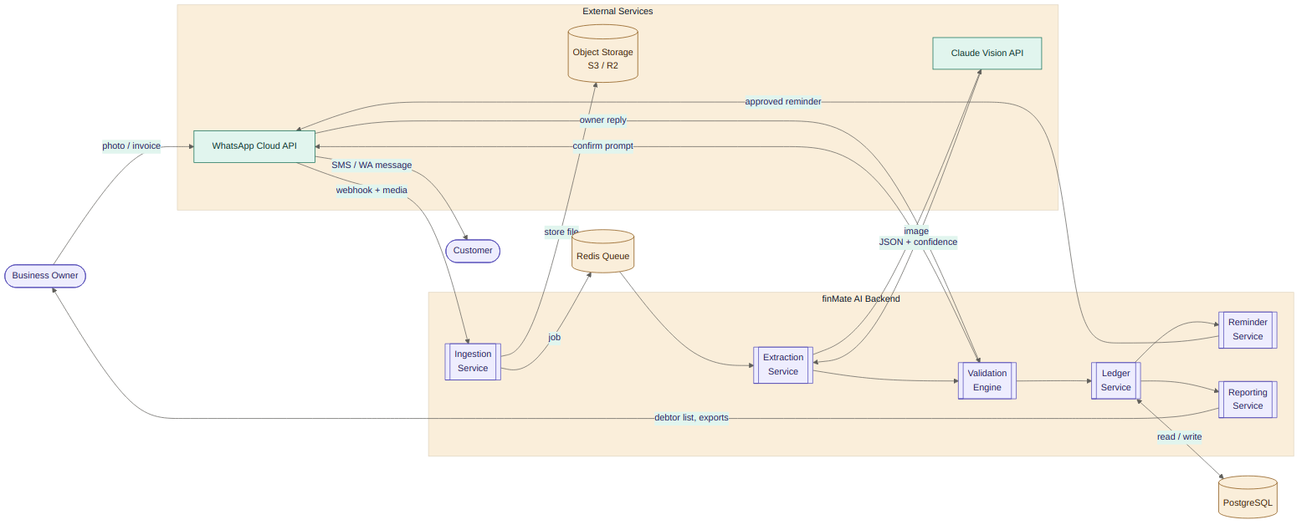
Figure 5 — Data flow diagram

7. Component / deployment architecture
Layered architecture: client, API, background workers, data, and observability. The WhatsApp webhook enqueues jobs to Redis; workers process the pipeline stages; PostgreSQL holds all ledger state; files live in S3/R2.
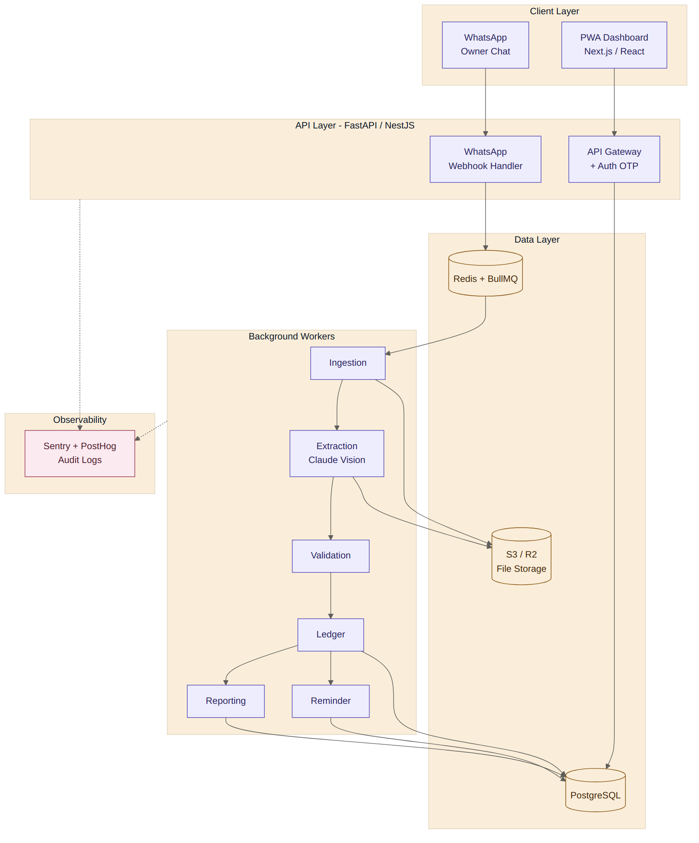
Figure 6 — Component and deployment architecture

8. Entity relationship diagram
The database schema. Use this as the basis for the initial migration. All primary keys are UUIDs; all money fields are DECIMAL (never float) to avoid rounding errors on balances.
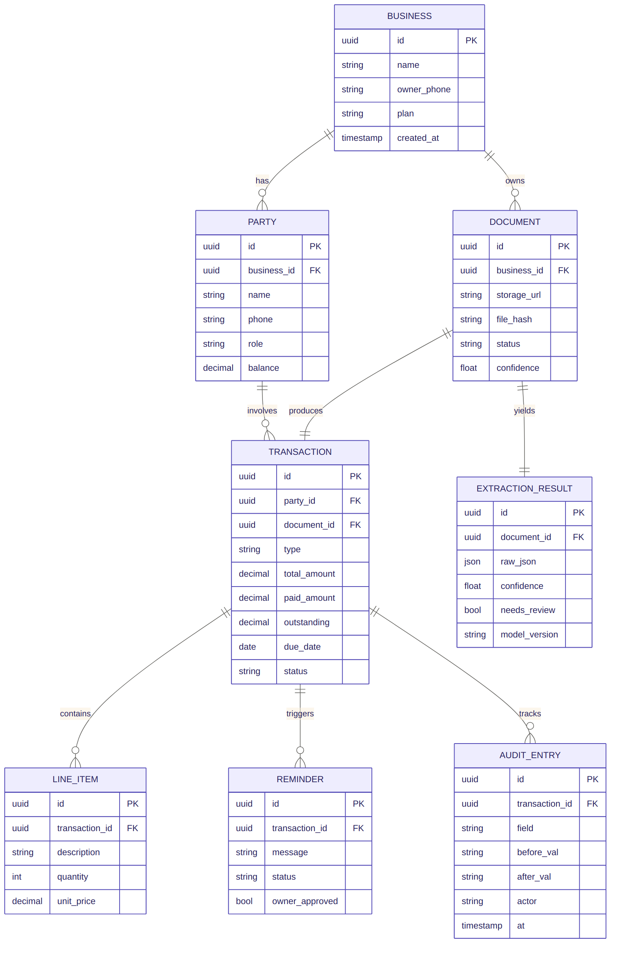
Figure 7 — Entity relationship diagram

9. AI extraction contract
The Extraction Service calls the Claude API with the document image and must return this exact JSON structure via structured output / tool-use (a strict JSON schema), not free-text parsing. The confidence field drives the routing branch in sections 2–4.
{
"document_type": "invoice", // invoice | receipt | payment_proof | screenshot
"transaction_type": "sale", // sale | purchase | payment_in | payment_out
"direction": "money_in", // money_in | money_out
"party": {
"name": "Ali Traders",
"phone": "03001234567",
"role": "customer" // customer | supplier
},
"invoice_number": "INV-1042",
"date": "2026-06-27",
"due_date": "2026-07-05",
"currency": "PKR",
"subtotal": 12000,
"tax_amount": 0,
"discount": 0,
"total_amount": 12000,
"paid_amount": 5000,
"outstanding_amount": 7000,
"line_items": [
{ "description": "Mobile covers", "quantity": 100, "unit_price": 120, "amount": 12000 }
],
"confidence": 0.87, // 0.0 - 1.0, drives routing
"needs_review": false,
"notes": "Partial payment detected from handwritten note."
}
Implementation notes for Claude Code:
- Use Anthropic's API with a tool/structured-output schema matching the above; validate the response against a JSON schema before trusting it.
- Extraction should handle Urdu/Roman-Urdu text, handwritten notes, and messy screenshots. Prompt the model to set a lower confidence when the image is unclear rather than guessing.
- Validation Engine independently re-checks math (subtotal, tax, discount, total; paid + outstanding = total) and lowers confidence / flags needs_review on any mismatch.
- Duplicate detection: file hash first, then fuzzy match on party + date + amount.

10. Service responsibilities
Service | Responsibilities
Ingestion | Receive WhatsApp webhooks, download media, store to object storage, create Document record, detect duplicates, push job to queue.
Extraction | Call Claude vision, return structured JSON, classify document, detect language, score confidence.
Validation | Check required fields, math, duplicates, date sanity, party matching, apply confidence thresholds and routing.
Ledger | Create transaction drafts, post approved entries, maintain party balances, support corrections with audit trail.
Reminder | Detect overdue invoices, draft reminders, request owner approval, send after approval, track status.
Reporting | Weekly debtor list, monthly Urdu summary, P/L view, accountant-ready CSV/PDF export.

Recommended tech stack
Layer | Choice
Frontend / dashboard | Next.js / React as a PWA (mobile-first); native app later
Backend API | FastAPI (Python) or NestJS (Node) — pick one and stay consistent
Database | PostgreSQL
File storage | S3-compatible: AWS S3, Cloudflare R2, or MinIO
Queue / workers | Redis + BullMQ (Node) or Celery (Python)
AI extraction | Anthropic Claude API (vision, structured output)
Messaging | WhatsApp Cloud API (or Twilio WhatsApp)
Auth | OTP login / magic link
Deployment | Docker on a VPS initially; Kubernetes only if scale demands
Monitoring | Sentry + PostHog + uptime monitoring; audit logs from day one

11. MVP scope — build vs defer
Build exactly these features for the MVP. Anything marked defer must not be started until the core loop is validated with real users.
Feature | In MVP? | Notes
WhatsApp document/photo intake | Yes | Matches existing owner behaviour.
Manual upload dashboard | Yes | Backup channel for staff/accountant.
AI extraction | Yes | Core magic.
Human correction UI | Yes | Money mistakes are serious.
Customer ledger + payment status | Yes | Core wedge.
Payment reminders (owner-approved) | Yes | Clear ROI.
Weekly debtor summary | Yes | Core wedge.
Monthly Urdu summary + export | Yes | Emotional value + accountant-ready.
Full double-entry accounting | Defer – Phase 2 | Too heavy for MVP.
Cash-in/out (CashBook) | Defer – Phase 2 | Receivables-first.
Inventory / stock | Defer | Scope trap.
FBR direct filing | Defer – Phase 3 | Regulatory risk; say tax-ready, not certified advice.
Embedded lending / financing | Defer – Phase 4 | Needs license + capital.

12. Suggested build sequence
A pragmatic order for implementation so there is a working vertical slice as early as possible:
- 1. Schema + migrations from the ERD (section 8). Money as DECIMAL, IDs as UUID.
- 2. WhatsApp webhook + Ingestion service: receive a photo, store it, create a Document, dedupe by hash.
- 3. Extraction service against the Claude API using the JSON contract (section 9), with schema validation.
- 4. Validation engine + confidence routing (the three-way branch). Make thresholds config.
- 5. Ledger service: post transactions, maintain Party balances, write AuditEntry on every change.
- 6. Owner-confirm loop over WhatsApp for medium-confidence entries; human review queue for low.
- 7. Reminder service: overdue detection, owner approval, send.
- 8. Reporting: weekly debtor list + monthly export (CSV/PDF).
- 9. PWA dashboard for manual upload, review queue, and ledger viewing.
- 10. Observability: Sentry, PostHog, and audit-log review.
Guardrails: keep the MVP to the receivables wedge, log every correction from day one, never send a reminder without owner approval, and always position outputs as “tax-ready, not certified tax advice.”

