XỬ LÝ ẢNH SỬ DỤNG C#
1. Tạo một Project đơn giản trên C#
Bước 1: Chạy Visual Studio
Bước 2: Tạo một Project cho phép tạo một ứng dụng trên Windows
+ Trong menu File chọn New Project, cửa sổ New Project xuất hiện như sau:
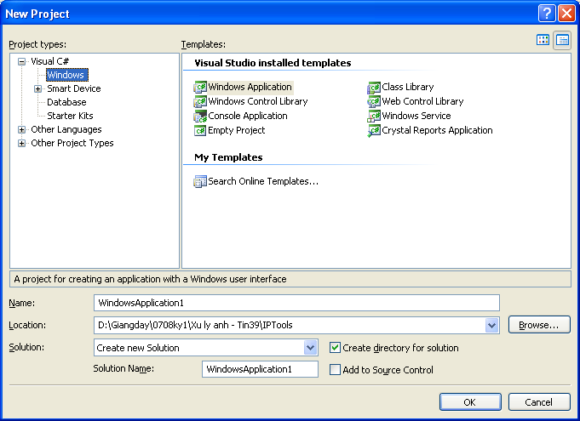
+ Project types: Chọn Visual C#, chọn Windows
+ Templates: Chọn Windows Application
+ Name: Chọn tên Project (đặt là IPTools)
+ Location: Chọn thư mục lưu ứng dụng
+ Chọn OK để tạo project.
Bước 3: Custemize Project cho bài toán xử lý ảnh
+ Trong cửa sổ Solution Explorer kích phải chuột vào Form1->Chọn Rename và đổi tên Form1 thành MainForm

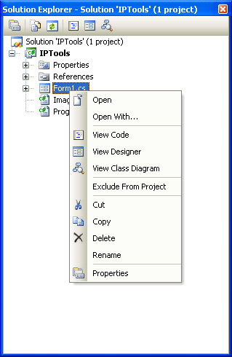
+ Trong cửa sổ Solution Explorer kích đúp vào MainForm: Thêm vào trên form hai PictureBox và đặt tên là PicGoc va PicKetQua; thêm 2 buttom vào mainform và đặt tên là LoadImage và GrayTranform; đổi tên form thành MainForm.
+ Trong cửa sổ Solution Explorer kích chuột phải vào IPTools -> Chọn Add -> chọn Class như hình sau:
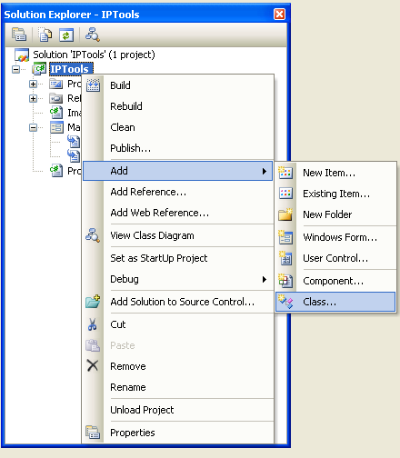
-> cửa sổ Add new item xuất hiện như hình sau, đặt tên cho Class là ImageClass -> Chọn Add.
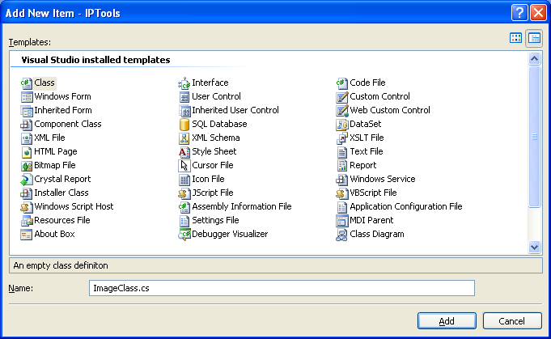
2. Lớp BITMAP
Encapsulates a GDI+ bitmap, which consists of the pixel data for a graphics image and its attributes. A Bitmap is an object used to work with images defined by pixel data.
The following tables list the members exposed by the Bitmap type.
Public Constructors
 | Name | Description
 | Bitmap | Overloaded. Initializes a new instance of the Bitmap class.
Top
Public Properties
 | Name | Description
 | Flags | Gets attribute flags for the pixel data of this Image.(Inherited from Image.)
 | FrameDimensionsList | Gets an array of GUIDs that represent the dimensions of frames within this Image.(Inherited from Image.)
 | Height | Gets the height, in pixels, of this Image.(Inherited from Image.)
 | HorizontalResolution | Gets the horizontal resolution, in pixels per inch, of this Image.(Inherited from Image.)
 | Palette | Gets or sets the color palette used for this Image.(Inherited from Image.)
 | PhysicalDimension | Gets the width and height of this image.(Inherited from Image.)
 | PixelFormat | Gets the pixel format for this Image.(Inherited from Image.)
 | PropertyIdList | Gets IDs of the property items stored in this Image.(Inherited from Image.)
 | PropertyItems | Gets all the property items (pieces of metadata) stored in this Image.(Inherited from Image.)
 | RawFormat | Gets the format of this Image.(Inherited from Image.)
 | Size | Gets the width and height, in pixels, of this image.(Inherited from Image.)
 | Tag | Gets or sets an object that provides additional data about the image.(Inherited from Image.)
 | VerticalResolution | Gets the vertical resolution, in pixels per inch, of this Image.(Inherited from Image.)
 | Width | Gets the width, in pixels, of this Image.(Inherited from Image.)
Top
Public Methods
(see also Protected Methods )
 | Name | Description
 | Clone | Overloaded. Creates a copy of the section of this Bitmap defined with a specified PixelFormat.
 | CreateObjRef | Creates an object that contains all the relevant information required to generate a proxy used to communicate with a remote object. (Inherited from MarshalByRefObject.)
 | Dispose | Releases all resources used by this Image. (Inherited from Image.)
 | Equals | Overloaded. Determines whether two Object instances are equal. (Inherited from Object.)
 | FromFile | Overloaded. Creates an Image from the specified file. (Inherited from Image.)
 | FromHbitmap | Overloaded. Creates a Bitmap from a Windows handle. (Inherited from Image.)
 | FromHicon | Creates a Bitmap from a Windows handle to an icon.
 | FromResource | Creates a Bitmap from the specified Windows resource.
 | FromStream | Overloaded. Creates an Image from the specified data stream. (Inherited from Image.)
 | GetBounds | Gets the bounds of the image in the specified unit. (Inherited from Image.)
 | GetEncoderParameterList | Returns information about the parameters supported by the specified image encoder. (Inherited from Image.)
 | GetFrameCount | Returns the number of frames of the specified dimension. (Inherited from Image.)
 | GetHashCode | Serves as a hash function for a particular type. GetHashCode is suitable for use in hashing algorithms and data structures like a hash table. (Inherited from Object.)
 | GetHbitmap | Overloaded. Creates a GDI bitmap object from a GDI+Bitmap.
 | GetHicon | Returns the handle to an icon.
 | GetHowFromImage | (Inherited from Image.)
 | GetLifetimeService | Retrieves the current lifetime service object that controls the lifetime policy for this instance. (Inherited from MarshalByRefObject.)
 | GetPixel | Gets the color of the specified pixel in this Bitmap.
 | GetPixelFormatSize | Returns the color depth, in number of bits per pixel, of the specified pixel format. (Inherited from Image.)
 | GetPropertyItem | Gets the specified property item from this Image. (Inherited from Image.)
 | GetThumbnailImage | Returns a thumbnail for this Image. (Inherited from Image.)
 | GetType | Gets the Type of the current instance. (Inherited from Object.)
 | InitializeLifetimeService | Obtains a lifetime service object to control the lifetime policy for this instance. (Inherited from MarshalByRefObject.)
 | IsAlphaPixelFormat | Returns a value that indicates whether the pixel format for this Image contains alpha information. (Inherited from Image.)
 | IsCanonicalPixelFormat | Returns a value that indicates whether the pixel format is 32 bits per pixel. (Inherited from Image.)
 | IsExtendedPixelFormat | Returns a value that indicates whether the pixel format is 64 bits per pixel. (Inherited from Image.)
 | LockBits | Overloaded. Locks a Bitmap into system memory.
 | MakeTransparent | Overloaded. Makes the default transparent color transparent for this Bitmap.
 | ReferenceEquals | Determines whether the specified Object instances are the same instance. (Inherited from Object.)
 | RemovePropertyItem | Removes the specified property item from this Image. (Inherited from Image.)
 | RotateFlip | This method rotates, flips, or rotates and flips the Image. (Inherited from Image.)
 | Save | Overloaded. Saves this image to the specified stream in the specified format. (Inherited from Image.)
 | SaveAdd | Overloaded. Adds the information in the specified Image to this Image. The specified EncoderParameters determine how the new information is incorporated into the existing image. (Inherited from Image.)
 | SelectActiveFrame | Selects the frame specified by the dimension and index. (Inherited from Image.)
 | SetPixel | Sets the color of the specified pixel in this Bitmap.
 | SetPropertyItem | Stores a property item (piece of metadata) in this Image. (Inherited from Image.)
 | SetResolution | Sets the resolution for this Bitmap.
 | ToString | Returns a String that represents the current Object. (Inherited from Object.)
 | UnlockBits | Unlocks this Bitmap from system memory.
Top
Protected Methods
 | Name | Description
 | Finalize | Allows an Object to attempt to free resources and perform other cleanup operations before the Object is reclaimed by garbage collection. (Inherited from Object.)
 | MemberwiseClone | Overloaded. (Inherited from MarshalByRefObject.)
Top
See Also

Reference
Bitmap Class
System.Drawing Namespace

Navigation
MSDN Library > .NET Development > Previous Versions > .NET Framework SDK 2.0 > Class Library Reference > System.Drawing > Bitmap Class > Bitmap Members

3. Project IPTools
a. Khai báo
Bitmap anhGoc; -> Lưu trữ ảnh gốc
Bitmap anhKetQua; -> Lưu trữ ảnh kết quả
ImageClass image = new ImageClass(); -> Thực hiện các phép xử lý ảnh
b. Load ảnh từ file vào picturebox. Viết thủ tục Click cho nút lệnh LoadImage như sau:
private void LoadImage_Click(object sender, EventArgs e)
{
Sử dụng lớp OpenFileDialog để chọn ảnh cần load
OpenFileDialog dlgOpen = new OpenFileDialog();

Nếu người sử dụng chọn OK
if (dlgOpen.ShowDialog() == DialogResult.OK)
{
Tạo anhGoc, anhKetQua từ file ảnh vừa chọn
anhGoc = new Bitmap(dlgOpen.FileName);
anhKetQua = new Bitmap(dlgOpen.FileName);

Hiển thị ảnh gốc vào pictureboc PicGoc
PicGoc.Image = anhGoc;
}
}
c. Tạo thủ tục Gray để chuyển ảnh màu thành ảnh xám trong ImageClass như sau:

public void Gray(Bitmap bmpInput)
{
// Lock the bitmap's bits.
Rectangle rtg = new Rectangle(0, 0, bmpInput.Width, bmpInput.Height);
BitmapData bmpData = bmpInput.LockBits(rtg, ImageLockMode.ReadWrite, bmpInput.PixelFormat);

// Get the address of the first line.
IntPtr ptr = bmpData.Scan0;

// Declare an array to hold the bytes of the bitmap.
// This code is specific to a bitmap with 24 bits per pixels.
int bytes = bmpInput.Width * bmpInput.Height * 3;
byte[] rgbValues = new byte[bytes];

// Copy the RGB values into the array.
System.Runtime.InteropServices.Marshal.Copy(ptr, rgbValues, 0, bytes);

// Gray transform
int GrayLevel;
for (int counter = 0; counter < rgbValues.Length; counter += 3)
{
GrayLevel = (rgbValues[counter+0] + rgbValues[counter + 1] + rgbValues[counter+2])/3;
rgbValues[counter] = rgbValues[counter+1] = rgbValues[counter+2]= (byte) GrayLevel;
}

// Copy the RGB values back to the bitmap
System.Runtime.InteropServices.Marshal.Copy(rgbValues, 0, ptr, bytes);

// Unlock the bits.
bmpInput.UnlockBits(bmpData);
}
d. Thực hiện chuyển ảnh màu thành ảnh xám và hiển thị lên ảnh picturebox PicKetQua:
private void GrayTransform_Click(object sender, EventArgs e)
{
image.Gray(anhKetQua);
PicKetqua.Image = anhKetQua;
}

