本機環境建置

1. 安裝XAMPP

<https://www.apachefriends.org/zh_tw/download.html>

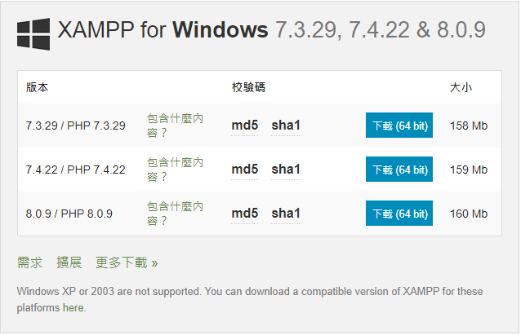

1. 安裝Composer

<https://getcomposer.org/download/>

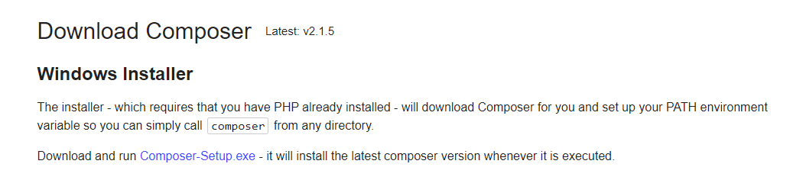

1. 安裝Laravel

進入Terminal輸入：

composer global require laravel/installer

1. 建立專案或直接pull專案到資料夾

cd c:\xampp\htdocs

composer create-project --prefer-dist laravel/laravel trendforce_cn

1. 設定hosts

Windows 版本請至 C:\Windows\System32\drivers\etc\hosts

設定範例 127.0.0.1 trendforce_cn.local

1. 設定 vhost

Windows 版本請至C:\xampp\apache\conf\extra\httpd-vhosts.conf

<VirtualHost *:80>

DocumentRoot "C:\xampp\htdocs\trendforce_cn\public"

ServerAdmin trendforce_cn.local

ServerName trendforce_cn.local

ErrorLog "logs/ trendforce_cn.local -error.log"

CustomLog "logs/ trendforce_cn.local -access.log" combined

</VirtualHost>