LGVG FLOW | OFFICIAL GUIDE

User Manual
  - Order flow indicator for the WIN mini index futures on B3
File LGVGFLOWATUAL.psf | Profit Pro and Profit Ultra | Recommended chart: 2 minutes | Manual 2.0
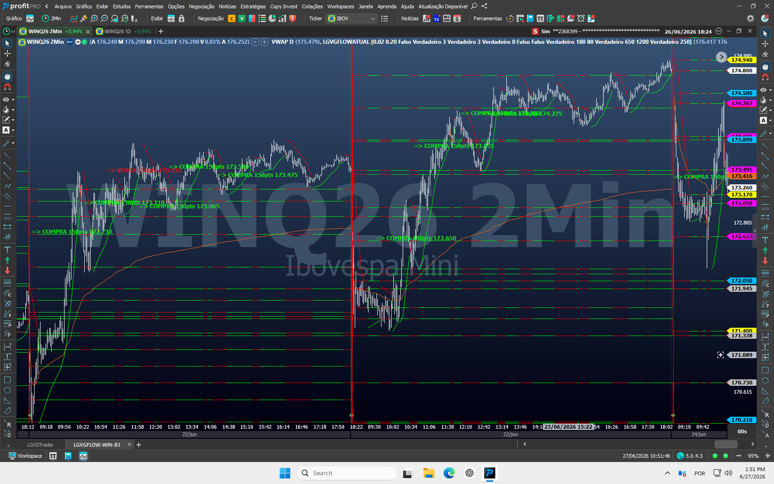
Operational view of LGVG Flow in Profit Pro.
lgvgflow.uaisoftware.com.br
Educational material. The indicator does not execute orders and does not guarantee results.

READ BEFORE OPERATING

What this manual delivers
This guide turns the signals and levels displayed by LGVG Flow into a clear process for installing, reading and making a responsible decision.
RISK WARNING Day trading and scalping involve a high risk of loss. Use a simulation account until you master the reading process, define a loss limit, and never risk an amount that could compromise your financial security.

Essential requirements
Item | Requirement
Platform | Profit Pro or Profit Ultra
Instrument | Mini index futures (WIN) traded on B3
Time frame | 2 minutes, according to calibration and examples in this manual
Data | Active market feed and aggressive order-flow data on the platform
Knowledge | Market fundamentals, order execution, and risk management

TECHNICAL SOURCE AND COMPATIBILITY Based on the LGVGFLOWATUAL.psf file. Requires Profit Pro or Ultra because it uses real aggressive order flow and delta data.

What LGVG Flow does
- Analyzes aggressive order flow, delta, imbalance, executed volume and closing force.
- Combines order flow with VWAP, market structure, daily levels, and the automatic B3 grid.
- Displays signal, suggested price and sound alert after confirmation.
- Filters out some of the noise to highlight situations that are compatible with your internal rules.

What it does not do
- Does not automatically send, change or cancel orders.
- It does not itself define position size, stop, target or daily limit.
- It does not replace training, context or a risk plan and does not promise profit.

LEARNING ROUTE

How to use this manual
Study as you would in a class: first understand what the indicator observes, then learn to recognize the chart, and finally practice the decision-making process. Do not jump straight to an entry.
Step | Target | Expected result
1 | Learn | Understand the proposal, the data used and the limitations.
2 | Install | Import LGVGFLOWATUAL.psf and apply the indicator to the chart.
3 | Configure | Use WIN, 2 minutes, daily VWAP and recommended parameters.
4 | Read | Recognize levels, colors, M signal, D signal and alerts.
5 | Execute | Wait for the candle to close and validate the risk before sending your order.
6 | Review | Record context and learn without optimizing parameters on impulse.

Quick start in 8 steps
- Confirm that your platform is Profit Pro or Profit Ultra and that the feed is connected.
- Download LGVGFLOWATUAL.psf from the official website and import the file into Profit Pro or Profit Ultra.
- Open a chart of the current contract of the WIN mini index futures in 2 minutes.
- Add the daily VWAP and then apply LGVG Flow to the chart.
- Keep the default parameters on first use.
- Check that levels, directional line and indicator name appear on the chart.
- Train in simulation and wait for the signal candle to close before deciding.
- Always use predefined risk; the signal is neither an order nor a guarantee.
GOLDEN RULE The text “150pts” indicates the offset used to calculate the M limit entry. It does not represent a profit target.

SECTION 1

Get to know LGVG Flow
Before trading, learn the sequence of questions that LGVG Flow asks the market.

Think of the indicator as five doors
Question | What the code checks
1. Flow present? | Measures buy/sell aggression, delta, imbalance, and total volume.
2. Candle confirmed? | Evaluates range, body proportions, and closing strength.
3. Location valid? | Compares VWAP, short-term structure, the 0.25% B3 grid, and prior-session levels.
4. Context valid? | Applies time, trend, ICT, distance, repetition, and late-entry safeguards.
5. Entry confirmed? | Waits for M or D confirmation, then shows direction, price, and an alert without submitting an order.

What do you need to learn
You do not need to calculate every filter, but you must understand the reading sequence. A signal appears only when flow, candle, location, context, and confirmation align. The chart may therefore move significantly without producing a signal.
IMPORTANT Imagine five gates in sequence. If one condition is not met, the final signal will not appear. No marker usually means that one of the LGVG Flow safeguards was not satisfied.

Recognized contexts
- Continuity after pullback at VWAP or daily level acting as support/resistance.
- Distant VWAP reversal with flow and structure confirmation.
- Rejection or acceptance in automatic B3 adjustment ranges.
- Confluences of liquidity, sweep, change of character, displacement and imbalance.
- Repetition control to avoid excessive alternation of signals in the same region.
TRADING HOURS The analyzed configuration enables primary signals between 10:05 and 17:45. Opening context may be observed earlier, but the final signal follows the indicator's time filters.

SECTION 1A

Aggressive order flow, absorption and delta
Understand the microstructure used as the basis for reading LGVG Flow.
The price moves due to the meeting between aggressive orders, which consume liquidity, and passive orders, which offer liquidity. The price behavior after this meeting helps to distinguish continuity, absorption and exhaustion.
Concept | What happens | Practical reading
Aggressive order flow | Orders executed against the best available offer. | Shows initiative and urgency as a buyer or seller.
Absorption | Passive liquidity absorbs aggressive orders without allowing proportional price movement. | May reveal defense of a region, but requires confirmation.
Delta | Balance between buying and selling aggressive orders. | Helps compare executed pressure with the resulting price movement.
Exhaustion | Aggressive order flow loses intensity near an extreme. | Indicates loss of continuity; by itself, it is not a reversal signal.

Effort versus result
Scenario | Evidence to watch
Breakout with acceptance | Aggressive order flow increases and price advances, closes beyond the region, and sustains the move.
Possible absorption | There is relevant aggressive order flow, but the price does not progress and rejects the extreme.
Possible exhaustion | Aggressive order flow decreases, the move loses range, and new participants fail to appear in the prior direction.

HOW LGVG FLOW PARTICIPATES The indicator combines aggressive order flow, delta, imbalance, volume, and the candle close with VWAP, structure, and levels. Always compare effort with price movement, confirm the candle, and treat the signal as the result of multiple filters, not as a substitute for risk control.

SECTION 1B

Order Book, Footprint, and hidden orders
Optional tools for the trader; they are not part of LGVG Flow's automatic outputs.
Tool | What it shows | Recommended use
Order Book | Shows visible limit orders and their movement. | Use it to observe whether orders remain, are canceled, or refill near the region.
Times & Trades | Shows effectively executed trades. | Confirm whether the aggressive activity shown in the Order Book resulted in actual trades.
Footprint/Delta | Organizes executed aggressive orders by candle and price level. | Compare pressure, imbalance and price response.
LGVG Flow | Summarizes order-flow and context filters on the chart. | Use the signal as an additional confluence and respect the indicated price.

Spoofing versus real defense
Reading | Behavior | Conduct
Possible spoofing | A large order moves away or is repeatedly canceled as price approaches. | Do not treat the visible order as confirmed support or resistance.
Possible resting liquidity | A large order remains, receives executions, and reappears during the attack. | Wait for aggressive order flow to fail and for price to respond before considering an entry.

Iceberg and refill
An Iceberg order hides part of its quantity and may be identified when lots repeatedly refill at the same price while trades continue. Treat refill as contextual evidence: confirm executions in Times & Trades, the price reaction, and an objective invalidation point.
SEPARATE INDICATOR FROM COMPLEMENTARY READING LGVG Flow uses aggressive order flow and delta, but it does not label spoofing, resting liquidity, or Iceberg orders. These interpretations come from the platform tools and the trader's own analysis.
CONFIRMATION SEQUENCE Locate the region, observe whether orders remain and execute, compare delta with the price response, and use LGVG Flow plus the candle close as confluence. The stop is based on the invalidation point.

SECTION 1C

Confluence of the LGVG methodology
Location first, flow confirmation later.
Reference | Definition | Application
H1 Gap | Imbalance range observed on the 1-hour chart. | It can serve as an area of interest, target, or reaction point; mark it before the trading session.
Empire Point | Proprietary reference within the LGVG methodology. | Only use the points provided by the official training or template.
LGVG Flow Levels | VWAP, B3 grid, open, close, and previous trading sessions. | They serve as an objective context for locating the signal intraday.
LGVG Flow Signal | Result of flow, structure, time and distance filters. | Confirms context, direction and suggested price; does not execute the order.

TECHNICAL DISTINCTION H1 Gaps and Empire Points are complementary references in the methodology. They are not drawn automatically by the analyzed LGVG Flow code unless another indicator or an official template is applied to the workspace.

Wait-and-confirm model
- The price reaches a previously understood region such as H1 Gap, Empire Point, VWAP or daily level.
- Observe the initial reaction without anticipating it; the Order Book, Times & Trades, or Footprint should confirm the response.
- LGVG Flow confirms the context and presents direction and suggested price.
- The order is only sent if risk, invalidation and daily limit are defined.
Filter | Mandatory question
Location | Is the price in a marked and understood region?
Execution | Do delta and executed trades confirm the reading?
Evidence and veto | Did confirmation remain through the close, without order withdrawals or strong opposing aggressive flow?
Risk | Were stop, quantity and maximum loss set before the order?

SECTION 2

Installation and activation
Use the LGVGFLOWATUAL.psf file available on the official website.
BEFORE INSTALLING Close duplicate versions of the chart and save the original file in a known folder. Do not edit code or share protected license files.

Recommended procedure
- Open Profit Pro or Profit Ultra with your usual account.
- Access the Strategy Editor through the platform's Strategies menu.
- Choose the import option and select LGVGFLOWATUAL.psf downloaded from the official website.
- Confirm the import and, when prompted, compile or save the strategy without changing the content.
- Open the mini index futures chart and locate LGVG Flow in the list of available indicators/strategies.
- Apply the indicator, confirm the default parameters, and save the workspace layout.
- Restart the platform only if the name does not appear after a completed import.

How to confirm installation
- The name LGVGFLOW appears in the indicator line of the chart.
- The horizontal levels and directional curve are drawn after the data is loaded.
- The chart does not display the EXP mark.
- The history and candles continue to update without error messages.
LICENSE If “EXP” appears, the license is not valid for the current date. Do not try to change the file: contact official support to verify its activation.

Updates
When there is an update, preserve your workspace, download LGVGFLOWATUAL.psf again from the official website and confirm the parameters. Avoid keeping two versions with similar names in the same chart.

SECTION 3

Chart configuration
The recommended environment reduces reading differences and facilitates support.
Configuration | Recommendation
Instrument | WIN mini index futures current contract
Time frame | 2 minutes
Platform | Profit Pro or Profit Ultra
Reference | Daily VWAP added to chart
Parameters | LGVG Flow defaults on first use
Theme | Dark background recommended for color contrast

Workspace setup
- Open the most liquid WIN contract and confirm the current expiration.
- Select 2 minutes in the chart period.
- Add the daily VWAP. In the screenshots in this manual it appears in orange.
- Apply LGVG Flow and leave AjusteManual at zero to use the automatic B3 reference.
- Adjust zoom and scale to view price, signal texts and labels on the right axis at the same time.
- Save the workspace with an easy-to-identify name, such as “LGVG Flow - WIN 2M”.
VWAP The daily VWAP shown in the screenshots is a complementary chart reference. Add it to the workspace so the visual reading matches the examples.

SECTION 4

Visual anatomy
Use color as a shortcut, but always confirm the text and price on the price scale.
Color | Element | How to use
Green | Buy signal and bullish direction | Buy labels and bullish segments of the directional indicator.
Red | Sell signal and bearish direction | Sell labels and bearish segments of the directional indicator.
Magenta | Automatic B3 grid | Ranges derived from the adjustment and their 0.25% steps.
Yellow | Previous trading session | High, low and intermediate reference of the previous day.
Blue | Opening / D2 | Opening of the day and levels from two trading sessions ago.
White | Previous close | Closing price of the last trading session.
Gray | D3 | High, low and 50% from three trading sessions ago.
Orange | Daily VWAP | Complementary indicator added to the chart.

Directional curve
The green/red curve is LGVG Flow's visual PSAR. Think of it as a context arrow: it helps identify changes in direction, but the code does not use it by itself to confirm an entry.

Horizontal levels
The colored horizontal lines act as reference and liquidity regions: magenta for the B3 grid, yellow for D1, blue for the open/D2, white for the previous close, and gray for D3. Green and red indicate direction and signals, not a horizontal-level category.
GOOD PRACTICE When two colors appear to overlap, read the price-axis label, zoom in, and confirm whether the level belongs to the B3 grid, the previous trading session, or VWAP.

SECTION 5

Reading the signals
The final signal provides direction and price; the decision to execute remains the trader's.
Marker | Meaning | Practical reading
M | Entry by mitigation | Buy: candle close - 150 points. Sell: candle close + 150 points.
D | Direct entry | Buy at the low of the trigger candle; sell at its high. Disabled by default.
=> BUY | Suggested price | Shows the calculated price for a buy order.
=> SELL | Suggested price | Shows the calculated price for a sell order.
Audible alert | New confirmation | Triggered only on the most recent candle when a new final signal appears.
EXP | License | Indicates expired or invalid license for the current date.

ATTENTION TO THE 150 POINTS For an M signal, “150pts” is the distance between the candle close and the suggested limit order. It is not a target, stop, or price-move forecast.

Correct sequence when receiving a signal
- Wait for the candle to close and confirm that the signal text remains on the chart.
- Read the direction and note the exact price displayed after BUY or SELL.
- Confirm that the price is still close to the region that originated the signal and that there has not been an abrupt change in context.
- Calculate position size, invalidation and maximum loss before submitting any orders.
- For M, use limit order at the price shown. Do not chase the market if the order is not executed.
- If the entry does not occur promptly, treat the context as stale and wait for a new signal.
VALIDITY WINDOW Mitigation confirmation waits for up to three candles. Separately, the buy-order monitoring logic tracks an M order fill for up to four candles, about eight minutes on the 2-minute chart. After that, reassess the scenario.

SECTION 5A

Guided class: how the signal is born
Now let's follow LGVG Flow's reasoning from setup to the price written on the graph.

First: the setup needs to pass through the filters
Step | Instructor's explanation
1. Reading | LGVG Flow measures aggressive order flow, delta, imbalance, candle, VWAP, structure, time and regions.
2. Attention | When the context is ready, the setup is saved. This is not yet an order.
3. Mitigation | With Direct Entry disabled, price must retrace 40% of the trigger candle without reaching full invalidation.
4. Confirmation | The retracement must close again in favor of the setup: buy with a bullish candle and strong close; sell with a bearish candle and weak close.
5. Validity window | The mitigation window lasts no more than three candles. If price breaks the trigger low/high or the window expires, the setup is canceled.
6. Signal output | After confirmation, the chart shows M and calculates the order: buy 150 points below the close; sell 150 above.

DO NOT CONFUSE 40% WITH 150 POINTS The 40% belongs to the internal confirmation of the setup. The 150 points belong to the M order price displayed after the signal was confirmed. There are two different stages.

Guided M buy example
Moment | What happens
Trigger candle | Minimum 100,000, maximum 100,200: range of 200 points.
40% level | 100,200 - 40% of 200 = 100,120.
Confirmation | The next candle touches 100,120, holds above 100,000, and closes bullish at 100,180.
Price M | 100,180 - 150 = suggested limit order at 100,030.

AND WHEN DOES D APPEAR? D can only appear when AtivarEntradaDireta is enabled. In small setups, with a range of up to 120 points, or in a specific ICT opening context, a buy uses the low and a sell uses the high of the confirmed candle. LGVG Flow keeps D disabled by default.

SECTION 5B

Entry Types
Choose the model before placing the order and do not mix rules during the operation.
The methodology provides two entry approaches: anticipate a reaction at an unmitigated liquidity region, or wait for a complete LGVG Flow buy or sell signal.

Entry Type 1 - Liquidity Region
Rule | Application
Condition | Use only a colored horizontal reference line that has not yet been touched by price during the day.
Sell | Place sell limit order in the liquidity region located above the current price.
Buy | Place buy limit order in the liquidity region located below the current price.
Mitigation | Once price touches the line, it no longer meets the unmitigated region criteria for a new Entry 1 that day.
Cancellation | Cancel the order if the line is touched before its planned execution or if the context that justified the operation changes.

LIMIT ORDER Entry 1 seeks reaction on the exact price of the region. Do not chase the market if the order does not execute and do not reuse as new a line that has already been mitigated.

Entry Type 2 - Indicator Signal
Step | Conduct
Confirmation | Wait for LGVG Flow to complete confirmation and retain the BUY or SELL signal on the chart.
Price | Place the order at the exact price shown by the indicator, respecting the displayed M or D marker.
Execution | For an M signal, use a limit order at the suggested price; do not turn it into a market entry out of anxiety.
Validity | If the order is not filled promptly or the context changes, wait for a new signal.

INDICATOR VERSUS MANUAL METHOD Entry 1 is manual and originates from the region; Entry 2 originates from the LGVG Flow signal. Choose one rule so you do not duplicate risk on the same trade idea.

SECTION 5C

Targets, stops, and multiple contracts
Complementary operational plan: the LGVG Flow code does not calculate or send these orders.
METHOD STOP RULE In this operating model for the mini index futures, the stop-loss is 250 points per contract. The stop should never be extended after entry.

Trading with 1 contract
Item | Rule
Target | Scalp with a short target, normally up to 250 points.
Stop-loss | 250 points from entry price.
Reference 1:1 | 250-point stop and 250-point target.
Smaller target | If the exit occurs before 250 points, the return will be less than the risk of 250 points and the ratio will be below 1:1.

EXAMPLE 1:1 Entry at 120,000 points, stop at 119,750 and target at 120,250 for a buy. Risk: 250 points. Planned return: 250 points.

Trading with more than 1 contract
Management | Application
First contract | Close the first contract at the 250-point target to secure the scalp partial exit.
Other contracts | Keep them for the next liquidity regions, identified by the colored horizontal lines on the chart.
Stop-loss | Keep the 250-point stop defined for the trade; do not increase the risk on the remaining position.
Reference 1:3 | With 250 points of risk, the target region should be approximately 750 points from entry.

VALIDATE THE SPACE The mere existence of a liquidity line does not automatically create a 1:3 ratio. Measure the distance before entry; if the region is less than 750 points away, record the actual ratio.
EXECUTION RESPONSIBILITY LGVG Flow does not submit stops, targets, partial exits, or full-position exits. Every order and contract quantity is defined and managed by the user.

PRACTICAL EXAMPLE 1

Continuity and reversal on the same day
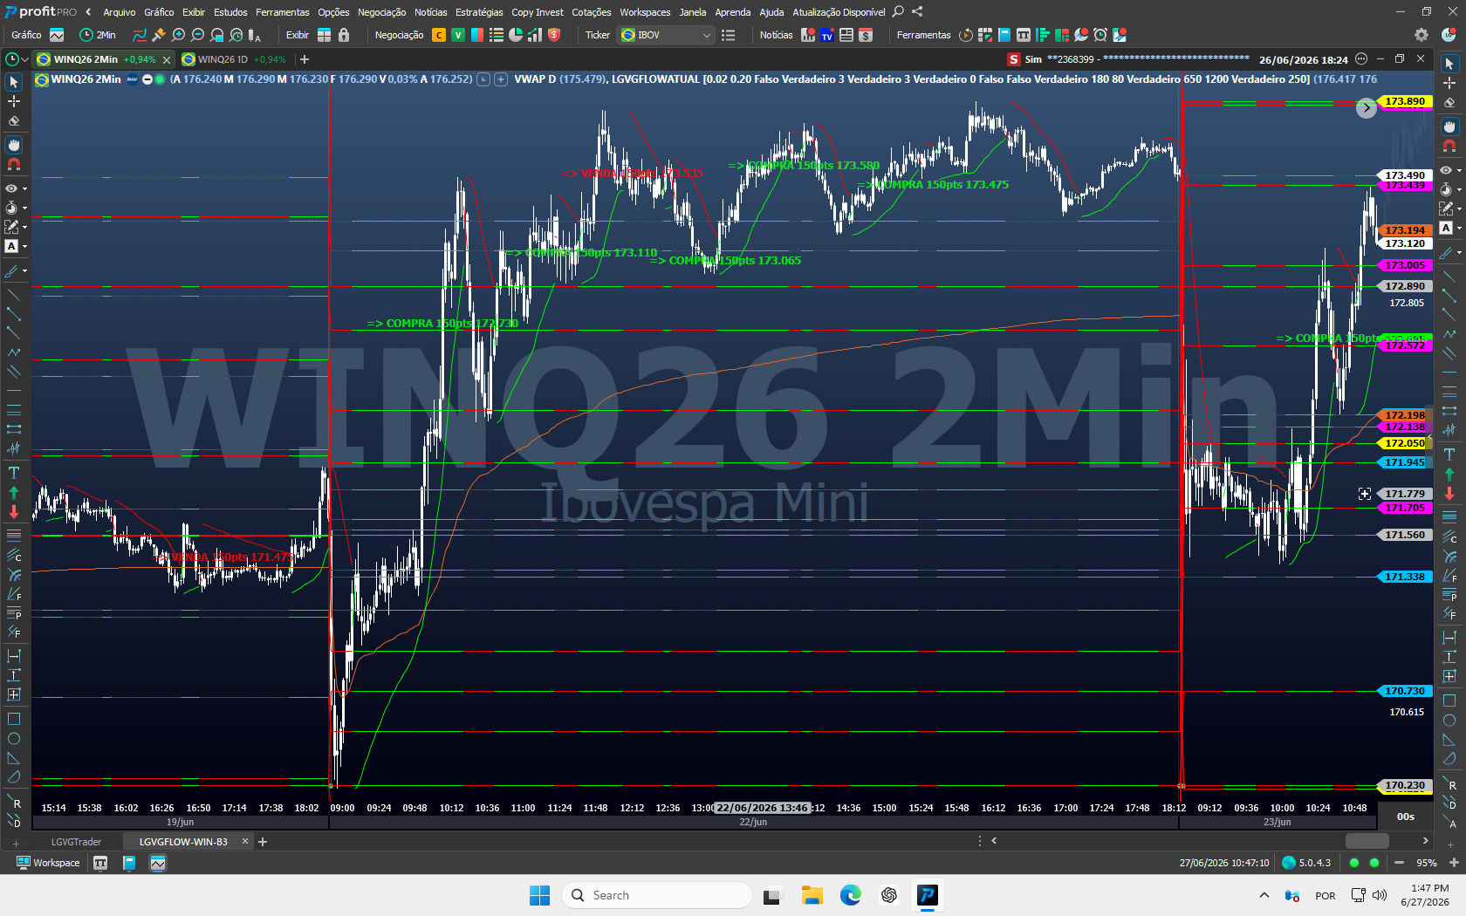
Figure 1 - Historical example with buy and sell signals in different WIN regions.

How to study the image
- Note where each text starts in relation to the VWAP, the horizontal levels and the direction of the curve.
- Compare the distance between the candle close and the price suggested in the M signal.
- Notice that opposite signals do not appear on every oscillation; context and rearm filters control repetition.
- Use example to recognize elements, never to assume that historical behavior will be repeated.
HISTORICAL EXAMPLE The image is didactic and does not represent a promise of future results.

PRACTICAL EXAMPLE 2

Sell signal confirmed, followed by a new setup
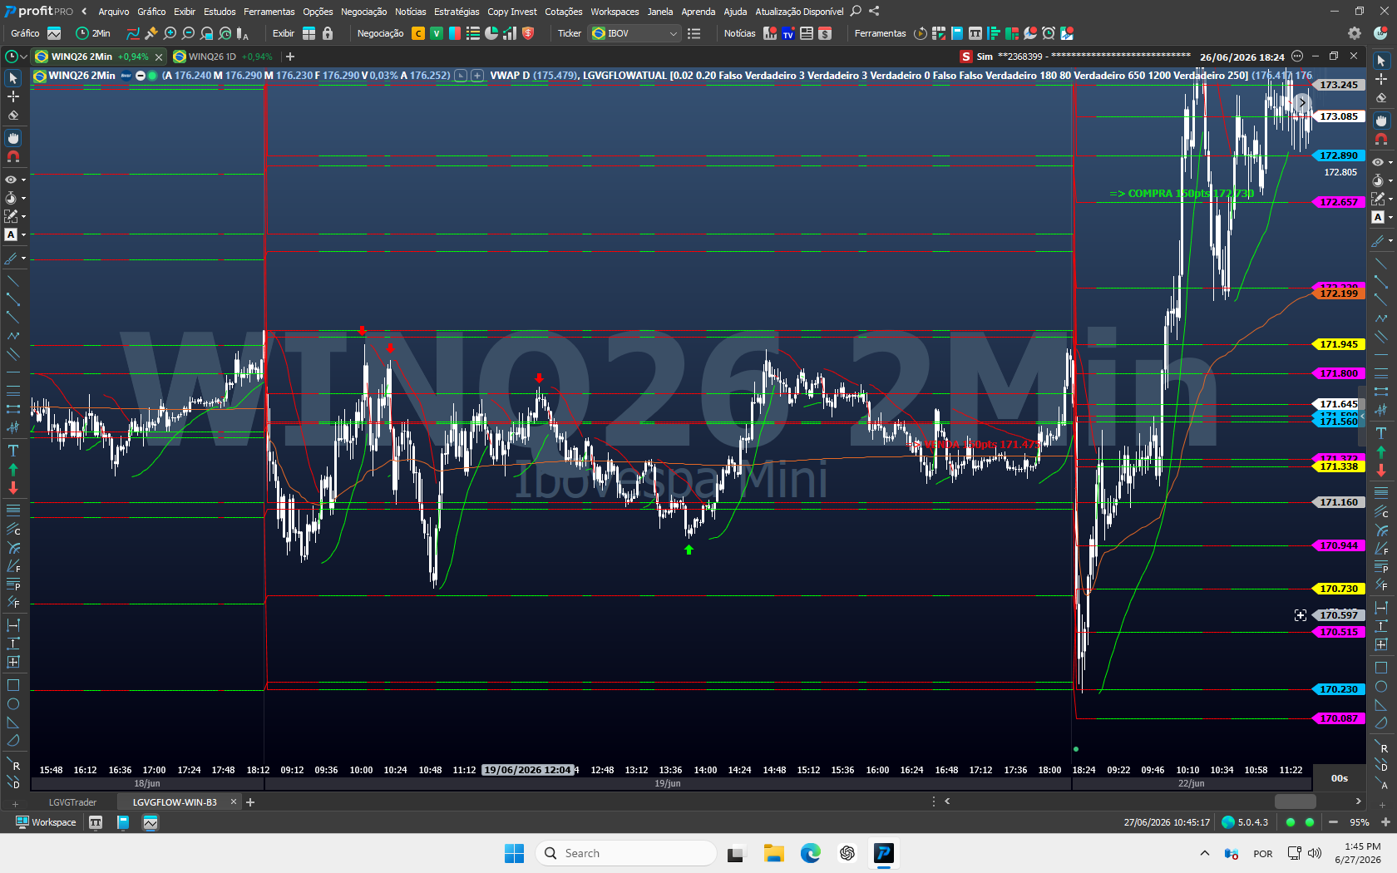
Figure 2 - M sell signal followed by a new bullish context in another trading session.

Reading Points
- The suggested price is written on the chart itself; do not rely on a visual estimate when the price label is available.
- A new trading session recalculates the daily references and may completely change the context.
- The sell signal does not authorize maintaining a thesis indefinitely; the reading must be updated candle by candle.
- The next opening must be treated as a new scenario, with new levels and new risk control.
DISCIPLINE The indicator highlights opportunity; Your routine defines whether it fits into the day's plan.

PRACTICAL EXAMPLE 3

Pullback, support, and continuation
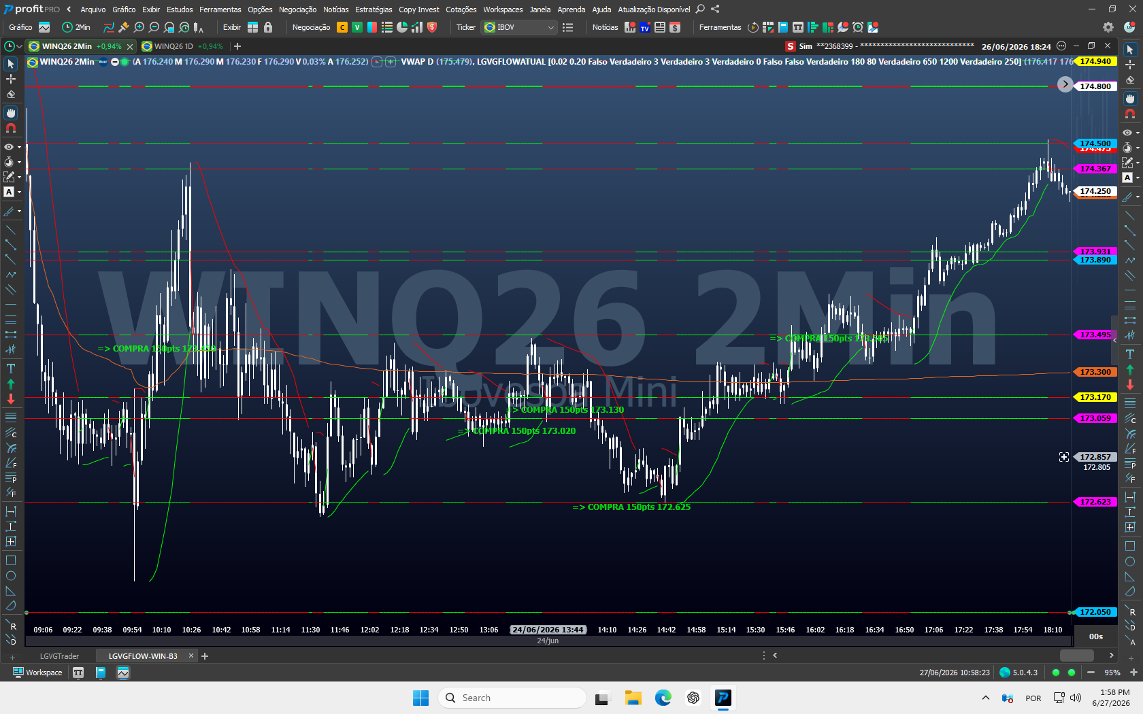
Figure 3 - Buy signals in different regions during a recovery and intraday continuation.

Reading Points
- Buy signals may appear during both a recovery and pullbacks within an established trend.
- Proximity to support, VWAP, or the B3 grid is part of the context; the buy label is the final visual confirmation.
- After an extended push, the stretch buy filter helps prevent late entries, but does not eliminate all risk.
- Don't anticipate the green text just because the price touched a line.
DO NOT ANTICIPATE Touching a level provides context; a confirmed signal is a separate event.

PRACTICAL EXAMPLE 4

Trend, distance and levels
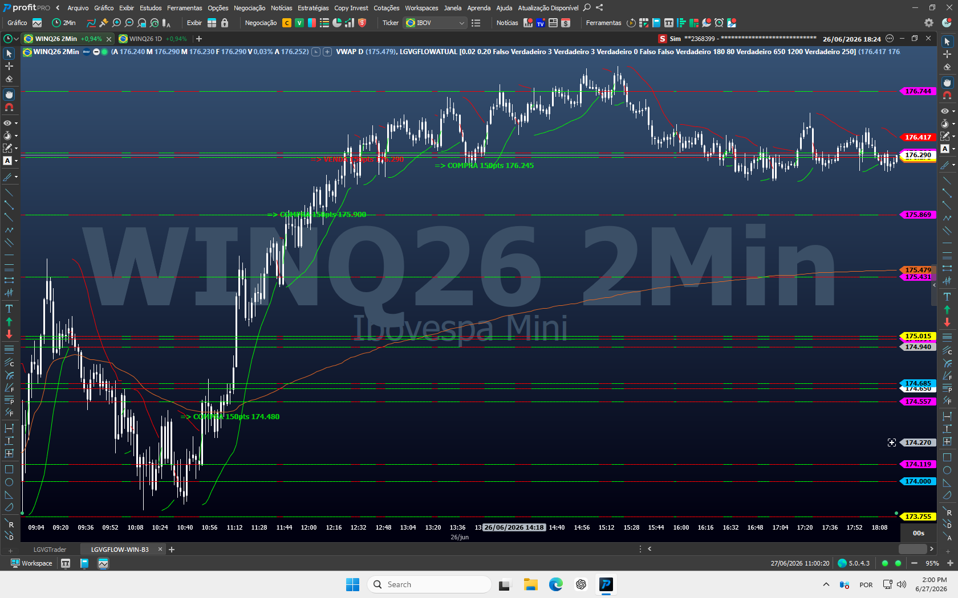
Figure 4 - Bullish trend with filtered signals and price references on the right axis.

Reading Points
- The distance to the VWAP and subsequent levels influences the operational quality of the available space.
- Strong countertrend selling requires additional confirmation when it occurs above the VWAP.
- The price may continue without generating a new signal if the stretch or repeat filters block entry.
- The absence of a signal after a move is not an invitation to trade without defined criteria.
CONTEXTUAL READING Direction, location, and room to the next level matter as much as the signal color.

SECTION 6

Recommended parameters
Start with the defaults. Change one item at a time and record why.

Basic parameters
Parameter | Default | Guidance
Factor | 0.02 | Maintain the default, unless instructed by support.
Limit | 0.20 | Maintain the default, unless instructed by support.
VisualHistoric | False | Use the default for everyday trading; enable it only for guided study.
AtivarAlarmeEntrada | True | Activates sound when new final signal appears on the current candle.
RepeticoesAlarme | 3 | Increases or reduces the perceived duration of the audible warning.

Confluence and reference B3
Parameter | Default | Guidance
UsarConfluenciaICT | True | Maintains liquidity, structure and displacement filters.
PontuacaoMinICT | 3 | 3 is balanced; 4 is more selective; 2 produces more signals.
UsarReversaoAberturaICT | True | Allows you to consider the specific configuration of the opening.
AjusteManual | 0 | Zero uses the automatic B3 adjustment. Change it only when instructed.

CHANGES CONTROL Change only the Inputs exposed by the indicator. The other numbers belong to the internal calibration of the LGVG Flow. Before testing an Input, write down the date, previous value and reason; compare in simulation and do not conclude based on a single operation.

ADVANCED SETUP

Entry, distance, and context safeguards
Parameter | Default | Guidance
AtivarEntradaDireta | False | Disabled: waits for M. Enabled: allows D at the low/high of the candle.
UsarFiltroAlmoco | False | If true, blocks signals between 12:00 and 13:00.
UsarConfirmacaoVendaAcimaVWAP | True | Requires additional confirmation for a sell setup far above VWAP.
DistMinConfirmVendaVWAP | 180 | Distance beyond which a sell above VWAP requires additional confirmation.
DistMaxEntradaAjuste | 100 | Maximum distance between the suggested order and the 0.25% B3 region.
UsarFiltroCompraEsticada | True | Filters some late buy entries after an extended impulse.
DistMaxCompraAcimaVWAP | 650 | Distance limit used by the extended-buy filter.
ImpulsoMaxCompraPts | 1200 | Recent impulse threshold used by the same filter.
UsarRecuperacaoSetaB3 | True | Recovers strong rejections that missed the first M entry.
UsarTravaViradaRegiaoB3 | True | Prevents early opposite alternation in the same region.
RearmeViradaRegiaoPts | 250 | Distance required before allowing a new directional reversal.

RECOMMENDED PROFILE For the first month, keep all default values and leave Direct Entry disabled. First learn to read M and avoid chasing price.
DO NOT CONFUSE SELECTIVITY WITH DEFECT Tighter filters reduce the frequency. The goal is not to produce signals in every movement, but rather to avoid conditions that do not meet the minimum set of rules.

SECTION 7

Operational routine
Transform the tool into a repeatable process, with a beginning, middle and end.

Before the market
- Confirm current WIN contract, 2-minute period, data connection, VWAP and LGVG Flow levels.
- Define maximum loss for the day, risk per operation and maximum number of contracts.
- Check Financial Market News on the official website and monitor events that may increase volatility and slippage.
- Confirm that you are emotionally able to follow the plan.

When a signal appears
- Choose first: Manual Entry 1 or Entry 2 confirmed by the indicator?
- At Entry 2, wait for the close, read the exact price and identify whether the signal is M or D.
- Measure risk to invalidation and check space to VWAP, grid B3 and next daily level.
- Submit the order only if risk, context and daily limit allow.
- Cancel the idea if the price moves away or the context gets old.

After the operation
- Record a screenshot, time, direction, signal type, risk, and result.
- Separate execution error, discipline error and normal method loss.
- Do not change parameters to recover results and stop when you reach the daily limit.
Checklist | Mandatory question
Context | Is the signal near a clearly understood reference?
Confirmation and price | Did the candle close, did the text remain and will the order respect the indicated value?
Risk | Were the stop, position size, and maximum loss calculated beforehand?
Discipline | Does the operation fit within the daily limit and the written plan?

SECTION 8

Risk management and good practices
The quality of execution depends more on discipline than on the quantity of signals.
CORE PRINCIPLE No indicator knows your capital, your loss tolerance or your emotional limit. These decisions must exist before the signal.

Best practices
- Train in replay or simulation until you recognize M, D, levels and validity window without hesitation.
- Use fixed and small risk per operation, defined in your personal plan.
- Do not increase contracts after loss to try to recover quickly.
- Do not move stop to increase risk after entering.
- Do not turn an unexecuted M order into a market entry out of anxiety.
- Avoid trading during data failure, platform delay, or broker instability.
- Review weekly with enough sample before concluding that a parameter needs to change.

Errors that the manual wants to avoid
Error | How it appears
Anticipate | Enter before the candle closes because the condition “seems ready”.
Chase | Buy above or sell below the M price when the order does not execute.
Confuse 150 pts | Treat the entry offset as a profit target.
Optimize for emotion | Change filters after an isolated loss.
Ignore context | Use only the green/red color without looking at levels and VWAP.
Operate without limit | Leave position size, stop, and daily loss to be decided during the trade.

RESPONSIBILITY The decision to trade, submit the order, and manage the position always belongs to the user. Past results and historical screenshots do not guarantee future performance.

SECTION 9

Troubleshooting
Carry out the checks in order and only change what is necessary.
Symptom | Probable cause | Recommended Action
LGVG Flow does not appear | Import incomplete or list not updated. | Reimport LGVGFLOWATUAL.psf, compile/save and restart Profit.
Indicator without levels | Data still loading or incorrect graph. | Confirm WIN 2M, connection and history; reapply the indicator.
No signals appear | Filter criteria were not met. | Check the time and parameters; do not force a reduction in selectivity.
M signal does not execute | Price did not return to 150 points. | Do not chase the market. Cancel when the context becomes stale and wait for another signal.
No sound alert | Alarm off, low volume or historical candle. | Activate the parameter, use repetitions above zero and check the Profit audio.
EXP Text | License out of date. | Contact official support to review activation.
Levels appear to overlap | Zoom low or references close. | Zoom in to scale and read the colored labels on the right axis.
Different behavior | Divergent version, asset, period or parameters. | Compare it with the defaults in this manual and send a screenshot to support.

Useful support information
- Full chart screenshot, including the instrument name, time frame, and indicator line.
- Profit version and indication of whether it is Pro or Ultra.
- List the parameters used or provide a screenshot of them.
- Date, time and objective description of the observed behavior.
- Full error message, if any.
SECURITY Never send broker password, authentication code or remote access without validating the official channel.

SECTION 10

FAQ, glossary and support
Quick reference for recurring questions.

FAQ
Does it work with every Profit version? No. Profit Pro is the minimum version because LGVG Flow uses real order-flow data. It also works with Profit Ultra.
Can it be used on another asset? This manual and the calibration presented are specific to the WIN mini index futures.
Does the indicator send orders? No. It displays signals and alerts; the user decides whether to submit the order.
What does 150pts mean? It is the offset of the M limit entry from the candle close, not a target.
Can I enable Entry D? You can, but it is disabled by default and requires greater execution and risk.
Why are there few signals? The indicator combines multiple filters; periods without a signal may indicate insufficient confluence.
Is there a guarantee of results? No. Financial markets involve risk and no tool guarantees profit.

Essential Glossary
Term | Practical definition
Aggressive order flow | Order executed against the available offer, indicating buyer or seller initiative.
Absorption | When passive liquidity receives attacks without allowing proportional price advancement.
Delta | Difference between buying and selling aggressive order flow in a given context.
Imbalance | Relevant imbalance between buying and selling pressure.
VWAP | Average price weighted by volume; intraday location and direction reference.
Mitigation | Price returning to a region after the trigger; in LGVG Flow, this produces Entry M.
Sweep | Liquidity sweep beyond an extreme before possible rejection.
Reset | Distance required to allow a new signal after a previous marker.

LGVG FLOW | KEEP LEARNING

Official channels
Product updates, support, a 60-day trial, and content to improve your order-flow reading.
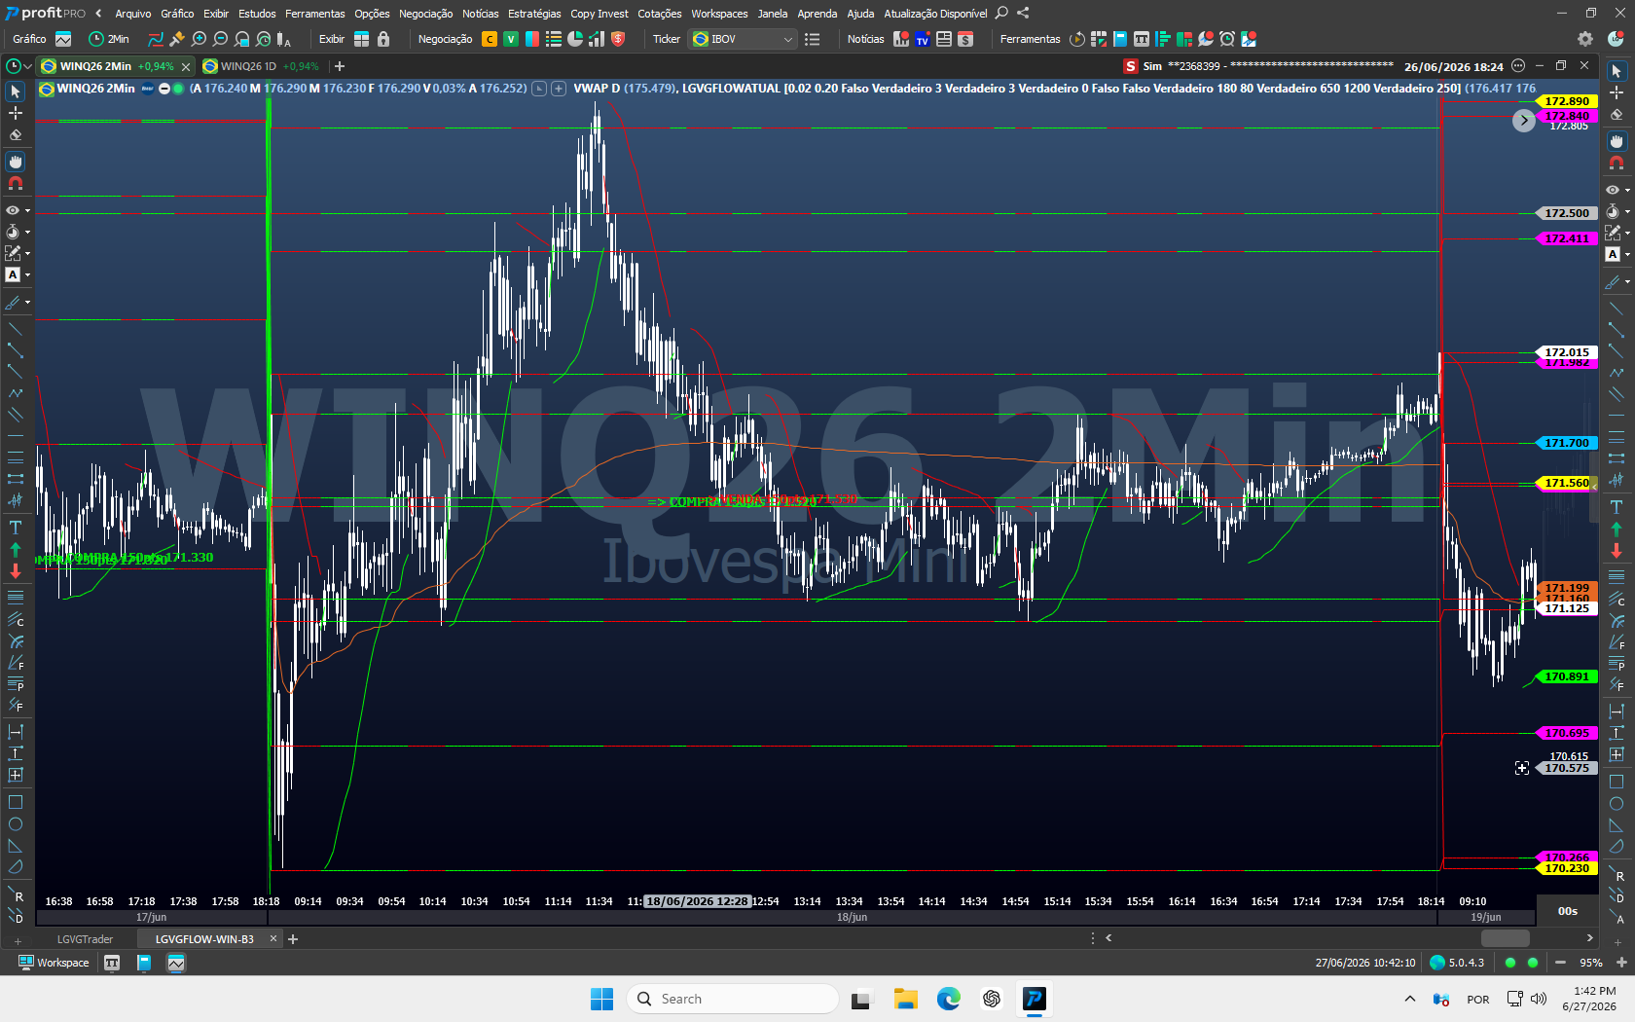
Historical example of LGVG Flow applied to WIN in 2 minutes.
Website and updated information: lgvgflow.uaisoftware.com.br
Support via WhatsApp: open official channel
Conditions on the portal: Indicator test for 60 days and free online consultancy; confirm the current offer on the official website
Author: Gustavo Guimarães - trader, order-flow specialist, and developer of LGVG Flow
Technical basis: Import file: LGVGFLOWATUAL.psf
Document: LGVG Flow User Manual - version 2.0 - July 2026
CLOSING Learn to read first. Then, practice execution. Only then take the process to the real environment, always with limited risk and recording of decisions.

