Group no. 4

Storyboard

1. Commerce

The first page what user will see. It contains information about the website. In order to have an access to the website’s content the user must have an account. Click the login logo at the top right portion of the website in order to login.



And then the user will go to the login page where they can login their account.

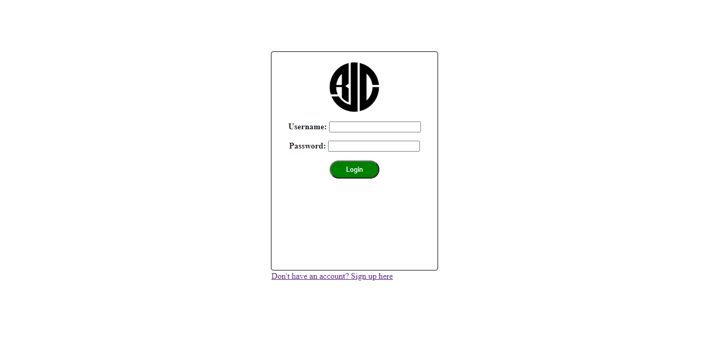

If the user don’t have an account they can click sign up to create an account then login their new created account to enter the website.

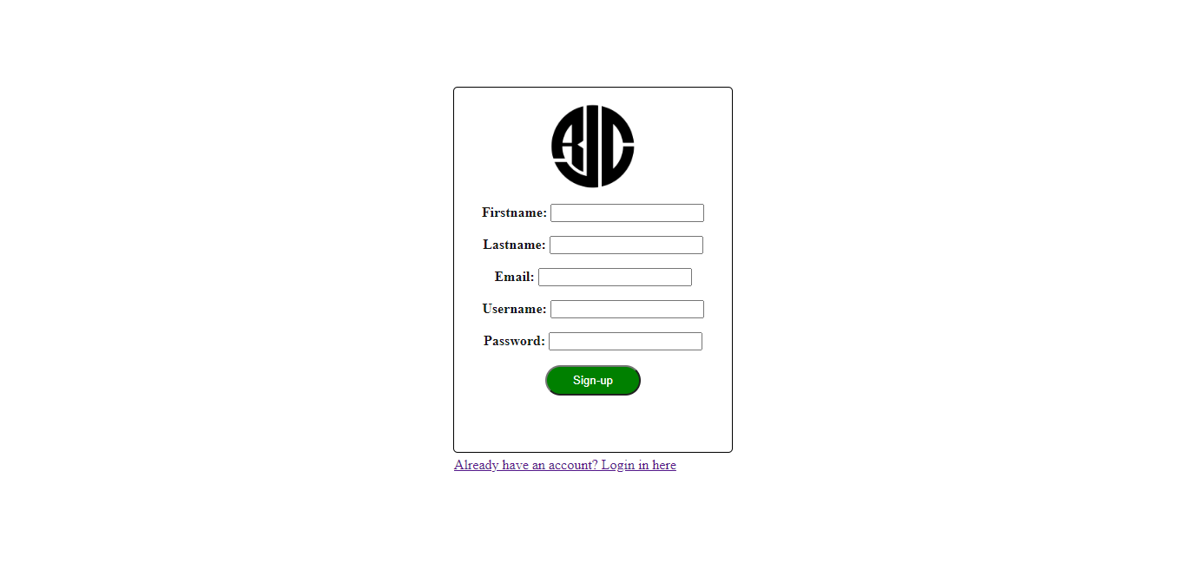

Upon entering the user will see the prices and ratings of each product to match their preference.





If the user finally choose a product they must click the add to cart button to add the product.



In this section the user can see the product name and price and can change its quantity. The user can let the product stay in the cart section and check it out anytime. If the user finally decide to checkout the product they must click the checkout button to place their order.

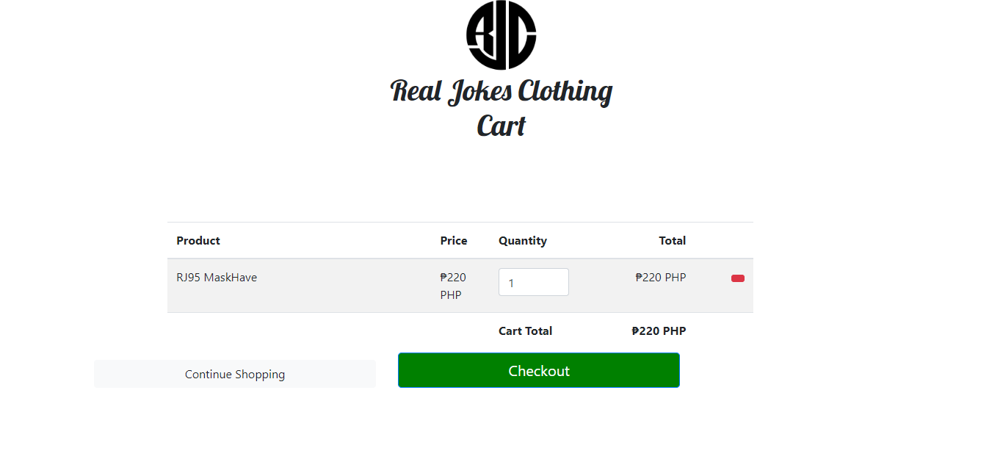

In this section the user website will get user’s information such as name, email, phone, and address. If the information is correct the user can place the order or double check first the cart. If the user want to add more items they can click the add items button.

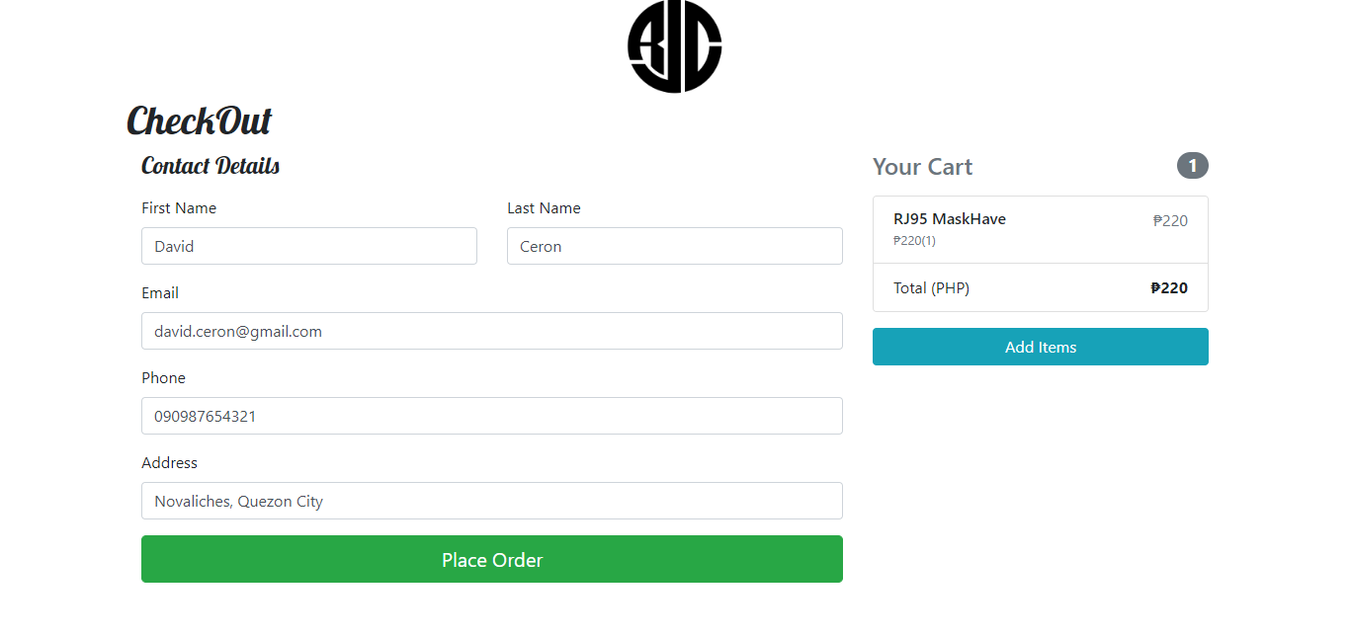

After placing the order the user will see the information of their order and will just wait until their product to arrive. And its means the transaction is complete.

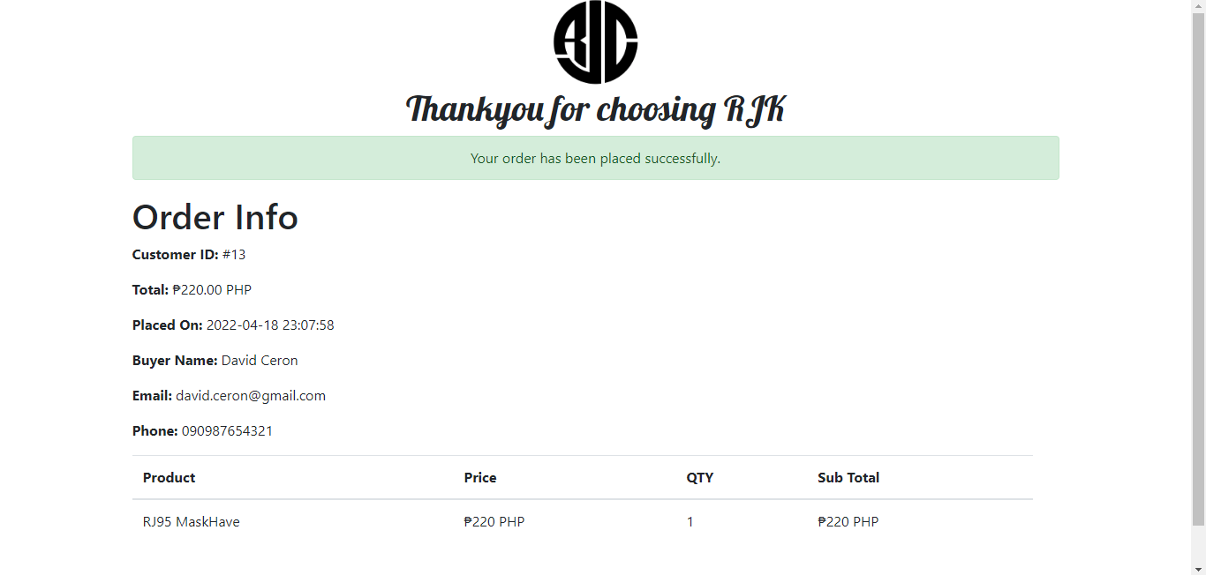

If the user desire to look to other products they can click the home button.



If the user transaction is finished they can logout their account.

