Lecture 13. MemRef, Layout, Memory Space
DRAM/SRAM/Accumulator memory mapping for AI/NPU Compiler
Generated: 2026-05-07

1. 강의 목표
- MemRef type을 shape/type/layout/memory-space로 분해해 읽는다.
- strided layout과 affine layout map을 NPU address generation으로 해석한다.
- DRAM/SRAM/ACCUM memory space를 target ABI contract로 설계한다.
- MatMul tile buffer의 placement, footprint, descriptor를 작성한다.
- layout/memory-space verifier와 FileCheck test를 설계한다.

2. 13강의 위치
- 12강에서 tensor-level value semantics를 memref-level storage semantics로 낮췄습니다. 13강은 buffer가 어디에 있고, 어떻게 주소 계산되며, 어떤 DMA/kernel ABI로 전달되는지 결정하는 단계입니다.

3. MemRef Type Anatomy
- MemRef type은 shape, element type, layout, memory space를 포함합니다. NPU backend는 이 정보를 kernel ABI와 runtime descriptor로 연결해야 합니다.
Pipeline Stage | IR 관점 | NPU compiler decision
Before bufferization | tensor / linalg-on-tensors | fusion, tiling, layout 후보 결정
After bufferization | memref / view ops | allocation, alias, lifetime, memory space 명시
13강 focus | memref<shape, layout, space> | DRAM/SRAM/ACCUM mapping, bank/layout/DMA descriptor
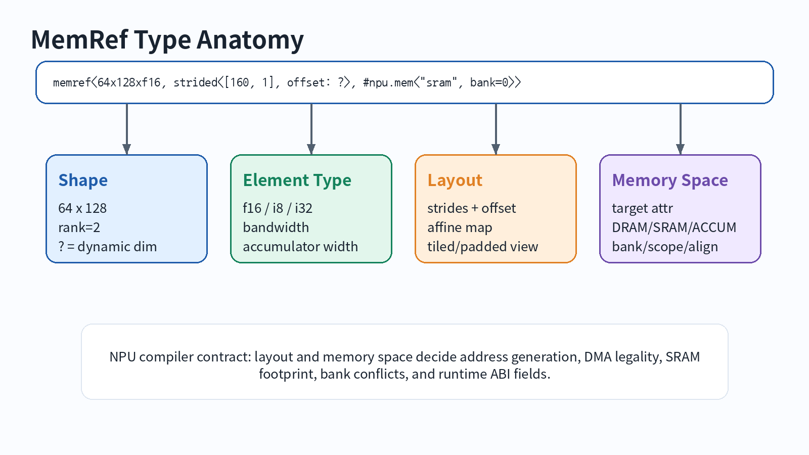

4. MemRef는 pointer가 아니다
일반적인 runtime descriptor는 base pointer 외에도 offset, sizes, strides, dtype, memory space, alignment 정보를 포함합니다. Dynamic dimension이나 dynamic stride가 있으면 metadata는 command buffer로 내려가야 합니다.
Descriptor field | Why | NPU example
base/aligned pointer | storage 위치 | DRAM physical address 또는 SRAM handle
offset | view 시작점 | tile subview offset
sizes[] | dynamic shape | edge tile M/N 크기
strides[] | address calculation | padded row stride, banked layout
memory_space | target placement | DRAM=0, SRAM=1, ACCUM=2

5. Layout: strided form과 affine map
#tile_16x32 = affine_map<(m, n) -> (m floordiv 16, n floordiv 32, m mod 16, n mod 32)>
memref<64x128xf16, #tile_16x32, 1>
memref<64x128xf16, strided<[160, 1], offset: 0>, 1>
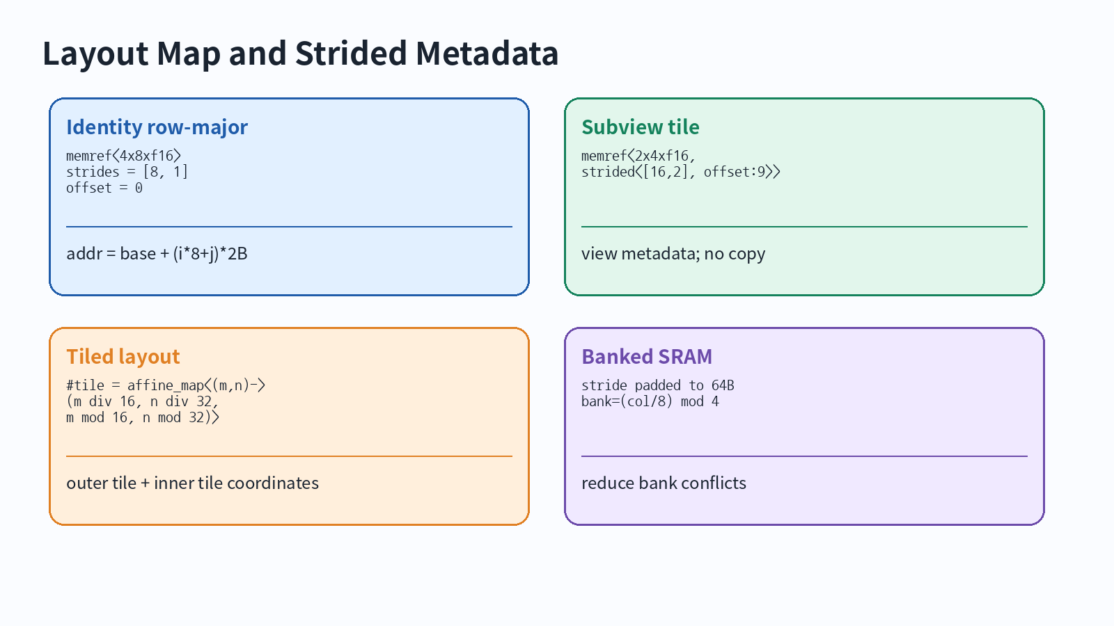
linear_index = offset + sum_i(index_i * stride_i)
byte_address = base + linear_index * sizeof(element)

6. View operations: subview, transpose, extract_strided_metadata
Tile extraction은 대부분 copy가 아니라 metadata view로 먼저 표현하는 것이 좋습니다. 이후 backend가 DMA copy 또는 scalar copy를 결정합니다.
%A_tile = memref.subview %A[%m0, %k0] [64, 128] [1, 1]
: memref<1024x1024xf16, strided<[1024,1], offset:0>, 0>
to memref<64x128xf16, strided<[1024,1], offset:?>, 0>
Operation | 성격 | NPU 사용처
memref.subview | metadata view | tile view, edge tile, DMA source view
memref.transpose | strided metadata permutation | layout-only transpose 판단
memref.extract_strided_metadata | base/offset/sizes/strides 추출 | runtime descriptor lowering
memref.reinterpret_cast | metadata 재해석 | descriptor rebuild, ABI bridge

7. Memory Space = target-specific ABI contract
memref<64x128xf16, 0> // DRAM
memref<64x128xf16, 1> // SRAM
memref<64x64xi32, 2> // ACCUM
memref<64x128xf16, strided<[160,1], offset:0>, #npu.mem<"sram", bank=0, align=64>>
Memory space | Hardware resource | Typical object | Verifier rule
DRAM | External memory | input/output activations, weights | DMA reachable, descriptor-visible, alignment valid
SRAM | Scratchpad | A/B/C tiles, ping-pong buffers | fits capacity, bank assignment valid, lifetime non-overlap
ACCUM | Accumulator | matmul/reduction output | legal producer/consumer, no illegal escape
CONST | Constant memory | weights, LUTs | read-only, prefetch policy consistent
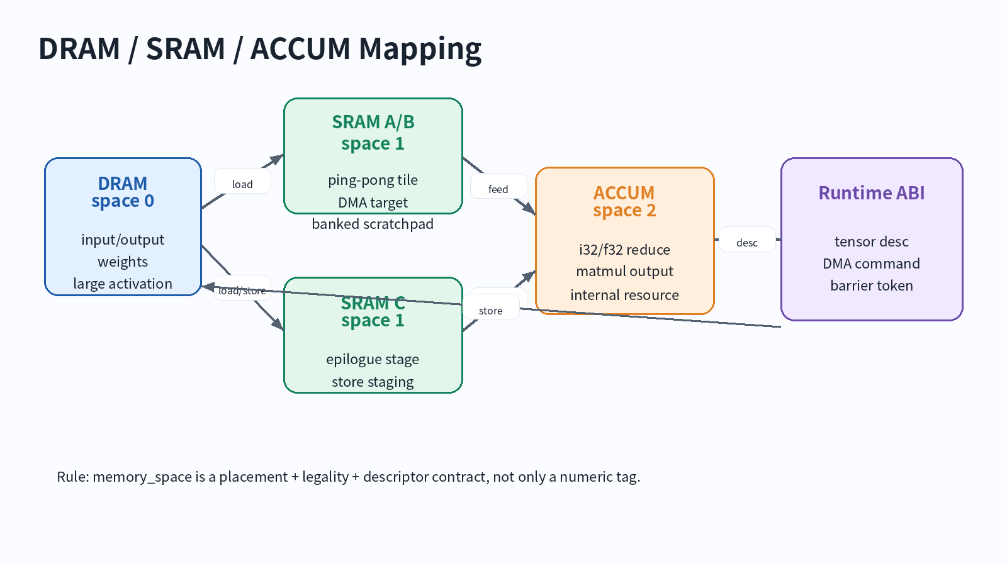

8. DRAM/SRAM/ACCUM MatMul mapping case study
A[MxK] in DRAM -> A_tile[Mt x Kt] in SRAM bank0
B[KxN] in DRAM -> B_tile[Kt x Nt] in SRAM bank1
C_acc[Mt x Nt] in ACCUM -> C_stage[Mt x Nt] in SRAM -> C[MxN] in DRAM
Buffer | Shape | Element | Space | Purpose
A_tile ping/pong | 64x128 | f16 | SRAM bank0 | activation tile load
B_tile ping/pong | 128x64 | f16 | SRAM bank1 | weight tile load
C_acc | 64x64 | i32 | ACCUM | K reduction accumulate
C_stage | 64x64 | i8/f16 | SRAM | requant/activation/store staging

9. Footprint 계산과 layout decision
A_tile = Mt * Kt * sizeof(A)
B_tile = Kt * Nt * sizeof(B)
C_acc = Mt * Nt * sizeof(accum)
SRAM_total = pingpong * (A_tile + B_tile) + C_stage + tags + padding
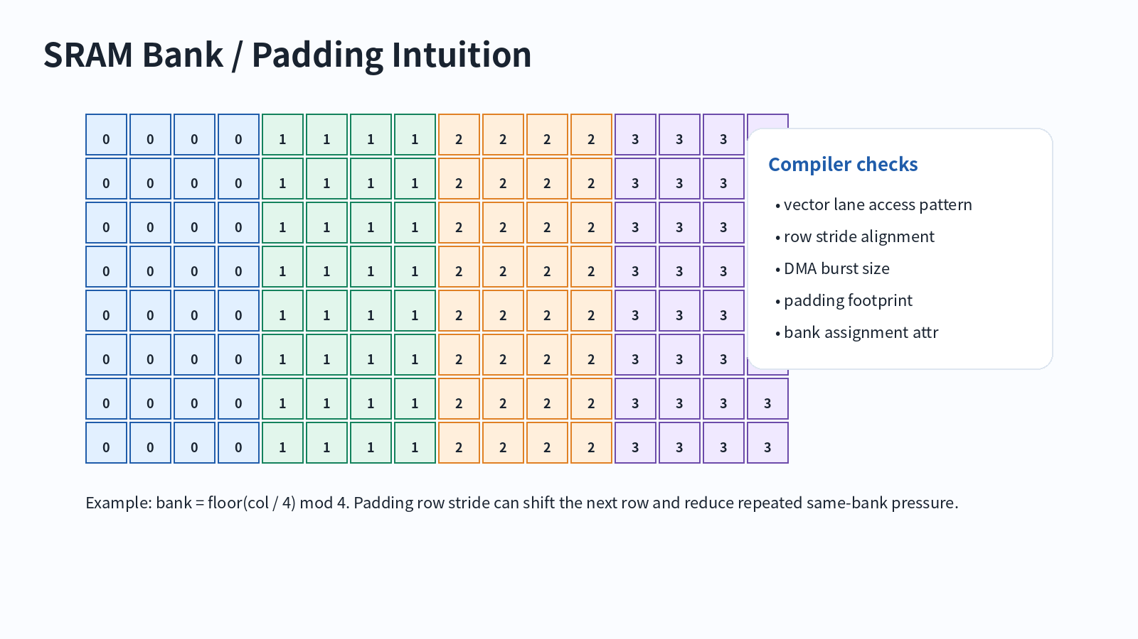

10. Runtime descriptor lowering
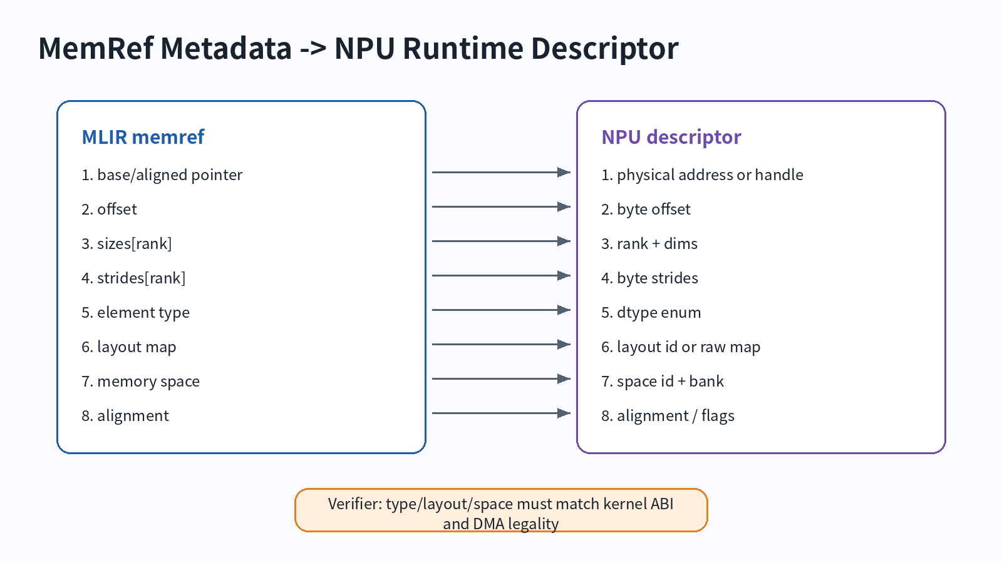
struct NpuTensorDesc {
uint64_t handle_or_phys_addr;
uint32_t byte_offset;
uint16_t rank, dtype, memory_space, layout_id;
int64_t sizes[MAX_RANK];
int64_t byte_strides[MAX_RANK];
};

11. Pass design: memory-space assignment
Step | Input | Output/check
Classify buffers | memref.alloc, block args, subview | DRAM/SRAM/ACCUM/CONST 후보
Analyze lifetime | def-use, dominance, schedule region | reuse 가능성, ping-pong 필요성
Assign space | tile role, producer/consumer | memref type or npu.alloc op
Assign layout | kernel contract, vector lanes | strides, padding, layout id
Verify | capacity, alignment, escape | diagnostic or legal IR
one-shot-bufferize -> npu-classify-buffers -> npu-assign-memory-spaces -> npu-propagate-layout -> npu-insert-dma -> npu-lower-runtime-descriptors

12. Regression test checklist
- SRAM allocation이 예상한 memory space로 남는지 CHECK한다.
- unexpected memref.copy가 생기지 않는지 CHECK-NOT으로 확인한다.
- unsupported layout은 negative diagnostic으로 잡는다.
- ACCUM memory space가 function boundary로 escape하지 않는지 확인한다.
- dynamic offset/stride descriptor field가 runtime lowering에서 보존되는지 확인한다.

13. 실습 산출물
Exercise | Task | Output
A | memref type anatomy annotation | shape/type/layout/space 표
B | subview tile offset/stride 계산 | tile view descriptor
C | MatMul tile memory mapping | DRAM/SRAM/ACCUM table
D | SRAM footprint 계산 | capacity pass/fail decision
E | runtime descriptor 설계 | C struct 또는 YAML

14. Takeaways
- MemRef는 storage semantics를 가진 structured reference이며 pointer 하나가 아니다.
- Layout은 address generation, DMA burst, bank conflict, vectorization을 결정한다.
- Memory space는 target-specific attribute이므로 NPU backend의 ABI contract로 설계해야 한다.
- DRAM/SRAM/ACCUM mapping은 correctness + performance + runtime ABI 문제다.

References
- MLIR MemRef Dialect: https://mlir.llvm.org/docs/Dialects/MemRef/
- MLIR Builtin Dialect - MemRef type: https://mlir.llvm.org/docs/Dialects/Builtin/
- MLIR Data Layout Modeling: https://mlir.llvm.org/docs/DataLayout/
- MLIR FAQ - MemRef is not only a pointer: https://mlir.llvm.org/getting_started/Faq/
- MLIR Passes: https://mlir.llvm.org/docs/Passes/

