MLIR NPU Compiler - Lecture 18
Custom NPU Dialect: npu.matmul / npu.dma / npu.barrier ODS Design

1. 강의 목표
- Custom NPU dialect가 필요한 위치와 abstraction boundary를 설명한다.
- ODS/TableGen으로 operation contract를 정의하는 방법을 익힌다.
- npu.matmul, npu.dma, npu.barrier의 operands/results/attributes/verifier를 설계한다.
- parser/printer, verifier, lowering, FileCheck test를 하나의 dialect bring-up flow로 연결한다.

2. 왜 Custom NPU Dialect인가?
NPU backend는 native tile shape, SRAM/ACCUM memory space, DMA direction, barrier scope, accumulator width, epilogue policy와 같은 target contract를 필요로 합니다. custom dialect는 이러한 hardware contract를 operation/type/attribute/verifier로 고정해 lowering pass와 test가 같은 의미를 공유하게 합니다.
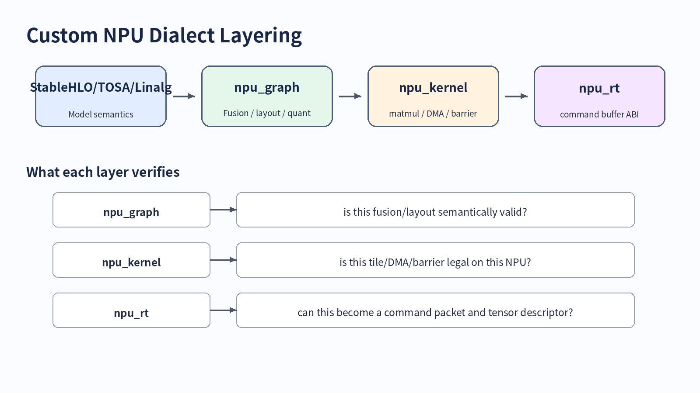

3. ODS/TableGen 핵심
ODS는 operation 구조의 single source of truth입니다. op name, documentation, arguments, results, traits/interfaces, assembly format, verifier hook를 TableGen record로 선언하고 mlir-tblgen이 C++ declaration/definition/doc skeleton을 생성합니다.
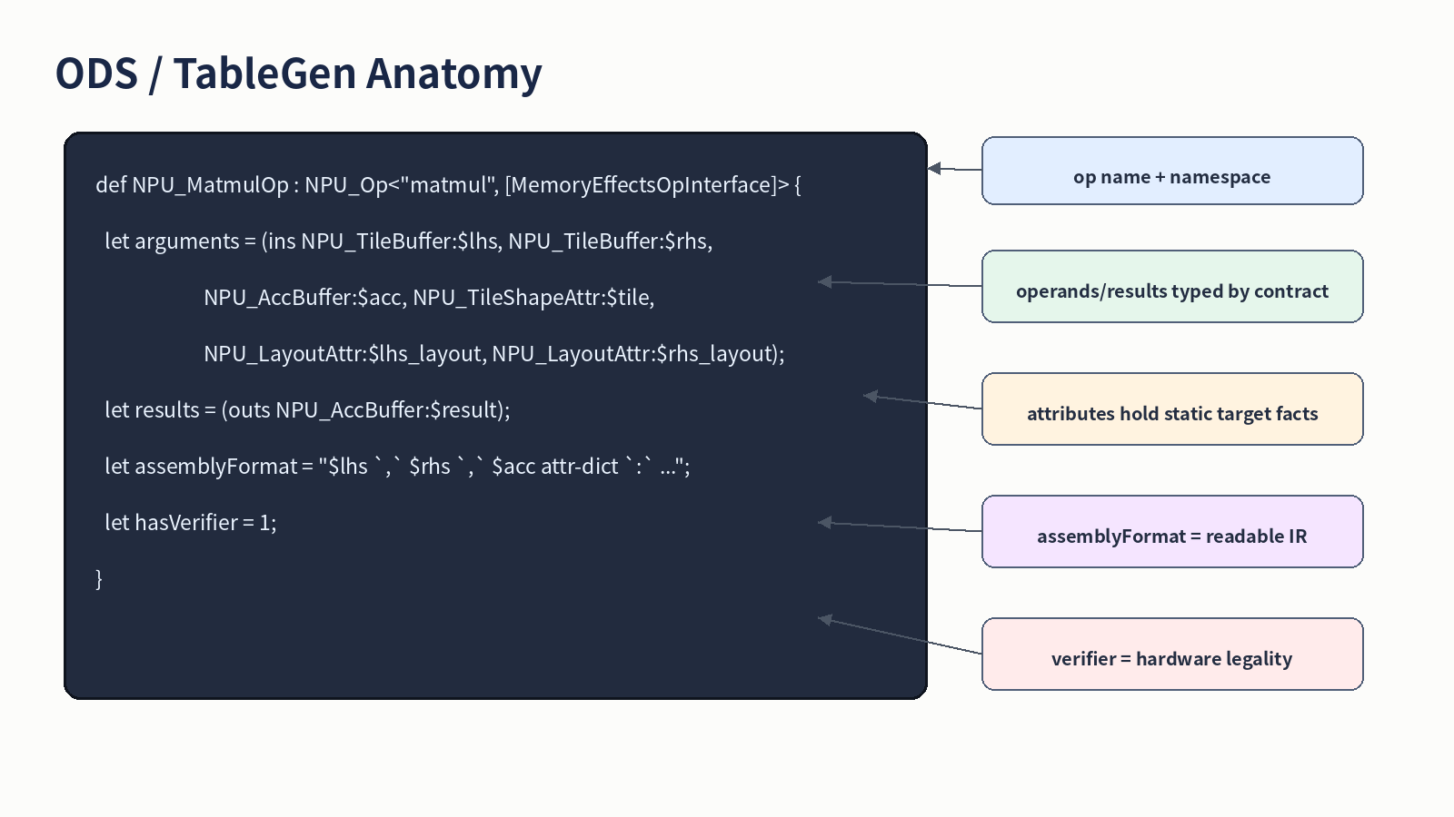

4. npu.matmul / npu.dma / npu.barrier contract
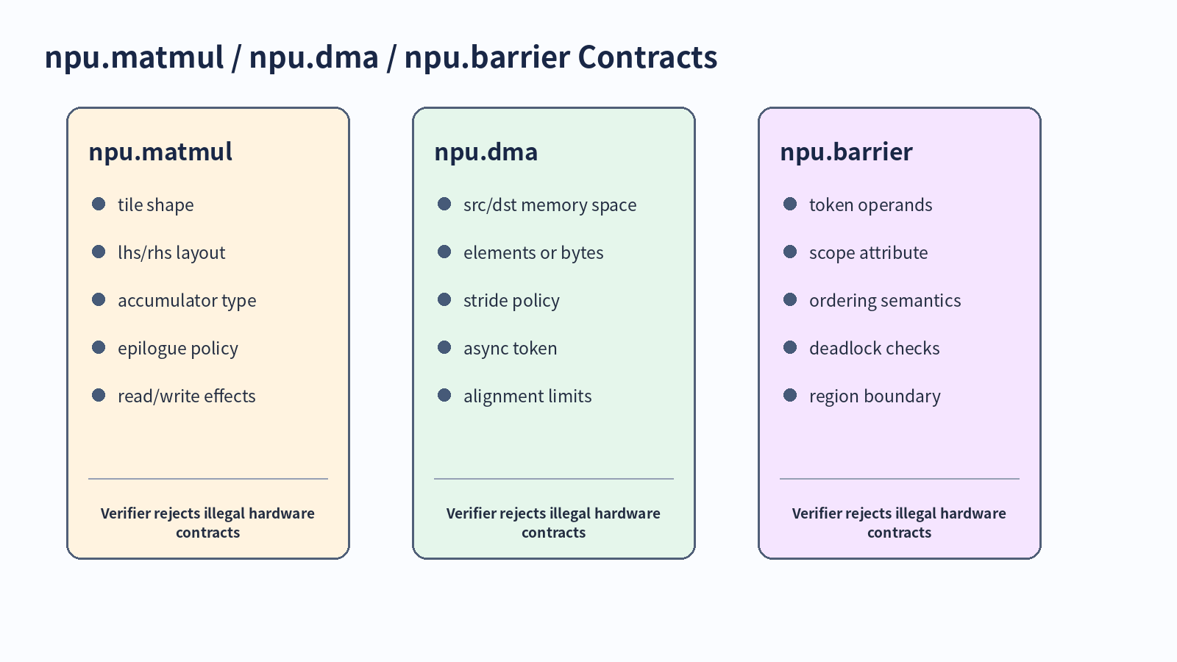
Op | Purpose | Verifier focus
npu.matmul | native tile compute command | tile shape, layout, dtype, accumulator, memory effects
npu.dma | asynchronous memory transfer | src/dst memory space, size, stride, alignment
npu.barrier | dependency/order command | non-empty tokens, scope, dependency consistency

5. ODS skeleton excerpt
//===- NPUOps.td - NPU dialect op definitions -----------*- tablegen -*-===//
// Educational skeleton. Adapt constraints and namespaces for a real compiler.
#ifndef NPU_OPS_TD
#define NPU_OPS_TD
include "mlir/IR/OpBase.td"
include "mlir/Interfaces/SideEffectInterfaces.td"
include "mlir/Interfaces/InferTypeOpInterface.td"
include "NPUTypes.td"
def NPU_Dialect : Dialect {
let name = "npu";
let cppNamespace = "::mlir::npu";
let summary = "Target-specific NPU kernel and command dialect";
let description = [{
Captures NPU tile-level compute, DMA, and synchronization contracts after
tiling, layout, memory-space, and quantization decisions have been made.
}];
}
class NPU_Op<string mnemonic, list<Trait> traits = []> : Op<NPU_Dialect, mnemonic, traits>;
def NPU_MatmulOp : NPU_Op<"matmul", [
DeclareOpInterfaceMethods<MemoryEffectsOpInterface>,
DeclareOpInterfaceMethods<InferTypeOpInterface>
]> {
let summary = "Issue one native NPU matrix multiply tile command";
let arguments = (ins NPU_TileBuffer:$lhs, NPU_TileBuffer:$rhs,
NPU_AccBuffer:$acc, NPU_TileShapeAttr:$tile,
NPU_LayoutAttr:$lhs_layout, NPU_LayoutAttr:$rhs_layout,
OptionalAttr<NPU_EpilogueAttr>:$epilogue);
let results = (outs NPU_AccBuffer:$result);
let assemblyFormat = [{
$lhs `,` $rhs `,` $acc attr-dict `:`
type($lhs) `,` type($rhs) `,` type($acc) `->` type($result)
}];
let hasVerifier = 1;
let hasCanonicalizer = 1;
}

6. DMA + Barrier command scheduling
npu.dma는 asynchronous transfer를 시작하고 token을 반환합니다. npu.barrier는 token을 consume하여 command order를 명시합니다. 이 모델은 hardware tag-buffer 기반 DMA로도 낮출 수 있고, command buffer generation 전 hazard verification에도 유용합니다.
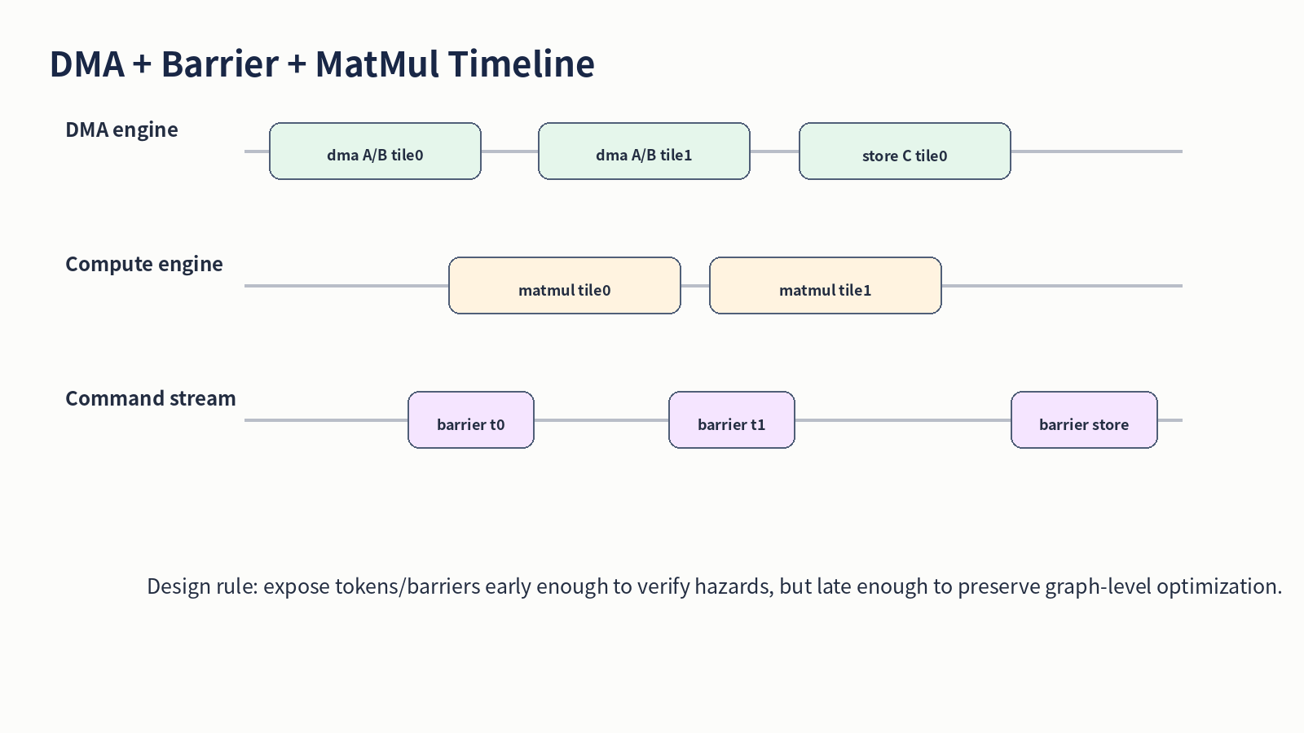

7. Verifier 설계 원칙
Verifier는 illegal IR을 reject해야 합니다. 단순히 느린 schedule이나 덜 최적인 layout은 verifier가 아니라 cost model/fallback policy가 판단해야 합니다.
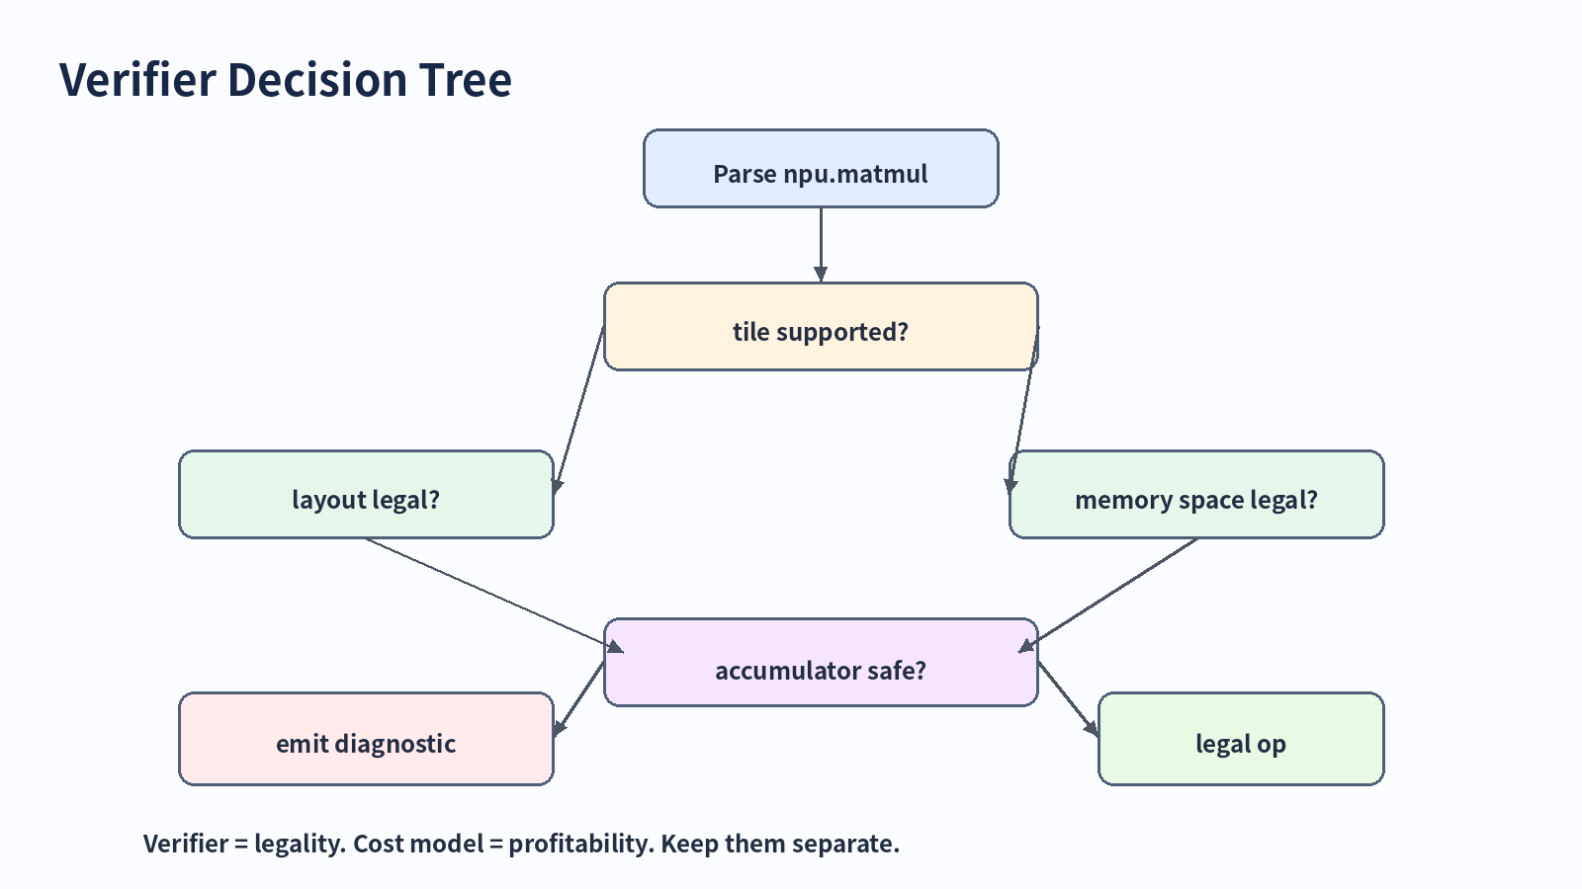

8. 실습 과제
- npu.matmul fields를 operand/type/attribute로 분류한다.
- npu.dma token-based ODS skeleton을 작성한다.
- unsupported tile shape negative verifier test를 작성한다.
- vector.contract -> npu.matmul lowering legality matrix를 작성한다.

9. 참고자료
- MLIR Defining Dialects: https://mlir.llvm.org/docs/DefiningDialects/
- MLIR Operation Definition Specification (ODS): https://mlir.llvm.org/docs/DefiningDialects/Operations/
- MLIR Creating a Dialect: https://mlir.llvm.org/docs/Tutorials/CreatingADialect/
- MLIR Customizing Assembly Behavior: https://mlir.llvm.org/docs/DefiningDialects/Assembly/
- MLIR Defining Dialect Attributes and Types: https://mlir.llvm.org/docs/DefiningDialects/AttributesAndTypes/
- MLIR MemRef Dialect: https://mlir.llvm.org/docs/Dialects/MemRef/
- MLIR Testing Guide: https://mlir.llvm.org/getting_started/TestingGuide/

