Synthetic mosaic sample README

Overview
The aim was to create a synthetic sample with known mosaicisms at known variant allele frequencies. We made this by using WT gDNA (HG002 GM24385) and spiking in 21 long synthetic oligos containing the mutations at known concentrations. The resulting sample should behave like a patient sample with the mosaicisms in question. Variants are a mix of known pathogenic variants (clinvar, literature) and putative pathogenic variants within the FORCE project. A majority of variants are located in MTOR and PIK3CA. Concentrations are measured accurately in copies/μl with ddPCR assays. These assays are ordered from ThermoFisher (TaqMan assays) or Bio-Rad, and consists of two primers, two probes (FAM/HEX) and a quencher. One assay had to be designed manually and ordered from IDT.

Important files
- syntheticMosaic_README.docx: this overview document.
- mosaic-v01b04_truthVAF.vcf.gz: details of the mosaic sites in VCF format with VAF (in the first field of the INFO column)
- variants_oligos_synthetic_sample_v1b4.xlsx: details of oligos, targeted variant allele frequencies (VAF), spike-in calculations, and ddPCR assays for VAF verification in final sample.

Sample naming
- The latest synthetic mosaic sample is mosaic_v1b4:
- The version number should increase if the mosaic variants in the sample change.
- The batch number starts at 1 when there is a new version and increases for every new batch of that version. A new batch needs to have VAF verification as this may change slightly between batches.

Sample and reagent storage
- 4 aliquots à > 100 μl in DNA low-bind tubes. DNA concentration is measured to 15.1 ng/μl by Qubit HS. Kept in -20°C 1st floor technical room.
- The aliquots of oligos used to make the sample and the ddPCR assays for VAF verification are stored together with the sample (in the box at -20°C).
- The assays we got from diagnostic are still kept in their respective places (+4/ -20°C). See the spreadsheet for details.

Creation protocol
- Starting point: All variants have a specific ddPCR assay (MUT/WT) and positive control oligo (oligo bearing the mutation), in the form of gBlock from IDT (~500 bp). The oligos have been diluted to working concentrations ~1000 copies/μl and accurate concentration was measured by ddPCR. Concentration of WT gDNA was also measured by ddPCR, using 5 of the variant assays. Using the ddPCR-measured concentrations, we calculated spike-in volumes required to achieve different variant allele frequencies (VAF) for different variants (0.5-8 %). See spreadsheet for calculations.
- VAF verification: We then verified the VAF of each variant within the synthetic sample by ddPCR. These measurements are spread across 4 experiments, including 2 experiments where the aim was to prepare samples for amplicon-seq. The resulting VAFs are in the range 0.6-5.9%. Documentation of these measurements is kept at [googleDrive/]proj_force_mosaic/000_doc/050_syntheticSample/020_sampleDocumentation/ddPCR/
Final sample: The synthetic sample contains mixture of TE buffer (low-EDTA TE from IDT), carrier tRNA (to prevent adsorption of oligos which can distort VAF over time), WT human gDNA (HG002 GM24385) and oligos with known mutations within the FORCE project. Details of concentrations and mix volumes are in the spreadsheet. [googleDrive/]proj_force_mosaic/000_doc/050_syntheticSample/020_sampleDocumentation/variants_oligos_synthetic_sample_v1b4.xlsx

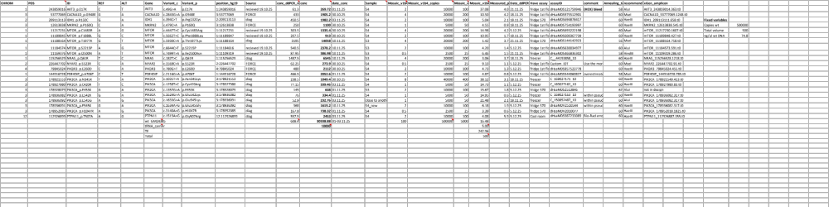

Applications of this sample
- The synthetic sample mosaic_v1b4 has been prepped for amplicon sequencing with a IDT xGen custom range of amplicons. The sequencing was done on the MiSeq i100 (150 bp PE 5M reads) in the project Hughes-AmpliconLibs1-2025-12-10.
- The synthetic sample mosaic_v1b4 has also been delivered for exome sequencing, prepped by GDx (Ann Kristin) in December 2025. The goal is to get higher coverage than what is normally done, and compare the analysis of a full depth sample to a downsampled one.

