**Connecticut: Drugs, Death, and the Data**

David Hinton, Shivani Sampathkumar, Allison Gallant

**Research Question:** Between 2012 and 2016, how have accidental drug-related death rates changed and what is the relationship between these deaths and the number of opioid-related treatment admissions in each county in Connecticut? Is there a trend between the number of deaths, the number of treatment admissions, and each county’s median income?

We are interested in exploring this research question because we want to gain a deeper understanding of the factors that can influence the number of drug-related deaths in a population. With this knowledge, appropriate policies and programs can be implemented in the communities that need them most with the ultimate goal of reducing the number of accidental drug-related deaths.

**Data Story:**

Opioid related deaths have been a huge topic of discussion over the last few years. In 2014, the state of Connecticut alone recorded 623 overdoses from opioid drugs. The CDC reports that in 2016, the number of opioid related deaths is 5 times higher than it was in 1999. Interestingly, the amount of prescription opioids sold to pharmacies, hospitals, and doctors’ offices has nearly quadrupled in that same time period. We want to explore the data that is available to us in order to discover any relevant trends and relationships regarding the rising opioid epidemic.

The first variables that we want to focus on is where these overdoses are occurring and who is it effecting. Using the data set “Accidental Drug Related Deaths 2012-2017”, we can compare the number of deaths in each county in Connecticut to determine if there is a certain area of this state that is experiencing more overdoses. We will also be able to determine if there has been migration of this problem to or from any region of the state. Below is a chart displaying the deaths that occurred in each county between 2012 and 2017.

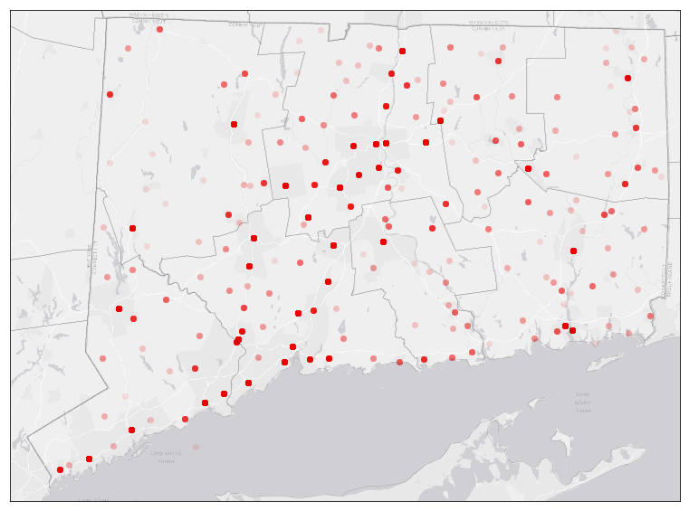

Figure 1: Deaths per Connecticut county 2012-2017

It is also important to take a look at who is being affected by the opioid deaths. Using the same data set as we used above, we have made graphs showing the age and sex of the individuals who died from opioid overdoses in Connecticut from 2012 to 2017.

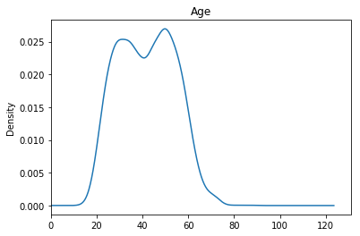

Figure 2: Age of opioid-overdose victims

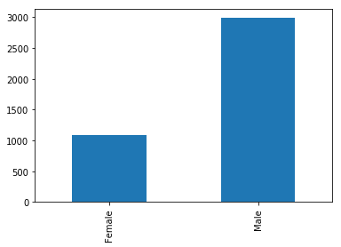

Figure 3: Comparison of sex of opioid-overdose victims

Once we have explored the variables of who and where, we plan on using the data set titled “Opioid Related Treatment Admissions by Town in Department of Mental Health and Addiction Services Programs” to determine the number of treatment admissions in each Connecticut county between 2012 and 2016. This data could be useful in determining if there is a trend between counties experiencing high numbers of overdoses and those with high levels of treatment admissions. We plan to explore whether, over time, the number of treatment admissions in a county may have played a role in reducing the number of overdoses that they experienced.

Another variable we will be exploring is whether there has been a change in the drug-type causing opioid-related death as legislation around opioid prescriptions has become more strict. We will use the “Accidental Drug Related Deaths 2012-2017” data set to determine if there was a shift in the drugs that most commonly caused death from 2012 to 2017. 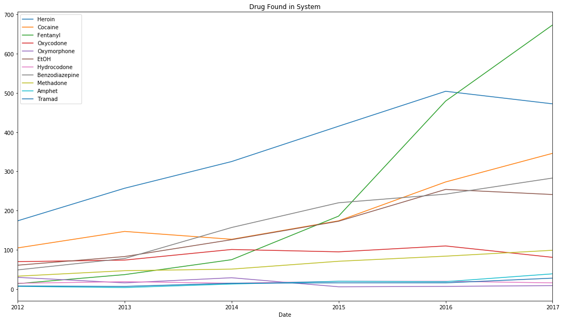For each year, we want to compare the fraction of prescription opioid deaths vs non-prescription opioid deaths. This will show if there has been a shift towards non-prescription opioids (e.i. heroin) as opioid prescribing/dispensing has been monitored more carefully. Researching programs and new policies during this time period, such as the 2016 Prescription Drug Monitoring Program (PDMP), will also allow us to gain insight on any shifts in drug-type abuse.

Finally, we hope to determine how the cost of prescription opioids has changed during this time period. We will use monthly drug prices to evaluate whether the price of commonly used prescription opioid drugs has become elevated with the increased use and prescription of opioids.

Resources:

<https://datausa.io/profile/geo/connecticut/>

<http://www.portal.ct.gov/DCP/Prescription-Monitoring-Program/Prescription-Monitoring-Program>

<https://www.cdc.gov/drugoverdose/data/index.html>