### Chilkoot Lake Sockeye Salmon

Chilkoot Lake, located on mainland Alaska approximately 13 km northeast of Haines, supports one of the largest runs of sockeye salmon in Southeast Alaska, which are primarily harvested in the District 15 commercial drift gillnet fisheries in northern Lynn Canal. Smaller, but unknown, portions of this run are also harvested in purse seine fisheries in Icy and northern Chatham straits. In addition, subsistence and sport fisheries harvest up to several thousand sockeye salmon from this stock each year. Since 1976, escapement of sockeye salmon to Chilkoot Lake has been assessed with a weir located on the Chilkoot River and estimates have ranged from 7,177 (1995) to 118,166 (2012) with a median of 72,678. However, mark-recapture techniques have sometimes resulted in escapement estimates that are considerably higher than weir counts; therefore, there is some uncertainty about the extent to which the weir has counted all sockeye salmon spawning in the Chilkoot system. Scale pattern analysis has been used to apportion District 15 commercial harvests of sockeye salmon bound for Chilkoot Lake and other systems in the area (Chilkat Lake, Berners Bay stocks, etc.), and the estimated annual harvest of the Chilkoot Lake component has ranged from 2,838 (1998) to 327,323 (1987) with a median harvest of 61,833 and harvest rates of 18–84% (median of 46%).

The current sustainable escapement goal of 38,000–86,000 sockeye salmon was established in 2009, based on stock-recruit analysis from the 1976–2003 brood years (Eggers et al. 2009). Eggers et al. (2009) used an autoregressive Ricker model optimized using maximum likelihood and the recommended escapement goal range was expected to produce at least 90% of maximum sustained yield over the long term. Eggers et al. (2009) opted for an SEG rather than a BEG due to the uncertainty in harvest and escapement estimates and large fluctuations in the productivity of this system over time, possibly as a result of density dependence of juvenile sockeye salmon in Chilkoot Lake in association with environmental drivers.

Brenner et al. (*In prep.*) reviewed and updated Chilkoot Lake sockeye salmon stock assessment information with escapement and return data from brood years 1976–2010. Similar to the Eggers et al. (2009) analysis, significant correlation of recruitment parameters at a lag of 1 year dictated the use of an autoregressive Ricker model (AR1); however, the updated analysis was constructed in a Bayesian framework. Based on analysis results, the Southeast escapement goal committee recommended keeping the existing sustainable escapement goal of 38,000–86,000 fish; a range of escapements estimated to provide a 57–93% probability of achieving greater than 80% of maximum sustained yield, and a 39–85% probability of achieving greater than 90% of maximum sustained yield, with the highest probabilities of achieving maximum yield at escapements of around 53,000. These probabilities were based on yield profiles developed from outputs of the Bayesian model, where the point estimate of the escapement that produces a fixed percentage (e.g., 80% or 90%) of maximum sustained yield has a probability of 50%.

We believe that the existing escapement goal is consistent with management considerations and sustained yield as defined in the sustainable salmon fisheries policy. A somewhat narrower range of escapements would increase the probability of achieving maximum sustainable yield. For example, escapements of 36,000–72,000 would result in a greater than 80% probability of achieving at least 80% of maximum sustained yield. However, three large escapements (86,700-118,166) since 2012 will provide some additional information about the productivity of this stock once recruits from these brood years return. Thus, we recommend waiting until 2020 or 2021 to reassess available spawner-recruitment relationships before proposing a change to this escapement goal.

Appendix B 5.–Chilkoot Lake sockeye salmon.

Chilkoot Lake is a glacial system located on the mainland, approximately 13 km northwest of Haines, Alaska. The Chilkoot drainage supports one of the larger runs of sockeye salmon in the region, which is harvested primarily in the District 15 Lynn Canal drift gillnet fishery and in a subsistence fishery in Lutak Inlet. Escapements have been enumerated annually at an adult counting weir in the Chilkoot River, below the outlet of the lake, since 1976.

**Escapement Goals and Stock Status:** This stock was managed for informal escapement goals of 80,000–100,000 sockeye salmon starting in 1976, and 60,000–80,000 sockeye salmon starting in 1981 (McPherson 1990). In 1990, ADF&G established a biological escapement goal of 50,500–91,500 sockeye salmon divided into separate goals for early- and late-runs, based on an extensive stock-recruit analysis by McPherson (1990). The run underwent an extended downturn in production in the 1990s related to changes in the lake rearing environment, which is glacially turbid; very warm summers increased the silt load in the lake, which greatly reduced zooplankton abundance (Eggers et al. 2009b). An extremely low weir count in 1995 prompted ADF&G to verify weir counts with mark-recapture studies, which were conducted in 12 years between 1996 and 2011 (Bachman et al. 2014). Mark-recapture estimates were greater than weir counts, consistent with the idea that weir counts likely under-represented total escapement, but differences between the two estimates were not consistent enough to calibrate weir counts. Geiger et al. (2005) recommended maintaining essentially the same escapement goal, 50,000–90,000 sockeye salmon, but classified the goal as a sustainable escapement goal. In 2009, the escapement goal was changed to a sustainable escapement goal of 38,000–86,000 sockeye salmon based on an updated stock-recruit analysis by Eggers et al. (2008, 2009b). The goal was considered a sustainable goal, rather than a biological goal, due to uncertainty in escapement levels based on weir counts. Eggers et al. (2009b) developed weekly escapement targets, based on historical run timing at the weir, rather than separate escapement goals for early- and late-run fish. Escapements were within or above the escapement goal range in 4 of the past 5 years (Appendix Figure B 5).



Appendix Figure B 5.–Chilkoot Lake sockeye salmon escapement (weir counts), 1976–2016, and sustainable escapement goal range of 38,000–86,000 fish.

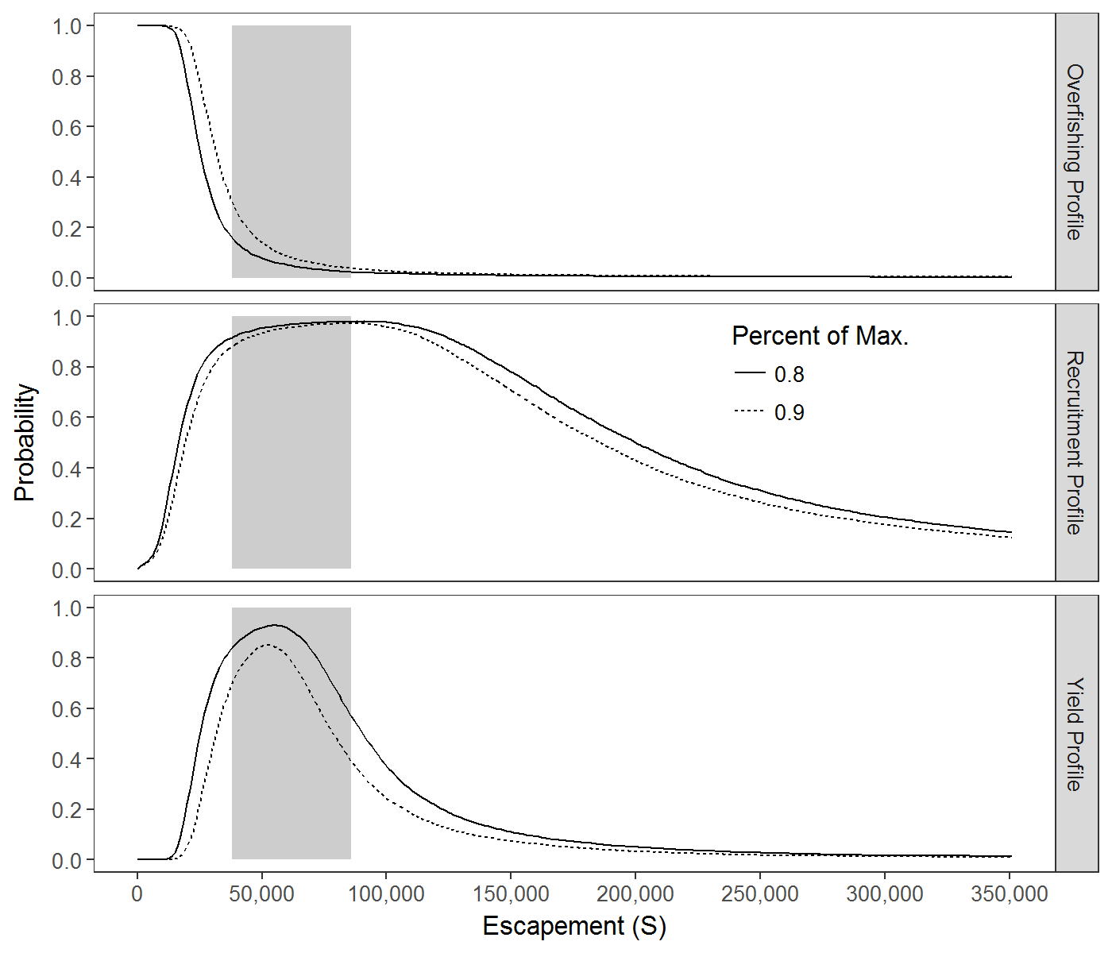

Appendix Figure B 6.–Chilkoot Lake sockeye salmon 80% and 90% probability profiles for overfishing, optimal recruitment, and optimal yield based on updated brood year escapement and return data 1976–2010 (Brenner et al. *In Prep*.). Results are from an autoregressive Ricker model and the shaded areas shows the existing escapement goal range of 38,000–86,000.

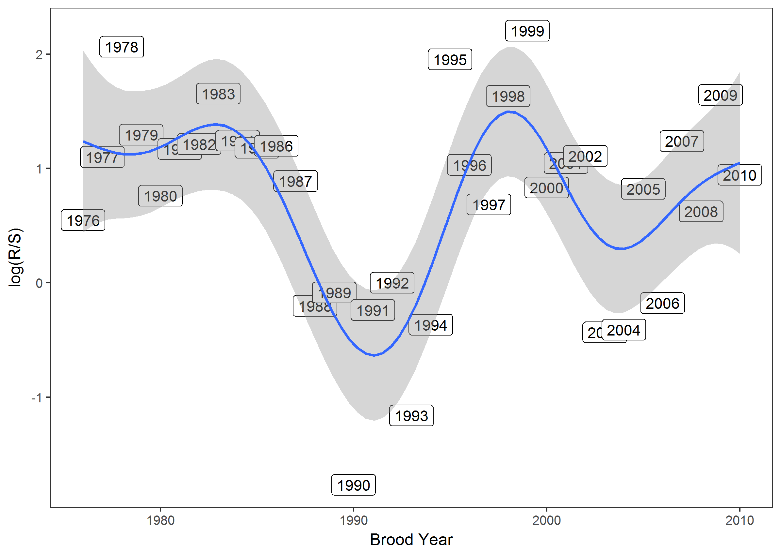

Appendix Figure B 7.–Productivity (log (R/S) of Chilkoot Lake sockeye salmon from brood years 1976–2010.