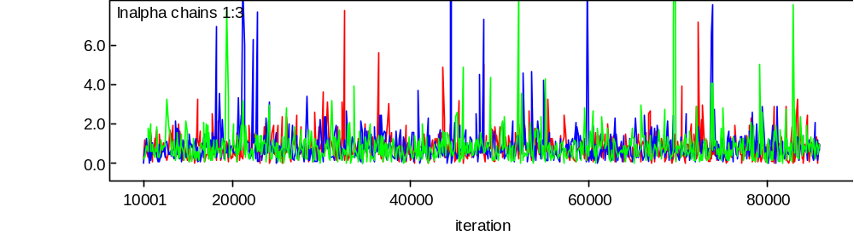
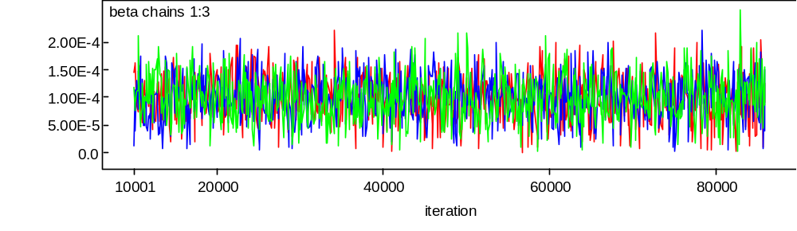
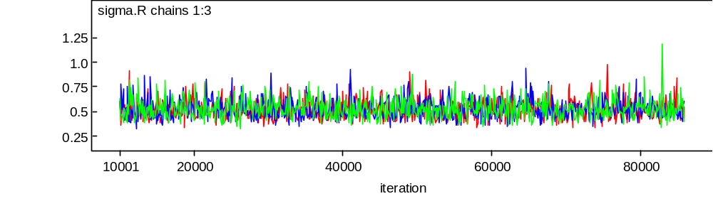
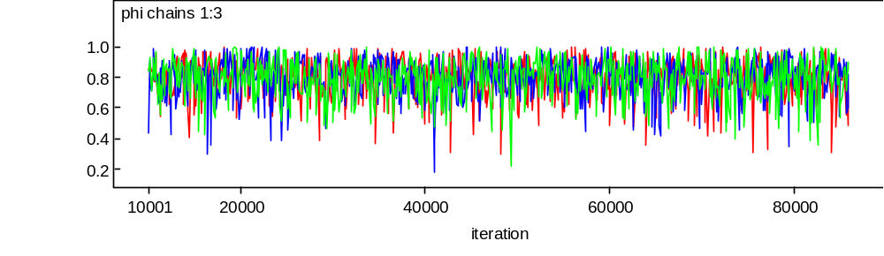
Figure S1. MCMC history plots for key model quantities, page 1 of 2.

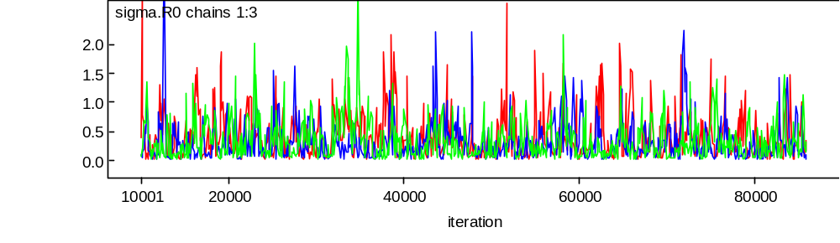
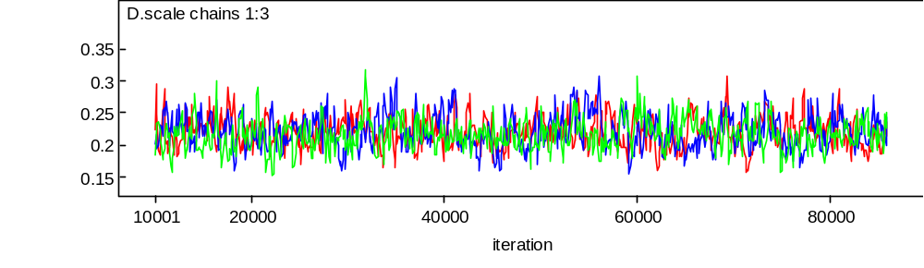
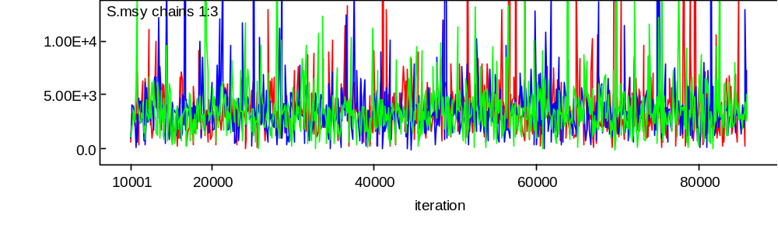
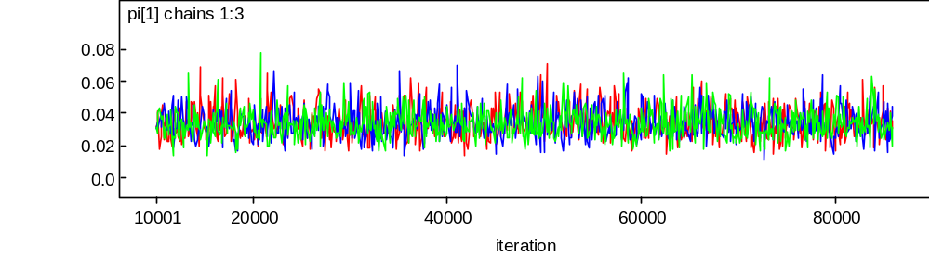
Figure S2. MCMC history plots for key model quantities, page 2 of 2.

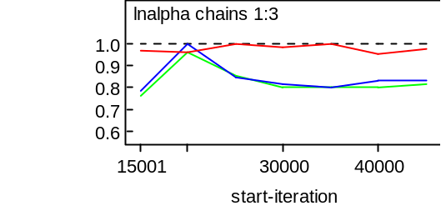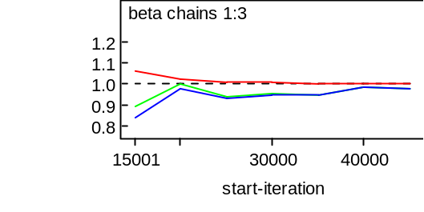

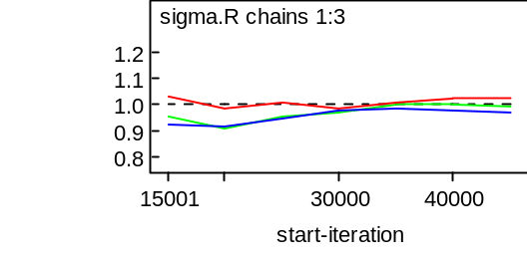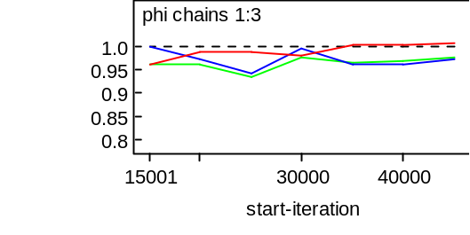

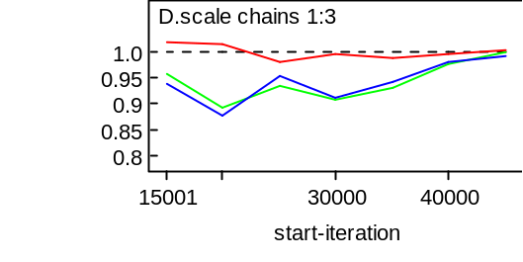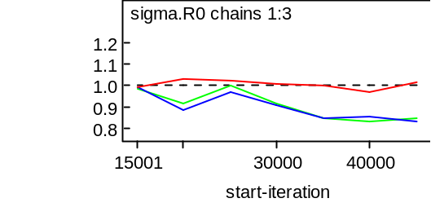
Figure S3. Gelman Rubin convergence diagnostics for key model quantities.
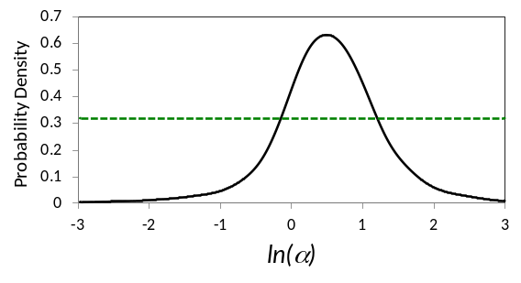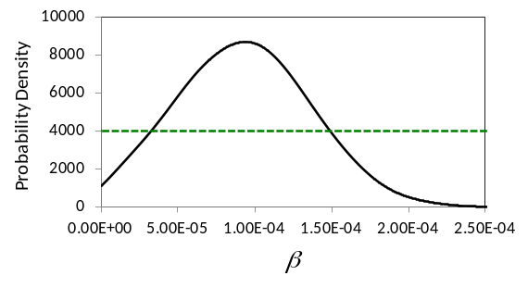
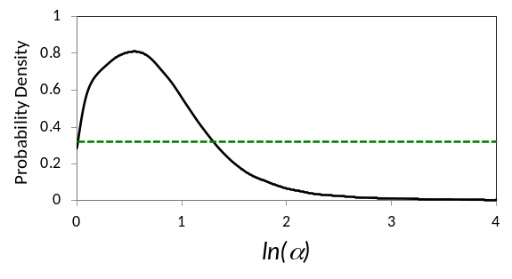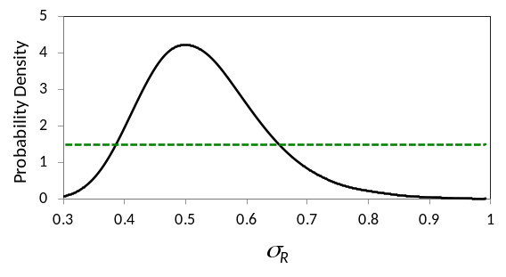
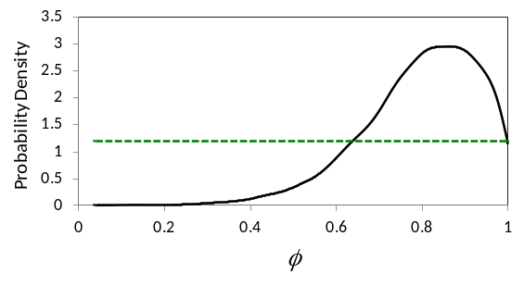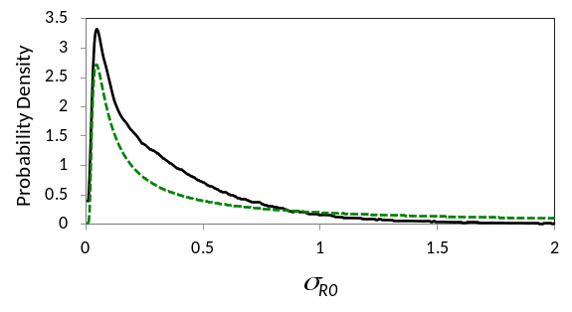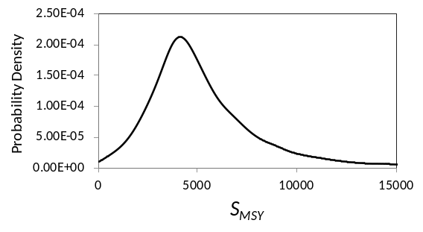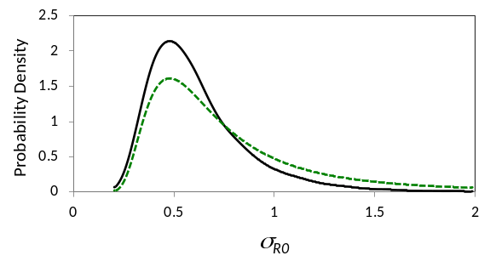
ª Alternate priors and posteriors shown for ln(α) and σ_{R0}.
Figure S4. Prior (green) and posterior (black) distributions for key model quantities. Alternate priors and posteriors are also shown for ln(α) and σ_{R0.}

Retrospective Analysis of Karluk River Chinook Salmon
To our knowledge, strict, annually-updated policies based on time-varying productivity, such as those proposed by Collie et al (2012), have not yet been implemented in practice for Pacific salmon stocks. Seeking to understand potential advantages and disadvantages of such policies, we calculated retrospective estimates from the Karluk data using two modes of analysis. In the first “AR-cumulative” mode, the state-space model with AR(1) productivity was fit to the accumulated data up to and including the most recent calendar year, and inference about reference points flowed from estimates of central tendencies derived from the entire historical record. The second “RW-recent” mode was to fit the state space model with a RW productivity sub-model, again using all data up to the current year, however inference about reference points was restricted to the three most recent brood years represented in the data (cohorts that spawned three, four, and five years before the most recent data). Changes to the model required for a RW configuration are summarized in the paper in Table 5; code is provided in this online supplement. Note that, because the RW model provides separate productivity estimates for each cohort (e.g., Figure 5), each run of the RW model produces C-valued vectors of annual α, S_{EQ}, S_{MSY}, and U_{MSY} estimates, where C is the number of cohorts represented in the return data.

Both analyses were repeated at three year intervals on datasets ending with 1995, 1998, 2001, 2004, 2007, and 2010. Presumably the results of each analysis would be available to guide harvest policy beginning in the following year (1996, 1999, 2002, 2005, 2008, or 2011). This three-year interval mirrors the current schedule for review and potential revision of Pacific salmon escapement goals in Alaska. We did not produce estimates prior to 1995 because collection of age composition data commenced in 1993.

In figure S5a, we compare estimates of log productivity ln(α) from the AR(1) and RW sub-models. In figure S5b, we compare estimates of S_{MSY} from the two sub-models to actual historical escapements, and in figure S5c, we compare estimates of U_{MSY} from the two sub-models to historical harvest rates. Retrospectively, the AR(1) model produced estimates of productivity central tendency that slowly increased, then decreased over time, but recent annual estimates of ln(α) derived from the RW model were more volatile (Figure S5a). Immediately following the 2001 season, when escapement had declined by more than a factor of two, the RW analysis would have portrayed a rapid fall-off in productivity, declining to as few as one recruit per spawner for the 1998 cohort (log(1)=0 in Figure S5a). This was an abrupt decline from the 1995 and 1998 analyses, which yielded log productivities greater than one (3 recruits per spawner). By the 2004 analysis, productivity had rebounded nearly to previous levels, before becoming deeply negative in 2007 and 2010.

Clearly, annual estimates such as those produced from the RW model have the potential to be more timely because they respond more quickly to changing productivity. However, for the Karluk case study, a fixed-escapement harvest policy updated frequently with a RW analysis would have produced potentially risky advice. Because optimal escapement decreases monotonically with decreasing productivity (can be shown by plotting Equation 14), the natural consequence of a rapid decline in estimated productivity is a corresponding decline in the escapement goal. The Karluk data produced very small estimates of S_{MSY} in 2001, and they “vanished” entirely in the 2007 and 2010 analyses when ln(α) was negative. Thus the RW/recent algorithm would have called for dramatic reductions in escapement goals for a declining stock that, at the time, was producing no harvestable surplus. The AR(1) model, updated triennially with fresh data from a stock declining sharply in abundance, produced estimates of S_{MSY} that slowly declined over time (Figure S5b). The AR-cumulative mode of analysis results in slower adjustment of goals to ambient productivity levels.

The AR-cumulative mode applied to a fixed escapement policy resembles current harvest policy for many Pacific salmon stocks in Alaska, including Karluk Chinook salmon. As the Karluk stock declined, the lower bound of the escapement goal was reduced from 6,000 to 4500 in 1996, from 4500 to 3600 in 2002, and from 3600 to 3000 in 2011 (Nemeth et al. 2010). Harvest eventually ceased in 2009, and escapement has slowly begun to rebound. Ideally, the policy has the effect of nudging escapement goals periodically in the appropriate direction. This potentially provides some relief to restricted fisheries on declining stocks, hopefully without exposing those stocks to excessive biological risk. Approximately 20% of escapement goals were revised during the most recent triennial review (Munro and Volk 2012).

Under a fixed harvest rate policy, estimates of U_{MSY} from a RW-recent mode of analysis would appear to provide reasonable advice for this stock. Such a policy would have promoted a rapid decline in harvest rates, to zero starting in 2007 (Figure S5c). The AR-cumulative mode of analysis would have advised only a moderate decline in harvest rate during the same time period. It is worth noting that Su and Peterman (2012) found that traditional analysis methods provided more biologically conservative estimates of optimal harvest rate than did a Bayesian state space model, although their model did not accommodate time-varying productivity.

In conclusion, recent estimates of stock productivity generated by these models have the potential to provide timely, valuable information for management. More work is needed to devise polices that make the best use of such estimates.

Literature Cited only in Supplement
Munro, A. R., and E. C. Volk. 2012. Summary of Pacific Salmon Escapement Goals in Alaska with a Review of Escapements from 2003 to 2011. Alaska Department of Fish and Game, Fishery Manuscript Series No. 12-03, Anchorage. http://www.adfg.alaska.gov/FedAidpdfs/FMS12-03

Nemeth, M. J., M. J. Witteveen, M. B. Foster, H. Finkle, J. W. Erickson, J. S. Schmidt, S. J. Fleischman, and D. Tracy. 2010. Review of escapement goals in 2010 for salmon stocks in the Kodiak Management Area,Alaska. Alaska Department of Fish and Game, Fishery Manuscript Series No. 10-09, Anchorage. http://www.adfg.alaska.gov/FedAidpdfs/FMS10-09
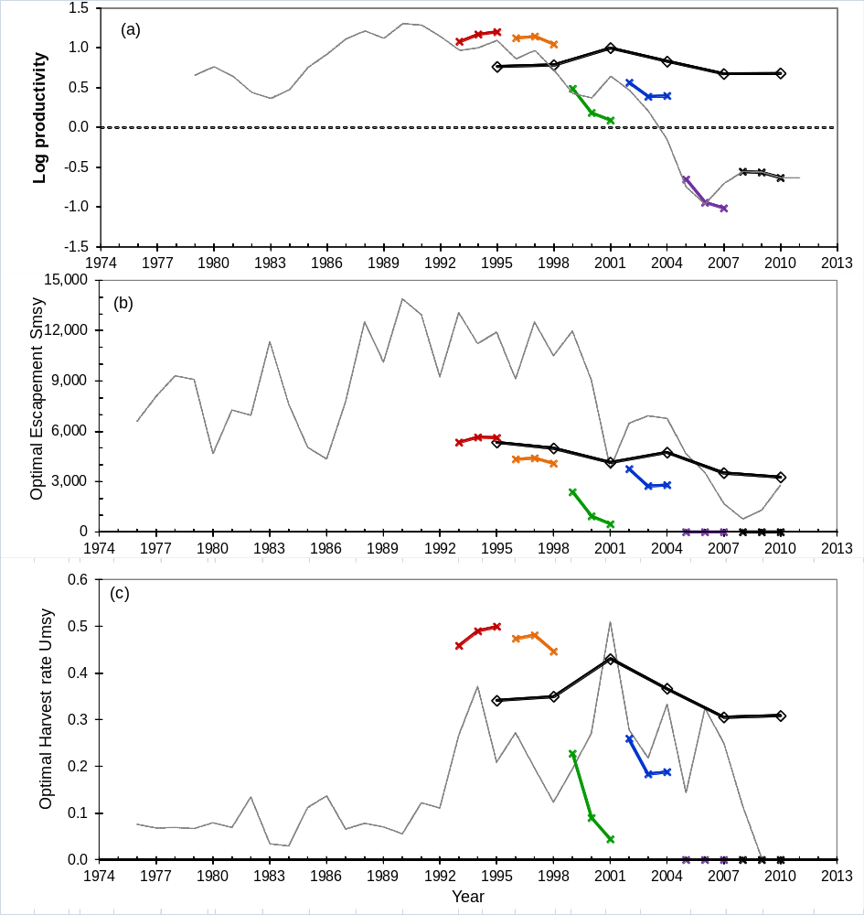
Figure S5. Retrospective estimates of (a) productivity, (b) optimal escapement S_{MSY}, and (c) optimal harvest rate U_{MSY} from analysis of all available data from Karluk River Chinook salmon at 3-year intervals beginning in 1995. Thick black lines and open diamonds are from AR(1) model, for which single estimates reflect central tendency of the stock. Colored lines and Xs are from RW model using 3 most recent cohorts (y-5 to y-3), as described in the paper. For context, thin black line in (a) connects values of annual log productivity from the 2010 RW model; in (b) connects annual escapements from the base model; and in (c) connects annual harvest rates from the base model. Values of annual log productivity (thin black line in a) is plotted versus spawning year plus 3, to be consistent with recent 3-year retrospective estimates. When estimates of optimal escapement or optimal harvest rate were negative, zeroes were plotted.
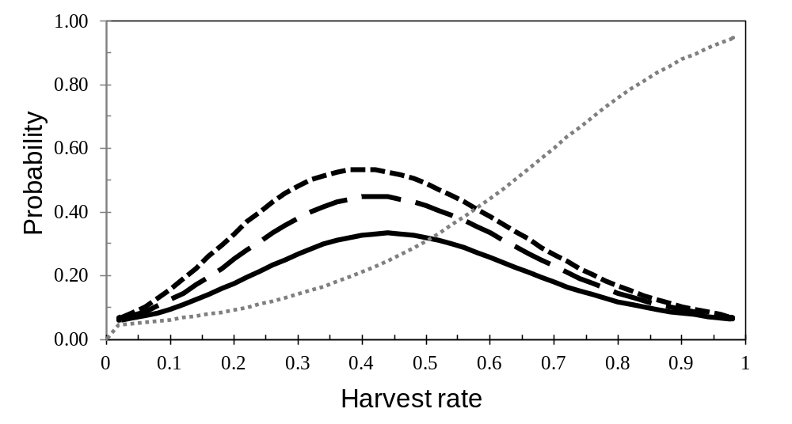Figure S6. Optimal yield profiles, under harvest rate management, for Karluk River Chinook salmon, showing the probability that a specified harvest rate will achieve 70% (short dashes), 80% (long dashes), and 90% (solid line) of maximum sustained yield . Also plotted (gray dotted line) is an “extirpation risk profile” (ERP), which displays the risk that a given harvest rate exceeds U_{MAX} = 1 - 1/α. thus exceeding the productive potential of the stock. Because information about productivity of the stock is very imprecise, the ERP is not steep, and it is not possible to reduce the risk to near zero (say <5%) without selecting a very low harvest rate (<10%). See Discussion, and Table 4, rows 2 and 3, for further explanation. All years of data (through 2010) were used to obtain the profiles.

WinBUGS program code, base model
PRIOR DISTRIBUTIONS IN GREEN
SAMPLING DISTRIBUTIONS OF DATA IN BLUE
NOTE THAT THE SECOND PARAMETER OF DNORM() IS THE INVERSE VARIANCE
model {
lnalpha ~ dnorm(0,1.0E-6)
beta ~ dnorm(0,1.0E-6)I(0,)
phi ~ dnorm(0,1.0E-6)I(-1,1)
sigma.R ~ dunif(0,100)
mean.log.R0 ~ dnorm(0,1.0E-12)
tau.R0 ~ dgamma(0.001,0.001)
log.resid.0 ~ dnorm(0,tau.red)

# lnalpha ~ dnorm(0,1.0E-6)I(0,) #ALT PRIOR
# tau.R ~ dgamma(0.001,0.001) #ALT PRIOR
# sigma.R <- 1 / sqrt(tau.R) #FOR ALT PRIOR
# tau.R0 ~ dgamma(1.25,0.4) #ALT PRIOR

alpha <- exp(lnalpha)
sigma.R0 <- 1 / sqrt(tau.R0)
tau.red <- tau.R * (1-phi*phi)
lnalpha.c <- lnalpha + (sigma.R * sigma.R / 2 / (1-phi*phi) )
S.msr <- 1 / beta

for (c in A+a.min:C) {
log.R[c] ~ dnorm(log.R.mean2[c],tau.R)
R[c] <- exp(log.R[c])
log.R.mean1[c] <- log(S[c-a.max]) + lnalpha - beta * S[c-a.max]
log.resid[c] <- log(R[c]) - log.R.mean1[c]
}
log.R.mean2[A+a.min] <- log.R.mean1[A+a.min] + phi * log.resid.0
for (c in A+a.min+1:C) {
log.R.mean2[c] <- log.R.mean1[c] + phi * log.resid[c-1]
}

# THE FIRST SEVERAL COHORTS ORIGINATE FROM UNMONITORED SPAWNING EVENTS
# DRAW THESE RETURNS FROM A COMMON LOGNORMAL DISTRIBUTION
R.0 <- exp(mean.log.R0)
for (c in 1:a.max) {
log.R[c] ~ dnorm(mean.log.R0,tau.R0)
R[c] <- exp(log.R[c])
}

positive.lna <- step(lnalpha)
lnalpha.nonneg <- lnalpha * positive.lna
S.eq <- lnalpha.nonneg * S.msr
peterman.approx <- (0.5 - 0.65*pow(lnalpha.nonneg,1.27) / (8.7 + pow(lnalpha.nonneg,1.27)))
U.msy <- lnalpha.nonneg * peterman.approx
S.msy <- U.msy / beta
U.max <- 1 - 1 / exp(lnalpha.nonneg)

# CORRECTION FOR LOGNORMAL SKEWNESS
alpha.c <- min(exp(lnalpha.c),1.0E4)
positive.lna.c <- step(lnalpha.c)
lnalpha.c.nonneg <- lnalpha.c * positive.lna.c
S.eq.c <- lnalpha.c.nonneg * S.msr
peterman.approx.c <- (0.5 - 0.65*pow(lnalpha.c.nonneg,1.27) / (8.7 + pow(lnalpha.c.nonneg,1.27)))
U.msy.c <- lnalpha.c.nonneg * peterman.approx.c
S.msy.c <- U.msy.c / beta
U.max.c <- 1 - 1 / exp(lnalpha.c.nonneg)
U.msy.hilborn.c <- lnalpha.c.nonneg * (0.5 - 0.07*lnalpha.c.nonneg)
S.msy.hilborn.c <- U.msy.hilborn.c / beta

# MATURITY SCHEDULE, DIRICHLET, BY COHORT
D.scale ~ dunif(0,1)
D <- 1 / (D.scale * D.scale)
pi[1] ~ dbeta(0.2,0.8)
pi.2p ~ dbeta(0.2,0.6)
pi.3p ~ dbeta(0.2,0.4)
pi.4p ~ dbeta(0.2,0.2)
pi[2] <- pi.2p * (1 - pi[1])
pi[3] <- pi.3p * (1 - pi[1] - pi[2])
pi[4] <- pi.4p * (1 - pi[1] - pi[2] - pi[3])
pi[5] <- 1 - pi[1] - pi[2] - pi[3] - pi[4]
for (a in 1:A) {
gamma[a] <- D * pi[a]
for (c in 1:C) {
g[c,a] ~ dgamma(gamma[a],0.1)
p[c,a] <- g[c,a]/sum(g[c,])
}
}

# N.YA AS PRODUCT OF P*R (Y INDEX STARTS AT 1ST YEAR OF ESCAPEMENT DATA)
for (a in 1:A) {
for (y in a:(Y + (a - 1))) {
N.ya[y - (a - 1), (A + 1 - a)] <- p[y, (A + 1 - a)] * R[y]
}
}

# MULTINOMIAL AGE COUNTS OBSERVED
for (y in 1:Y) {
N[y] <- sum(N.ya[y,1:A])
for (a in 1:A) {
q[y,a] <- N.ya[y,a] / N[y]
}
n[y] <- sum(x[y,1:A])
x[y,1:A] ~ dmulti(q[y,],n[y])
}

# HARVEST BELOW WEIR, WEIR PASSAGE, AND HARVEST ABOVE WEIR OBSERVED
for (y in 1:Y) {
mu.HB[y] ~ dbeta(0.5,0.5)
H.B[y] <- mu.HB[y] * N[y]
log.HB[y] <- log(H.B[y])
tau.log.hb[y] <- 1 / log(cv.hb[y]*cv.hb[y] + 1)
h.b[y] ~ dlnorm(log.HB[y],tau.log.hb[y])

W[y] <- max(N[y] - H.B[y], 1)
log.W[y] <- log(W[y])
tau.log.w[y] <- 1 / log(cv.w[y]*cv.w[y] + 1)
w[y] ~ dlnorm(log.W[y],tau.log.w[y])

mu.HA[y] ~ dbeta(0.5,0.5)
H.A[y] <- mu.HA[y] * W[y]
log.HA[y] <- log(H.A[y])
tau.log.ha[y] <- 1 / log(cv.ha[y]*cv.ha[y] + 1)
h.a[y] ~ dlnorm(log.HA[y],tau.log.ha[y])

S[y] <- max(W[y] - H.A[y], 1)
mu[y] <- (H.B[y] + H.A[y]) / N[y]
}

# PROPORTION MATURING AT AGE 5 AND UNDER, FOR FIGURE 3
for (y in 1:Y+A-1) {
p.le5[y] <- p[y,1] + p[y,2] + p[y,3]
}
# PROXY VALUES FOR TIME VARYING PRODUCTIVITY, FOR FIGURE 5
for (y in A+a.min:Y+A-1) {
lnalpha.y[y] <- lnalpha + log.resid[y]
lnalpha.c.y[y] <- lnalpha.c + log.resid[y]
}
# BROOD YEARS OF COHORTS REPRESENTED IN THE DATA
# (GO TO INFO NODE TO CHECK VALUES OF BROOD YEAR)
for (c in 1:C) {
brood.year[c] <- first.brood.year + c - 1
}
# CALENDAR YEARS OF ESCAPEMENT DATA + FORECAST
# (GO TO INFO NODE TO CHECK CALENDAR YEAR)
for (y in 1:Y) {
calendar.year[y] <- first.brood.year + a.max + y -1
}

USE PETERMAN ET AL (2000) APPROXIMATION OF S.MSY
TO PRODUCE OPTIMAL YIELD PROFILES
LOOP OVER INCREMENTS OF S, DETERMINE IF YIELD EXCEEDS X% OF MSY
R.msy.c <- S.msy.c * exp(lnalpha.c - beta * S.msy.c)
MSY.c <- R.msy.c - S.msy.c
for (i in 1:50) {
S.star[i] <- 200*i
R.star.c[i] <- min(S.star[i] * exp(lnalpha.c - beta * S.star[i]),1.0E6)
SY.c[i] <- R.star.c[i] - S.star[i]
Exceed70MSYc[i] <- positive.lna.c * step(SY.c[i] - 0.7 * MSY.c)
Exceed80MSYc[i] <- positive.lna.c * step(SY.c[i] - 0.8 * MSY.c)
Exceed90MSYc[i] <- positive.lna.c * step(SY.c[i] - 0.9 * MSY.c)
}
for (i in 1:49) {
mu.star[i] <- 0.02*i
S.star.raw.c[i] <- lnalpha.c/beta + log(1-mu.star[i])/beta # S as function of mu
Zero.Yield.c[i] <- 1 - step(S.star.raw.c[i]) # for extirpation risk profile
S.star0.c[i] <- max(S.star.raw.c[i],0) # S cannot be negative
R.star2.c[i] <- min(S.star0.c[i] * exp(lnalpha.c - beta * S.star0.c[i]),1.0E6)
SY2.c[i] <- R.star2.c[i] - S.star0.c[i]
muExceed70MSYc[i] <- step(SY2.c[i] - 0.7 * MSY.c)
muExceed80MSYc[i] <- step(SY2.c[i] - 0.8 * MSY.c)
muExceed90MSYc[i] <- step(SY2.c[i] - 0.9 * MSY.c)
}
} # END OF CODE

#VERSION WITHOUT SKEW BIAS CORRECTION, NOT USED
MSY <- R.msy - S.msy
R.msy <- S.msy * exp(lnalpha - beta * S.msy)
for (i in 1:50) {
R.star[i] <- S.star[i] * exp(lnalpha - beta * S.star[i])
SY[i] <- R.star[i] - S.star[i]
Exceed70MSY[i] <- positive.lna * step(SY[i] - 0.7 * MSY)
Exceed80MSY[i] <- positive.lna * step(SY[i] - 0.8 * MSY)
Exceed90MSY[i] <- positive.lna * step(SY[i] - 0.9 * MSY)
}
#FOR OPTIMAL PRODUCTION PROFILE, NOT USED
R.max <- S.msr * exp(lnalpha - beta * S.msr)
R.max.c <- S.msr * exp(lnalpha.c - beta * S.msr)
for (i in 1:100) {
S.star[i] <- 200*i
R.star[i] <- S.star[i] * exp(lnalpha - beta * S.star[i])
SY[i] <- R.star[i] - S.star[i]
Exceed70Rmax[i] <- step(R.star[i] - 0.7 * R.max)
Exceed80Rmax[i] <- step(R.star[i] - 0.8 * R.max)
Exceed90Rmax[i] <- step(R.star[i] - 0.9 * R.max)
R.star.c[i] <- S.star[i] * exp(lnalpha.c - beta * S.star[i])
SY.c[i] <- R.star.c[i] - S.star[i]
Exceed70Rmaxc[i] <- step(R.star.c[i] - 0.7 * R.max.c)
Exceed80Rmaxc[i] <- step(R.star.c[i] - 0.8 * R.max.c)
Exceed90Rmaxc[i] <- step(R.star.c[i] - 0.9 * R.max.c)
}

WinBUGS program code, random walk model
model {
lnalpha0 ~ dnorm(0,1.0E-6)I(-4,4)
beta ~ dnorm(0,1.0E-6)I(0,)
tau.alpha ~ dgamma(0.001,0.001)
tau.white ~ dgamma(0.001,0.001)
mean.log.R0 ~ dnorm(0,1.0E-6)I(0,)
tau.R0 ~ dgamma(0.001,0.001)
lnalpha.lag[1] <- lnalpha0
for (c in A+a.min:C) {
log.R[c] ~ dnorm(log.R.mean[c],tau.white)
log.R.mean[c] <- log(S[c-a.max]) + lnalpha[c-a.max] - beta * S[c-a.max]
log.resid[c] <- log(R[c]) - log.R.mean[c]
R[c] <- exp(log.R[c])
alpha[c-a.max] <- exp(lnalpha[c-a.max])
lnalpha[c - a.max] ~ dnorm(lnalpha.lag[c - a.max], tau.alpha)
lnalpha.lag[c - a.max + 1] <- lnalpha[c - a.max]
S.eq[c-a.max] <- lnalpha[c-a.max] * S.max
S.msy[c-a.max] <- S.eq[c-a.max] * (0.5 - 0.07*lnalpha[c-a.max])
U.msy[c-a.max] <- lnalpha[c-a.max] * (0.5 - 0.07*lnalpha[c-a.max])
}
S.msr <- 1 / beta
R.max.mean.a <- S.msr * exp(mean.lnalpha - beta * S.max)
sigma.alpha <- 1 / sqrt(tau.alpha)
sigma.R <- 1 / sqrt(tau.R)

# THE FIRST SEVERAL COHORTS ORIGINATE FROM UNMONITORED SPAWNING EVENTS
# DRAW THESE RETURNS FROM A COMMON LOGNORMAL DISTRIBUTION
R.0 <- exp(mean.log.R0)
sigma.R0 <- 1 / sqrt(tau.R0)
for (c in 1:a.max) {
log.R[c] ~ dnorm(mean.log.R0,tau.R0)
R[c] <- exp(log.R[c])
}

# MATURITY SCHEDULE, DIRICHLET, BY COHORT
D.scale ~ dunif(0,1)
D <- 1 / (D.scale * D.scale)
pi[1] ~ dbeta(0.2,0.8)
pi.2p ~ dbeta(0.2,0.6)
pi.3p ~ dbeta(0.2,0.4)
pi.4p ~ dbeta(0.2,0.2)
pi[2] <- pi.2p * (1 - pi[1])
pi[3] <- pi.3p * (1 - pi[1] - pi[2])
pi[4] <- pi.4p * (1 - pi[1] - pi[2] - pi[3])
pi[5] <- 1 - pi[1] - pi[2] - pi[3] - pi[4]
for (a in 1:A) {
gamma[a] <- D * pi[a]
for (c in 1:C) {
g[c,a] ~ dgamma(gamma[a],0.1)
p[c,a] <- g[c,a]/sum(g[c,])
}
}

# N.YA AS PRODUCT OF P*R (Y INDEX STARTS AT 1ST YEAR OF ESCAPEMENT DATA)
for (a in 1:A) {
for (y in a:(Y + (a - 1))) {
N.ya[y - (a - 1), (A + 1 - a)] <- p[y, (A + 1 - a)] * R[y]
}
}

# MULTINOMIAL AGE COUNTS OBSERVED
for (y in 1:Y) {
N[y] <- sum(N.ya[y,1:A])
for (a in 1:A) {
q[y,a] <- N.ya[y,a] / N[y]
}
n[y] <- sum(x[y,1:A])
x[y,1:A] ~ dmulti(q[y,],n[y])
}

# HARVEST BELOW WEIR, WEIR PASSAGE, AND HARVEST ABOVE WEIR OBSERVED
for (y in 1:Y) {
mu.HB[y] ~ dbeta(0.5,0.5)
H.B[y] <- mu.HB[y] * N[y]
log.HB[y] <- log(H.B[y])
tau.log.hb[y] <- 1 / log(cv.hb[y]*cv.hb[y] + 1)
h.b[y] ~ dlnorm(log.HB[y],tau.log.hb[y])

W[y] <- max(N[y] - H.B[y], 1)
log.W[y] <- log(W[y])
tau.log.w[y] <- 1 / log(cv.w[y]*cv.w[y] + 1)
w[y] ~ dlnorm(log.W[y],tau.log.w[y])

mu.HA[y] ~ dbeta(0.5,0.5)
H.A[y] <- mu.HA[y] * W[y]
log.HA[y] <- log(H.A[y])
tau.log.ha[y] <- 1 / log(cv.ha[y]*cv.ha[y] + 1)
h.a[y] ~ dlnorm(log.HA[y],tau.log.ha[y])

S[y] <- max(W[y] - H.A[y], 1)
mu[y] <- (H.B[y] + H.A[y]) / N[y]
}
}
Karluk Chinook data for WinBUGS
# Y IS NUMBER OF CALENDAR YEARS OF DATA PLUS FORECAST
# A IS NUMBER OF AGE CLASSES
# C (= Y + A - 1) IS NUMBER OF COHORTS REPRESENTED IN DATA PLUS FORECAST

list( Y=36, A=5, C=40, a.min=3, a.max=7, first.brood.year=1969,

h.b=c(
178,215,285,244,123,193,399,152,90,241,
603,413,413,280,351,801,693,3905,5870,2468,
2515,2250,843,1958,2008,3265,1912,1635,2658,608,
1158,452,97,1,1,1),

cv.hb=c(
0.89,0.76,0.65,0.74,0.89,0.79,0.70,0.70,0.69,0.69,
0.08,0.17,0.72,0.72,0.50,0.46,0.16,0.06,0.05,0.08,
0.10,0.09,0.19,0.12,0.15,0.07,0.16,0.09,0.07,0.25,
0.11,0.24,0.05,0.9,0.9,0.9),

w=c(
6897,8434,9795,9555,4810,7575,7489,11746,7747,5362,
4429,7930,13337,10484,14442,14022,9601,13944,12049,12657,
10051,13443,10239,13063,10460,4453,7175,7256,7525,4798,
4112,1765,752,1306,2916,NA),

cv.w=c(
0.05,0.05,0.05,0.05,0.05,0.05,0.05,0.05,0.05,0.05,
0.05,0.05,0.05,0.05,0.05,0.05,0.05,0.05,0.05,0.05,
0.05,0.05,0.19,0.05,0.05,0.05,0.05,0.05,0.05,0.05,
0.05,0.05,0.05,0.05,0.05,0.05),

h.a=c(
175,215,249,243,122,193,397,152,87,236,
61,99,409,279,349,798,427,816,740,641,
846,786,586,882,1288,651,601,291,720,114,
439,68,1,1,1,1),

cv.ha=c(
0.90,0.76,0.75,0.74,0.89,0.79,0.70,0.70,0.70,0.70,
0.71,0.70,0.73,0.72,0.50,0.46,0.26,0.22,0.20,0.25,
0.29,0.25,0.27,0.25,0.23,0.28,0.05,0.05,0.05,0.60,
0.62,0.50,0.9,0.9,0.9,0.9),

x = structure(.Data =c(
0,0,0,0,0,
0,0,0,0,0,
0,0,0,0,0,
0,0,0,0,0,
0,0,0,0,0,
0,0,0,0,0,
0,0,0,0,0,
0,0,0,0,0,
0,0,0,0,0,
0,0,0,0,0,
0,0,0,0,0,
0,0,0,0,0,
0,0,0,0,0,
0,0,0,0,0,
0,0,0,0,0,
0,0,0,0,0,
0,0,0,0,0,
1,25,94,189,1,
10,26,53,160,17,
8,34,36,156,27,
1,22,32,69,11,
10,20,85,111,14,
1,16,14,94,0,
3,30,139,139,20,
6,12,93,178,3,
0,0,16,48,7,
9,73,93,105,12,
3,56,174,59,3,
4,11,85,138,14,
3,9,28,26,2,
0,3,12,34,14,
0,2,6,23,12,
0,0,2,16,3,
1,7,13,9,3,
0,5,15,26,9,
0,0,0,0,0
),.Dim = c(36, 5))
)

Advice on a common MCMC technical difficulty

The most common technical problem encountered when running the age-structured state space model involves recurring “bracket slice failures” when sampling annual Dirichlet “g” vectors. We recommend the following steps, taken approximately in the order listed. If neither of the first two suggestions are successful, try 3, 4, and/or 5.

1) Restart sampling by clicking on Update. This can be repeated multiple times, and with luck, one may get past the critical adaptive phase during which these errors are most likely to occur.

2) Reduce the second Dirichlet gamma parameter that generates the g vectors from 1 to 0.1, or possibly lower. This may slow the sampling but also makes it more robust to bracket slice problems.

3) Provide good initial values for the matrix of g vectors. Use a spreadsheet to re-construct age-at-maturity proportions by cohort.

4) The failures occur for elements of the g vectors that are associated with very small proportions. If one or more of the age classes are very rare (< 2% or so), ignore them by reducing the length of the age vectors, or possibly combine them with the second oldest or second youngest ages. To do this you must alter your data, the code, and possibly the initial values for g.

5) Run the model in OpenBUGS. This may be the best long-term strategy. However note that the default settings in OpenBUGS often do not result in successful mixing for this model. You must first disable all “block” updaters (at this time there are 4 of them) before compiling the code.

