User’s Manual for HWLER (Hardy-Weinberg and Linkage Equilibrium Sampler)

Gibbs and Split-merge Sampler

Michele Masuda and Jerry Pella

National Marine Fisheries Service
Alaska Fisheries Science Center
Auke Bay Laboratory
11305 Glacier Hwy.
Juneau, AK 99801-8626

7 July 2005
Table of Contents

I. General Description 3
II. Installing HWLER 4
III. Setting Up the Files 4
A. Data File 4
1. Description 4
2. Format 4
B. Control File 5
1. Description 5
2. Format 5
IV. Running HWLER 7
A. Executing HWLER 7
B. Loading the Control File 7
C. Running the Gibbs and Split-merge Sampler 7
D. Assessing Convergence 7
E. Pull-down Menu Options 8
1. Summary statistics of sampled population proportions 8
2. Summary of sampled population assignments of mixture individuals 8
3. Summary of the posterior distribution of the total number of clusters or number of extra-baseline populations 8
4. Trace plots of population proportions 9
5. Trace plot of total number of clusters or number of extra-baseline populations 9
F. Exiting HWLER 9
V. Output 9
A. Summary file (.SUM file) 9
B. Output file of population proportions (.BOT file) 10
C. Output file of individual assignments (.CLS file) 10
D. Output file of total number of clusters or number of extra-baseline populations (.STK file) 10
E. Output file of partitions (.TXT file) – Making a binary tree 11
F. Output file of the Dirichlet mass parameter (.ALP file) 12
VI. Example Runs: Sashin Creek steelhead (Oncorhynchus mykiss) (Thrower et al. 2004) 12
Description 12
A. Evaluation of a baseline population 13
B. Stock-mixture analysis with a partial baseline 20
C. Stock-mixture analysis with no baseline 27
VII. References 33

I. General Description
HWLER performs Gibbs and split-merge Markov chain Monte Carlo (MCMC) sampling for population mixture analysis from genetic data (Pella and Masuda In press). HWLER partitions the mixture sample into subsets of individuals from baseline and extra-baseline populations. Subsets of individuals are selected to satisfy Hardy-Weinberg and linkage equilibrium conditions. HWLER performs the MCMC sampling by alternating sequentially-allocated merge-split (SAMS) samples with Gibbs scans (see Pella and Masuda In press). HWLER is recommended to alternate 2 SAMS draws with 5 Gibbs scans, denoted as HWLER (2,5). Combinations other than HWLER (2,5) have not been tried. HWLER can be used for either population mixture analysis with partial or completely missing baselines or for baseline evaluation. Provided with baseline and mixture samples, HWLER outputs MCMC samples of baseline population proportions and a composite extra-baseline population proportion. The program summarizes MCMC samples of population composition (after burn-in discard) with means, standard deviations, and percentiles (2.5, 50, and 97.5). The program optionally outputs MCMC samples of assignments of individuals to baseline populations or to a composite extra-baseline population. Draws of assignments of individuals are summarized with the proportion of times (after burn-in discard) an individual was assigned to a baseline population or to a composite extra-baseline population. HWLER outputs MCMC samples of the numbers of extra-baseline populations (mixture analysis with baseline) or total numbers of clusters (analysis of baseline or mixture alone). HWLER also outputs MCMC sample partitions of subsets of individuals that can be summarized visually with a binary tree of relationships among individuals. A binary tree based on co-assignment probabilities, computed as measures of similarity between all pairs of individuals, allows the identification of clusters that are well supported by the draws from the posterior distribution of plausible partitions (see Dawson and Belkhir 2001).

HWLER is a Fortran 95 program with a windows-like interface written for an IBM-compatible personal computer. The Fortran code was compiled with the Lahey Fortran 95 compiler, release 5.00f (Lahey 1998). The largest mixture sample analyzed to date by us with HWLER is 600 individuals. HWLER run on data sets of this size or larger may take a long time to converge. Also, the memory limit of program PartitionView for constructing binary trees of relationships among individuals may be exceeded by the number of individuals or the number of MCMC partitions and will cause an error. Check the PartitionView web site for updates to the software. HWLER uses the following Fortran routines and libraries: Numerical Recipes (Press et al. 2002), Randgen.f (Chandler and Northrop 1999), RANLIB (Brown et al. 1993), and DISLIN (Michels 2005).

This document describes how to run HWLER and presents applications of the program. Data input to HWLER include allelic data for a single locus or several independent loci for mixture and baseline individuals. Baseline data is formatted differently for HWLER than for other stock mixture programs such as SPAM (Debevec et al. 2000) and BAYES (Pella and Masuda 2001) in that allelic data for each baseline individual, not simply baseline population summaries of data, must be provided to the program.

II. Installing HWLER
The program package consists of two files: HWLER.EXE and DISDLL.DLL. Install these files in a directory where the program will be run.

III. Setting Up the Files
HWLER requires two files: a file of baseline and/or mixture data and a control file of program settings. Input files for the BAYES program (Pella and Masuda 2001) may be modified for use with HWLER. Files must be ascii or text (no formatting characters).

A. Data File

1. Description
The data file contains the genetic data sampled from mixture individuals and/or baseline individuals of potential source populations. Baseline data is formatted differently for HWLER than for other stock mixture programs such as SPAM (Debevec et al. 2000) and BAYES (Pella and Masuda 2001) in that allelic data for each baseline individual, not simply baseline population summaries of data, must be provided to the program. Each line of the data file represents one baseline or mixture individual, and individuals can be in any order in the file. Included on each line is the baseline population identification number (0 if a mixture individual), number of occurrences of alleles at loci (0, 1, or 2), and an optional, alphanumeric identification for the individual. If only mixture individuals are present in the data file, then population identification numbers are not included in the file. The order of loci must match the order in the control file.

See example data files.

2. Format
Each line of the data file represents one baseline or mixture individual and identifies the single- or multiple-locus type of that individual. User specifies in the control file the Fortran format of the data file. Each line of the data file contains ordered information for a single individual:

Type | Description
Integer  (absent if mixture only) | Baseline population identification number of the individual matching the baseline population number in the control file (0 if a mixture individual or absent if no baseline present)
Integers | Occurrences of alleles (0, 1, or 2) at consecutive loci ordered as in the control file
Character (optional) (maximum length is 10) | Identification for the individual used in output files

The locus information for an individual contains groups of adjacent columns, and each group corresponds to one locus. The order of loci must match the order in the control file. Each column in a group corresponds to an allele. If an allele is not observed in any of the baseline or mixture individuals, then that allele should be excluded by either removing the column from the data file or skipping over the column with the Fortran format statement in the control file.

Columns in a group contain the number of occurrences of each allele (0, 1, or 2). If a locus is not observed for an individual, then the columns corresponding to that locus should be blank or contain 0s.

Each individual is optionally (option 7 in the control file) identified with a number, or combination of numbers and characters, of maximal length 10. The identification of individuals is used in the output files.

a. Mixture only
If only mixture individuals are present in the data file, then population identification numbers should not be included in the data file.

b. Baseline only or Mixture & Baseline
If baseline individuals are present in the data file, then a population identification number must start each line of the data file (0 if a mixture individual).

B. Control File

1. Description
The control file provides information to the program such as title of the analysis, names of input and output files, number of MCMC samples, seed values for the random number generators, format of the data file, program options, description of loci, and description of baseline populations if available.

See example control files.

2. Format
Following is a line by line description of the control file. Unless specified in the “Type or Format” column, lines may begin in any column. See example control files.

Line | Type or Fortran format | Description
1 | character | Title of analysis
2 | character | File of genetic data (input)
3 | character | Summary file (output) (suggested .SUM file)
4 | character | File of MCMC samples of population proportions (mixture analysis with baseline) or snapshots of numbers of individuals assigned to each cluster (analysis of baseline or mixture alone) (output) (suggested .BOT file)
5 | character | File of MCMC samples of assignments of mixture individuals to baseline populations or extra-baseline populations (mixture analysis with baseline) or snapshots of cluster assignments of individuals (analysis of baseline or mixture alone) (output) (suggested .CLS file)
6 | character | File of MCMC samples of numbers of extra-baseline populations (mixture analysis with baseline) or total numbers of clusters (analysis of baseline or mixture alone) (output) (suggested .STK file)
7 | character | File of MCMC samples of partitions for making a binary tree (output) (suggested .TXT file)
8 | character | File of MCMC samples of the Dirichlet mass parameter if option 9 in the control file is selected (output) (suggested .ALP file)
9 | 3 integers | Number of HWLER samples, number of SAMS samples per HWLER sample (suggested 2), and number of Gibbs scans per HWLER sample (suggested 5)
10 | integer | Number of populations with baseline data
11 | integer | Number of loci
12 | real | Initial value of the Dirichlet mass parameter if option 9 in the control file is selected or the fixed value of the Dirichlet mass parameter if option 9 is not selected (suggested value 1.0)
13-15 | 3 positive integers | Three different seeds for random number generators (maximum value possible is 2,147,483,647 [Lahey 1998]) (these should be changed in every control file)
16 | integer | Thinning interval¹ for MCMC samples of population proportions or snapshots of numbers of individuals assigned to each cluster
17 | integer | Thinning interval¹ for MCMC samples of assignments of mixture individuals to baseline populations or extra-baseline populations or snapshots of cluster assignments of individuals
18 | integer | Thinning interval¹ for MCMC samples of partitions for making a binary tree
19 | character | Fortran format of data file
20 | logical (9(L1,1X)) | Options are turned “on” with “T” for true or “off” with “F” for false. Program options: 1. print summary of baseline data to summary file, 2. print mixture data to summary file, 3. output MCMC population assignments of individuals (mixture analysis with baseline) or snapshots of cluster assignments of individuals (analysis of baseline or mixture alone), 4. suppress the output of MCMC samples of population proportions (mixture analysis with baseline) or snapshots of numbers of individuals assigned to each cluster (analysis of baseline or mixture alone), 5. baseline samples provided, 6. mixture samples provided, 7. alphanumeric identification for each baseline or mixture individual provided at the end of each line of data file, 8. output MCMC samples of partitions for making a binary tree, and 9. perform MCMC sampling of the Dirichlet mass parameter.
21-xx | Fortran format (2I3,2X,A18) | Following lines form the locus definition block. Each line provides information about a single locus: 1. locus identification number that is only used in the summary file, 2. number of alleles, and 3. locus name. Order of loci must match the order of loci in the data file.
xx-xx | Fortran format (I4,1X,A18) | Following lines form the population definition block if baseline data are present (blank if baseline absent). Each line provides information about a single population: 1. population identification number matching number in the data file and 2. population name.
¹If n is the thinning interval, then every n-th MCMC sample or n-th snapshot is output. If the disk space required for storing MCMC samples is too large, then thinning samples is necessary.

IV. Running HWLER
Below is an outline of how to run HWLER. See example runs for more details (Sec. VI).

A. Executing HWLER
HWLER can be executed from an MS-DOS window. Change to the directory where the program is located and enter HWLER. Program can also be run from the Start menu: click Start, select Run, enter the directory and program name, HWLER.EXE, and select OK.

B. Loading the Control File
From the pull-down menu, select File/Load control file. Select a control file and Open.

C. Running the Gibbs and Split-merge Sampler
From the pull-down menu, select Run. HWLER displays the current sample number and a real-time trace plot of number of clusters or number of extra-baseline populations.

D. Assessing Convergence
After convergence, MCMC samples can be considered draws from posterior distributions. Following are suggestions for determining convergence of samples and the number of initial samples to discard as burn-in (see Pella and Masuda In press for details). Check trace plots of population proportions (if baseline and mixture samples are provided) and total numbers of clusters or numbers of extra-baseline populations (.STK file). A trace plot of samples is a plot of the samples as a time series. The population proportions and number of partitions should stabilize, after which the samples may have converged. Initial samples should be discarded as burn-in. Repeatable binary trees among the early and late portions of the chain, after burn-in discard, may be evidence of convergence. After burn-in discard, binary trees can be constructed from the first and second halves of the chain. Reasonable agreement between the binary trees is evidence of convergence of samples.

A trace plot of the estimated number of clusters (baseline or mixture samples only) or number of extra-baseline populations (baseline and mixture samples) is output to the screen in real time. If convergence of the number of clusters or number of extra-baseline populations seems likely to have occurred before completion of sampling, HWLER can be interrupted and most samples will be saved to files (HWLER saves files every 100 MCMC samples). If HWLER is interrupted before all MCMC sampling has completed, be sure to note the exact numbers of samples saved to files (.ALP, .BOT, .CLS, .STK, and .TXT) when summarizing posterior samples (e.g. computing summary statistics, constructing binary trees, etc.). In particular, you must edit the file of sampled partitions (.TXT file) and correct the number of partitions in the file (line 4).

E. Pull-down Menu Options
Output from the pull-down menu options is sent to the summary file. Graphs are sent to the screen or to a postscript file.

1. Summary statistics of sampled population proportions
MCMC samples (after burn-in discard) of population proportions can be summarized with means, standard deviations, and empirical percentiles (2.5, 50, and 97.5).

From the pull-down menu, select Stats/Mixture analysis with baseline/Stock composition. HWLER prompts the user for chain length or total number of MCMC samples (SAMS samples and Gibbs scans) and number of burn-in samples to discard. The file name of MCMC samples of population proportions (usually .BOT file) is read from the control file.

2. Summary of sampled population assignments of mixture individuals
MCMC samples (after burn-in discard) of population assignments of mixture individuals can be summarized with the proportion of times an individual was assigned to a population or extra-baseline population.

From the pull-down menu, select Stats/Mixture analysis with baseline/Individual stock assignments. HWLER prompts the user for chain length or total number of MCMC samples (SAMS samples and Gibbs scans) and number of burn-in samples to discard. The file name of MCMC samples of population assignments (usually .CLS file) is read from the control file.

3. Summary of the posterior distribution of the total number of clusters or number of extra-baseline populations
From the pull-down menu, select Stats/# of clusters or extra-baseline stocks. HWLER prompts the user for total number of samples (SAMS samples and Gibbs scans) and the number of burn-in samples to discard. HWLER reads the filename (usually .STK file) of the sampled number of clusters or extra-baseline populations from the control file. The probabilities of number of clusters or number of extra-baseline populations are computed from the MCMC samples that are considered draws from the posterior distribution (samples after burn-in discard). The number of clusters or number of extra-baseline populations are tabulated and divided by the number of samples.

4. Trace plots of population proportions
Trace plots of population proportions (plots of proportions as a time series) can be used for determining convergence of MCMC samples and the number of samples to discard as burn-in. Trace plots can be sent to the screen or to a postscript file (.PS file).

From the pull-down menu, select Trace plots/Mixture analysis with baseline/Stock composition. HWLER prompts the user for chain length or total number of MCMC samples (SAMS samples and Gibbs scans) and number of samples to trace. The file name of MCMC samples of population proportions (usually .BOT file) is read from the control file.

See example plots.

5. Trace plot of total number of clusters or number of extra-baseline populations
Trace plots of number of clusters or number of extra-baseline populations (plots of numbers as a time series) can be used for determining convergence of MCMC samples and the number of samples to discard as burn-in. Trace plots can be sent to the screen or to a postscript file (.PS file).

From the pull-down menu, select Trace plots/# of clusters or extra-baseline stocks. Plots can be sent to the screen or to a postscript file. HWLER reads the filename (usually .STK file) of the sampled number of clusters or extra-baseline populations and number of samples from the control file.

See example plots.

F. Exiting HWLER
At the end of sampling, HWLER outputs the total number of MCMC samples drawn. Click the OK button. Click the secondary mouse button (usually the right button) on the trace plot of number of clusters or number of extra-baseline populations. Exit from the pull-down menu or the “exit” button on the far-right window title bar. Program must be exited before another control file can be loaded.

V. Output

A. Summary file (.SUM file)
Summary file includes information from the control file, any errors, and summary statistics.

B. Output file of population proportions (.BOT file)

Mixture analysis with baseline: If option 4 in the control file is not selected (F), then MCMC samples of population proportions are output to this file. Population proportions are computed as the number of mixture individuals clustered with baseline populations and extra-baseline populations divided by the size of the mixture sample. Individuals assigned to extra-baseline populations are pooled in the summary into one cluster. Summary statistics can be computed from the samples in this file (after burn-in discard) with the pull-down menu: Stats/Mixture analysis with baseline/Stock composition.

Analysis of baseline or mixture alone: If option 4 in the control file is not selected (F), then snapshots of numbers of individuals assigned to each cluster are output to this file. If the data consists of only baseline individuals, then the numbers of individuals by population assigned to each cluster are output to this file. Note that cluster labels (1 to the number of clusters) may not correspond to the same sets of individuals from one MCMC sample to the next (i.e. label switching likely occurs). With large numbers of MCMC samples, this file can become large. Thinning is recommended (line 16 of the control file).

C. Output file of individual assignments (.CLS file)

Mixture analysis with baseline: If option 3 in the control file is selected (T), then at each iteration, the population assignment of each mixture individual is output. Output file contains for each mixture individual a row of 0s and a single 1, 1 indicating the baseline or extra-baseline population the individual was assigned to. Each MCMC sample in the file consists of one line per mixture individual. MCMC samples (after burn-in discard) of population assignments can be summarized with the proportion of times an individual was assigned to a baseline or extra-baseline population (Stats/Mixture analysis with baseline/Individual stock assignments from the pull-down menu). Individuals assigned to extra-baseline populations are pooled in the summary into one cluster. This option can produce a large file depending on the numbers of baseline populations, MCMC samples, and mixture individuals. Thinning is recommended (line 17 of the control file).

Analysis of baseline or mixture alone: If option 3 in the control file is selected (T), then snapshots of cluster assignments of individuals are output to this file. Note that cluster labels (1 to the number of clusters) may not correspond to the same sets of individuals from one MCMC sample to the next (i.e. label switching likely occurs). With large numbers of individuals and MCMC samples, this file can become large. Thinning is recommended (line 17 of the control file).

D. Output file of total number of clusters or number of extra-baseline populations (.STK file)

Mixture analysis with baseline: The MCMC samples of number of extra-baseline populations is output to this file. A trace plot of these samples (plot of samples as a time series) can be used to determine convergence and the number of burn-in samples to discard (from the pull-down menu, select Trace plots/# of clusters or extra-baseline stocks). Use histogram-plotting software to display the distribution of the number of extra-baseline populations after burn-in discard. The probabilities of number of extra-baseline populations can be computed from the MCMC samples after convergence (Stats/# of clusters or extra-baseline stocks). See Sec. IV. E. 3.

Analysis of baseline or mixture alone: The MCMC samples of total number of clusters are output to this file. A trace plot of these samples (plot of samples as a times series) can be used to determine convergence and the number of burn-in samples to discard (from the pull-down menu, select Trace plots/# of clusters or extra-baseline stocks). Use histogram-plotting software to display the distribution of the total number of clusters after burn-in discard. Check the output file of numbers of individuals assigned to each cluster (.BOT file) as some clusters may be assigned small numbers of individuals. The probabilities of total number of clusters can be computed from the MCMC samples after convergence (Stats/# of clusters or extra-baseline stocks). See Sec. IV. E. 3.

E. Output file of partitions (.TXT file) – Making a binary tree

Mixture analysis with baseline: MCMC sample partitions of the mixture individuals are output to this file. With large numbers of mixture individuals and MCMC samples, this file can become large. Thinning may be necessary (line 18 of the control file).

Analysis of baseline or mixture alone: MCMC sample partitions of the baseline or mixture individuals are output to this file. With large numbers of individuals and MCMC samples, this file can become large. Thinning may be necessary (line 18 of the control file).

The HWLER file of MCMC sample partitions (.TXT) includes the number of individuals, number of MCMC sample partitions, number of clusters or subsets per partition, and the specific individuals in each subset. The file of sampled partitions (.TXT) is formatted for analysis by software PartitionView (previously ANALYSE) (Dawson and Belkhir 2001) that computes co-assignment probabilities between pairs of individuals and performs hierarchical agglomerative clustering of individuals into a binary tree. Since PartitionView was developed for use with output from software PARTITION, a model-based statistical software package for identifying population subsets (Dawson and Belkhir 2001), some lines of the HWLER partitions file (.TXT) have meaningless values and should be ignored such as the log likelihood of the partition, prior parameters, etc. See the PARTITION web site for a description of input to PartitionView. To run PartitionView, select the button Open Partition result file. Open the HWLER .TXT file. Enter the number of samples or partitions to discard as burn-in. Check the trace plot of number of clusters or number of extra-baseline populations to make a guess of the number of burn-in samples to discard. Assess convergence of samples, after burn-in discard, by constructing binary trees from the first and second halves of the chain and verifying reasonable agreement of the binary trees. For more guidance in determining the number of burn-in samples to discard and assessing convergence of samples, see Section IV. D. Assessing Convergence. Select the Make Tree tab. Select the Make Tree button. Select OK and exit the program. PartitionView creates the binary tree file Tree.txt (default name). The binary tree can be viewed with standard tree viewing software such as NJplot (Perrière and Gouy 1996) or TreeView (Page 1996). To run NJplot, select File/Open from the pull-down menus and open Tree.txt to view the binary tree. Branch lengths are optionally displayed. The numbers identifying individuals in the binary tree correspond to the order of individuals in the data file.

The memory limit of program PartitionView may be exceeded by the number of individuals or the number of MCMC partitions and will cause an error. In this case, one could increase the thinning of partitions (line 18 of the control file) and rerun the analysis to limit the number of partitions in the .TXT file. Another memory-saving option is to edit the .TXT file by removing burn-in partitions starting at line 8 and changing the number of sample partitions on line 4. See the PARTITION web site for a description of input to PartitionView.

F. Output file of the Dirichlet mass parameter (.ALP file)
The mass parameter,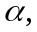 of the Dirichlet process mixture model can either be set to a small fixed value such as 1 or estimated from the mixture sample (option 9 in the control file) (see Pella and Masuda In press). The posterior distribution of can be generated during the MCMC sampling. Use histogram drawing software to display the posterior distribution of after discarding burn-in samples.

VI. Example Runs: Sashin Creek steelhead (Oncorhynchus mykiss) (Thrower et al. 2004)

Description
The stock-mixture analysis of 59 Sashin Creek anadromous adults with an incomplete baseline is described in Pella and Masuda (In press). Thrower et al. (2004) found variation in 10 microsatellite loci (2–24 alleles per locus) and genotyped 59 mature adults that returned to Sashin Creek in 1996 as well as 60 juvenile steelhead each from Sashin Lake and Round Lake. Baseline samples were only available from the upper watershed (Sashin and Round Lakes) and not the lower creek which was thought to comprise most of the mature adults returning to Sashin Creek. Here we analyze with HWLER the Round Lake baseline samples (analysis of the Sashin Lake samples is omitted from this manual) and the 59 samples of anadromous lower-river adults with a partial baseline: Round Lake and Sashin Lake. Note that for this example, we set the number of HWLER (2,5) samples to only 1,000. The analysis of the anadromous samples described in Pella and Masuda (In press) required 120,000 HWLER (2,5) draws or a total of 840,000 samples with a burn-in discard of 420,000 samples. The analysis of the Round Lake samples described in Pella and Masuda (In press) required 60,000 HWLER (2,5) draws or a total of 420,000 samples with a burn-in discard of 210,000 samples. We use this example to illustrate three different HWLER analyses: 1) evaluation of one baseline population, 2) mixture analysis with a partial baseline, and 3) mixture analysis with no baseline.

A. Evaluation of a baseline population
The files used in this example are as follows:

File | Type | Description
round.ctl | input | control file
round.bse | input | data file of baseline individuals
round.sum | output | summary file
round.bot | output | snapshots of numbers of individuals assigned to each cluster
round.cls | output | snapshots of baseline individuals assigned to each cluster
round.stk | output | file of MCMC samples of total numbers of clusters
round.txt | output | file of MCMC sample partitions for making a binary tree
round.alp | output | file of MCMC samples of the Dirichlet mass parameter

Step-by-step baseline analysis

- Set up input files
Create a file of baseline individuals and a control file.

2. Run HWLER
i. Execute HWLER.EXE.

ii. Load control file, ROUND.CTL (File/Load control file/Open). Overwrite ROUND.SUM (Yes).

iii. Run HWLER (Run). Overwrite ROUND.STK (Yes). Overwrite ROUND.TXT (Yes). Overwrite ROUND.CLS (Yes). Overwrite ROUND.BOT (Yes). Overwrite ROUND.ALP (Yes).

3. Run complete (OK). Click the secondary mouse button (usually the right button) on the on-screen trace plot of total number of clusters.

4. Trace plot of the total number of clusters
A trace of the total number of clusters (plot of numbers as a time series) can be used in determining convergence of samples and the number of initial samples to discard as burn-in.

From the pull-down menu, select Trace plots/# of clusters or extra-baseline stocks. Trace plots can be sent to the screen or to a postscript file. Select to Screen. Click the secondary mouse button (usually the right button) on the graph to exit the screen.

5. Summary of the posterior distribution of the total number of clusters
From the pull-down menu, select Stats/# of clusters or extra-baseline stocks. Enter length of chain or total number of MCMC samples in .STK file (7000) and the number of burn-in samples to discard (3500) (OK). HWLER reads the name of the .STK file from the control file.

6. Exit

7. Examine output files, ROUND.BOT and ROUND.CLS
Snapshots of the numbers of individuals from the baseline population that were assigned to each cluster are output to ROUND.BOT. Also, snapshots of baseline individuals that were assigned to each cluster are output to ROUND.CLS. Note that cluster labels (1 to the number of clusters) may not correspond to the same sets of individuals from one MCMC sample to the next (i.e. label switching likely occurs).

8. Examine output file, ROUND.SUM
Probabilities of the total number of clusters are output to this file. The posterior distribution for number of clusters in Round Lake peaked at 3 populations with probability equal to 0.771 and most of the mass occurring between 3 and 5 populations (see Pella and Masuda In press). See the binary tree plot. (Note also that the analysis described in Pella and Masuda [In press] required 60,000 HWLER (2,5) draws or a total of 420,000 samples with burn-in discard of 210,000 samples.)

9. Example plots: trace plot and histograms
Following are example plots produced from the output of HWLER: trace plot of total number of clusters (produced by S-Plus 2001), histogram of total number of clusters (210,000 samples after burn-in discard) (produced by S-Plus 2001), and histogram of the sampled Dirichlet mass parameter (30,000 samples after burn-in discard) (produced by S-Plus 2001). Plots were generated from the analysis described in Pella and Masuda (In press). HWLER (2,5) was run for a total of 420,000 samples, and convergence was determined after 210,000 samples. Convergence for the last 210,000 samples was determined from the trace plot of total number of clusters and agreement between binary trees created from the first and second halves of the last 210,000 partitions (105,000 samples each) (plots not shown).

10. Example plot: binary tree
Start PartitionView. Select the button Open Partition result file. Open ROUND.TXT. Enter the number of samples or partitions to discard as burn-in (3500). Select the Make Tree tab. Select the Make Tree button. Select OK and exit the program. PartitionView creates the tree file Tree.txt. View the binary tree with NJplot (Perrière and Gouy 1996) or TreeView (Page 1996). Start NJplot, select File/Open from the pull-down menus and open Tree.txt to view the binary tree. (Note that the binary tree plot included in this manual was generated from the analysis described in Pella and Masuda (In press). HWLER (2,5) was run for a total of 420,000 samples, and convergence was determined after 210,000 samples.)

Trace plot of total number of clusters
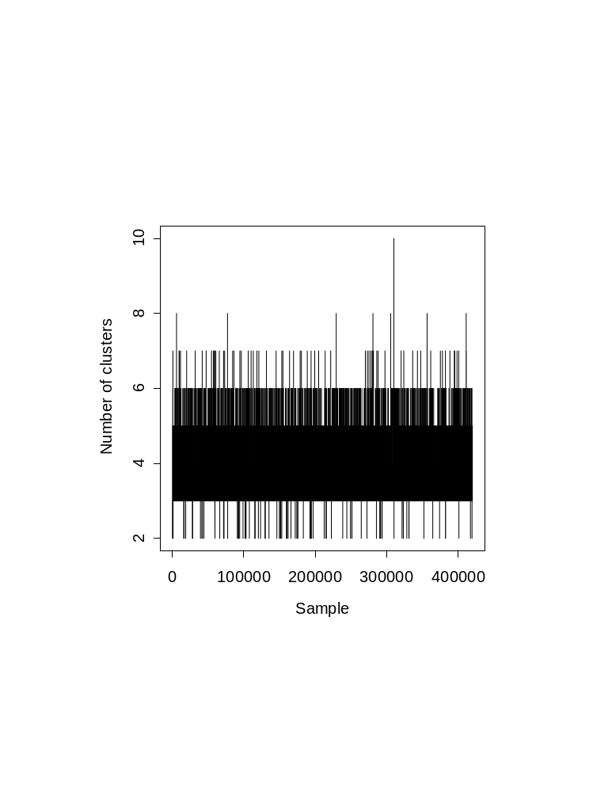
Histogram of total number of clusters
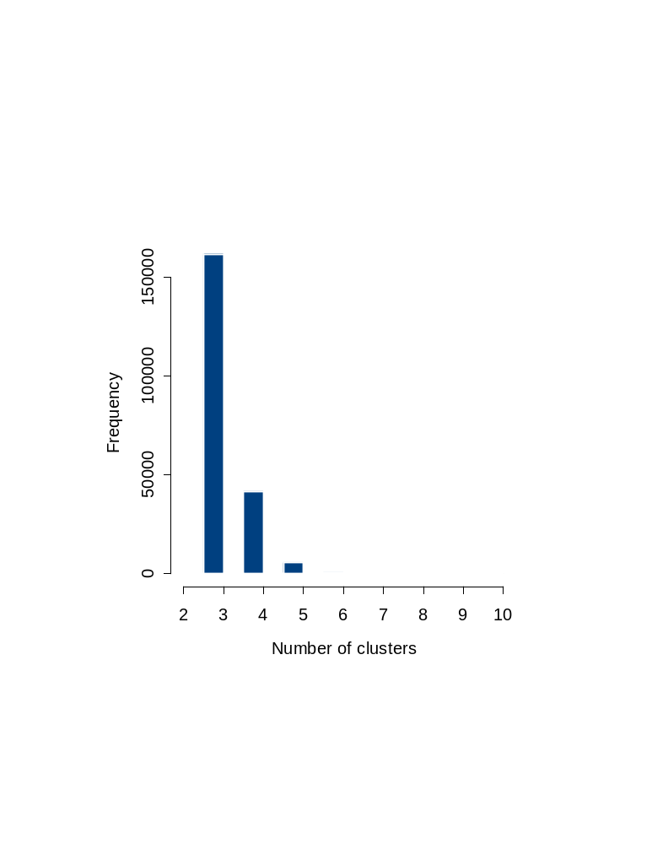
Histogram of the sampled Dirichlet mass parameter
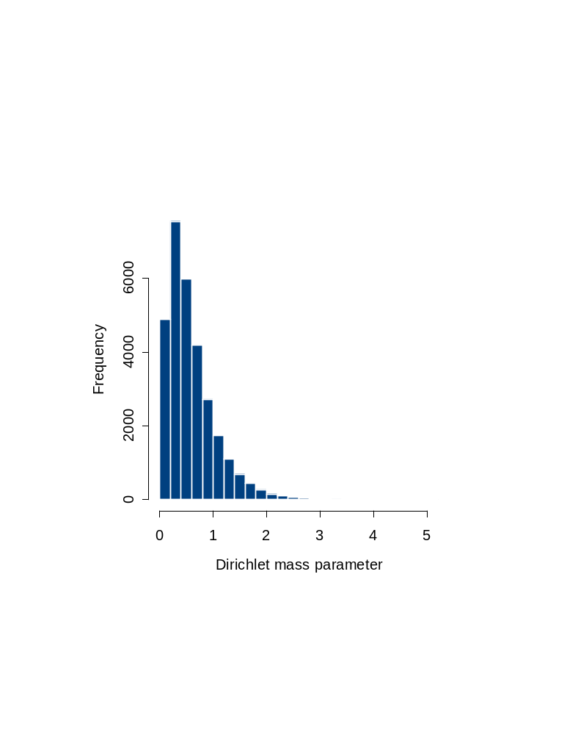
Binary Tree of Baseline Individuals
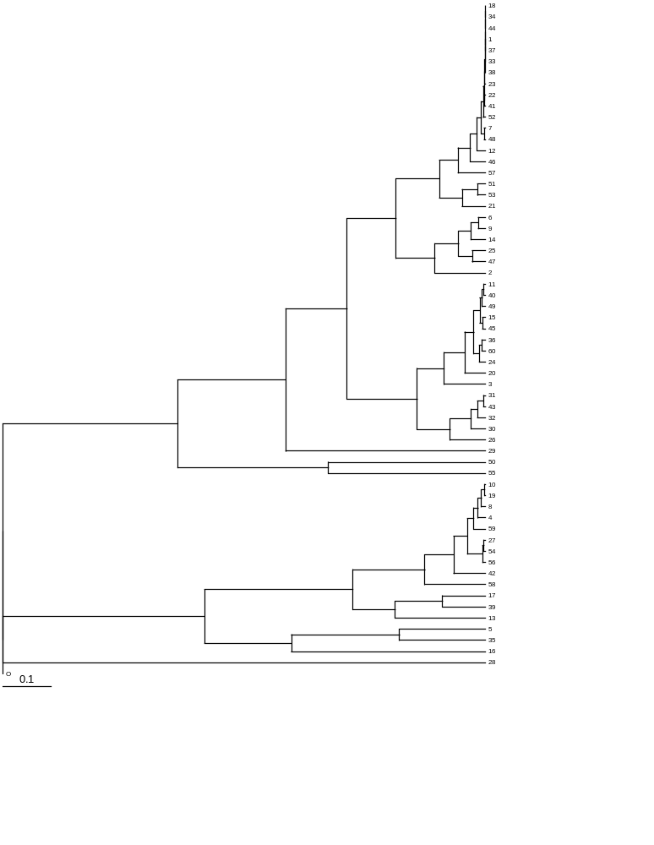

B. Stock-mixture analysis with a partial baseline
The files used in this example are as follows:

File | Type | Description
basemix.ctl | input | control file
anad.mix | input | data file of partial baseline and mixture individuals
basemix.sum | output | summary file
basemix.bot | output | file of MCMC samples of population proportions
basemix.cls | output | file of MCMC samples of population assignments of mixture individuals
basemix.stk | output | file of MCMC samples of number of extra-baseline populations
basemix.txt | output | file of MCMC sample partitions for making a binary tree of mixture individuals only
basemix.alp | output | file of MCMC samples of the Dirichlet mass parameter

Step-by-step stock-mixture analysis

1. Set up the input files
Create one file of baseline and mixture individuals and a control file.

2. Run HWLER
a. Execute HWLER.EXE.

b. Load control file, BASEMIX.CTL (File/Load control file/Open). Overwrite BASEMIX.SUM (Yes).

c. Run HWLER (Run). Overwrite BASEMIX.STK (Yes). Overwrite BASEMIX.TXT (Yes). Overwrite BASEMIX.CLS (Yes). Overwrite BASEMIX.BOT (Yes). Overwrite BASEMIX.ALP (Yes).

3. Run complete (OK). Click the secondary mouse button (usually the right button) on the on-screen trace plot of number of extra-baseline populations.

4. Trace plot of the population proportions
A trace of population proportions (plots of proportions as a time series) can be used in determining convergence of samples and the number of initial samples to discard as burn-in.

From the pull-down menu, select Trace plots/Mixture analysis with baseline/Stock composition. Trace plots can be sent to the screen or to a postscript file. Select to Screen. Enter length of chain or total number of MCMC samples (7000) and the number of samples to trace (7000) (OK). Click the secondary mouse button (usually the right button) on the graph to exit the screen.

5. Trace plot of the number of extra-baseline populations
A trace of number of extra-baseline populations (plot of numbers as a time series) can be used in determining convergence of samples and the number of initial samples to discard as burn-in.

From the pull-down menu, select Trace plots/# of clusters or extra-baseline stocks. Trace plots can be sent to the screen or to a postscript file. Select to Screen. Click the secondary mouse button (usually the right button) on the graph to exit the screen.

- Summary statistics of the population proportions
From the pull-down menu, select Stats/Mixture analysis with baseline/Stock composition. Enter length of chain or total number of MCMC samples (7000) and the number of burn-in samples to discard (3500) (OK). HWLER reads the name of the .BOT file from the control file. (Note that the analysis described in Pella and Masuda [In press] required 120,000 HWLER (2,5) draws or a total of 840,000 samples thinned by 4 with burn-in discard of 105,000 samples.)

7. Summary statistics of the individual assignments
From the pull-down menu, select Stats/Mixture analysis with baseline/Individual stock assignments. Enter length of chain or total number of MCMC samples (100) and the number of burn-in samples to discard (50) (OK). HWLER reads the name of the .CLS file from the control file. (Note that the analysis described in Pella and Masuda [In press] required 120,000 HWLER (2,5) draws or a total of 840,000 samples thinned by 4 with burn-in discard of 105,000 samples.)

8. Summary of the posterior distribution of the number of extra-baseline populations
From the pull-down menu, select Stats/# of clusters or extra-baseline stocks. Enter length of chain or total number of MCMC samples in .STK file (7000) and the number of burn-in samples to discard (3500) (OK). HWLER reads the name of the .STK file from the control file. (Note that the analysis described in Pella and Masuda [In press] required 120,000 HWLER (2,5) draws or a total of 840,000 samples with burn-in discard of 420,000 samples.)

9. Exit

10. Examine summary file, BASEMIX.SUM
Summary statistics of the MCMC samples of population proportions, after burn-in discard, are output to this file. Also, the proportion of times, after burn-in discard, each mixture individual was assigned to a population or to an extra-baseline population is printed to the summary file. Individuals assigned to any extra-baseline populations are pooled in the summary into one cluster. Probabilities of the number of extra-baseline populations are output to this file. The posterior distribution of the number of extra-baseline populations for the anadromous steelhead ranged from 2 to 5 or more with a maximum at 4 equal to 0.50 (see Pella and Masuda In press). (Note that the analysis described in Pella and Masuda [In press] required 120,000 HWLER (2,5) draws or a total of 840,000 samples with burn-in discard of 420,000 samples.)

11. Example plots: trace plots and histograms
Following are example plots produced by HWLER or from the output of HWLER: trace plots of population proportions, trace plot of number of extra-baseline populations (produced by S-Plus 2001), histogram of the number of extra-baseline populations (420,000 samples after burn-in discard) (produced by S-Plus 2001), and histogram of the sampled Dirichlet mass parameter (60,000 samples after burn-in discard) (produced by S-Plus 2001). Plots were generated from the analysis described in Pella and Masuda (In press). One hundred and twenty thousand HWLER (2,5) samples were run for a total of 840,000 samples, and convergence was determined for the second one-half of samples. Convergence for the second one-half of samples was determined from trace plots of population proportions, the trace plot of number of extra-baseline populations, and agreement between binary trees created from the first and second halves of the last 105,000 partitions (52,500 samples each) after burn-in discard (plots not shown).

Trace Plots of population proportions

Trace plot of number of extra-baseline populations
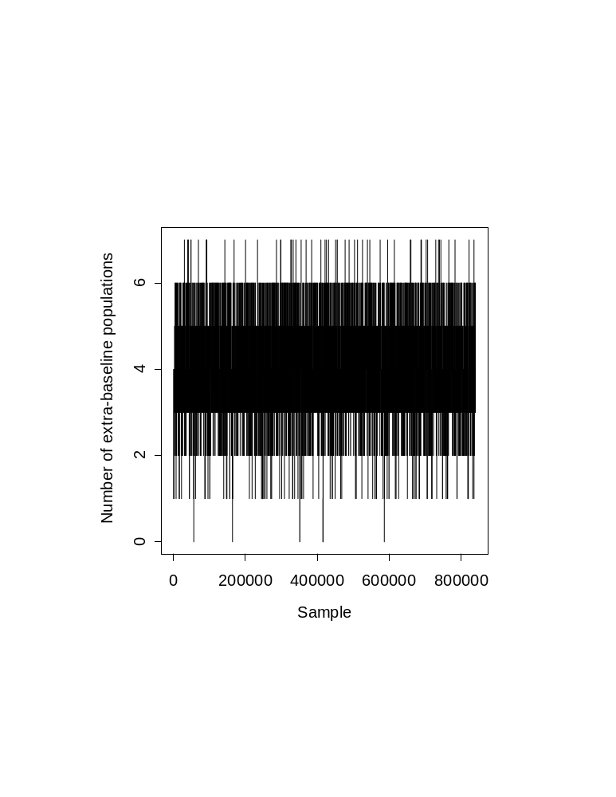
Histogram of number of extra-baseline populations
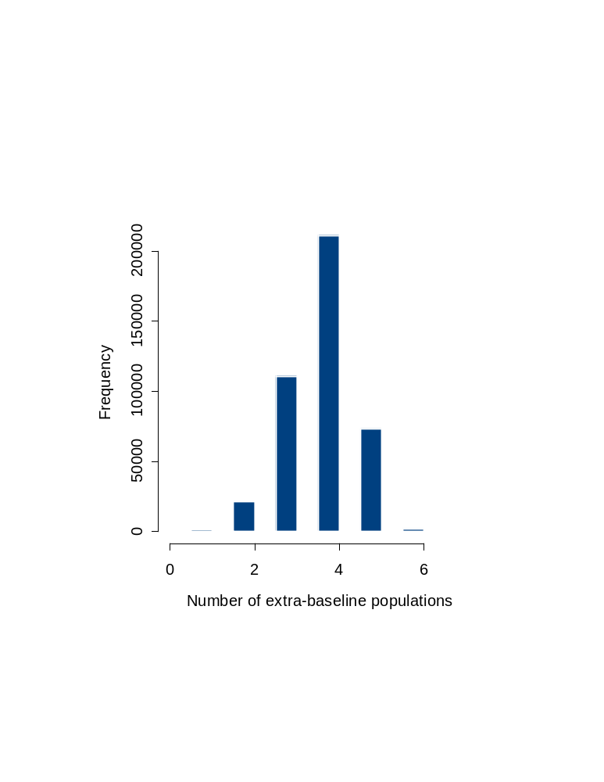
Histogram of the sampled Dirichlet mass parameter
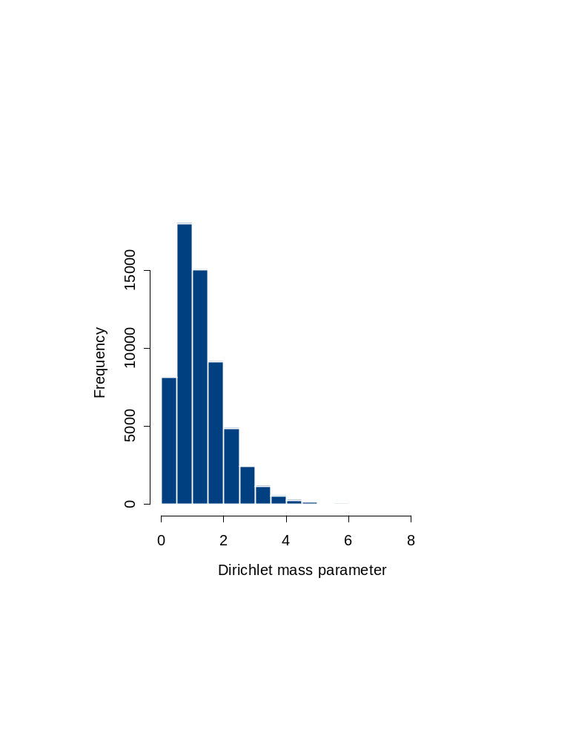

C. Stock-mixture analysis with no baseline
The files used in this example are as follows:

File | Type | Description
mixonly.ctl | input | control file
anad.in | input | data file of mixture individuals
mixonly.bot | output | snapshots of numbers of mixture individuals assigned to each cluster
mixonly.sum | output | summary file
mixonly.stk | output | file of MCMC samples of total number of clusters
mixonly.txt | output | file of MCMC sample partitions for making a binary tree
mixonly.alp | output | file of MCMC samples of the Dirichlet mass parameter

Step-by-step stock-mixture analysis with no baseline

- Set up input files
Create a file of mixture individuals and a control file.

2. Run HWLER
i. Execute HWLER.EXE.

ii. Load control file, MIXONLY.CTL (File/Load control file/Open). Overwrite MIXONLY.SUM (Yes).

iii. Run HWLER (Run). Overwrite MIXONLY.STK (Yes). Overwrite MIXONLY.TXT (Yes). Overwrite MIXONLY.BOT (Yes). Overwrite MIXONLY.ALP (Yes).

3. Run complete (OK). Click the secondary mouse button (usually the right button) on the trace plot of number of clusters on the screen.

4. Trace plot of the total number of clusters
A trace of the total number of clusters (plot of numbers as a time series) can be used in determining convergence of samples and the number of initial samples to discard as burn-in.

From the pull-down menu, select Trace plots/# of clusters or extra-baseline stocks. Trace plots can be sent to the screen or to a postscript file. Select to Screen. HWLER reads the name of the .STK file from the control file. Click the secondary mouse button (usually the right button) on the graph to exit the screen.

5. Summary of the posterior distribution of the total numbers of clusters
From the pull-down menu, select Stats/# of clusters or extra-baseline stocks. Enter length of chain or total number of MCMC samples in .STK file (7000) and the number of burn-in samples to discard (3500) (OK). HWLER reads the name of the .STK file from the control file.

6. Exit

7. Examine output file, MIXONLY.BOT
Snapshots of the numbers of mixture individuals that were assigned to each cluster are output to MIXONLY.BOT. Note that cluster labels (1 to the number of clusters) may not correspond to the same sets of individuals from one MCMC sample to the next (i.e. label switching likely occurs).

8. Examine summary file, MIXONLY.SUM
Probabilities of the total number of clusters are output to this file. The posterior distribution of the total number of clusters for the adults ranged from 3 and above with most of the mass occurring between 5 and 6 populations and the maximum occurring at 5 equal to 0.54. (Note that the analysis required 120,000 HWLER (2,5) draws or a total of 840,000 samples with burn-in discard of 560,000 samples.)

9. Example plots: trace plot and histograms
Following are example plots produced from the output of HWLER: trace plot of total number of clusters (produced by S-Plus 2001), histogram of total number of clusters (280,000 samples after burn-in discard) (produced by S-Plus 2001), and histogram of the sampled Dirichlet mass parameter (60,000 samples after burn-in discard) (produced by S-Plus 2001). HWLER (2,5) was run for a total of 840,000 samples, and convergence was determined after 560,000 samples. Convergence for the last 280,000 samples was determined from the trace plot of total number of clusters and agreement between binary trees created from the first and second halves of the last 70,000 partitions (35,000 samples each) (plots not shown).

10. Example plot: binary tree
Start PartionView. Select the button Open Partition result file. Open MIXONLY.TXT. Enter the number of samples or partitions to discard as burn-in (3500). Select the Make Tree tab. Select the Make Tree button. Select OK and exit the program. PartionView creates the tree file Tree.txt. View the binary tree with NJplot (Perrière and Gouy 1996) or TreeView (Page 1996). Start NJplot, select File/Open from the pull-down menus and open Tree.txt to view the binary tree. (Note that the binary tree plot included in this manual was generated from the last 70,000 partitions.)

Trace plot of total number of clusters
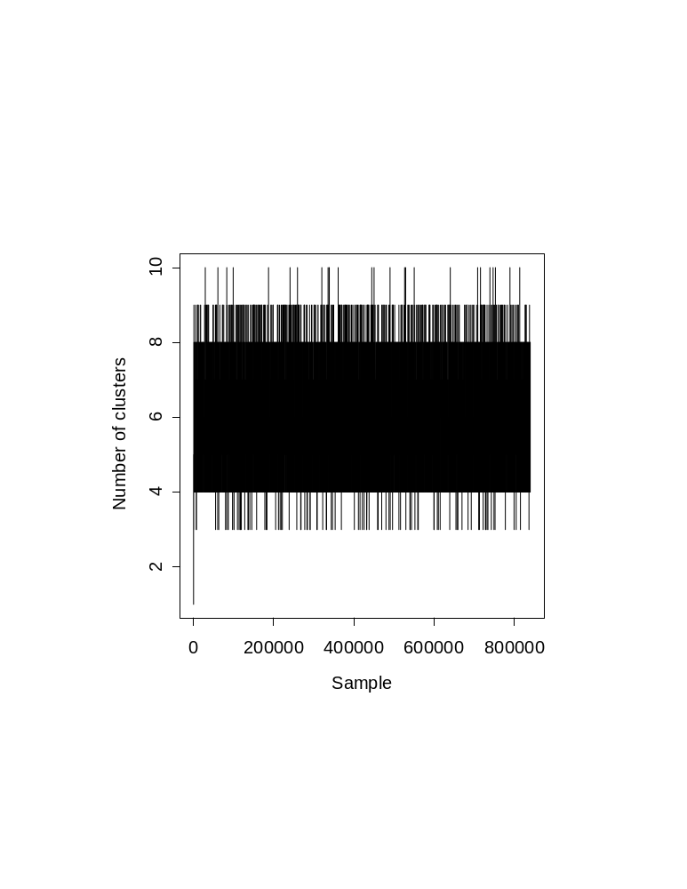
Histogram of total number of clusters
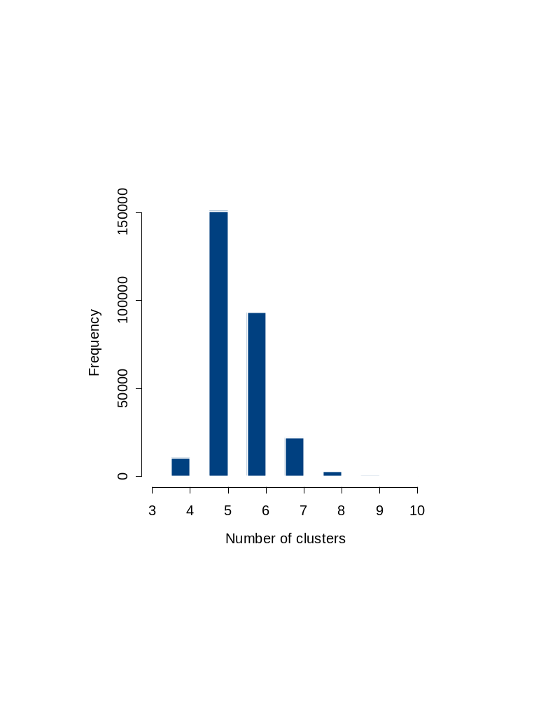
Histogram of the sampled Dirichlet mass parameter
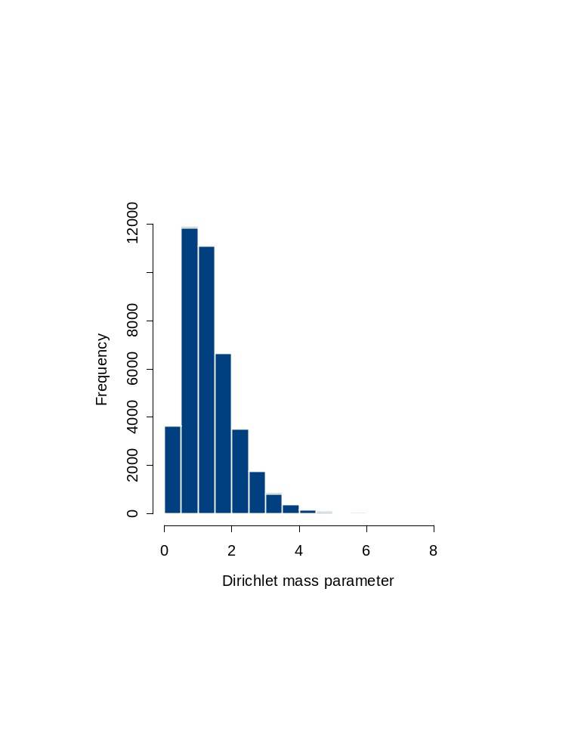
Binary Tree of Mixture Individuals
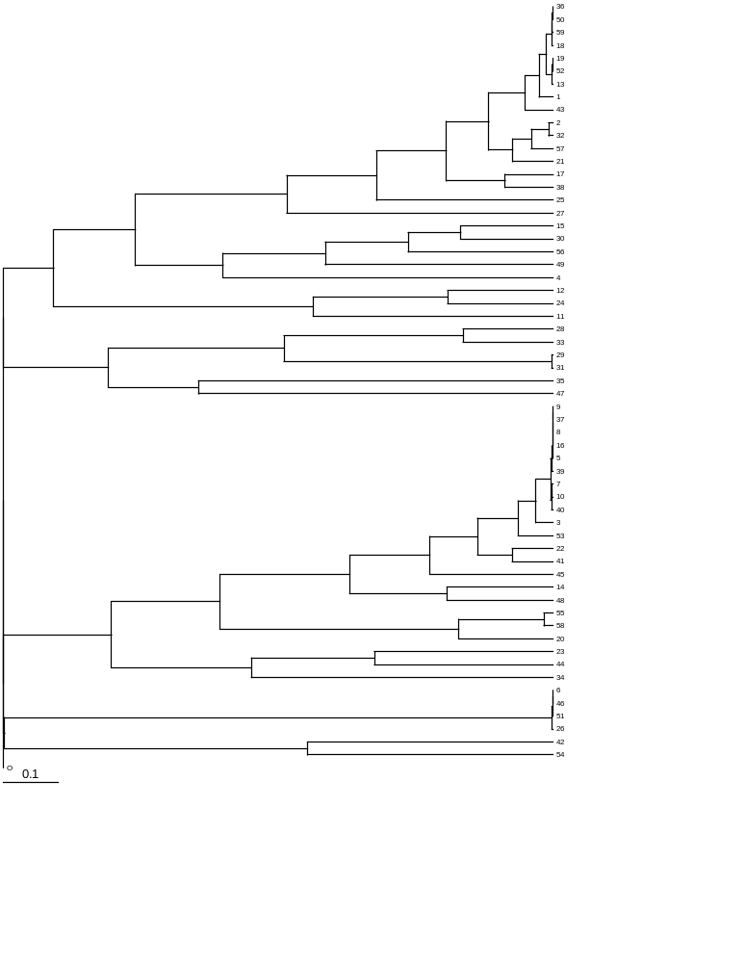

VII. References
Brown, B. W., and J. Lovato. 1993. RANLIB. Library of Fortran routines for random number generation. Department of Biomathematics, Box 237, University of Texas, M.D. Anderson Cancer Center, 1515 Holcombe Blvd., Houston, TX 77030.

Chandler, R., and P. Northrop. 1999. Randgen.f. Collection of Fortran functions and subroutines to produce pseudo-random numbers from a variety of distributions. Department of Statistical Science, University of College London, Gower Street, London WC1E 6BT.

Dawson, K. J., and K. Belkhir. 2001. A Bayesian approach to the identification of panmictic populations and the assignment of individuals. Genetical Research 78:59–77.

Debevec, E. M., R. B. Gates, M. Masuda, J. Pella, and L. W. Seeb. 2000. SPAM (Version 3.2): Statistics Program for Analyzing Mixtures. J. Hered. 91:509–510.

Lahey Computer Systems, Inc. 1998. Lahey Fortran 95 language reference. Lahey Computer Systems, Inc., 299 p.

Michels, H. 2005. DISLIN version 8.3. A data plotting library. Max-Planck-Institut für Sonnensystemforschung, Katlenburg-Lindau, Germany, E-mail michels@linmpi.mpg.de.

Page, R. D. M. 1996. TREEVIEW: An application to display phylogenetic trees on personal computers. Computer Applications in the Biosciences 12:357–358.

Pella, J., and M. Masuda. 2001. Bayesian methods for analysis of stock mixtures from genetic characters. Fishery Bulletin. 99:151–167.

Pella, J., and M. Masuda. In press. The Gibbs and split-merge sampler for population mixture analysis from genetic data with incomplete baselines. Can. J. Fish. Aquat. Sci.

Perrière, G., and M. Gouy. 1996. WWW-Query: An on-line retrieval system for biological sequence banks. Biochimie 78:364–369.

Press, W. H., S. A. Teukolsky, W. T. Vetterling, and B. P. Flannery. 2002. Numerical Recipes in Fortran 90: the art of parallel scientific computing. Cambridge Univ. Press. New York. 1486 p.

S-Plus. 2001. S-Plus 6 for Windows. User’s Guide. Insightful Corporation, Seattle, Washington.

Thrower, F., C. Guthrie III, J. Nielsen, and J. Joyce. 2004. A comparison of genetic variation between an anadromous steelhead, Oncorhynchus mykiss, population and seven derived populations sequestered in freshwater for 70 years. Environmental Biology of Fishes 69:111–125.

PARTITION and PartitionView web site: http://www.univ-montp2.fr/~genetix/partition/partition.htm
Software PartitionView can be downloaded from the PARTITION web site: http://www.univ-montp2.fr/~genetix/partition/partition.htm.
PARTITION web site: http://www.univ-montp2.fr/~genetix/partition/partition.htm.
Software NJplot can be downloaded from http://pbil.univ-lyon1.fr/software/njplot.html.
Software TreeView can be downloaded from http://taxonomy.zoology.gla.ac.uk/rod/treeview.html.

