Norton Sound Red King Crab Stock Assessment in Spring 2009

Jie Zheng¹, Hamachan Hamazaki² and Joyce K. Soong³
Alaska Department of Fish and Game
Commercial Fisheries Division
¹P.O.Box 115526, Juneau, AK 99811-5526
Phone : 907-465-6102
Email : Jie.Zheng@alaska.gov
²333 Raspberry Rd., Anchorage, AK 99518-1565
Phone: 907-267-2158
Email: Hamachan.Hamazaki@alaska.gov
³P.O.Box 1148, Nome, AK 99762
Phone: 907-443-5167
Email: Joyce.Soong@alaska.gov

Executive Summary
Red king crab, Paralithodes camtschaticus, in Norton Sound, Alaska, support three main fisheries: summer commercial, winter commercial, and winter subsistence fisheries. Four types of surveys have been conducted periodically during the last three decades: summer trawl, summer pot, winter pot, and preseason summer pot, but none of these surveys were conducted every year. To improve abundance estimates, Zheng et al. (1998) developed a length-based stock synthesis model of male crab abundance that combines multiple sources of survey, catch, and mark-recovery data from 1976 to 1996. A maximum likelihood approach was used to estimate abundance, recruitment, and catchabilities of the commercial pot gear. We updated the model with the data from 1976 to 2009 and estimated population abundance in 2009. Estimated abundance and biomass in 2009 are:
Legal males: 1.3421 million crabs with a standard deviation of 0.1609 million crabs.
Mature male biomass: 4.6922 million lbs with a standard deviation of 0.5791 million lbs.
Average of mature male biomasses during 1983-2009 was used as the B_{MSY} proxy and due to uncertainty of abundance estimates, γ=0.6 was used to derive the F_{MSY} proxy from a plausible M of 0.3. Estimated B_{MSY} proxy, F_{MSY} proxy and retained catch limit in 2009 are:
B_{MSY} proxy = 3.363 million lbs,
F_{MSY} proxy = 0.18,
Retained catch limit: 0.2211 million crabs.

Summary of Major Changes in 2009
- The model was updated with new data from the 2008 fall trawl survey, 2008 winter pot survey, and 2008 summer commercial fishery.
- Natural mortality was changed from the default 0.18 for king crabs to 0.30, and all length groups were assumed to have the same natural mortality.
- Survey CVs were used to compute likelihood values.
- F_{35%} and F_{40%} were estimated.
- Impacts of M estimates on abundance estimates and harvest rate determination were evaluated.

Response to CPT Comments (from May 2008)

“The team requests that additional information be included in future assessment reports on asymptotic standard errors and selectivity parameters (to indicate which are fixed not estimated). The team discussed the rationale for using the M value of 0.18 and its basis on laboratory studies. Some team members did not agree with this estimate usage for this stock noting that model information could be used to inform the best estimate. The team recommends that alternative M values be examined in the next assessment. The team recommends exploration of a broader range of models and sensitivity analyses for this stock for the May 2009 assessment. The team further recommends the authors include a clear explanation of the gamma value chosen for future models. The assessment authors should also provide a more complete rationale for choice of range of years.”

First, the previous reports as well as this report all showed which parameters are estimated and which are fixed. Second, the standard deviations of estimated parameters are now listed in this report (Table 5). Third, M=0.18 was not used in this report, and alternative M values were examined and M=0.3 was chosen as a baseline M value. Fourth, gamma = 0.6 is suggested in this report based on historical harvest rates. Finally, the rationale for choice of range of years is explained in this report.

Response to SSC Comments specific to this assessment (from October 2008)

- “The analyst should examine the implications of dropping the preseason survey from the model.”

The one-year pre-season survey has been dropped from this report. Since this is one year of data only, it does not affect the results.

- “The analysts should examine the tradeoffs between the assumption of higher M for the last length class and lower selectivity for the last length class after 1992. In addition the model should provide a rationale for changing selectivities in 1993.”

The higher M for the last length class was not assumed for this report. The change in selectivities after 1992 was based on a change in fleet structure, which was explained in the report.

- “The analyst should conduct a sensitivity analysis on the weights applied to the different data sources. A rationale for the values used to account for the aggregation effect should be provided. It is not clear why the weights were appropriate corrections for aggregation effects.”

CVs were used to weight the survey data in this report. It is difficult to find the right weight for aggregation effects. These weights, which function like an effective sample size, were determined primarily by the quality of data, as assessed by the authors.

- “It would be useful if reference points F_{MSY} proxy and B_{MSY} proxy were included on a phase plot of fishing mortality and mature male biomass.”

This was done in this report.

- “The SSC encourages continued exploration of likelihood profiles on the natural mortality rate including runs with fixed natural mortality for all length classes.”

A study on the impacts of natural mortality on stock assessments and harvest strategies was conducted and the results are included in this report.

- “The SSC requests a justification of the assumption of zero handling mortality for this stock.”

This is a data-limited issue. When the bycatch data becomes available, it will be used in the stock assessment. With small fishing vessels and a small economic value of the fishery, it may be difficult to have observers on board to collect bycatch data.

Several studies have been conducted to assess red king crab bycatch mortality. So far factors that cause high handling mortality rates are primarily cold or freezeing temperatures. The Norton Sound red king crab fishery occurs primarily during summer or early fall, and cold or freezeing temperatures do not occur during the main fishing periods.

Introduction
Norton Sound Red King Crab (Paralithodes camtschaticus) form one of the northernmost red king crab populations that can support a commercial fishery (Powell et al. 1983). It is distributed throughout Norton Sound with a westward limit of 167-168º W. longitude with depths less than 30 m and summer bottom temperatures above 4 ºC. One of the unique life-history traits of Norton Sound red king crab is that they spend their entire lives in shallow water since Norton Sound is generally less than 40 m in depth. Distribution and migration patterns of Norton Sound red king crab have not been well studied. Based on the 1976-2006 trawl surveys, red king crab in Norton Sound are found in areas with a mean depth range of 19 ± 6 (SD) m and bottom temperatures of 7.4 ± 2.5 (SD) ºC during summer. The same surveys show that they are consistently abundant offshore of Nome. Red king crab generally show a migration pattern between deeper offshore waters during molting/feeding and inshore shallow waters during the mating period. Timing of the inshore mating migration is unknown. Scant data exists about mating location in the nearshore area. They are assumed to mate during March-June. Offshore migration is considered to begin in May-July. Trawl surveys during 1976-2006 show that crab distribution is dynamic. While crabs have always been abundant near shore in front of Nome, more recent surveys show high abundance on the southeast side of the Sound, offshore of Stebbins and Saint Michael. However, it is unknown whether this is due to a migratory shift because of oceanographic change or due to changes in stock composition. Thus far, no studies have been made on possible stock separation within the putative stock known as Norton Sound red king crab.

The Norton Sound red king crab management area consists of two units: Norton Sound Section (Q3) and Kotzebue Section (Q4) (Soong et al. 2008). The Norton Sound Section (Q3) consists of all waters in Registration Area Q north of the latitude of Cape Romanzof, east of the International Dateline, and south of 66°N latitude (Figure 1). The Kotzebue Section (Q4) lies immediately north of the Norton Sound Section and includes Kotzebue Sound. Commercial fisheries have not occurred regularly in the Kotzebue Section. Our report deals with the Norton Sound Section of the Norton Sound red king crab management area.

Fisheries
Norton Sound red king crab fisheries consist of commercial and subsistence fisheries. The commercial red king crab fishery started in 1977 and occurs in summer (July – August) and in winter (December – March) (Banducci et al. 2007).

Summer Commercial Fishery
A large-vessel summer commercial crab fishery existed in the Norton Sound Section from 1977 through 1990. No summer commercial fishery occurred in 1991 because there was no staff to manage the fishery. In 1992, the summer commercial fishery resumed. In March 1993, the Alaska Board of Fisheries (BOF) limited participation in the fishery to small boats. Then on June 27, 1994, a super-exclusive designation went into effect for the fishery. This designation stated that a vessel registered for the Norton Sound crab fishery may not be used to take king crabs in any other registration areas during that registration year. A vessel moratorium was put into place before the 1996 season. This was intended to precede a license limitation program. In 1998, Community Development Quota (CDQ) groups were allocated a portion of the summer harvest; however, no CDQ harvest occurred until the 2000 season. On January 1, 2000 the North Pacific License Limitation Program (LLP) went into effect for the Norton Sound crab fishery. The program dictates that a vessel which exceeds 32 feet in length overall must hold a valid crab license issued under the LLP by the National Marine Fisheries Service. Regulation changes and location of buyers resulted in harvest distribution moving eastward in Norton Sound in the mid 1990s. Commercial fisheries history and catch data are summarized in Table 1.

CDQ Fishery
The Norton Sound and Lower Yukon CDQ groups divide the CDQ allocation. Only fishers designated by the Norton Sound and Lower Yukon CDQ groups are allowed to participate in this portion of the king crab fishery. Fishers are required to have a CDQ fishing permit from the Commercial Fisheries Entry Commission (CFEC) and register their vessel with the Alaska Department of Fish and Game (ADF&G) before they make their first delivery. Fishers operate under authority of the CDQ group and each CDQ group decides how their crab quota is to be harvested. During the March 2002 BOF meeting, new regulations were adopted that affected the CDQ crab fishery and relaxed closed-water boundaries in eastern Norton Sound and waters west of Sledge Island. At its March 2008 meeting, the BOF changed the start date of the Norton Sound open-access portion of the fishery to be opened by emergency order and as early as June 15. The CDQ fishery may open at any time, by emergency order.

Winter Commercial Fishery
The Norton Sound winter commercial fishery is a small fishery involving approximately 10 fishers harvesting 2,400 crabs on average annually during 1978-2007 (Soong 2007).

Subsistence Fishery
The Norton Sound subsistence crab fishery mainly occurs during winter using hand lines and pots through the nearshore ice. Average annual subsistence harvest is 5,300 crabs (1978-2007). Subsistence fishers need to obtain a permit before fishing and record their daily effort and catch. The subsistence fishery catch is influenced not only by crab abundance, but also by changes in distribution, changes in gear (e.g., more use of pots instead of hand lines since 1980s), and ice conditions (e.g., reduced catch due to unstable ice conditions: 1987-88, 1988-89, 1992-93, 2000-01, 2003-04, 2004-05, and 2006-07).

Harvest Strategy
Norton Sound red king crab have been conservatively managed since 1997 through varying harvest rates from 5% to 10% of estimated legal male abundance. The GHL for the summer fishery is set in three levels: (1) estimated legal biomass < 1.5 million lbs: legal harvest rate = 0%; (2) estimated legal biomass ranges from 1.5 to 2.5 million lbs: legal harvest rate ≤ 5%; and (3) estimated legal biomass >2.5 million lbs: legal harvest rate ≤ 10%.

Data
Available survey, catch, and tagging data are summarized in Table 2. The National Marine Fisheries Service (NMFS) conducted trawl surveys every 3 years from 1976 to 1991 (Stevens and MacIntosh 1986), and ADF&G conducted five trawl surveys during 1996-2008 (Soong 2008). Total population abundances and length and shell compositions for males >73 mm CL were estimated by "area-swept" methods from the trawl survey data (Alverson and Pereyra 1969). The compositions consisted of six 10-mm length groups. If multiple hauls were conducted for a single station (10X10 nmi) during a survey, then the average of abundances from all hauls within the station was used. Some trawl surveys occurred during September, the molting period for males. To make survey abundances comparable with premolt abundances, we adjusted trawl survey abundances by subtracting the average growth increment of each length class (Table 3) from the length of each soft-shell crab (assumed to have molted within the past 2 months).
Four summer pot surveys were conducted by ADF&G (Table 2), and total male crab abundances were estimated using Petersen mark-and-recapture methods (Brannian 1987). ADF&G also conducted 25 winter pot surveys during 1980-2009 and one preseason pot survey in the summer of 1995 (Table 2); total crab abundances were not estimated for these pot surveys because of unreliable catch per unit effort (CPUE) data due to changing in environmental conditions over time and a lack of tagging data. For all pot surveys, length and shell condition compositions were estimated.
Red king crab catches from the summer fishery were sampled by ADF&G from 1976 to 2008 to determine length and shell condition. Bycatch of sublegal males (observer data) from the summer fishery in 1987-90, 1992, and 1994 were also sampled by observers to determine length and shell condition. Total catch from all fisheries and effort (potlifts) from the summer fishery were obtained from the ADF&G office in Nome. Red king crabs were tagged and released during 1980-1991 (Powell et al. 1983; Brannian 1987); 222 tagged male crabs were recovered after spending at least one molting season at liberty. These tagging data were used to estimate a growth matrix and molting probabilities by premolt length.

Analytic Approach
Main Assumptions for the Model
A list of main assumptions for the model:
- Natural mortality is constant over time and was estimated with a maximum age of 15 and the 1% rule (Zheng 2005).
- Survey selectivities are a function of length and are constant over time and shell condition. Fisheries selectivities are constant over time except summer fishery selectivities that have two selectivity curves, one before 1993 and another after 1992 because of changes in fishing vessel compositions and pot limits.
- Growth is a function of length and does not change over time.
- Molting probabilities are an inverse logistic function of length for males.
- A summer fishing season for the directed fishery is short.
- Handling mortality is assumed to be zero, in part due to lack of data and also because the fishery occurs mainly during the summer and early fall when handling mortality rates are expected to be at a minimum.
- Annual retained catch is measured without error.
- Trawl survey catchability is set to 1.0 for mature males.
- Male crabs are mature at sizes ≥94 mm CL.
- Length compositions have a multinomial error structure and abundance has a log-normal error structure.

Model Structure
Zheng et al. (1998) developed a length-based model for Norton Sound red king crab. The model is based on a length structured model with model parameters estimated by the maximum likelihood method. The model estimates abundances of crabs with CL ≥74 mm and with 10-mm length intervals because few crabs with CL <74 mm were caught during surveys or fisheries and there were relatively small sample sizes for trawl and winter pot surveys. There are 6 length classes.
The model was made for newshell and oldshell male crabs separately, but assumed they have the same molting probability and natural mortality. Summer crab abundances are the survivors of crabs from the previous winter:
where N_{s,l,t} and O_{s,l,t} are summer abundances of newshell and oldshell crabs in length class l in year t, N_{w,l,t} and O_{w,l,t} are winter abundances of newshell and oldshell crabs in length class l in year t, C_{w,t} and C_{p,t} are total winter and subsistence catches in year t, P_{w,n,l,t} and P_{p,n,l,t} are length compositions of winter and subsistence catches for newshell crabs in length class l in year t, P_{w,o,l,t} and P_{p,o,l,t} are length compositions of winter and subsistence catches for oldshell crabs in length class l in year t, and M_{l} is instantaneous natural mortality in length class l. For simplicity, we assumed constant (M) for all sizes and shell conditions. The time from Feb. 1 to July 1 is 5 months, or 0.417 year.
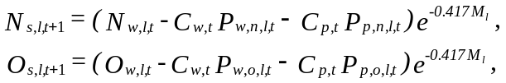 (1)
Winter abundance of newshell crabs is the combined result of growth, molting probability, mortality, and recruitment from the summer population:
(2)
where G_{l’, l} is a growth matrix representing the expected proportion of crabs molting from length class l’ to length class l, C_{s,t} are total summer catch in year t, P_{s,n,l,t} and P_{s,o,l,t} are length compositions of summer catch for newshell and oldshell crabs in length class l in year t, m_{l} is molting probability in length class l, y_{t} is the time in year from July 1 to the mid-point of the summer fishery, and R_{l,t} is recruitment into length class l in year t. The time from July 1 to Feb. 1 is 7 months, or 0.583 year. Winter abundance of oldshell crabs is the non-molting portion of survivors of crabs from summer:
(3)
Males >123 mm CL were grouped together to form the last length class. Sublegal males (<104 mm CL) are not legally retained in the commercial catch but are sorted, discarded, and subject to handling mortality. Due to complexity and lack of data, we did not model handling mortality. Following Balsiger's (1974) findings, we used a reverse logistic function to fit molting probabilities as a function of length and time:

where α and β are parameters, and i is the mean length of length class l. The sample size for the mark-recapture data is too small to estimate annual molting probabilities.
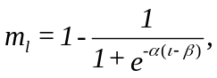 (4)
We modeled recruitment, R_{t}, as a stochastic process about the mean, R₀:
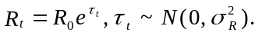 (5)
R_{t} was assumed only to enter length classes 1 and 2; thus, R_{l,t} = 0 when l ≥ 3. The recruits belonging to the first two length classes are:
where r is a parameter with a value less than or equal to 1.
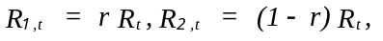 (6)
Estimated length/shell compositions of winter commercial catch were derived from the winter population, winter selectivity for pots, and proportion of legal crabs for each length class:
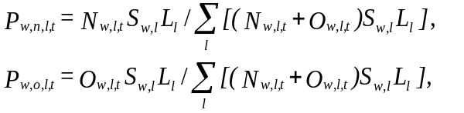 (7)
where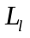is proportion of legal crabs for length class l, estimated from the observer data, and S_{w,l} is winter selectivity for pots for length class l. Based on winter pot survey data, winter selectivities for length classes 3-5 were assumed to be one, and S_{w,1,} S_{w,2} and S_{w,6} were estimated as parameters.
The subsistence fishery does not have a size limit, but crabs with size smaller than length class 3 are generally not retained. So, we estimated length compositions of subsistence catch as follow when l > 2:
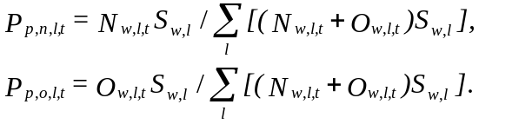 (8)
Estimated length compositions of winter pot survey for newshell and oldshell crabs, P_{sw,n,l,t} and P_{sw,o,l,t}, were also based on equation (7) except that l ≥ 1.
Estimated length/shell condition compositions of the summer commercial catch were based on summer population, selectivity, and legal abundance:
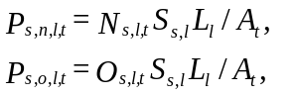 (9)
where S_{s,l} is pot selectivity for the summer commercial fishery, and A_{t} is exploitable legal abundance in year t. S_{s,l} was described by a logistic function with parameters φ and ω:
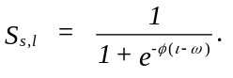 (10)
S_{s,l} was scaled such that S_{s,5} = 1 and S_{s,6} ≤ 1. Two sets of parameters (φ₁, ω₁) and (φ₂, ω₂) were estimated for selectivities before 1993 and after 1992 to reflect the vessel changes and pot limits. To correct the bias of the residuals, S_{s,6} was set to 0.6*S_{s,5} for the period after 1992. Exploitable abundance was estimated as:
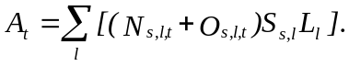 (11)
Summer fishing effort (f_{t}) measured as the number of pot-lifts was estimated as total summer catch, C_{t}, divided by the product of catchability q and mean exploitable abundance:
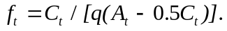 (12)
Because of the change in the fishing fleet and pot limit in 1993, q was replaced by q₁ for fishing efforts before 1993 and by q₂ after 1992. Estimated length/shell compositions of bycatch were:
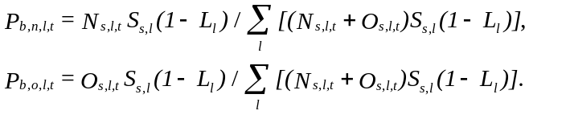 (13)
The same selectivity for the summer commercial fishery was applied to the summer pre-season survey, resulting in estimated length compositions for both newshell and oldshell crabs as:
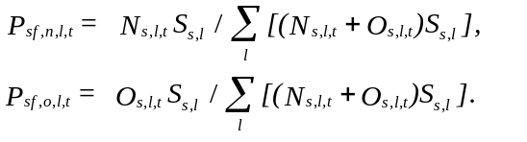 (14)
Estimated length/shell condition compositions of summer pot survey abundance were:
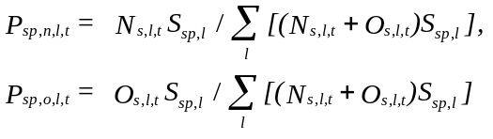 (15)
where S_{sp,l} = 1 when l ≥ 3, and S_{sp,1} and S_{sp,2} were estimated as two parameters. Similarly, length/shell condition compositions of summer trawl survey abundance were estimated with selectivity S_{st,l} = 1 when l ≥ 3, and S_{st,1} and S_{st,2} were two parameters. Because some trawl surveys occurred during the molting period, we combined the length compositions of newshell and oldshell crabs as one single shell condition, P_{st,l,t}.

Parameters Estimated Independently
The following parameters were estimated independently: natural mortality (M =0.3), proportions of legal males by length group, and the growth matrix. Natural mortality is based on an assumed maximum age of about 15 and the 1% rule (Zheng 2005). Tagging data were used to estimate mean growth increment per molt, standard deviation for each pre-molt length class, and the growth matrix (Table 3). Proportions of legal males by length group were estimated from the observer data (Table 4).
Natural mortalities used for defining U.S. federal overfishing limits for eastern Bering Sea crab stocks are based on an assumed maximum age, t_{max}, and the 1% rule (Zheng 2005):
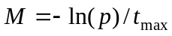, (16)
where p is the proportion of animals that reach the maximum age and is assumed to be 0.01 for the 1% rule (Shepherd and Breen 1992, Clarke et al. 2003). Maximum ages of 15 and 25 result in estimated M of 0.31 and 0.18, respectively. A maximum age of 25 was used to estimate M for U.S. federal overfishing limits for red king crab stocks (NPFMC 2007). We varied M from 0.1 to 0.5 to investigate its impacts on stock assessments and fisheries managements and selected M =0.3 as a baseline value.

Parameters Estimated Conditionally
Estimated parameters are listed in Table 5. Selectivities and molting probabilities based on these estimated parameters are summarized in Table 4.
A likelihood approach was used to estimate parameters, which include fishing catchability, parameters for selectivities of survey and fishing gears and for molting probabilities, recruits each year (except the first and the last years), and total abundance in the first year (Table 5). Under assumptions that measurement errors of annual total survey abundances and summer commercial fishing efforts follow lognormal distributions and each type of length composition has a multinomial error structure (Fournier and Archibald 1982; Methot 1989), the log-likelihood function is:
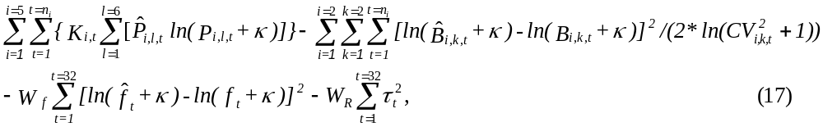
where i stands for a data set: 1 for summer trawl survey, 2 for summer pot survey, 3 for winter pot survey, 4 for summer fishery, and 5 for observer data during the summer fishery; n_{i} is the number of years in which data set i is available; k = 1 stands for legal crabs and k = 2 for non-legal crabs; K_{i,t} is the effective sample size of length compositions for data set i in year t;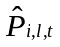and P_{i,l,t} are observed and estimated length compositions for data set i, length class l, and year t; κ is a constant equal to 0.001; CV is coefficient of variation for the survey abundance; 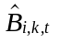and B_{i,k,t} are observed and estimated annual total abundances for data set i and year t; W_{f} is the weighting factor of the summer fishing effort;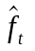and f_{t} are observed and estimated summer fishing efforts; and W_{R} is the weighting factor of recruitment. It is generally believed that total annual commercial crab catches in Alaska are fairly accurately reported. Thus, no measurement error was imposed on total annual catch. Variances for total survey abundances and summer fishing effort were not estimated; rather, we used weighting factors to reflect these variances.
Crabs usually aggregate, and this increases the uncertainty in survey estimates of abundance. To reduce the effect of aggregation, annual total sample sizes for summer trawl and pot survey data sets were reduced to 50% and all other sample sizes were reduced to 10%. Also, annual effective sample sizes were capped at 200 to avoid overweighting the data with a large sample size (Fournier and Archibald 1982). Weighting factors represent prior assumptions about the accuracy or the variances of the observed data or random variables. W_{f} was set to be 5, and W_{R} was set to be 0.01. According to the fishery manager, the fishing effort in 1992 was not as reliable as in the other years (C. Lean, ADF&G, personal communication). Thus, we weighted the effort in 1992 half as much as in the other years. W_{f} and maximum effective sample size was investigated.
We estimated parameters with AD Model Builder (Otter Research Ltd. 1994) using the quasi-Newton method to minimize negative likelihood values. To reduce the number of parameters, we assumed that length and shell compositions from the first year (1976) summer trawl survey data approximate true relative compositions. Abundances by length and shell condition in all other years were computed recursively from abundances by length and shell condition in the first year and by annual recruitment, catch, and model parameters. Initial parameter estimates were an educated guess based on observation and current knowledge.

Results
Impacts of Natural Mortality on Parameter and Abundance Estimates
Natural mortality affected the likelihood values, parameter estimates, and abundance estimates. The negative likelihood declined when M increased from 0.1 and reached the lowest value at about M = 0.35 (Figure 2). However, the likelihood values were basically flat with M = 0.3 to 0.4. Estimates of selectivity for the first stage (crabs 74-83 mm CL) were 1 when M was ≤ 0.28 and decreased when M increased from 0.28 (Figure 2). Estimated mature male biomasses and legal male abundances generally decreased when M increased from 0.1 and the decrease in estimated biomass and abundance slowed down sharply after M > 0.28 (Figure 2). Since the likelihood value and mature male biomass and legal male abundance did not change much for M ≥ 0.3 (Figure 2), we used M = 0.3 as our baseline scenario, which corresponds to about maximum age of 15 based on the 1% rule.

Abundance and Parameter Estimates
With M = 0.3, the model fit well to observed sublegal and legal male trawl abundances except in 1976 and 1979 when the trawl survey greatly underestimated the crab abundance (Figure 3). The trend in estimated fishing effort for the summer commercial fishery was very similar to, but smoother than, observed fishing effort in most years (Figure 3). This close fit between the observed effort and the model effort, which is calculated from catch and abundance data, indicates that the CPUE of the summer commercial fishery is closely associated with the estimated legal abundance.
The residuals of length compositions were generally large, except for the summer pot survey (Figures 4 and 5). The large residuals for the trawl survey are probably due to small sample sizes; all trawl surveys except in 1976 caught less than 200 legal crabs. The large residuals for the winter pot surveys and observer data also occurred in those years with a small sample size. The likelihood function placed less weight to those data with a small sample size. The sample sizes for the summer commercial fishery were large for most years; the large residuals may indicate a large sampling error. Residuals were generally uncorrelated among years and for length classes with two exceptions: (1) residuals of length classes for the winter pot surveys were generally negative for large length classes and positive for small length classes from 1981 to 1985 and opposite patterns from 1986 to 1993, and (2) residuals of length classes 2 and 6 for the summer trawl survey were mostly negative. These patterns could be modeled by increasing selectivity parameters. However, because the population abundance estimates are unaffected, we chose not to increase the number of model parameters to account for them.
Selectivities for both summer trawl and pot surveys were very close to each other; both were higher than for the summer commercial pot fishery (Table 4). The winter pot surveys caught a small number of crabs in the last length class. A small proportion of crabs belonged to legal crabs in length class 3, and almost all crabs in the last three length classes were legal crabs (Table 4). Here the proportion of legal crabs was only used to separate retained catch in the observer data. For the purpose of this study, legal crab abundance was the sum of abundances in the last three length classes.
Population abundances were very high in the late 1970s and low in the early 1980s and mid 1990s (Figure 6). Due to lack of commercial fishing and likely favorable recruitments during the mid 1970s, the abundance in the late 1970s was close to a peak of the pristine condition. Recruitment fluctuated greatly during the past 3 decades. Estimated recruitment was weak during the late 1970s and high during the early 1980s with a slight downward trend from 1983 to 1993. Estimated recruitment was strong during the recent years (Figure 6). High harvest rates (>25%) from the summer fishery occurred from 1979 to 1981, and since then estimated harvest rates have been below 20% (Figure 7). Estimated harvest rates during the last 10 years were below 16% (Figure 7). Coefficients of variation for recruitment estimates were up to 71%, whereas coefficients of variation for legal crab abundance and mature male biomass estimates were generally below 13% (Table 6).
Zheng et al. (1998) examined sensitivity of weighting factors and concluded that estimates of parameters and legal crab abundance were not very sensitive to weighting factors for survey abundances and fishing effort, and maximum effective sample size. Zheng et al. (1998) assumed M = 0.3.

Retrospective Analyses
Two kinds of retrospective analyses are presented in this report: (1) historical results and (2) the 2008 model results. The historical results are the trajectories of biomass and abundance from previous assessments that capture both new data and changes in methodology over time. Assuming the estimates in 2009 to be baseline values, we can also evaluate how well the model has done in the past. The 2009 model results are based on leaving one-year’s data out at a time to evaluate how well the current model performs with less data.
Several biologists conducted the stock assessments of Norton Sound red king crab using this model during the last 10 years. Complete historical results were not available. The estimated legal male abundances in terminal years from 1999 to present were available and were graphed to compare the results made in 2009 (Figure 8). The 2005 result was omitted in this report because it was most likely affected by a data input error. The historical results in 2001, 2002, 2003, and 2007 were very close to those made in 2009 and quite different in 1999, 2004 and 2006 (Figure 8). Note that large differences happened in years when the last trawl survey occurred two to four years prior. These errors were due to terminal years as well as lack of trawl surveys in the previous one to three years. Despite additional data and changes in the model fitting, estimated legal male abundance and mature male biomass were very close except during 2004-2006 (Figure 8).
Because no trawl survey was conducted prior to the abundance estimate before the summer fishery, the abundance estimate in a terminal year is like a one-year-ahead projection. Therefore, performance of the 2009 model includes leaving out data as well as one-year-ahead projection. The model performed very well except the estimates in the early 2000s and mid 2000s made with terminal years 2001, 2002, 2004, 2005 and 2006 (Figure 9). Like the historical results, the years with a large difference were without a trawl survey one year earlier.
The large projection errors were mainly due to data conflicts between the trawl survey and the winter pot survey. Based on modal progressions of length frequencies from the winter pot survey, strong year classes were observed to go through the population during 1996-1999 and 2002-2006 (Figure 10), yet legal abundance estimates from trawl surveys in 2002, 2006 and 2008 were unexpectedly low. In years without trawl survey data, winter pot survey data played an important role in projecting population abundances. Trawl survey data were weighted more heavily than winter pot survey data, and in years when trawl survey data were available, they influenced abundance estimates greatly. Because a trawl survey was conducted every three or four years, measurement errors from a single trawl survey could affect the model results greatly. It is hard to determine whether the large projection errors were due to sampling errors in winter pot surveys or measurement errors in summer trawl surveys.

Overfishing Limits for 2009
The Norton Sound red king crab stock is currently placed in Tier 4 (NPFMC 2007). For Tier 4 stocks, some abundance estimates are available, but complete population parameters are not available for computer simulation studies and spawning biomass per recruit analyses needed for Tier 3 stocks. The average of estimated biomasses for a given period is used to develop a B_{MSY} proxy for Tier 4 stocks. We evaluated averages of mature male biomasses from three periods for the B_{MSY} proxy: 1976-2009, 1980-2009 and 1983-2009 (Figure 11).
Besides B_{MSY} proxy, a γ value must also be determined. We evaluated two γ values: γ = 1 and γ = 0.6 for setting overfishing limits for 2009.
Estimated B_{MSY} proxy:
Based on the average during 1976-2009: 4.451 million lbs,
Based on the average during 1980-2009: 3.350 million lbs,
Based on the average during 1983-2009: 3.363 million lbs.
Estimated F_{MSY} proxy:
γ = 1: 0.30,
γ = 0.6: 0.18.
Estimated mature male biomass in 2009 was 4.692 million lbs, above all three B_{MSY} proxies. Because the population was at a near pristine condition in the late 1970s, we should not use the mature biomasses during that period for B_{MSY} proxy. Year classes after the 1976/77 regime shift (Overland et al. 1999) were expected to reach the mature population after 1982, and thus the average of mature biomasses during 1983-2009 is appropriate for B_{MSY} proxy. Because a trawl survey was conducted only every three or four years, abundance estimates are very uncertain. Therefore, a conservative γ (=0.6) should be used to set the overfishing limits.
With B_{MSY} proxy = 3.363 million lbs, F_{MSY} proxy = 0.18 (γ =0.6), B = 4.692 million lbs in 2009, legal male abundance = 1.3421 million crabs or 3.5052 million lbs in 2009, the overfishing limits for retained catch in 2009 are 0.2211 million crabs or 0.5664 million lbs. The average weight for legal crabs is approximate and may need to be adjusted based on the actual mean weight of the catch.
Estimated full fishing mortality at F_{35%} and harvest rate at H_{35%} increased greatly when M increased from 0.1 to 0.5 (Figure 12). Estimated fishing mortality at F_{35%} increased sharply for M > 0.42.
Application of default proxy F_{msy} = M and F_{35%} approaches to Norton Sound red king crab is questionable when the feasible estimate of M is high. When an artificially low M is used, the fishing mortalities or harvest rates based on these approaches may be plausible. However, a reasonable estimate of M may result in excessively high fishing mortalities or harvest rates for this stock. History of catch and estimated harvest rates (Figure 7) shows that the current harvest rates of 5-15% for the summer fishery may be reasonable, which allowed the stock to increase slowly. Higher harvest rates may drive the stock abundance to decline. These harvest rates are much lower than those based on proxy F_{msy} = M and F_{35%} approaches (0.32 with M = 0.3). One may argue that heavy fishing during 1979-1981 might have driven the stock abundance to be too low. However, red king crabs take several years from spawning to recruiting to the mature stock; it will take 6 or 7 years of heavy fishing to cover this time lag. Poor recruitment was estimated for Norton Sound red king crab even before the fishing started. Even without fishing, estimated number of recruits would not be able to sustain the high abundance during the late 1970s. These high abundances were results of exceptional strong recruitments, which were also observed for other king crab stocks in the eastern Bering Sea (Zheng and Kruse 2000, 2006).
The default proxy F_{msy} = M and F_{35%} approaches may require an assumption that stock surplus production is strongly associated with M. These may be reasonable approaches for many stocks, especially if combined with precautionary measures (Restrepo et al. 1998). However, Norton Sound red king crab live in shallow waters and are a northern-boundary stock. They may have a relatively higher M and a lower productivity than other red king crab stocks. The growth rates of Norton Sound red king crab are also much slower than those in Bristol Bay and the Gulf of Alaska. Overall, with uncertainties in M estimates and in stock assessment, and with slowly increasing stock abundance under extremely low harvest rates during the last 25 years, much more conservative harvest rates than those based on proxy F_{msy} = M and F_{35%} approaches are more suitable for Norton Sound red king crab. Therefore, we suggest γ = 0.6 for this stock.

Acknowledgments
We thank Doug Woodby and Shareef Siddeek of ADF&G for reviewing the earlier draft of this report.

References

Alverson, D.L., and W.T. Pereyra. 1969. Demersal fish in the Northeastern Pacific Ocean - an evaluation of exploratory fishing methods and analytical approaches to stock size and yield forecasts. J. Fish. Res. Board Can. 26:1985-2001.
Balsiger, J.W. 1974. A computer simulation model for the eastern Bering Sea king crab. Ph.D. thesis, Univ. Washington, Seattle, WA. 197 pp.
Banducci, A., T. Kohler, J. Soong, and J. Menard. 2007. 2005 Annual management report Norton Sound, Port Clarence, and Kotzebue. Alaska Department of Fish and Game, Divisions Sport Fish and Commercial Fisheries. Fishery Management Report No. 07-32. 194 pp.
Brannian, L.K. 1987. Population assessment survey for red king crab (Paralithodes camtschatica) in Norton Sound, Alaska, 1985. Alaska Dept. Fish and Game, Tech. Data Rep. 214. 51 pp.
Clarke, M.W., C.J. Kelly, P.L. Connolly, and J.P. Molloy. 2003. A life history approach to the assessment and management of deepwater fisheries in the Northeast Atlantic. J. Northw. Atl. Fish. Sci. 31:401-411.
Fournier, D., and C.P. Archibald. 1982. A general theory for analyzing catch at age data. Can. J. Fish. Aquat. Sci. 39:1195-1207.
Methot, R.D. 1989. Synthetic estimates of historical abundance and mortality for northern anchovy. Amer. Fish. Soc. Sym. 6:66-82.
North Pacific Fishery Management Coucil (NPFMC). 2007. Environmental assessment for proposed amendment 24 to the fishery management plan for Bering Sea and Aleutian Islands king and Tanner crabs to revise overfishing definitions. Public review draft.
Otter Research Ltd. 1994. An introduction to AD Model Builder: for use in nonlinear modeling and statistics. Otter Research Ltd., Nanaimo, B.C., Canada. 44 pp.
Overland, J.E., J.M. Adams, and N.A. Bond. 1999. Decadal variability of the Aleutian Low and its relation to high-latitude circulation. Journal of Climate 12:1542-1548.
Powell, G.C., R. Peterson, and L. Schwarz. 1983. The red king crab, Paralithodes camtschatica (Tilesius), in Norton Sound, Alaska: History of biological research and resource utilization through 1982. Alaska Dept. Fish and Game, Inf. Leafl. 222. 103 pp.
Restrepo, V.R., G.G. Thompson, P.M. Mace, W.L. Gabriel, L.L. Low, A.D. MacCall, R.D. Methot, J.E. Powers, B.L. Taylor, P.R. Wade, and J.F. Witzig. 1998. Technical guidance on the use of precautionary approaches to implementing National Standard 1 of the Magnuson-Stevens Fishery Conservation and Management Act. NOAA Tech. Memo. NMFS-F/SPO-31. 54 pp.
Shepherd, S.A., and P.A. Breen. 1992. Mortality in abalone: its estimation, variability, and causes. Pages 276-304 In S.A. Shepherd, M.J. Tegner, and S.A. Guzman del Proo (eds.). Abalone of the World: Biology, Fisheries, and Culture. Fishing News Books, Cambridge, UK.
Soong, J. 2007. Norton Sound winter red king crab studies, 2007. Alaska Department of Fish and Game, Fishery Data Series No. 07-53, Anchorage.
Soong, J. 2008. Analysis of red king crab data from the 2008 Alaska Department of Fish and Game trawl survey of Norton Sound. Alaska Department of Fish and Game, Fishery Data Series No. 08-58, Anchorage.
Soong, J., A.O. Banducci, S. Kent, and J. Menard 2008. 2007 Annual Management Report Norton Sound, Port Clarence, and Kotzebue. Fishery Management Report No. 08-39.
Stevens, B.G., and R.A. MacIntosh. 1986. Analysis of crab data from the 1985 NMFS survey of the northeast Bering Sea and Norton Sound. Northwest and Alaska Fisheries Science Center, Processed Rep. 86-16. National Marine Fisheries Service, National Oceanic and Atmospheric Administration, 7600 Sand Point Way NE, Seattle, WA 98115, USA. 35 pp.
Zheng, J. 2005. A review of natural mortality estimation for crab stocks: data-limited for every stock? Pages 595-612 in G.H. Kruse, V.F. Gallucci, D.E. Hay, R.I. Perry, R.M. Peterman, T.C. Shirley, P.D. Spencer, B. Wilson, and D. Woodby (eds.). Fisheries Assessment and Management in Data-limite Situation. Alaska Sea Grant College Program, AK-SG-05-02, Fairbanks.
Zheng. J., and G.H. Kruse. 2000. Recruitment patterns of Alaskan crabs in relation to decadal shifts in climate and physical oceanography. ICES Journal of Marine Science 57: 438-451.
Zheng, J., and G.H. Kruse. 2006. Recruitment variation of eastern Bering Sea crabs: climate-forcing or top-down effects? Progress in Oceanography 68:184-204.
Zheng, J., G.H. Kruse, and L. Fair. 1998. Use of multiple data sets to assess red king crab, Paralithodes camtschaticus, in Norton Sound, Alaska: A length-based stock synthesis approach. Pages 591-612 In Fishery Stock Assessment Models, edited by F. Funk, T.J. Quinn II, J. Heifetz, J.N. Ianelli, J.E. Powers, J.F. Schweigert, P.J. Sullivan, and C.-I. Zhang, Alaska Sea Grant College Program Report No. AK-SG-98-01, University of Alaska Fairbanks.
Table 1. Historical summer commercial red king crab fishery economic performance, Norton Sound Section, eastern Bering Sea, 1977-2007.
 | Guidline | Legal Male |  |  | Commercial
 | Harvest | Population Est. |  |  | Harvest (lbs) ^{a, b} |  |  |  |  |  |  |  | Total |  | Total
 | Level | No. crab |  |  | Open |  | Total Number (incl. CDQ) |  |  |  | Total Number of Pots |  | Exvessel | Fishery Value |  |  | Season Length
Year | (lbs) ^{b} | (millions) | lbs | ^{b} | Access | CDQ | Vessels | Permits | Landings |  | Registered | Pulls | Price/lb | (millions $) |  |  | Days | Dates
1977 | ^{c} | 1.7 | 5.1 |  | 0.52 |  | 7 | 7 | 13 |  | ^{c} | 5,457 | 0.75 |  | 0.229 |  | 60 |  | ^{c}
1978 | 3.00 |  |  |  | 2.09 |  | 8 | 8 | 54 |  | ^{c} | 10,817 | 0.95 |  | 1.897 |  | 60 | 6/07-8/15
1979 | 3.00 | 0.8 | 2.4 |  | 2.93 |  | 34 | 34 | 76 |  | ^{c} | 34,773 | 0.75 |  | 1.878 |  | 16 | 7/15-7/31
1980 | 1.00 | 1.9 | 5.7 |  | 1.19 |  | 9 | 9 | 50 |  | ^{c} | 11,199 | 0.75 |  | 0.890 |  | 16 | 7/15-7/31
1981 | 2.50 | 1.2 | 3.6 |  | 1.38 |  | 36 | 36 | 108 |  | ^{c} | 33,745 | 0.85 |  | 1.172 |  | 38 | 7/15-8/22
1982 | 0.50 | 0.9 | 2.7 |  | 0.23 |  | 11 | 11 | 33 |  | ^{c} | 11,230 | 2.00 |  | 0.405 |  | 23 | 8/09-9/01
1983 | 0.30 |  |  |  | 0.37 |  | 23 | 23 | 26 |  | 3,583 | 11,195 | 1.50 |  | 0.537 |  | 3.8 | 8/01-8/05
1984 | 0.40 |  |  |  | 0.39 |  | 8 | 8 | 21 |  | 1,245 | 9,706 | 1.02 |  | 0.395 |  | 13.6 | 8/01-8/15
1985 | 0.45 | 1.1 | 3.3 |  | 0.43 |  | 6 | 6 | 72 |  | 1,116 | 13,209 | 1.00 |  | 0.427 |  | 21.7 | 8/01-8/23
1986 | 0.42 |  |  |  | 0.48 |  | 3 | 3 | ^{c} |  | 578 | 4,284 | 1.25 |  | 0.600 |  | 13 | 8/01-8/25 | ^{d}
1987 | 0.40 |  |  |  | 0.33 |  | 9 | 9 | ^{c} |  | 1,430 | 10,258 | 1.50 |  | 0.491 |  | 11 | 8/01-8/12
1988 | 0.20 | 1.0 | 3.0 |  | 0.24 |  | 2 | 2 | ^{c} |  | 360 | 2,350 | ^{c} |  |  | ^{c} | 9.9 | 8/01-8/11
1989 | 0.20 |  |  |  | 0.25 |  | 10 | 10 | ^{c} |  | 2,555 | 5,149 | 3.00 |  | 0.739 |  | 3 | 8/01-8/04
1990 | 0.20 |  |  |  | 0.19 |  | 4 | 4 | ^{c} |  | 1,388 | 3,172 | ^{c} |  |  | ^{c} | 4 | 8/01-8/05
1991 | 0.34 | 1.3 | 3.9 |  |  |  | No Summer Fishery
1992 | 0.34 |  |  |  | 0.07 |  | 27 | 27 | ^{c} |  | 2,635 | 5,746 | 1.75 |  | 0.130 |  | 2 | 8/01-8/03
1993 | 0.34 |  |  |  | 0.33 |  | 14 | 20 | 208 |  | 560 | 7,063 | 1.28 |  | 0.430 |  | 52 | 7/01-8/28 | ^{e}
1994 | 0.34 |  |  |  | 0.32 |  | 34 | 52 | 407 |  | 1,360 | 11,729 | 2.02 |  | 0.646 |  | 31 | 7/01-7/31
1995 | 0.34 |  |  |  | 0.32 |  | 48 | 81 | 665 |  | 1,900 | 18,782 | 2.87 |  | 0.926 |  | 67 | 7/01-9/05
1996 | 0.34 | 0.5 | 1.5 |  | 0.22 |  | 41 | 50 | 264 |  | 1,640 | 10,453 | 2.29 |  | 0.519 |  | 57 | 7/01-9/03 | ^{f}
1997 | 0.08 |  |  |  | 0.09 |  | 13 | 15 | 100 |  | 520 | 2,982 | 1.98 |  | 0.184 |  | 44 | 7/01-8/13 | ^{g}
1998 | 0.08 |  |  |  | 0.03 | 0.00 | 8 | 11 | 50 |  | 360 | 1,639 | 1.47 |  | 0.041 |  | 65 | 7/01-9/03 | ^{h}
1999 | 0.08 | 1.6 | 4.8 |  | 0.02 | 0.00 | 10 | 9 | 53 |  | 360 | 1,630 | 3.08 |  | 0.073 |  | 66 | 7/01-9/04 | ^{i}
2000 | 0.33 | 1.4 | 4.2 |  | 0.29 | 0.01 | 15 | 22 | 201 |  | 560 | 6,345 | 2.32 |  | 0.715 |  | 91 | 7/01- 9/29 | ^{j}
2001 | 0.30 | 1.3 | 3.8 |  | 0.28 | 0.00 | 30 | 37 | 319 |  | 1,200 | 11,918 | 2.34 |  | 0.674 |  | 97 | 7/01- 9/09 | ^{k}
2002 | 0.24 | 1.0 | 3.1 |  | 0.24 | 0.01 | 32 | 49 | 201 |  | 1,120 | 6,491 | 2.81 |  | 0.729 |  | 77 | 6/15-9/03 | ^{l}
2003 | 0.25 | 1.0 | 3.1 |  | 0.25 | 0.01 | 25 | 43 | 236 |  | 960 | 8,494 | 3.09 |  | 0.823 |  | 68 | 6/15-8/24 | ^{m}
2004 | 0.35 | 1.6 | 4.4 |  | 0.31 | 0.03 | 26 | 39 | 227 |  | 1,120 | 8,066 | 3.12 |  | 1.063 |  | 51 | 6/15-8/08 | ^{n}
2005 | 0.37 | 1.7 | 4.8 |  | 0.37 | 0.03 | 31 | 42 | 255 |  | 1,320 | 8,867 | 3.14 |  | 1.264 |  | 73 | 6/15-8/27 | º
2006 | 0.45 | 1.6 | 4.5 |  | 0.42 | 0.03 | 28 | 40 | 249 |  | 1,320 | 8,695 | 2.26 |  | 1.021 |  | 68 | 6/15-8/22 | ^{n}
2007 | 0.32 | 1.1 | 3.1 |  | 0.29 | 0.02 | 38 | 30 | 251 |  | 1,200 | 9,118 | 2.49 |  | 0.750 |  | 52 | 6/15-
ª Deadloss included in total. |  |  |  |  | ^{h} First delivery was made 7/16. |  |  |  |  |  |  | º OA opened 7/1 - 8/15. CDQ opened 6/15-6/28 and 8/17-8/27.
^{b} Millions of pounds. |  |  |  |  | ^{i} The season was extended 24 hours due to bad weather.
^{c} Information not available. |  |  |  |  | ^{j} Open access (OA) closed 8/29. CDQ opened 9/1 - 9/29.
^{d} Fishing actually began 8/12. |  |  |  |  | ^{k} OA closed 9/1. CDQ opened from 9/1 - 9/9.
^{e} Fishing actually began 7/8. |  |  |  |  | ^{l} OA opened 7/1 - 8/6. CDQ opened 6/15-6/28 and 8/9- 9/3.
^{f} Fishing began 7/9 due to fishers' strike. |  |  |  |  | ^{m} OA opened 7/1 - 8/13. CDQ opened 6/15-6/28 and 8/15-8/24
^{g} First delivery was made 7/10. |  |  |  |  | ^{n} CDQ opened 6/15-6/28. OA opened 7/1 to the end date.

Table 2. Summary of available data for Norton Sound male red king crab.
Data Set | Years | Data Types
Summer trawl survey | 76,79,82,85,88,91,96, 99, 02,06, 08 | Abundance and prop. by length and shell condition
Summer pot survey | 80-82,85 | Abundance and prop. by length and shell condition
Winter pot survey | 81-87, 89-91,93,95-00,02-09 | Proportion by length and shell condition
Summer preseason survey | 95 | Proportion by length and shell condition
Summer commercial fishery | 76-90,92-08 | Catch, effort, and prop. by length and shell condition
Observer data | 87-90,92,94 | Proportion by length and shell condition
Winter commercial fishery | 76-09 | Catch
Subsistence fishery  Tagging data | 76-09  80-07 | Catch  Mean and standard deviation of growth increment

Table 3. Growth matrix (proportion of crabs molting from a given premolt carapace length range into postmolt length ranges) for Norton Sound male red king crab. Length is measured as mm CL. Results are derived from mark-recapture data from 1991 to 2007.

Pre-molt | Post-molt Length Class
Length Class | 74-83 | 84-93 | 94-103 | 104-113 | 114-123 | 124+
74-83 | 0 | 0.33 | 0.67 | 0 | 0 | 0
84-93 | 0 | 0 | 0.56 | 0.44 | 0 | 0
94-103 | 0 | 0 | 0 | 0.76 | 0.24 | 0
104-113 | 0 | 0 | 0 | 0.18 | 0.61 | 0.21
114-123 | 0 | 0 | 0 | 0 | 0.33 | 0.67
124+ | 0 | 0 | 0 | 0 | 0 | 1.00

Table 4. Estimated selectivities, molting probabilities, and proportions of legal crabs by length (mm CL) class for Norton Sound male red king crab.
Selectivities Molt. Prob.
Length | Length | Proportion | Summer | Summer | Winter | Summer Fishery |  | All Years
Class | Range | of Legals | Trawl | Pot Surv | Pot Surv | 77-92 | 93-08
1 | 74 - 83 | 0.00 | 0.94 | 0.67 | 0.70 | 0.19 | 0.09 | 1.00
2 | 84 - 93 | 0.00 | 0.95 | 0.75 | 0.97 | 0.28 | 0.17 | 0.90
3 | 94 - 103 | 0.15 | 1.00 | 1.00 | 1.00 | 0.43 | 0.31 | 0.77
4 | 104 - 113 | 0.92 | 1.00 | 1.00 | 1.00 | 0.66 | 0.57 | 0.61
5 | 114 - 123 | 1.00 | 1.00 | 1.00 | 1.00 | 1.00 | 1.00 | 0.44
6 | >123 | 1.00 | 1.00 | 1.00 | 0.41 | 1.00 | 0.60 | 0.30

Table 5. Summary of parameter estimates for a length-based stock synthesis population model of Norton Sound red king crab. Recruits R and N₇₆ are in million crabs. Total number of free parameters: 50.
Parameter | Value |  | Std. deviation | Parameter |  |  | Value | Std. deviation
Log_mean | 6.2979 |  | 0.2333 | Log_R₀₀ |  |  | -0.5691 | 0.3100
Log_N₇₆ | 2.6565 |  | 0.2359 | Log_R₀₁ |  |  | 0.6720 | 0.2665
Log_R₇₇ | 0.2598 |  | 0.3954 | Log_R₀₂ |  |  | 0.1915 | 0.2890
Log_R₇₈ | -4.3387 |  | 2.9433 | Log_R₀₃ |  |  | 0.8003 | 0.2611
Log_R₇₉ | -2.4493 |  | 0.6512 | Log_R₀₄ |  |  | -0.2502 | 0.3450
Log_R₈₀ | -0.9963 |  | 0.3053 | Log_R₀₅ |  |  | -0.0232 | 0.3357
Log_R₈₁ | 0.8216 |  | 0.2489 | Log_R₀₆ |  |  | 0.9615 | 0.2643
Log_R₈₂ | 0.2352 |  | 0.2721 | Log_R₀₇ |  |  | 0.5772 | 0.3209
Log_R₈₃ | 1.0874 |  | 0.2607 | Log_R₀₈ |  |  | 1.0606 | 0.2910
Log_R₈₄ | 0.5290 |  | 0.2611 | log_q1 |  |  | -10.9690 | 0.0996
Log_R₈₅ | 0.6811 |  | 0.2525 | log_q2 |  |  | -10.8430 | 0.1055
Log_R₈₆ | 0.1899 |  | 0.2898 | r1 |  |  | 0.5545 | 0.0213
Log_R₈₇ | 0.3350 |  | 0.2595 | log_α |  |  | -2.8734 | 0.2011
Log_R₈₈ | -0.0870 |  | 0.2661 | log_β |  |  | 4.7023 | 0.0337
Log_R₈₉ | 0.3972 |  | 0.2597 | log_Sst1 |  |  | -3.3437 | 0.5916
Log_R₉₀ | -0.0188 |  | 0.2659 | log_Sst2 |  |  | 1.0101 | 0.1211
Log_R₉₁ | -0.6679 |  | 0.2929 | log_Ssp1 |  |  | -3.2999 | 1.3907
Log_R₉₂ | 0.0389 |  | 0.3175 | log_Ssp2 |  |  | 4.0846 | 0.5626
Log_R₉₃ | -0.4950 |  | 0.4030 | log_Sw1 |  |  | -1.3001 | 0.0035
Log_R₉₄ | -0.3266 |  | 0.3126 | log_Sw2 |  |  | 4.3287 | 0.0134
Log_R₉₅ | 0.1507 |  | 0.2815 | Sw3 |  |  | 0.4125 | 0.0439
Log_R₉₆ | -0.5680 |  | 0.2887 | log_φ₁ |  |  | -3.1688 | 0.1004
Log_R₉₇ | 0.5824 |  | 0.2604 | log_ω₁ |  |  | 5.7498 | 0.2787
Log_R₉₈ | 0.7906 |  | 0.2534 | log_φ₂ |  |  | -2.7646 | 0.2738
Log_R₉₉ | -2.2285 |  | 0.5892 | log_ω₂ |  |  | 5.0002 | 0.3934
Data Component |  | Neg.Likelihood Value
Trawl immat. indices |  | 7.031
Trawl mat. indices |  | 17.794
Pot immat. indices |  | 1.391
Pot mat. indices |  | 3.825
Total effort |  | 5.104
Trawl length compos. |  | 2341.920
Pot length compos. |  | 1275.730
Winter length compos. |  | 3398.770
Summer length compos |  | 5259.150
Observed length comp. |  | 535.370
Recruitment deviation |  | 0.469
Total |  | 12867.300
Table 6. Annual abundance estimates (million crabs) and mature male biomass (MMB, million lbs) for Norton Sound red king crab estimated by length-based analysis from 1976-2009.

Year Total (>73 mm) Matures (>93 mm) Legals (>103 mm) MMB
Abund. St.Dev. Biomass St.Dev.
1976 | 7.7999 | 6.6383 | 4.9784 | 0.1987 | 15.2141 | 0.6074
1977 | 6.4001 | 5.6572 | 4.8551 | 0.1716 | 14.5651 | 0.5190
1978 | 4.5816 | 4.4622 | 3.9887 | 0.1197 | 12.4070 | 0.3103
1979 | 2.9412 | 2.8905 | 2.7393 | 0.0743 | 8.6235 | 0.2287
1980 | 1.6227 | 1.4380 | 1.3840 | 0.0557 | 4.4726 | 0.1776
1981 | 2.0434 | 0.9226 | 0.8385 | 0.0424 | 2.8472 | 0.1423
1982 | 1.8327 | 1.0407 | 0.5921 | 0.0430 | 2.3950 | 0.1732
1983 | 2.7211 | 1.1833 | 0.7928 | 0.0566 | 2.7346 | 0.2040
1984 | 2.7184 | 1.6573 | 0.9878 | 0.0656 | 3.6218 | 0.2410
1985 | 2.8461 | 1.7439 | 1.2029 | 0.0788 | 3.9893 | 0.2576
1986 | 2.5671 | 1.8170 | 1.2806 | 0.0861 | 4.2595 | 0.2876
1987 | 2.4401 | 1.6601 | 1.2609 | 0.0877 | 4.0665 | 0.2796
1988 | 2.1652 | 1.6051 | 1.2193 | 0.0853 | 4.0084 | 0.2760
1989 | 2.2532 | 1.4573 | 1.1609 | 0.0822 | 3.7678 | 0.2636
1990 | 2.0656 | 1.4692 | 1.1016 | 0.0794 | 3.7311 | 0.2662
1991 | 1.7211 | 1.3871 | 1.0823 | 0.0795 | 3.5812 | 0.2586
1992 | 1.7566 | 1.2104 | 1.0181 | 0.0740 | 3.2881 | 0.2359
1993 | 1.5722 | 1.1927 | 0.9395 | 0.0651 | 3.1831 | 0.2201
1994 | 1.4137 | 1.0124 | 0.8150 | 0.0595 | 2.7148 | 0.1912
1995 | 1.5117 | 0.8921 | 0.6973 | 0.0540 | 2.3570 | 0.1808
1996 | 1.3085 | 0.9387 | 0.6599 | 0.0520 | 2.3242 | 0.1783
1997 | 1.7702 | 0.8589 | 0.6596 | 0.0534 | 2.1753 | 0.1749
1998 | 2.3353 | 1.1301 | 0.7383 | 0.0556 | 2.6604 | 0.2008
1999 | 1.7645 | 1.5247 | 0.9821 | 0.0636 | 3.4930 | 0.2164
2000 | 1.5642 | 1.2705 | 1.0667 | 0.0662 | 3.2706 | 0.2014
2001 | 2.0111 | 1.0249 | 0.8647 | 0.0583 | 2.7612 | 0.1870
2002 | 1.9903 | 1.2485 | 0.8347 | 0.0570 | 3.0270 | 0.2083
2003 | 2.4667 | 1.2900 | 0.9225 | 0.0664 | 3.1293 | 0.2230
2004 | 2.1283 | 1.5677 | 1.0371 | 0.0727 | 3.6555 | 0.2519
2005 | 1.9490 | 1.4042 | 1.0810 | 0.0790 | 3.4697 | 0.2524
2006 | 2.5918 | 1.2534 | 0.9739 | 0.0768 | 3.1764 | 0.2539
2007 | 2.6474 | 1.5766 | 1.0055 | 0.0890 | 3.6551 | 0.3271
2008 | 3.2505 | 1.7064 | 1.1813 | 0.1166 | 4.0056 | 0.4080
2009 | 3.1545 | 2.0434 | 1.3421 | 0.1609 | 4.6922 | 0.5791

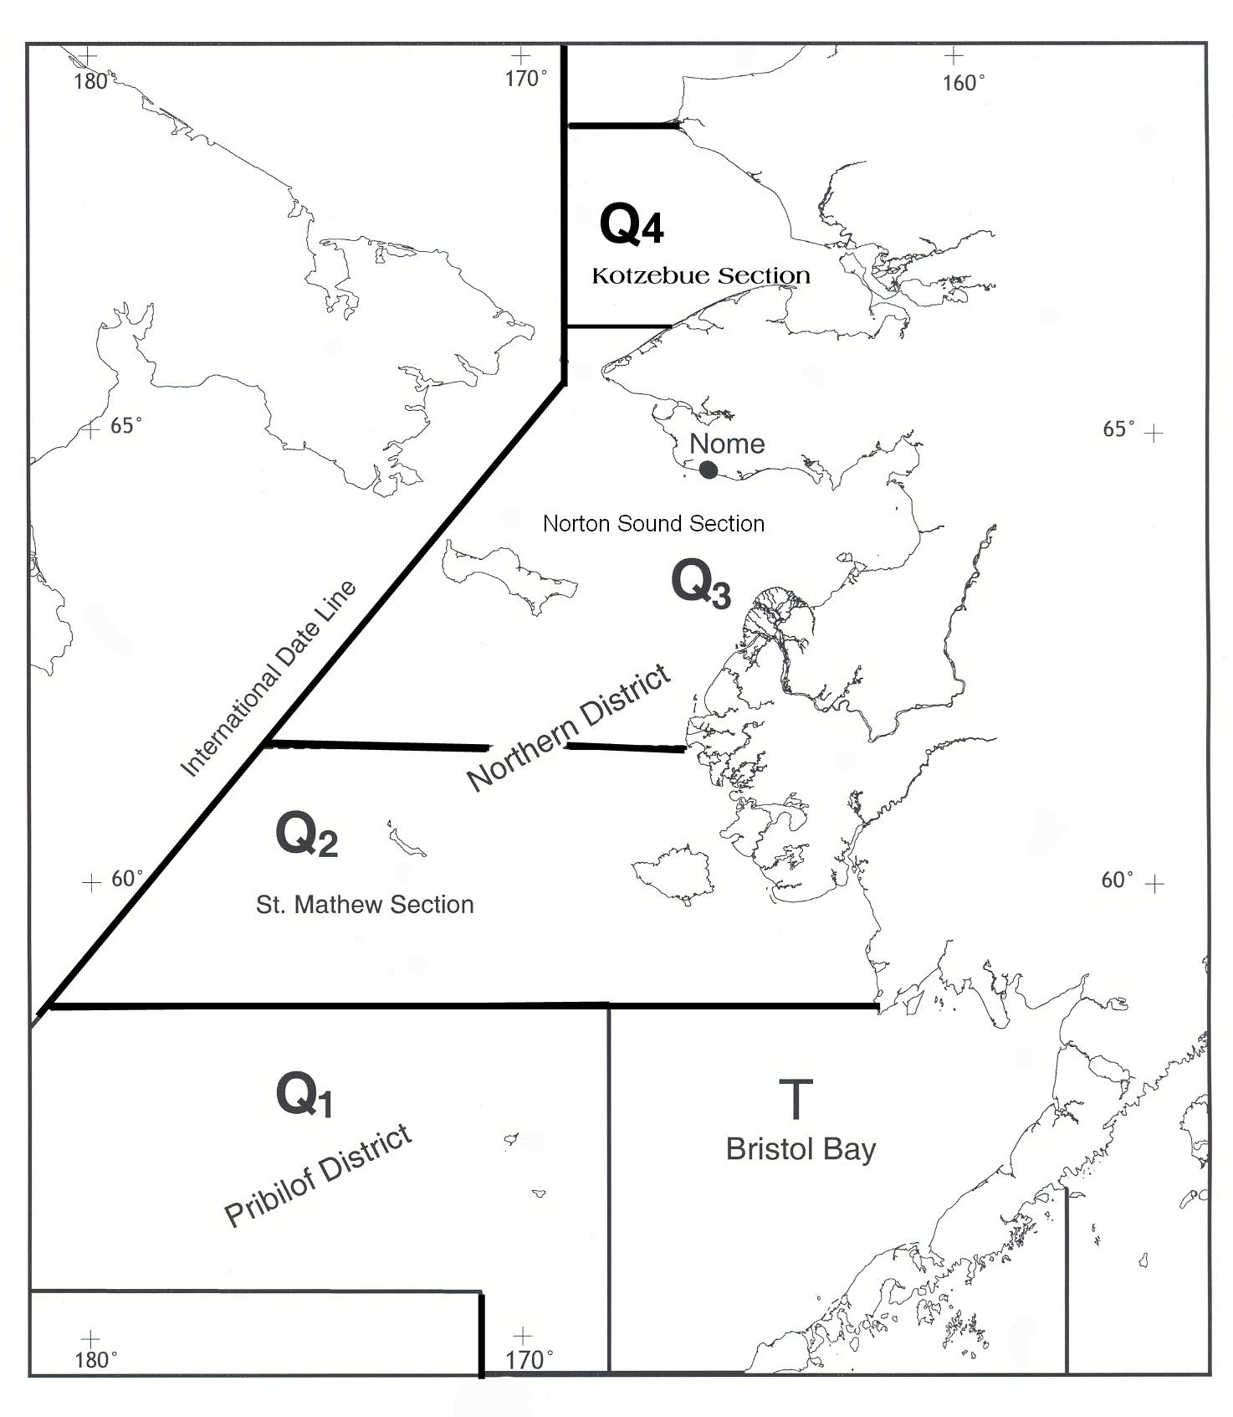

Figure 1. King crab fishing districts and sections of Statistical Area Q.

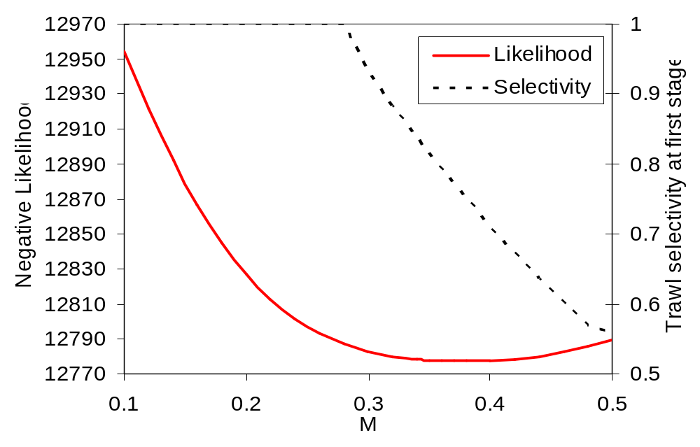
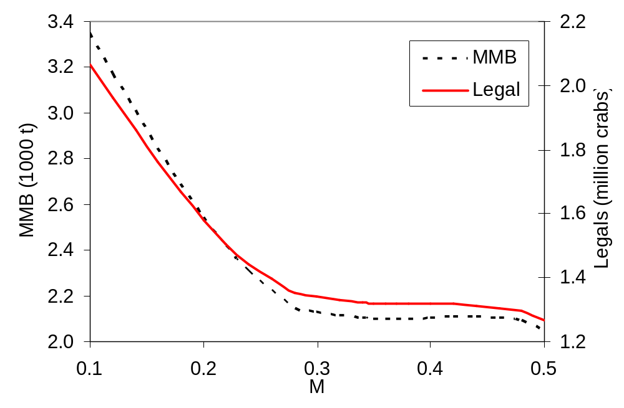
Figure 2. Likelihood profile for natural mortality, estimated selectivity for crabs 74-83 mm CL for summer trawl surveys, estimated legal abundance and mature male biomass in 2008 under different natural mortality values.
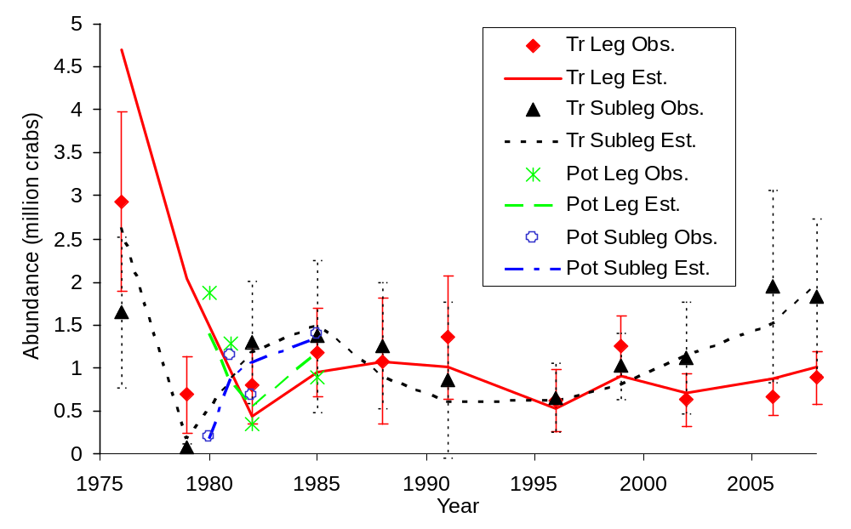
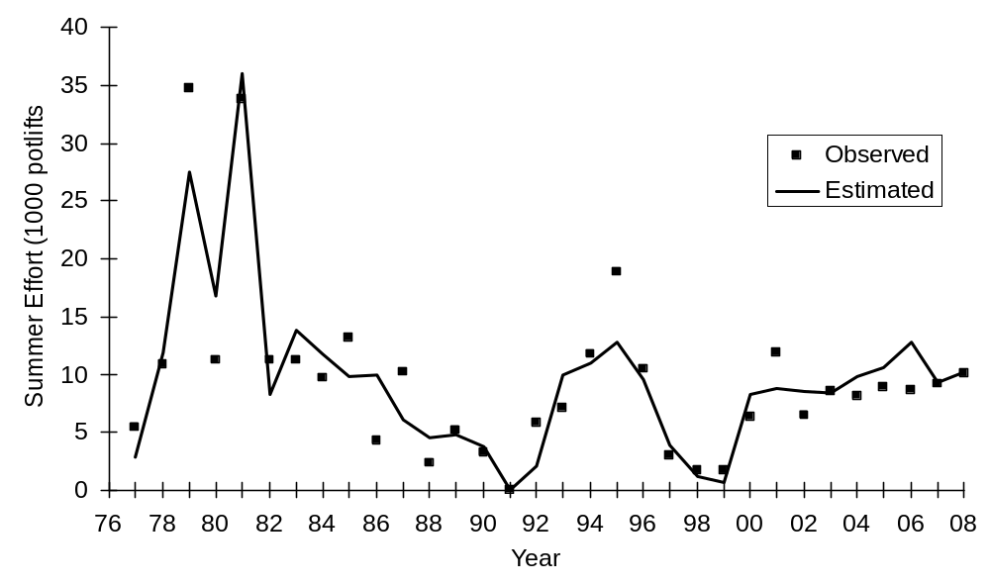
Figure 3. Comparison of observed and estimated Norton Sound red king crab abundances (legal and sublegal males) by summer trawl and pot surveys (upper plot) and observed and estimated summer fishing efforts (lower plot). “Tr” is trawl, “Leg” is legal, “Obs.” is observed or survey catchable abundance, and “Est.” is estimated catchable abundance. The 95% C.I. were plotted separately for sublegal and legal crabs from the summer trawl surveys. Catchable abundance is equal to population abundance times survey selectivities.
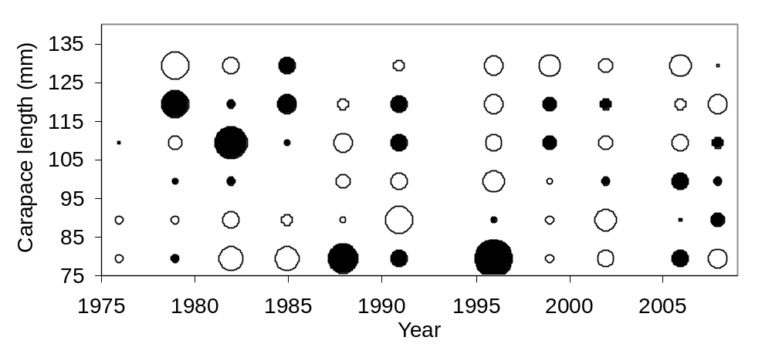
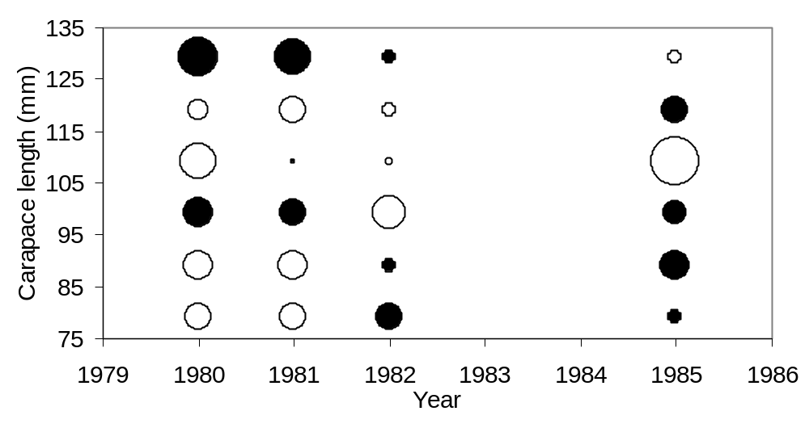
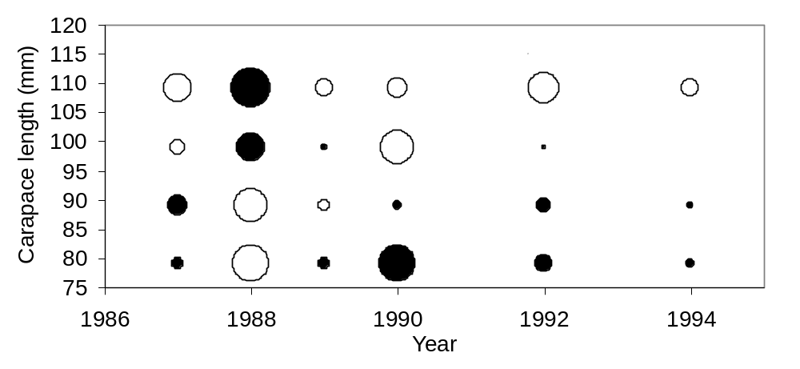
Figure 4. Residuals of length compositions by year for summer trawl and pot surveys and observer data for Norton Sound red king crab. Solid circles are positive residuals, and open circles are negative residuals.
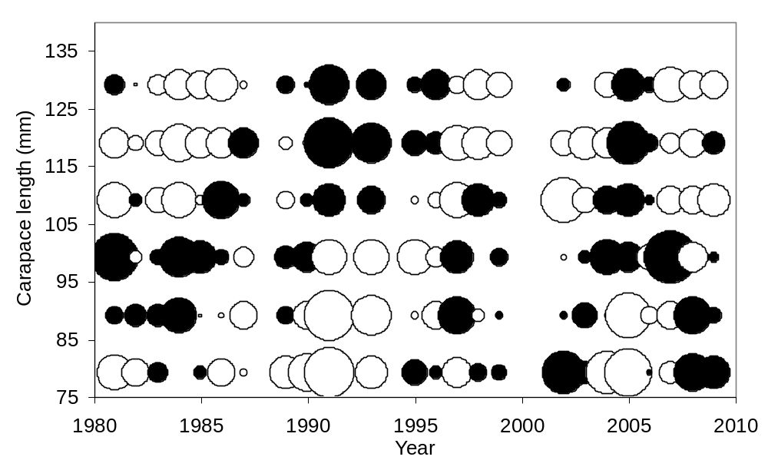
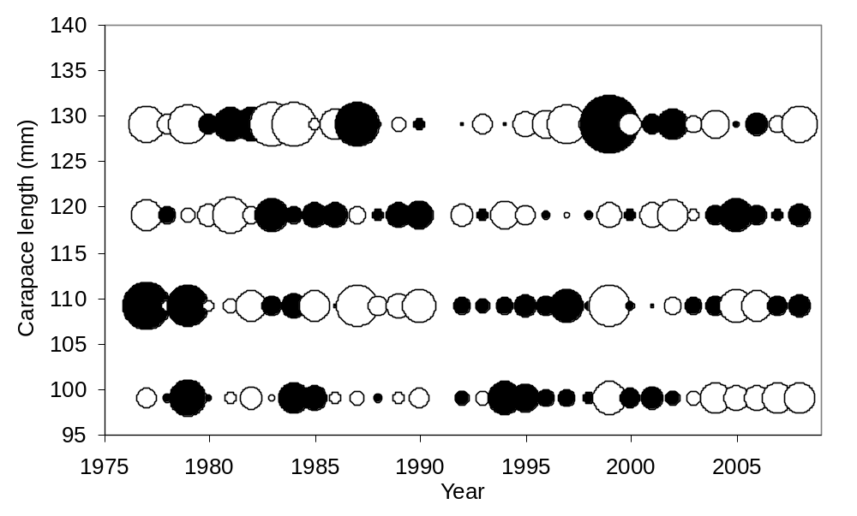

Figure 5. Residuals of length compositions by year for winter pot surveys and summer fishery for Norton Sound red king crab. Solid circles are positive residuals, and open circles are negative residuals.

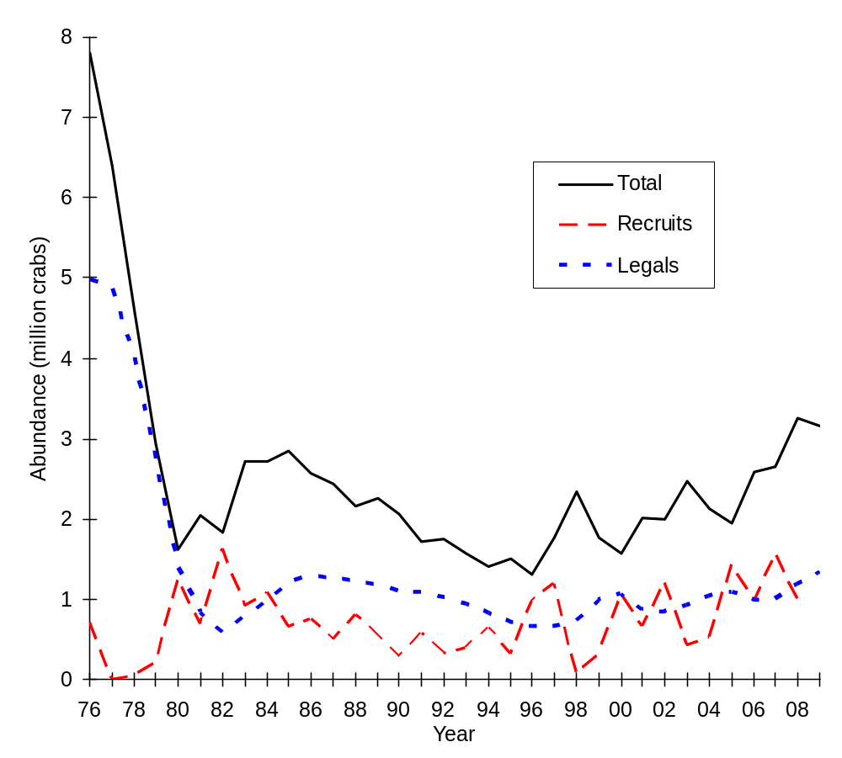

Figure 6. Estimated total (crabs>73 mm CL) and legal male abundances and recruits from 1976 to 2009.

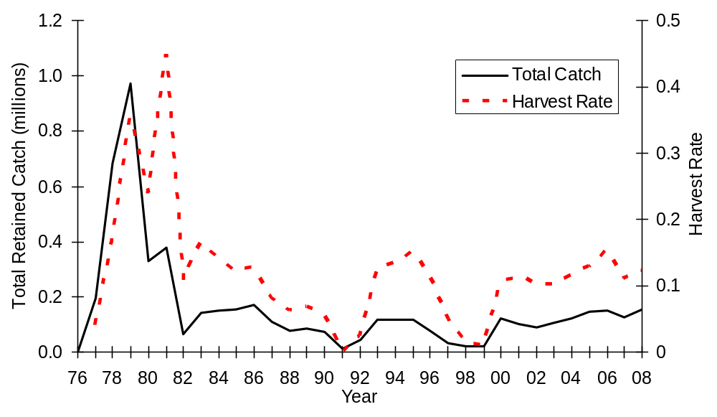
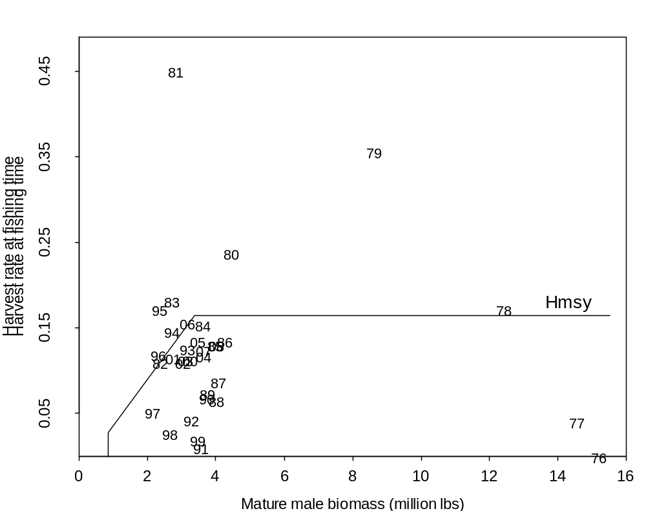
Figure 7. Total retained catches and harvest rates (upper plot) and relationship between harvest rates and mature male biomass (lower plot) of Norton Sound red king crab from July 1, 1976 to June 30, 2009. Hmsy is a proxy MSY harvest rate corresponding to Fmsy with γ=0.6.

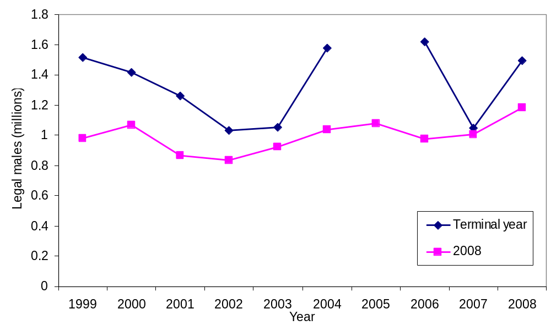

Figure 8. Comparison of estimates of legal male abundance of Norton Sound red king crab with terminal years 1999-2009. These are results of historical assessments. Legend shows the year in which the assessment was conducted.

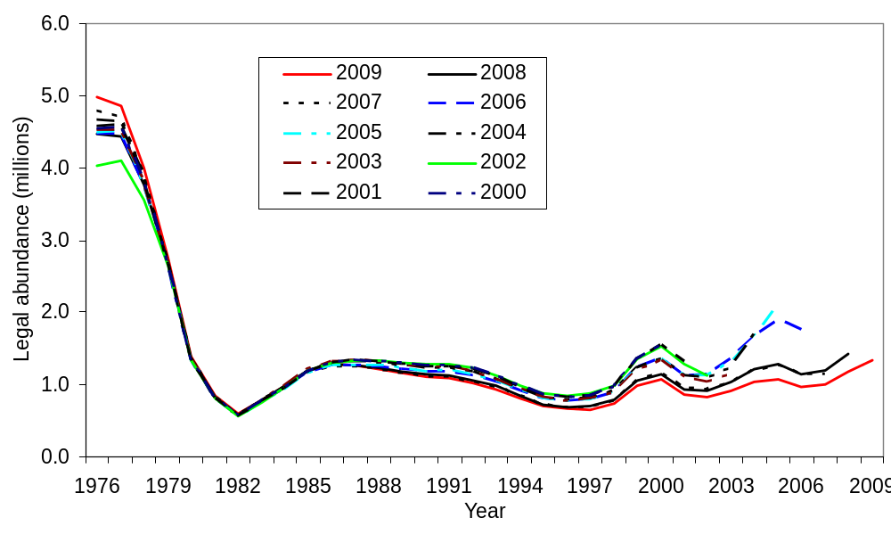
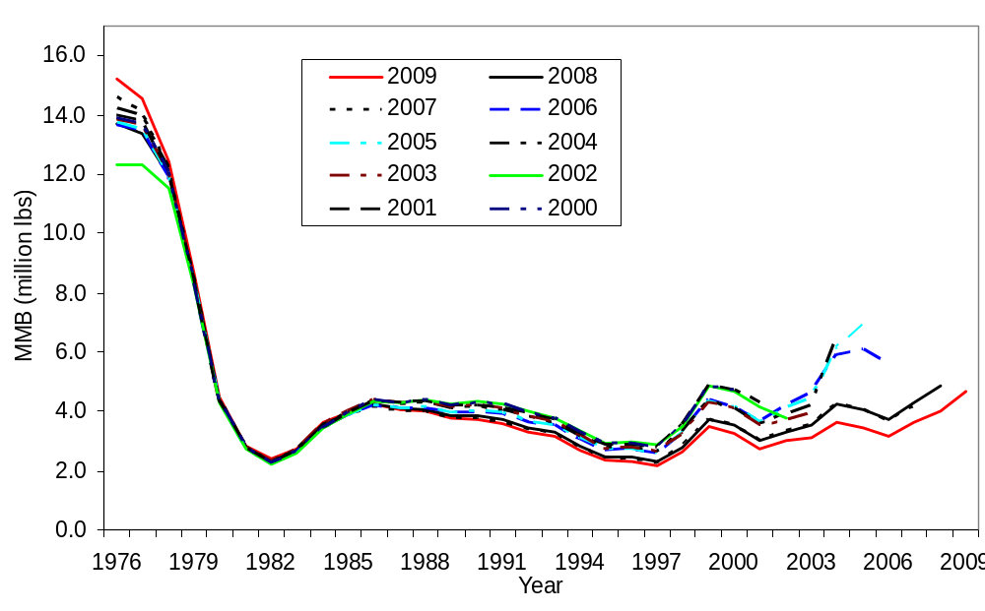
Figure 9. Comparison of estimates of legal male abundance (upper plot) and mature male biomass (lower plot) of Norton Sound red king crab from 1976 to 2009 made with terminal years 2000-2009. These are results of the 2008 model. Legend shows the year in which the assessment was conducted.
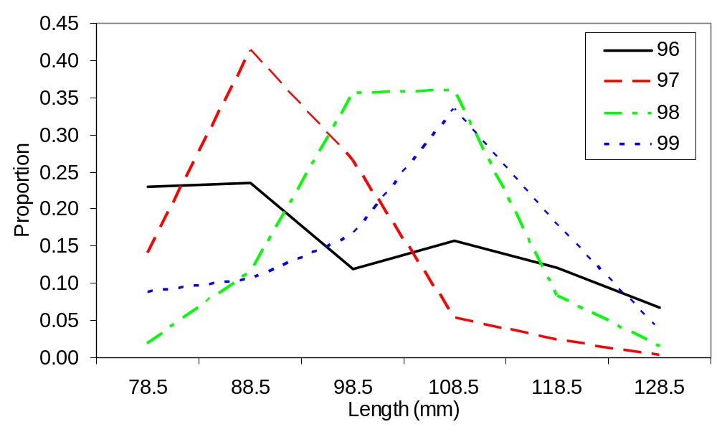
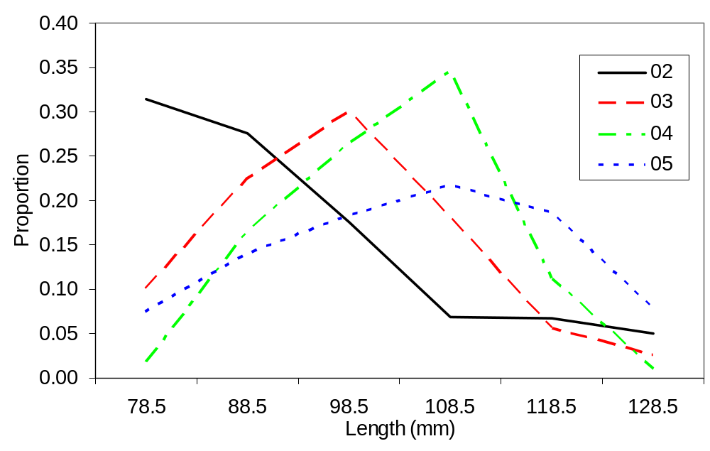

Figure 10. Length frequency of newshell crabs from the winter survey during two periods: 1996-1999 and 2002-2005.

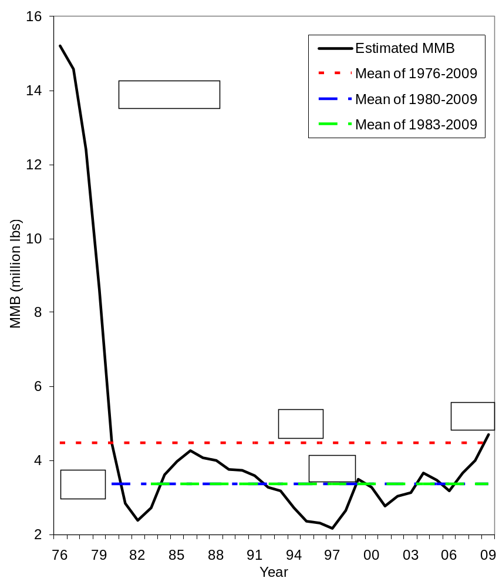

Figure 11. Comparison of estimated mean mature male biomasses during different periods of Norton Sound red king crab.

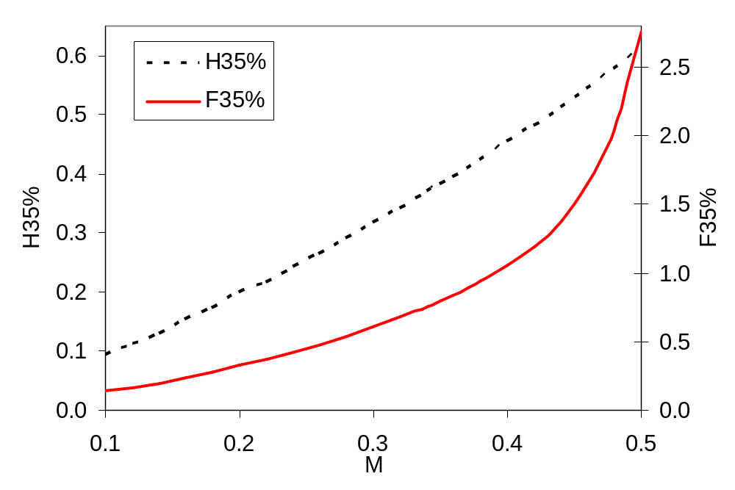

Figure 12. Estimated F_{35%} and H_{35%} (harvest rates that result in mature male biomass per recruit equal to 35% of its pristine level) under different natural mortality (M) values.

