SR Model Analysis Report
30 April, 2026
Table of Contents
1 Project Description 1
1.1 Stock Name : 1
1.2 Project description: 1
2 Analysis Methods 1
2.1 Data and Model Configurations 1
2.2 Model Parameters 1
2.3 Biological Reference Parameters 1
3 Figures 1
3.1 Spawner and Recruit timeseries 1
3.2 Spawner-Recruit Plot 1
4 Model Diagnoses 1
4.1 Prediction Plot 1
4.2 Residual Plot 1
4.3 MSY Profile 1
5 Methods 1
5.1 Spawner Recruit Model 1
5.2 Model data fitting 1
5.3 Mean Biass Correction 1
5.4 Biological Reference Parameters 1
5.4.1 Additional Model options 1
5.5 Model Output Parameters based on expected median vs. mean recruit 1
5.6 Outlier removal 1
5.7 Profile Analyses 1
5.7.1 MSY-RMAX Profile Analysis 1
5.7.2 Target Yield-Recruit Profile Analysis 1
5.7.3 Custom Escapement Goal Analyses 1

1 Project Description

1.1 Stock Name :

1.2 Project description:

2 Analysis Methods

2.1 Data and Model Configurations
Input Data
File name: data.csv
Data Type: S-R
Year range: 1976 - 2018
Brood Year range: 1976 - 2018
Age range: NA
Data Modification
Trimmed Brood Year range: No data trimming
Trimmed Age range: NA
Age Pooling Method:
Model
SR Model: Ricker
SR Model Type: standard
SR Model addition: None
Model Configuration
Total Iteration: 15000
Burn-in: 5000
Posterior: 10000
Thinning: 5
Chains: 3
Total Posterior Samples: 6000
Change Default Priors: Default
SR Target Median Target

2.2 Model Parameters
JAGS parameters summary.
 | mean | sd | 2.5% | 25% | 50% | 75% | 97.5% | Rhat | n.eff
beta | 0.136 | 0.018 | 0.100 | 0.123 | 0.135 | 0.148 | 0.172 | 1.001 | 4400
deviance | 1050.958 | 2.670 | 1047.936 | 1049.028 | 1050.245 | 1052.165 | 1058.148 | 1.001 | 4800
lnalpha | 1.596 | 0.156 | 1.293 | 1.491 | 1.594 | 1.700 | 1.906 | 1.002 | 1500
sigma | 0.408 | 0.048 | 0.328 | 0.375 | 0.402 | 0.435 | 0.516 | 1.001 | 5300
For each parameter, n.eff is a crude measure of effective sample size, and Rhat is the potential scale reduction factor (at convergence, Rhat=1).
DIC info (using the rule, pV = var(deviance)/2) pV = 3.56 and DIC = 1054.52 DIC is an estimate of expected predictive error (lower deviance is better).

2.3 Biological Reference Parameters
Spawner Recruit model parameters summary.
List | alpha | lnalpha | beta x10^(-4) | Seq | Smsy | Umsy | Sgen | Smax
Min | 2.588 | 0.951 | 0.071 | 94560 | 35491 | 0.415 | 4577 | 47662
2.5% | 3.643 | 1.293 | 0.100 | 105780 | 39902 | 0.532 | 6832 | 58060
Mean | 4.994 | 1.596 | 0.136 | 118465 | 46231 | 0.621 | 11109 | 75164
Median | 4.924 | 1.594 | 0.135 | 117664 | 45820 | 0.622 | 10816 | 74049
97.5% | 6.726 | 1.906 | 0.172 | 135349 | 54699 | 0.700 | 17187 | 100192
Max | 9.587 | 2.260 | 0.210 | 165551 | 69531 | 0.774 | 26958 | 141037
SD | 0.788 | 0.156 | 0.018 | 7574 | 3775 | 0.043 | 2655 | 10770
CV | 0.158 | 0.097 | 0.136 | 0 | 0 | 0.069 | 0 | 0

3 Figures

3.1 Spawner and Recruit timeseries
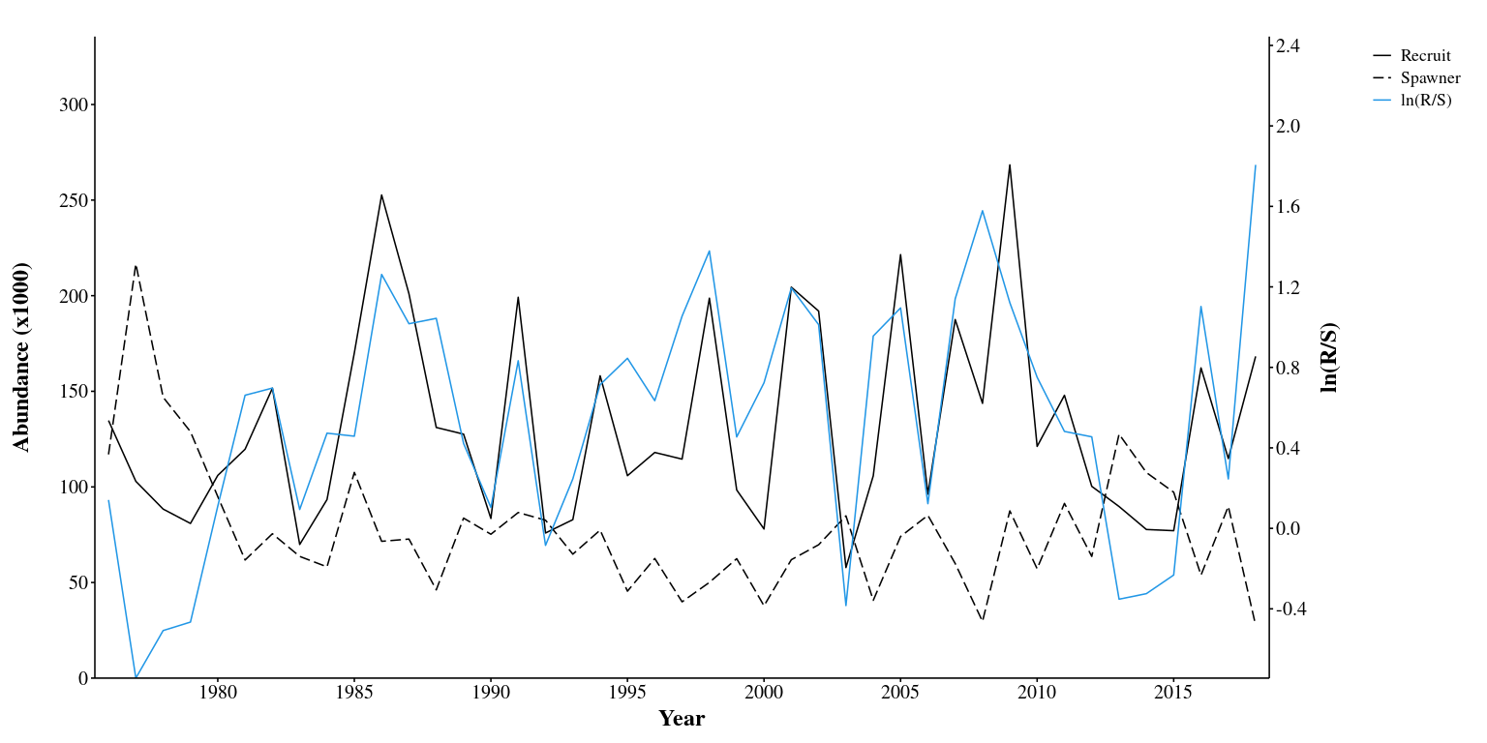
Figure 1. Spawner(Escapement) and brood year recruit, and Recruit per Spawner (R/S)

3.2 Spawner-Recruit Plot
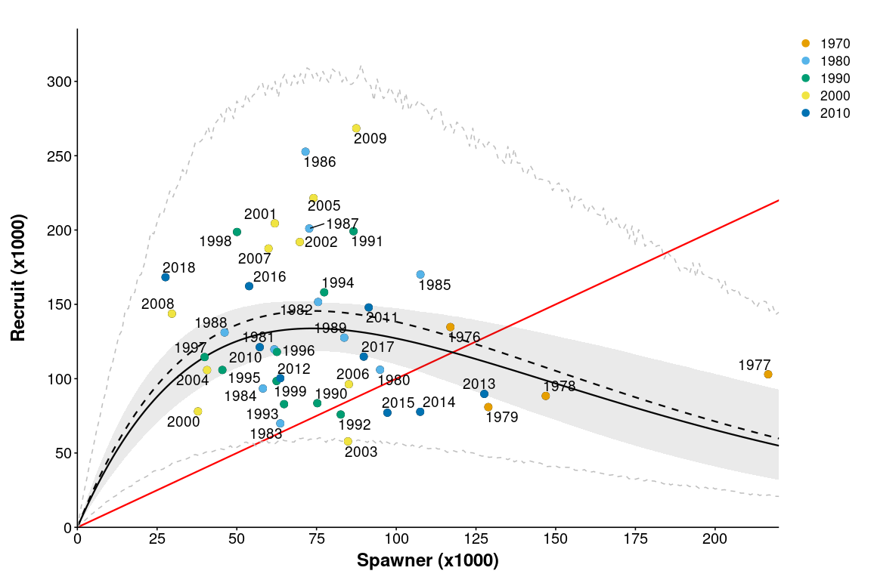
Spawner-recruit curve (sold line: median, dash mean). Gray shade indicates 95% Bayesian credible interval.

4 Model Diagnoses

4.1 Prediction Plot
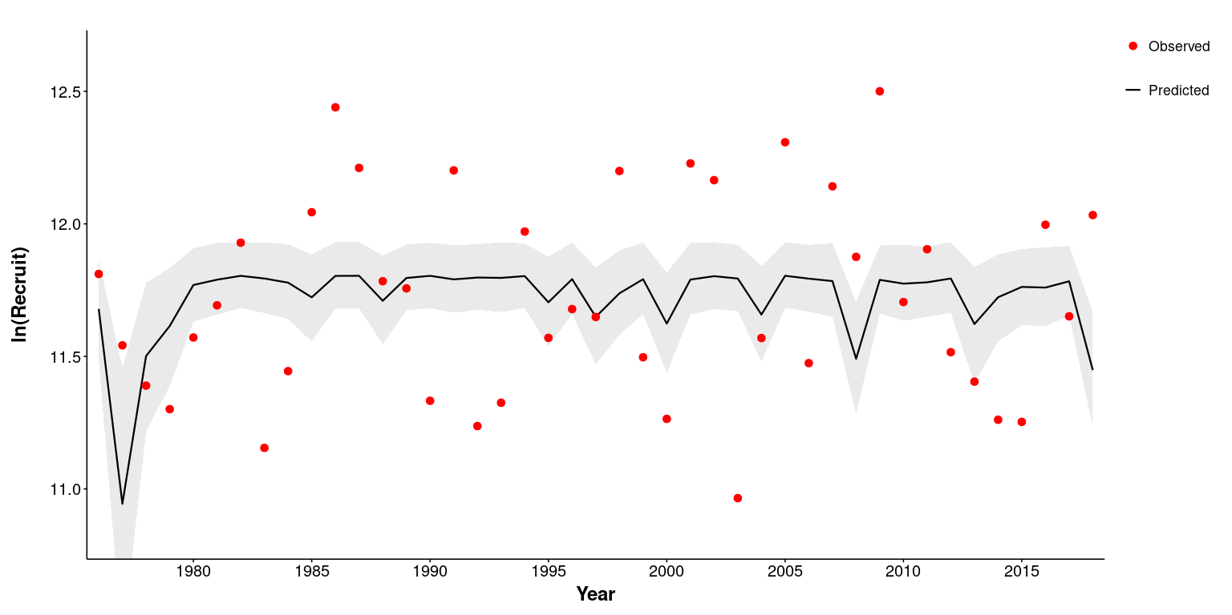
Figure . Predicted and observd recruit.

4.2 Residual Plot
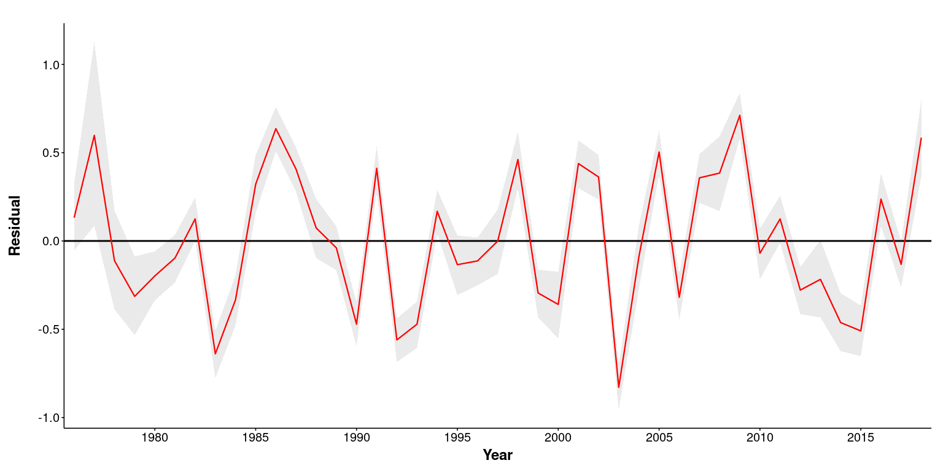
Figure . Residual plot.

4.3 MSY Profile
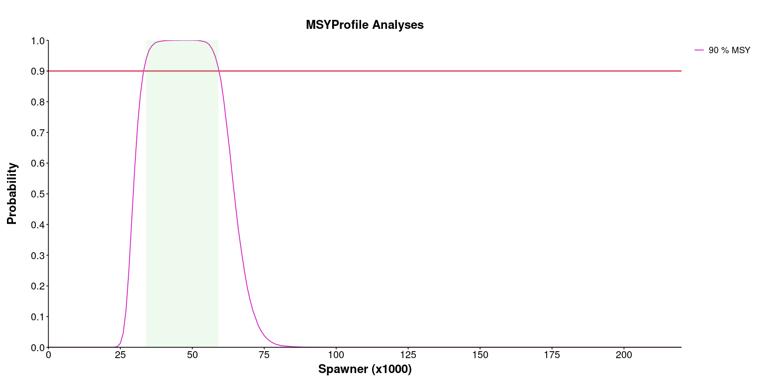
MSY Profile Analyses plot. The lines indicate the probability of a specified escapement producing yield greater than x percent of the MSY.

5 Methods

5.1 Spawner Recruit Model
The spawner-recruit data are fitted to the Ricker (1957) model.
$$R_{y}=αS_{y}e^{-βS_{y}}e^{ε_{​}}$$
Log-linear form
$$R_{y}=ln.α-βS_{y}+ln\left(S_{y}\right)+ε_{iid}$$
where $ln.α=ln\left(α\right)$, $s_{y}=S_{y}⋅{10}^{-d}$ and $d=Int\left(log\left(\overset{‾}{S}\right)\right)$.
where
$$ε_{iid}∼N\left(0,σ^{2}\right)$$
AR(1) model option AR(1) model (First-order auto-regressive model) assumes that error is serially correlated or that the value of residual at time y is a linear function of the residual at time y-1.
This is modeled as
$$R_{y}=ln.α-βS_{y}+ln\left(S_{y}\right)+ε_{y}$$
$$ε_{y}=ϕε_{y-1}+ν_{iid}$$
where
$$ν_{iid}∼N\left(0,{σ_{ν}}^{2}\right)$$
Time variant alpha model
Time variant alpha model assumes that alpha takes random walk process.
$$R_{y}=ln.α_{y}-βS_{y}+ln\left(S_{y}\right)+ε_{iid}$$
where
$$ln.α_{y}=ln.α_{y-1}+ω_{iid}$$
$$ω_{iid}∼N\left(0,{σ_{ω}}^{2}\right)$$

5.2 Model data fitting
Standard Model In data fitting of the model, recruit ($R_{y}$) derived from the y-th brood year spawner ($S_{y}$) is assumed to be log-normally distributed with mean $μ_{y}$ and variance $σ^{2}$
Standard and Time variant alpha models
$$ln\left(R_{y}\right)∼N\left(μ_{y},σ^{2}\right)$$
AR1 model
$$ln\left(R_{y}\right)∼N\left(μ_{y},{σ_{ν}}^{2}\right)$$
where $μ_{y}$ is a log- linearised Ricker spawner-recruit model
Standard Model
$$μ_{y}=ln.α-βs_{y}+ln\left(S_{y}\right)$$
AR1 Error Model
$$μ_{y}=ln.α-βs_{y}+ln\left(S_{y}\right)+ϕε_{y-1}$$
Time variant alpha Model
$$μ_{y}=ln.α_{​}-βs_{y}+ln\left(S_{y}\right)$$
In the above equations, the conversion from $S$ to $s$ makes $β$ to a range similar to the range of $ln.α$. This is numerically more efficient to estimate parameters.

5.3 Mean Biass Correction
Under the assumption of lognormal distribution of recruit (R),
$$R∼LN\left(μ,σ^{2}\right)$$
or
$$ln\left(R\right)∼N\left(μ,σ^{2}\right)$$
, $μ$ is an expected Median R
Expected Mean R is
$$E\left(R\right)=exp\left(μ+\frac{σ^{2}}{2}\right)$$
$$E\left(R\right)=exp\left(μ+\frac{{σ_{ν}}^{2}}{2\left(1-ϕ^{2}\right)}\right)$$
statistical bias corrected alpha parameters
$$ln.α_{c}=ln.α+\frac{σ^{2}}{2}$$
$$ln.α_{c}=ln.α+\frac{{σ_{ν}}^{2}}{2\left(1-ϕ^{2}\right)}$$

5.4 Biological Reference Parameters
Following biological reference parameters are generated from the model
* Seq Spawner abundance expected to produce the same number of recruits
* Smsy Spawner abundance expected to produce the maximum number of yield (MSY)
* Umsy Exploitation rate expected to produce MSY
* Smax Spawner abundance expected to produce the maximum number of recruits.
* Sgen Spawner abundance expected to produce recruitment size of Smsy. Sgen is a conservation benchmark used by Department of Ocean Canada (DFO)
Seq
$$S_{eq}=\frac{ln.α}{β}$$
Smsy and Umsy of the Ricker model is an approximate
where 0 < $ln\left(α\right)$ < 3 (Hilbon 1985)
$$S_{msy}=\frac{1-W\left(e^{1-ln.α}\right)}{β}$$
$$U_{msy}=1-W\left(e^{1-ln.α}\right)$$
$$S_{max}=\frac{1}{β}$$
Note For mean biased correction replace $ln.α$ with $ln.α_{c}$ Smax does not practically exist when ln.alpha or ln.alpha.c is less than 1.0. This is because the Smax (spawner size that produces RMAX) will be greater than Seq
Sgen is approximated by numerically solving $S$ in following equation
$$ln.α-βS_{gen}+ln\left(S_{gen}\right)-ln\left(S_{msy}\right)=0$$

5.4.1 Additional Model options

5.4.1.1 AR(1) model option
AR(1) model (First-order autoregressive model) assumes that the residual is serially auto correlated or that the value of residual at time y is a linear function of the residual at time y-1.
This is modeled as
$$ε_{y}=ϕε_{y-1}+ν_{y}$$
where
$$ν_{y}∼N\left(0,{σ_{ν}}^{2}\right)$$

5.4.1.2 Time variant alpha model option
Time variant alpha model assumes that alpha takes random walk process.
$$ln.α_{y}=ln.α_{y-1}+ω_{y}$$
where
$$ω_{y}∼N\left(0,{σ_{ω}}^{2}\right)$$
## Model priors Model priors were set to be uniform (Table 1)
Parameter | Prior | Note
$$ln\left(α\right)$$ | $$ln\left(α\right)∼U\left(0,10\right)$$ | All models
$$β$$ | $$β∼U\left(0,10\right)$$ | All models
$$σ$$ | $$σ∼U\left(0,10\right)$$ | All models
$$ϕ$$ | $$ϕ∼N\left(0,0.5\right)$$ | AR1 option
$$ε_{0}$$ | $$ε_{0}∼N\left(0,100\right)$$ | AR1 option
$$σ_{ω}$$ | $$σ_{ω}∼U\left(0,10\right)$$ | TVA option
Table 1. Priors for the Ricer/Beverton-Holt spawner recruit model parameters.

5.5 Model Output Parameters based on expected median vs. mean recruit
The model expected mean ln(R) corresponds to median recruit. To obtain mean recruit statistical bias correction is performed as:
statistical bias corrected alpha parameters
$$ln\left(α_{c}\right)=ln\left(α\right)+\frac{σ^{2}}{2}$$
and
$$α.c=αe^{\frac{σ^{2}}{2}}$$
AR1 model,
$$ln\left(α_{c}\right)=ln\left(α\right)+\frac{σ^{2}}{2\left(1-ϕ^{2}\right)}$$
and
$$α_{c}=αe^{\frac{σ^{2}}{2\left(1-ϕ^{2}\right)}}$$
When using lognormal bias corrected model, $α$ and $ln\left(α\right)$ are replaced with $α.c$ and $ln\left(α.c\right)$.

5.6 Outlier removal
Outlier is defined as posteriors that are below $q_{0.25}-1.5⋅IQR$ or above $q_{0.75}+1.5⋅IQR$, where $q_{0.25}$ and $q_{0.75}$ are 25% and 75% percentile or Q1 and Q3, and $IQR$ is the difference between the two.
The outliers are removed when
* beta is negative ( $β≤$ 0) * log-odd ratio of $ln\left(0.001β/\left(1-0.001β\right)\right)$ is outlier * log-odd ratio of $ln\left(0.001ln.α/\left(1-0.001ln.α\right)\right)$ is outlier

5.7 Profile Analyses

5.7.1 MSY-RMAX Profile Analysis
The MSY-RMAX profiles at given range of $S$ was calculated with following steps.
- In each posterior sample of SR parameters (j) and a given range of spawners $\left(S_{i}:i=1,2,...i,..n\right)$
  - Calculate the model predicted yield $\left(Y_{i,j}\right)$ or recruit $\left(R_{i,j}\right)$.
  - For each posterior (j) find the maximum yield (MSY) $Max\left(Y_{j}\right)$ or recruit (RMAX) $Max\left(R_{j}\right)$.
  - Assign $X_{i,j}$ to 1 if the expected yield or recruit is above the q% of the MSY or RMAX
  - Assign $X_{i,j}$ to 0 if otherwise
  - At each $\left(S_{i}\right)$, calculate the mean of $X_{i,j}$ across the simulation samples (j) that is $\left(P\left(S_{i}\right)\right)$
  - $P\left(S_{i}\right)$ is the probability of a given spawner size ($S_{i}$) producing a mean/median yield or recruit above the q.MSY or q.RMax.
This is written as:
$$P\left(S_{i}\right)=\frac{\sum_{j=1}^{n}{X_{i,j}}}{n}$$
where
$$X_{i,j}=\left\{\begin{matrix}1 & Y_{i,j}≥q⋅ Max\left(Y_{j}\right) \\ 0 & otherwise\end{matrix}\right.$$
and
$$X_{i,j}=\left\{\begin{matrix}1 & R_{i,j}≥q⋅ Max\left(R_{j}\right) \\ 0 & otherwise\end{matrix}\right.$$
MSY and RMAX profile based Escapement Goal range
The MSY and RMAX profile based Escapement Goal range is determined by setting a target achievement probability (p) and deriving a range of S ($S_{l},S_{u}$) where P(S) is equal to and greater than the target p.
$$\left\{S_{msy}←\left[S_{l} , S_{u}\right]|P\left(S\right)≥p\right\}$$
$$\left\{S_{max}←\left[S_{l} , S_{u}\right]|P\left(S\right)≥p\right\}$$

5.7.2 Target Yield-Recruit Profile Analysis
Similar to the MSY and RMAX rpofile analyses, target Yield-Recruit profile at given range of $S$ was calculated with following steps.
- In each posterior sample of SR parameters (j) and a given range of spawners
$$\left(S_{i}wherei=1,2,...i,...\right)$$
  - Calculate the model predicted yield $\left(Y_{i,j}\right)$ or recruit $\left(R_{i,j}\right)$.
  - Assign $X_{i,j}$ to 1 if the expected yield or recruit is above the target yield (TY) or recruit (TR)
  - Assign $X_{i,j}$ to 0 if otherwise
  - At each $\left(S_{i}\right)$, calculate the mean of $X_{i,j}$ across the simulation samples (j) that is $(P\left(S_{i}\right)$
  - $(P\left(S_{i}\right)$ is the probability of a given spawner size ($S_{i}$) producing a yield or recruit above the TY or TR.
$$X_{i,j}=\left\{\begin{matrix}1 & Y_{i,j}≥TY \\ 0 & otherwise\end{matrix}\right.$$
or
$$X_{i,j}=\left\{\begin{matrix}1 & R_{i,j}≥TR \\ 0 & otherwise\end{matrix}\right.$$
Target Yield-Recruit based Escapement Goal range
The target yield and recruit profile based Escapement Goal range is determined by setting a target achievement probability (p) and deriving a range of S ($S_{l},S_{u}$) where P(S) is equal to and greater than the target p.

5.7.3 Custom Escapement Goal Analyses
In the Custom Escapement Goal Analyses, the user defined escapement range(S) was divided to 200 sequence of S ($\left(S_{1},S_{2},...,S_{i},...S_{200}\right)$). The expected and predicted yield and recruit were calculated for each S for each posterior sample (j), and summarized.
The probability of yield above the target yield (TY) over the S range was calculated as:
$$P\left(Y≥TY\right)=\frac{\sum_{i=1}^{200}{\sum_{j=1}^{n}{X_{i,j}}}}{200⋅ n}$$
$$P\left(R≥TR\right)=\frac{\sum_{i=1}^{200}{\sum_{j=1}^{n}{X_{i,j}}}}{200⋅ n}$$

