Yukon River Fall Chum MSA

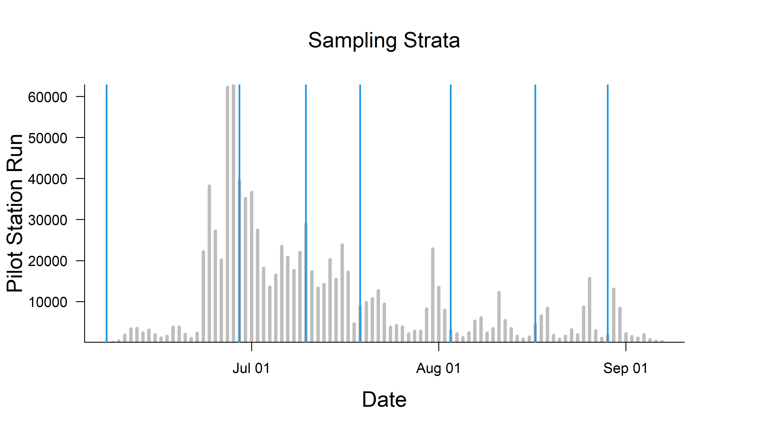 Figure 1. Pilot Station Sample Strata.